The difference between Communities, Groups, and Networks

Our traditional communities are evaporating. The advance of communication and transportation technologies changes the meaning of local, automated services replace human interactions, and we have moved away from the idea of a lifelong marriage and colleagues.
We can easily feel lost adrift in a world of incomprehensible scale and complexity, and as a result we have a higher need than ever to create “tribes” adapted to our new situation. At the same time, we know the power of having a broad network. It is thus, not surprising that more and more of us aim to join, engage, and create new kinds of communities.
However, as our need and desire becomes greater than ever, the term is increasingly abused in marketing and PR. Misconceptions can quickly propagate, so I find it important that we look more carefully into the definitions.
Below are some primary concepts from my personal research and experience in dealing with communities. I concentrated on the differences between groups, networks, and communities to keep this post concise. You can find my comments on other social forms here: On Movements, Mobs, and Organizations. I hope the definitions are of use and please let me know your thoughts!
The Network:
A network is a web of interconnected personal relationships. For example, social media groups allow different individuals to communicate with one another through a dynamic web of relationships. Contrarily, a mailing list is a “channel” as it only allows for communication in one/two directions.
Networks are rarely discrete, meaning the boundaries of a network are hard to define as every individual can be connected with yet someone else. As such, it is best to define networks in terms of density, as clusters.
Networks exhibit another interesting property depending on the level of trust present in the individual relationships. Relationships of trust are extendable, or as the saying goes: ‘my friend’s friend, is my friend’. Networks with a high amount of trust relationships, facilitate the creation of new relationships among its members. They are self reinforcing and tend to form tighter clusters. On the other hand, networks where the trust is broken in one of the relationships tend to divide. This is for example what happens when a couple ends their relationship and inadvertently puts pressure on their network of friends to choose between the two.
A Group:
The best definition I have encountered is ‘a group is a collection of individuals who consider themselves to be a group’*1
The definition might seem to be a truism, but unlike a category (externally observed commonality) or people in the same space (a crowd), a group is defined by the sense of belonging from its members. In this sense, groups are psychologically opted-in by individuals who at a given point take on a set of shared belief and behaviours.
Groups are the result of a constant negotiation of identity between the individual differences and the common identity. A. T. Fisher (among others) showed how this negotiation happens in both directions: not only do the individuals create an abstraction of what the groups “is”, also being associated to a group affects the self-image and thus the behaviour of individuals (Sonn and Fisher, 1996).
Problematically, to develop a sense of belonging, it is not necessary to fully agree with other members on the identity of the group, an illusion of agreement is sufficient. For example, the feminism banner gives an artificial sense of agreement to several groups who have an otherwise very different idea of what they stand for.
As well, it is important to note that we belong to several groups simultaneously, and can feel more closely linked to some than others. For example, I am a fan of modern/contemporary music and underground electronic beats, thus identifying with these group (although I rarely interact with others who share that belonging). Simultaneously, I am a “western world millennial”, and a Colombian and Belgian. Identity is not binary, nor is belonging.
Communities:
“Sense of community is a feeling that members have of belonging, a feeling that members matter to one another and to the group, and a shared faith that members’ needs will be met through their commitment to be together” McMillan, 1976
Communities happen at the intersection of a network and a group. When the individuals of a network share a set of common belief and behaviour, a network can take on an identity. For example, members of the LGBT community have often expressed their appreciation for the community as a welcoming and embracing space where they feel identified as seen in community actions to save underground clubs being shut down instead of simply moving on to the next venue.
Although identity and belonging are essential, like in groups, it is not strictly necessary for all the individuals from a community to agree on the exact same definition of their shared identity. For example, the two major schools of Buddhism, Theravada and the Mahayana, take on slightly different practices and values (forming 2 sub communities) but often meet and debate as a single Buddhist community.
Importantly, because communities are also a web of relationships, interactions between the members will create many opportunities to resolve discrepancies and strengthen the sense of belonging.
As well, the greater the perceived similarity among members of a collectivity, the more readily trust in one member transfers to trust in others (Williams 2001), thus belonging to the same community facilitates trust building between members.
In Communities, groups, and networks, members don’t have a common goal or objective. That is what differentiate them from Organizations, Movements, and Mobs. For more on that distinction, I have an article in progress that you can find here
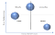
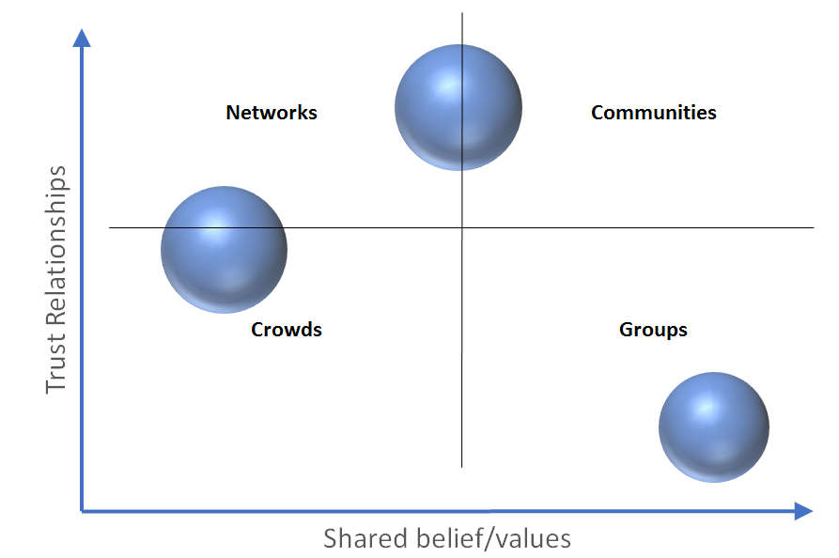
If you enjoyed this article, subscribe here for more!
Notes on the definitions:
Our definition is designed to be of use primarily for management. As such, we have obviated factors that affect these social forms.
Furthermore, we expect our definition to differ from previous definitions who have used these terms lightly or for different purposes than social forms taxonomy. Nevertheless, in an attempt to bride fields, we have included a short range of comparisons and appreciate any further references or help in extending the following:
- The literature on “Sense of Community” (see for example S. Tartaglia 2006) has an implicit definition of community that is local and bound to the satisfaction of material needs (as opposed to only psychological ones). However, several terms (e.i. local community, exchange network, market, etc.) can be used to properly qualify what the authors are dubbing “community” in a narrower category and thus prevent the conceptual ambivalence.
- In statistics, community is often defined simply as a tight network (see for example Y. Hu et al., 2013). Although the author’s mechanism gives a statistically reliable tool to “spot” communities, since we already have the definition of cluster, we champion the above mentioned distinction of ‘cluster’ from ‘community’ in both fields. This distinction allows for identity-related emergent properties (such as Institutionalisation in Philips Selznick definition) to be attributed to ‘communities’, thus creating a continuum with two conceptual extremes (“pure” community and “pure” cluster) that allows to map individual cases.
- In Biology, the definition also differs often by making reference to the coexistence of populations in a shared habitat (see for example G. Palla et al., 2005). However, we argue in favour of “saving “community” for social forms taxonomy since the term “ecosystem” and “cluster” can already explain the relevant concepts for biology.
Sources for this article:
*1: Reicher, S.D. (1982). The determination of collective behaviour (pp. 41–83). In H. Tajfel (ed.), Social identity and intergroup relations. Cambridge: Cambridge University Press
Ouchi (1980), Markets, Bureaucracies, and Clans for an analysis on social forms according to congruence of goals and ambiguity/lack of ambiguity on performance.
C. C. Sonn and A. T. Fisher, ‘Psychological Sense of Community in a Politically Constructed Group’, Journal of Community Psychology, vol. 24, no. 4, 1996.
B. McEvil et al., ‘Trust as an Organizing Principle’, Organization Science, Vol. 14, №1, January–February 2003.
M. Williams, ‘In whom we trust: Group membership as an affective context for trust development’, Academy of Management Review. vol 26, 2001, pg 377–396
G. Palla et al., ‘Uncovering the overlapping community structure of complex networks in nature and society’, Nature, vol. 435, 2005
Y. Hu et al., ‘A New Comparative Definition of Community’, Physical Review E, vol. 78, 2008.
S.Tartaglia, ‘A preliminary study for a new model of Sense of Community’, vol. 34, №1, 2006, pg. 25–36

