Experiment NO#6
Objective: To calculate the efficiency of hydraulic ram pump.
Apparatus:
Hydraulic ram pump apparatus, hydraulic test bench.
Theory:
The hydraulic ram is a device (pump) that works without the use of electric energy and fossil fuels and used for pumping water. The hydraulic ram pumping water, using a potential energy of the supply. The ram pump takes water from the source (the source has head) and pumping to considerable height. The ram pump has two movable valve and an air chamber and pumping water after intermittent cycles. system of the hydraulic ram shown in figure 1.
The ram pump takes water from the source (the source has head) and pumping to considerable height. The ram pump has two movable valve and an air chamber and pumping water after intermittent cycles. system of the hydraulic ram shown in figure.
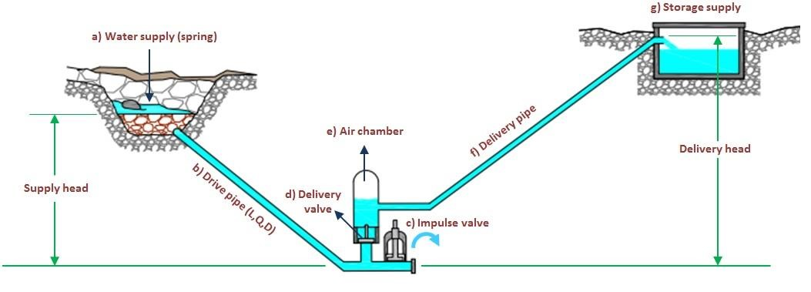

The device uses the water hammer effect to develop pressure that allows a portion of the input water that powers the pump to be lifted to a point higher than where the water originally started.
Construction:
According to the figure, the hydraulic ram system consists of several parts: (a) water supply, that can be rivers and springs, (b) drive pipe with definite length and diameter, (c) pump with impulse valve, and (d) delivery valve, (e) air chamber, contains water and air, (f) delivery pipe, (g) storage supply.
The main parameters to be considered in designing a hydraulic ram include:
- The difference in height between the water source and pump site (called vertical fall).
- The difference in the height between the pump site and the point of storage (called lift).
- The (Q) is the quantity of flow available from the source.
- The length of the pipe from the source to pump site (called the drains pipe).
- The length of pipe from the storage site (called the delivery pipe).
Working principle:
The energy required to make a Ram lift water to higher elevation comes from water falling downhill due to gravity. As in all other water powered devices, but unlike a water wheel or turbine, the ram uses the inertia of moving part rather than water pressure and operates in a cycle.
Working:
According Young (1997) acceleration of water in the drive pipe occurs when the impulse valve is open, and the delivery valve is closed. The impulse valve is open due to spring load or dead weight of valve. At a certain critical velocity, the impulse valve closes due to flow force overcoming the force of spring load or dead weight. Water hammer occurs when the impulse valve closes. Pumping now takes place as shock waves induced by water hammer pass up and down the drive pipe at the speed of sound, the delivery valve opening in response to each pressure pulse.
Observations:
Sr #: | ℎ₁ (mm) | ℎ₂ (mm) | HAF=(^{ℎ2}) ℎ1
1
2
Uses of hydraulic ram pump:
- It is used in hilly areas where water is stored at higher levels than the ground
- It can be used for irrigation system in hilly areas.
Conclusions:

