Topic: Protein
Introduction to protein:
Proteins are the most abundant organic compounds in cells and cover over 50% of dry weight of the cell. In general they are second most abundant molecules in our body after water. They are present in all parts of cell and every type of cell. The core of the cell ( the genetic material ) also contain protein named as histone protein.
These are the extremely important macromolecules in our body as they perform a wide range of functions. Following are some important functions of [protein:
They serve as biological catalysts ( production of ATP involves different types of enzymes that speed up the reaction). Proteins serve as storage unit. Proteins as antibodies provide immunity against diseases and also helps in transportation of molecules ( for example haemoglobin a quaternary protein which serves the function of transportation of oxygen from lungs to tissues and other organs ). Cellular movements also involve protein like actin and myosin. They also help in blood clotting like fibrinogen.
Proteins are also involve in building the structure of the cell for example the entire cytoskeleton structure consists of protein. They provide mobility to some cells like flagellum in sperm cell and the proteins embedded in cell membranes usually act as transport regulators and allow the movements of different types of molecules and ions across the membrane. Proteins as hormones provide inter and intra cellular communication.
On molecular level:
Proteins are the polymers of amino acids containing carbon , Nitrogen , Hydrogen, Oxygen and sometime contain sulphur.

Sub unit of protein:
Amino acids are the subunits of protein and join to form polypeptide chains through peptide bond.
Amino acid is an organic compound having both amino and carboxylic group attached to alpha carbon. General structure of amino acid is:
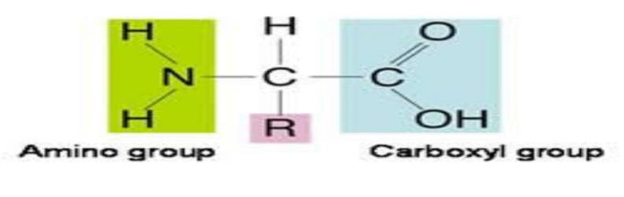
Where amino group carboxylic group and hydrogen is constant and alkyl group is variable. The amino acids differ due to R group.
For example where R is H it forms glycine
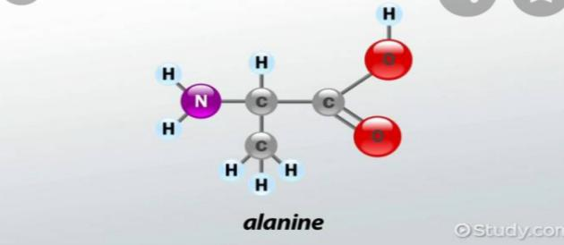
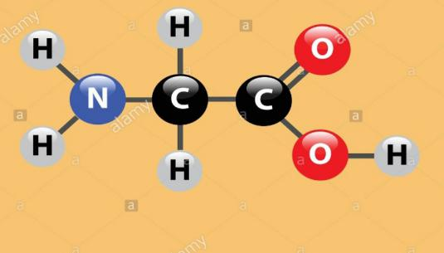

Similarly when R is CH₃ it forms alanine.
About 170 types of amino acids are present in cell and tissues.
Of these about 25 are involve in protein synthesis.
Most of the proteins are made up of only 20 types of amino acids.
These amino acids can be polar ( hydrophilic ) or nan polar ( hydrophobic ) acidic or basic in nature
Linkage of amino acids:
Amino acids bond together through the carboxylic group of one amino acid and the amino group of another amino acid and a molecule of water is released. Now the bond formed between nitrogen and carbon is called peptide bond. It’s dehydration synthesis in which synthesis of new molecule is accompanied by removal of water.
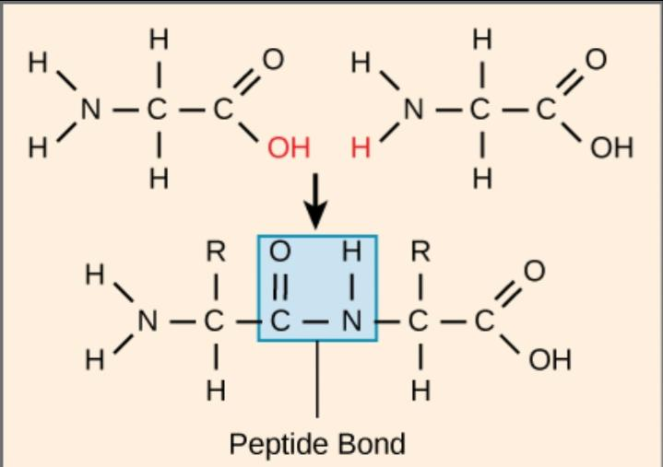

The chain having two amino acids called peptide and so on tri, tetra, up to polypeptide . And the chain containing more than hundred amino acids is called protein. But there is also an exception, insulin ( a protein which lowers blood glucose level ).
Structure of protein:
The structure of protein is basically determined by size and sequence of amino acids in a polypeptide chain. The sequence of amino acids is essential for its proper functioning.
Primary structure:
It is the simplest level of complexity of protein.
The primary structure of protein is simply the sequence of amino acids in polypeptide chains
Every single protein in our body has unique sequence of amino acids ( There are over 10000 proteins in our body and these are formed by specific arrangements of 20 types of amino acids ) and it is the sequence of amino acids that actually determines the final 3D structure of protein. This sequence of amino acids in a polypeptide chain is very essential for its proper functioning. If any amino acid is not at its normal place the protein fails to carry out its normal function.
For example
Sickle cell haemoglobin of human beings is one of the best examples. In this case only one amino acid glutamic acid ( acidic amino acid ) in each beta chain Out of 574 amino acids is replaced by valine ( neutral in nature ) another amino acid. Therefore haemoglobin fails to carry sufficient oxygen. This results in death of the patient.
Diagram
Now if we move along the chain we have repeated sections of N-C-C . this is called backbone of the chain and it continues to repeat over and over.
Now the amino acids in polypeptide chains are called amino acid residue after the removal of water molecule and bond formation.
No. Of peptide bonds is always one less than the no. Of amino acids present in the chain. If n is the no of amino acid then no. Of bonds will be n-1.
Under normal conditions and neutral pH this polypeptide chain will always have polarity. As alpha amino group will have full positive charge and alpha carboxylic group will have full negative charge on it.
As it is clear from the chain structure that it has great capacity of hydrogen bonding. It has two different groups on one amino acid.
Hydrogen bond donor : here amino group of amino acid is called hydrogen bond donor as it contains an atom having higher electronegativity than hydrogen and it creates a positive charge on hydrogen.
Hydrogen bond acceptor :carboxyl group is bond accepter group of amino acid as its carbon is less electronegative than oxygen and creates negative charge on it. Now it attracts opposing hydrogen atom and form an hydrogen bond.
Nature of peptide bond
Peptide bond is a single bond and is different from other single bonds present in the chain as it shows double bond characters (resonant stability) . This bond cannot rotate while other single bonds can rotate in space.
This polypeptide chains in primary structure is not rigid but flexible because of nature of bond.
Secondary structure:
Polypeptide chains begin to twist and form regular patterns through hydrogen bonds between amino acids . This coiling give rise to secondary structure. Alpha helix and beta pleated sheets are common secondary structure.
How polypeptide chains begin to twist
In chains peptide bonds are present holding the amino acids together . these peptide bond have double bond character though it is a single bond.
Double bond character means they don't rotate as double bond do while all other single bonds present inside the chain do rotate. This rotation of single bonds allows the polypeptide chain to coil.
Stability
What makes these regular patterns stable allows them to exist in first in first place is the hydrogen bonding . The amino group of one amino acid forms a hydrogen bond with the carboxylic group of the other amino acid present in closest proximity.
Alpha helix :
It is the most common structure in which the basic polypeptide chain is spirally coiled.
It is a uniform geometric structure having 3.6 amino acids in each turn of the helix ( amino group of one amino acid combines with the carboxylic group of 4th amino acid )
This structure is kept by the formation of hydrogen bonds among amino acids.
According to their rotation about there axis of rotation there are two types of alpha helix.
Right handed helix in which the polypeptide chain rotates clockwise about axis ( where the N C C backbone provides the axis ) and it is a stable configuration . While in left handed helix polypeptide chain rotates counter clockwise and it is much less stable.
Therefore majority of the proteins have right handed helical structure in our body.
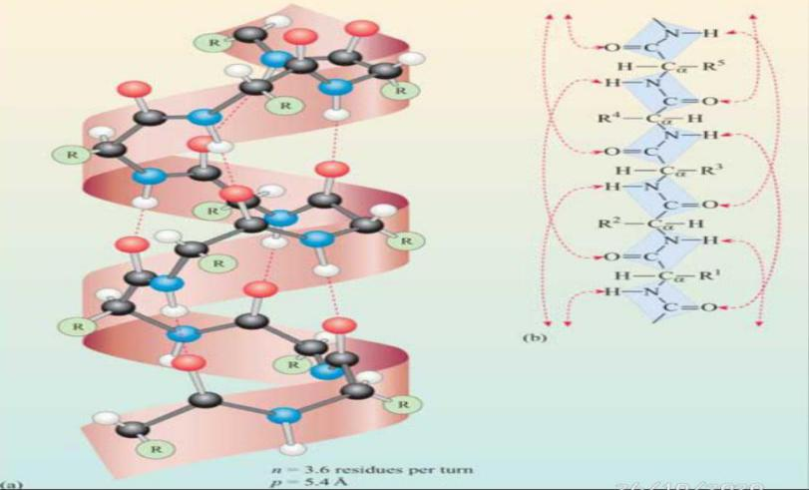
Beta pleated sheets:
Here in sheet structure polymers are linear and stack on each other instead of coiling. It is also a common secondary structure having hydrogen bonding in it. On the basis of arrangement of layers ( Two layers may point in the same direction or in opposite direction ) there are two types .
Parallel sheets in which both the layers move in the same direction and one amino acid has to combine with two different amino acids of opposite strand.
The amino group of one amino acid combines with carboxylic group of another amino acid on opposite strand and the carboxylic group of this amino acid combines with amino group of different amino acid .
In anti parallel two layers move in opposite direction . One amino acid interact with the other amino acid in opposite strand and this interactions is perfect as the hydrogen accepting group of one amino acid interact with hydrogen donating group of the other amino acid and the hydrogen donating group of this amino acid bonds with the hydrogen accepting group of the same amino acid. So one amino acid combines with only one amino acid of opposite strand.
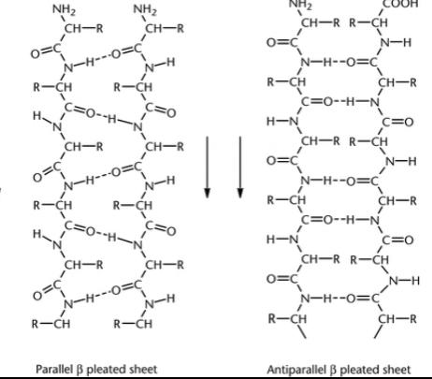
Beta turns:
The compact nature of protein is due to the ability of its polypeptide chains to make sudden turns. These turns are called beta turns and they are also stabilized by hydrogen bonding.
Tertiary structure:
A single polypeptide chains attain a special 3D structure with the help of inter and intra amino acids interactions . this structure is called tertiary structure of protein.
It is the actual functional form of protein . when tertiary structure is lost protein fails to carry out its normal function
Basic deriving driving force behind the formation of tertiary structure is hydrophobic interactions but van der waals force disulphide bridges hydrogen bond and ionic bond also contribute.
Hydrophobic interactions :
As most of the protein exists or form in aqueous environment so this local environment has effect on it if we put polypeptide chain in aqueous solution hydrophobic amino acids having non polar side chains ( as amino acids differ on the basis of their side chains ) aggregate together in the core while hydrophilic amino acids will form the surface
Van der walls force :
Non polar hydrophobic chains in the core are held together by van der Waals forces also called London dispersion force.
Disulphide bridges:
Amino acids having sulphur group such as cysteine interact with each other and form a covalent bond between S-S .this type of linkage is termed as disulphide bridge.
It is a special form of covalent bond
Hydrogen bond:
Polar molecules on the surface form hydrogen bond with the surrounding water molecule ( polar ) and also with each other and stabilize themselves.
Ionic bond:
Amino acids may have side chains that carry a positive charge like lysine arginine while some have side chains having negative charge. These positive and negative charges interact with each other and form ionic bond.
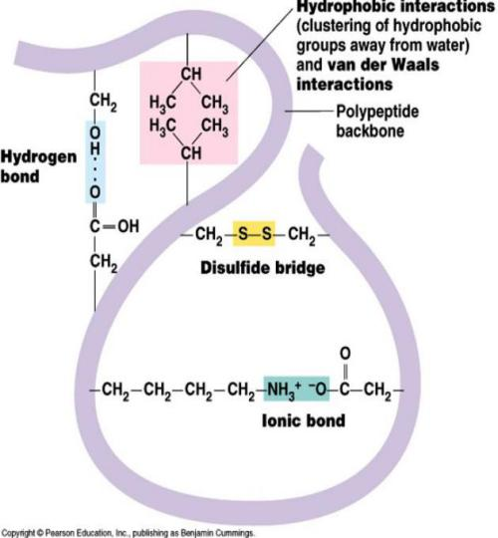
Quaternary structure:
When two or more polypeptide chains interact with each other it forms a quaternary protein.
These polypeptide chains also known as subunits that may or may not identical.
London dispersion force operate between non polar side chains while charged side chains form ionic bond between them.
All proteins have primary structure
Majority have secondary and tertiary structure
While some proteins have quaternary structure
Quaternary protein can classified as fibrous or structure protein and globular protein.
Proteins can be classified as fibrous and globular proteins.
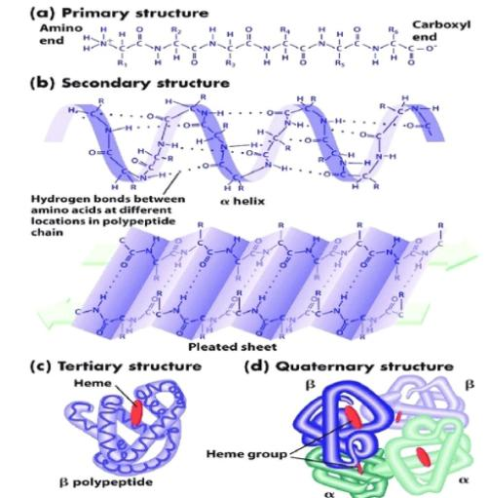
Fibrous protein:
These proteins have long fibers and are not soluble in aqueous media. They cannot be crystallized. These are elastic in nature and form cellular structure therefore they are also called structural proteins.
For example
Silk fibers, collagen fibers, keratin protein, histone protein.
Globular proteins:
These are spherical in shape and have wide range of functions. Therefore they are also called functional proteins. They are soluble and water and can be crystallized . They can be denatured with a change in PH and temperature.
For example
Hormones such as insulin is a globular protein
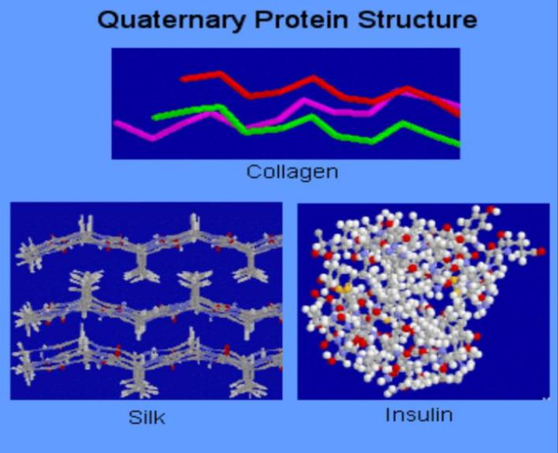
Albumin protein in egg, histone DNA protein and hemoglobin are all examples of quaternary protein .Slight changes in quaternary structure can effect the normal functioning of protein.

Multiple short questions
1: A polymer having fifty amino acids is termed as
- Protein
- Polypeptide
- Dipeptide
- Peptide
polypeptide

2: If R group of amino acid is replaced by CH3 it will be called
- Glycine
- Alanine
- Proline

cysteine
Alanine
3: The building blocks of proteins in primary structure are linked through
- Peptide bond
- hydrogen bond
- dipole forces
- hydrophobic interactions
Peptide bond
4: How many amino acids are present in our body
- 120
- 150
- 170
- 145
170
5:Amino acid containing Sulphur is
- Proline
- Glycine
- Alanine
- Cysteine
cysteine
6:Which is the actual functional configuration of protein
- Primary
- Secondary
- Tertiary
- Quaternary
tertiary
7:Fiberous proteins are
- Soluble
- not soluble
- Functional
- Spherical
Not soluble
8: Hemoglobin has _ structure
- Primary
- Secondary
- Tertiary
- Quaternary
quaternary
9: Protein as antibodies
- Protect the body against pathogens
- provide communication
- speed up the reaction
- provide transport
Protect the body against pathogens
10: Beta pleated sheets are the examples of
- Primary structure
- tertiary structure
- secondary structure
- quaternary structure
Secondary structure

THE END

