The renal system controls blood filtration, fluid balance, and acts a buffer system. The renal system includes the:

kidneys
ureters
urinary bladder
urethra
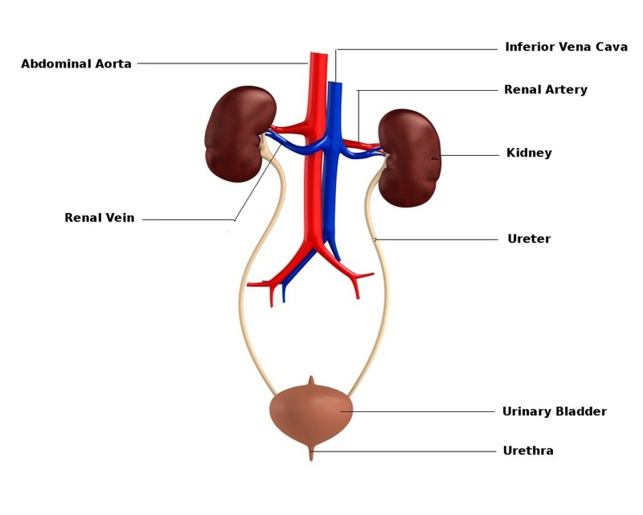

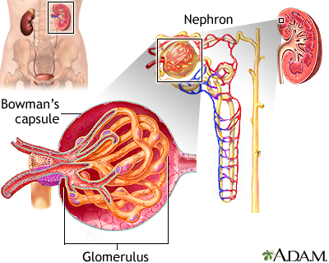
The Kidneys are the primary controllers of water, electrolyte, and pH balance in the body. They also help manage blood pressure regulation. The two major physiological components are the:

glomerulus
nephron
GLOMERULUS: can be thought of as a "coffee filter." It allows small particles and fluid to pass through specialized capillaries with slit-like holes, while keeping all cell types within the blood. This filtrate then passes to the NEPHRON, which is a microscopic sorting system. Important parts of the filtrate-- proteins, glucose, and most of the water--are pumped back into the blood, while certain waste products are actively pumped out of the blood and into the urine. These pumps can start/stop/reverse as needed, which is how the body balances its water, pH, and various chemical levels!

URETERS: far simpler than the kidney, they are tubes made of smooth muscle that carries urine from the kidney to the bladder. They do not work by simple gravity, but rather by peristalsis, via the smooth muscle in the ureter walls. Automatically contracting in a wavelike manner, similar to the intestines, the left and right ureters keep urine flowing away from each respective kidney toward the bladder.

BLADDER: pouch made of smooth muscle and special endothelial cells "cells lining the inside" that allow it to stretch dramatically as well as contract strongly when needed. The bladder has a complex nervous system. It is controlled both

intrinsically, as the cells can sense stretch and force voiding,
subconsciously, as the autonomic nervous system can "tell" you when you need to void, and
consciously, as you can force yourself to void even if the bladder is relatively empty.
URETHRA: differs greatly between men and women. In men it takes a long course, going through the prostate and having input from the reproductive organs. In females it has a short course and as a result is more prone to having bacteria "climb" up into the bladder resulting in cystitis (urinary tract infection, or "UTI").

