Project proposal (Group No. 4 BS Mathematics 2nd semester)
Course Name:
Citizenship education and community Engagement
Proposal Title:
Project idea template
Submission date
10 May 2020 1:00 p.m.
Group Members:
Laiba Bano
Roll No. BMAF19BM035
Rabia Farooq
Roll No. BMAF19BM032
Aniqa Raza
Roll No. BMAF19BM007
Areeba Rasool
Roll No. BMAF19BM003
Ayesha
Roll No. BMAF19BM006
Submitted to:
Mam Mehlah Jabeen
Session:
2019-23

University of Sargodha sub campus Bhakkar

1.Title of project:
Rescue the community in COVID-19 condition
2.Introduction:
Rescue 1122 (Urdu: 1122 پنجاب ایمرجنسی‎) is an emergency service that serves Punjab Province in Pakistan. The service is accessed by calling 1122 from any phone. It was established under the 2006 Punjab Emergency Service Act to provide management of emergencies such as fire, rescue and emergency medical services. The Punjab Emergency Council and District Emergency Boards have been constituted to ensure management and prevention of emergencies and to recommend measures for mitigation of hazards endangering public safety. Dr Rizwan Naseer is the current Director General of Rescue 1122 Pakistan.
After the success of the Lahore Pilot Project launched in 2004, Rescue 1122 is operational in all Districts of Punjab with a population of over 110 million and providing technical assistance to other Provinces of Pakistan. Rescue 1122 includes Emergency Ambulance, Rescue & Fire services and a Community Safety program.
The District Emergency Officer is responsible for the day-to-day operational management and administration of the Service in the Districts in close coordination with the District Administration. The office of the Director General is mainly responsible for the overall monitoring to ensure uniformity and quality, training, planning, research and development through the Provincial Monitoring Cell. The management is currently working to improve its services. In March 2013, Emergency Rescue Service Rawalpindi received 14 new fully equipped ambulances.
Presently, Rescue 1122 is representing a model of integrated emergency services in the world. It offers emergency, fire, rescue, disaster management, water rescue, animal rescue and community safety services under one umbrella.
"Introduction of Rescue 1122". rescue.gov.pk. Retrieved August 1, 2017.
2.1. Background:
In more advanced developing countries, establishing ambulance transport systems is more feasible, but still requires considerable expertise and planning. Prior to 2004, Pakistan did not have an organized emergency medical system. In that year, Rescue 1122 was launched as a professional pre-hospital emergency service, and it has managed to achieve an average response time of 7 minutes, comparable to that of developed nations. Some of the critical factors in its success included local manufacture of vehicles, training instructors to certify emergency medical technicians, adopting training materials to the local context, and branching out to include fire and rescue service response under a united command structure.
Waseem Hanniya, Naseer, Rizwan ,Razzak,Junid Abdul (June 1,2011) http://emj.bmj.com/content/emermed/28/6/513.full.pdf
2.2. Present Situation:
In Pakistan:
The Message of the Director General Punjab Emergency Service Dr Rizwan Naseer on UN Global Road Safety Week( 10 May 2020)
https://www.youtube.com/watch?v=kx98yb0laUQ&feature=youtu.be (YouTube channel Rescue 1122)
Rescuers are performing their duties at inside Expo Corona Hospital in Hall 1 and Hall 3 to take care of Corona positive patients.
Hats off to all Frontline Fighters of COVID-19
Rescue Officers with staff at Expo Corona Triage Center are also performing 24/7 duties to facilitate COVID-19 patients.(9 May 2020)
Mr. Zeeshan Assistant Commissioner Model Town visited Lahore Expo Triage Center and discussed in detail with Rescue Officers Sir Ahsan and Dr. Ali about the arrangements for the patients of Expo Corona Hall Number 1. He appreciated the organized set up by the Rescue Team at Expo Center and ensured to provide administrative support to the team during this pandemic (6 May 2020)
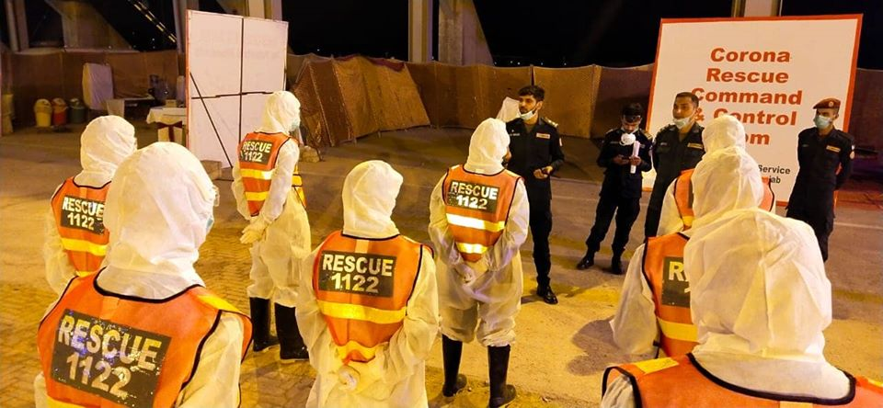
https://www.facebook.com/rescue1122official/ (Rescue official Page)
In Bhakkar:
All Rescue 1122 services are closed due to corona virus. Corona helpline 080099000 in Bhakkar. Tahir Mahmood as a District Emergency Services doing his job very well. Now they only serves the corona patient.
https://www.facebook.com/rescue1122official/(Rescue Mohafiz Bhakkar)
3.Justification of project:
a. Important of project activity:
First Aid knowledge is invaluable for both you as the individual and for your community. It enables you to assist persons who become injured in the event of an accident or emergency situation until help arrives. First Aid skills can be applied in the home, the workplace or in public locations, therefore the more First Aid certified people there are in a community the safer that community becomes. Becoming First Aid certified not only benefits you as an individual but it extends to your family, friends, co-workers and even the community as a whole. As unpleasant as it is to talk about, accidents and emergency situations are not completely preventable or unavoidable.
If an accident happens in the workplace, in your home or in a public space, being a helpless witness to an emergency situation can potentially worsen the situation.
This is why it is very important for as many people as possible to have at least a basic knowledge of First Aid. In its most basic form, First Aid is the initial assistance given to a victim of injury or illness. Basic First Aid knowledge is comprised of relatively simple techniques and procedures that can be performed with limited equipment and is typically carried out until professional medical assistance arrives
laiba Bano BMAF19BM035,(2020) , Bs Mathematics ,Department of Mathematics, University of Sargodha sub campus Bhakkar)
b. Practical Implication:(Who will get benefit of this project?)
1. It allows those trained with the potentially lifesaving ability to assist an injured or ill person during a variety of emergency situations.
In situations such as someone ingests a harmful substance, suffers from a heart attack, a seizure or stroke, is involved in a motor vehicle accident or is caught in a natural disaster, a person trained and knowledgeable in even the very basics of First Aid can be of extreme importance in assisting the injured person(s) until emergency responders arrive. The more people that are First Aid trained and knowledgeable the more the community as a whole benefit.
2. Knowledge in First Aid benefits the individuals themselves regardless of whether an emergency affects them directly or involves people they live and work with. First Aid can and often lessens the severity of an emergency in a given time and place.
3. While everyone can benefit from First Aid knowledge and training it is an even greater benefit to those working or living with individuals who require ongoing special attention or treatment such as children, persons with physical or mental disabilities, persons with chronic illness, persons with disorders such as epilepsy, the elderly, persons involved in recreational activities such as swimming or people working in dangerous environments such as a factory or construction site.
laiba Bano BMAF19BM035,(2020) , Bs Mathematics ,Department of Mathematics, University of Sargodha sub campus Bhakkar)
4.Objectives:
To provide participants with the knowledge to administer First Aid care and treatment in the workplace or in personal situations. How we provide First Aid adults, children & babies in a wide range of emergency situations
Our main objectives are given below:
We will aware people about
- emergency numbers
Country Emergency Numbers:
Dial 112 or 911 from a mobile phone with GSM coverage anywhere in the world and your call will be automatically directed to that country’s emergency number. (https://www.abcpublications.com.au)
- First aid basics
- Aware them through pamphlet
- Give basic training to public about rescue
- How ladies rescue their children in absence of male person.
- How people rescue their lives in Pandemic condition.
- Awareness through social media
(laiba Bano BMAF19BM035,(2020) , Bs Mathematics ,Department of Mathematics, University of Sargodha sub campus Bhakkar)
5. Plan of action
a. How will you do this project activity?

1.Going to community Institute:
First of all, I will visit the Rescue office 1122. Tell them my project .in this regard, In Bhakkar ,Mr. Asif Murawat give training to people.I will contact him and become a part of community service.
2. Get First Aid training:
I will visit recue 1122 office and get training of first aid from them. Mr. Asif Murawat is performs his duty in this regard.I will meet him and avail myself.
3.Print out a Pamphlet of basic first aid in lock down condition:
Pamphlet regarding treatment of first aid will be developed by group leader Laiba Bano on MS Word . I will print it out, distribute it among people and paste it on the walls of shops etc. So people will aware about that.
.4.Visit our neighborhood and train them:
Each member of group will visits his own neighborhood and teach them about first Aid treatment. I will visit my own neighbourhood and tell them about basics of first aid in lock down situation. The reason behind is that during lock down hospital is close for common person and public transport is also stop in this regard. So, i will tell them about basics, how they will rescue their beloved at home? It is specially for women who are not well educated, at the absence of male how can they give their children first aid
5.Tell people about First Aid basics:
- How to stock your home first aid kit?
- Peroxide or alcohol to clean cuts
- Prevent common injuries in the home
- First aid is essential for your car and purse.

6.Aware them about emergency numbers:
First Aid & Emergencies
CALL 911 NOW IF YOU ARE HAVING:
- Chest pain
- Sudden weakness or Numbness
- Difficulty Breathing
I will also aware people about emergency numbers of doctors, recue, fire brigade. In any situation they will dial given number.
laiba Bano BMAF19BM035,(2020) , Bs Mathematics ,Department of Mathematics, University of Sargodha sub campus Bhakkar)
Tell people about first aid basic
In a present situation, whole world is effected by COVID-19. According to my project title my paln of action is rescue the community in COVID-19 . In present situation people cannot go to hospital or clinic due to lockdown. So, I went to give them awareness that how they can rescue themselves at home. If they get any infection, how they can treat themselves. If they get any cut at any part of body how they bandages themselves.
(Rabia Batool, Bs maths,(2020) Department of Mathematics ,University of Sargodha sub campus Bhakkar)
b. Needed resources & the source of generation (financial, human resources etc.)
Financial Resources:
Every member of group will contribute and print out pamphlet.I will contribute my own pocket money.
Human Resources:
I need help of Rescue 1122 in this regard. They will traine me and then I will play a vital role in awareness of society.
laiba Bano BMAF19BM035,(2020) , Bs Mathematics ,Department of Mathematics, University of Sargodha sub campus Bhakkar)
.c.Each person’s role in the project
I searched it. Make it on the Ms word.
laiba Bano BMAF19BM035,(2020) , Bs Mathematics ,Department of Mathematics, University of Sargodha sub campus Bhakkar)
d.Proposed duration of the project
It will take couple of week . I will do that with this timeperiod. (In sha Alla
6. How will you evaluate your project for possible outcomes?
How Save time:
It is time saving for those who cannot go to training center due to lack of time.
Increase Awareness:
Those people who did not know about the first aid, will know it and they will save lives.
Helpful in lockdown:
In lockdown people cannot go to hospital of little bit emergency situation. Due to this they will handle tiny emergencies at home and saves their beloved lives.
laiba Bano BMAF19BM035,(2020) , Bs Mathematics ,Department of Mathematics, University of Sargodha sub campus Bhakkar)
References:

- "Introduction of Rescue 1122". rescue.gov.pk. Retrieved August 1, 2017.Wekipedia ,Rescue official website
- Waseem Hanniya, Naseer, Rizwan ,Razzak,Junid Abdul (June 1,2011) http://emj.bmj.com/content/emermed/28/6/513.full.pdf

- https://www.youtube.com/watch?v=kx98yb0laUQ&feature=youtu.be (YouTube channel Rescue 1122)
- https://www.facebook.com/rescue1122official/ (Rescue official Page)
- https://www.facebook.com/rescue1122official/(Rescue Mohafiz Bhakkar
- laiba Bano BMAF19BM035,(2020) , Bs Mathematics ,Department of Mathematics, University of Sargodha sub campus Bhakkar)
- (Rabia Batool, Bs maths,(2020) Department of Mathematics ,University of Sargodha sub campus Bhakkar)

