Experiment No-2
To study the relationship between voltage and current with the help of Ohm's Law.

OBJECTIVE:
Main objective of this lab is to verify ohm’s law experimentally.
APPARATUS:
1. DC power supply.
2. Resistances of different values
3. Connecting wires
4. Digital multi meter (DMM) / Voltmeter / Ammeter
THEORY:
Ohm’s Law:

When current I flows through a resistor, then the potential difference V (often simply called voltage) between its terminals is proportional to I as in equation (1), where R is the resistance.

Basic Equation: V = R · I | (1)

Combinations of Resistors:
When two or more resistors ( R1, R2, R3,…) are connected in series (Fig. 1) then this combination is equivalent to a single resistor of resistance Req given by (2).

Basic Formula: Req = R1 + R2 + R3+. . . . . | (2)

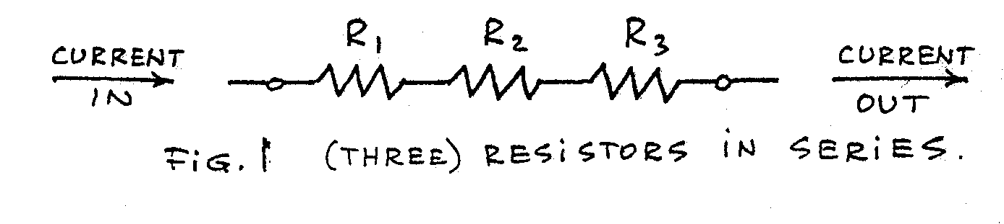
When two or more resistors are connected in parallel (Fig. 2) then the equivalent resistance Req is given by (3).

Basic Formula: Req = 1 + 1 + 1 . . .  R1 R2 R3 | (3)
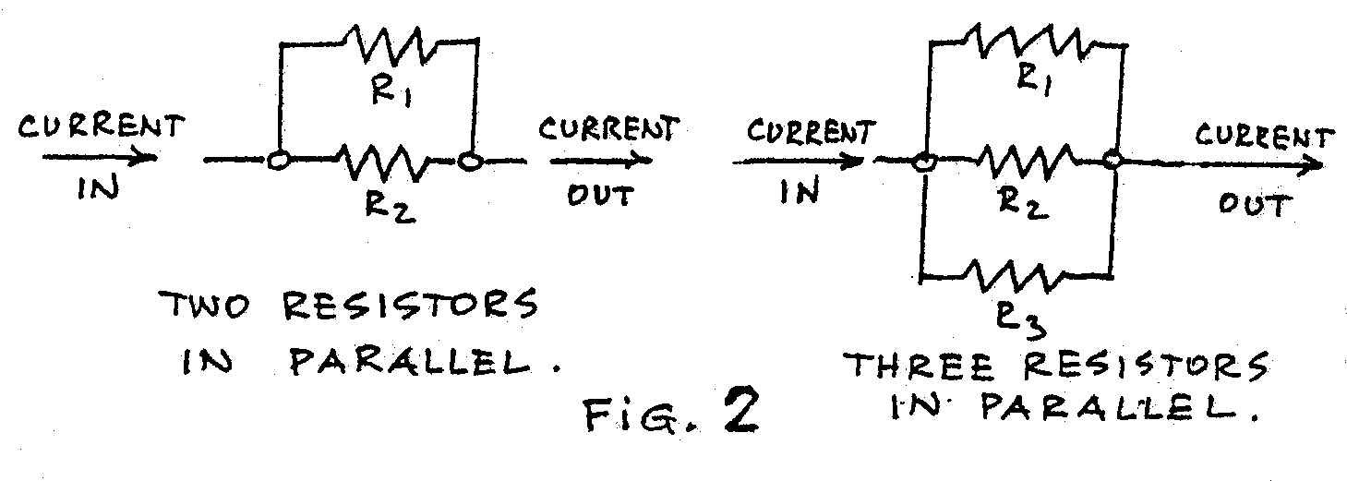

PROCEDURE & OBSERVATIONS:
Part I: Ohm’s Law

- Make sure that the DC power supply is off and unplugged. Make sure that the regulating
knobs are in minimum positions.
- Construct the circuit as in Fig. 3a, using the resistor marked R1 in your sample. Use the dc ammeter scale and make sure that + and – markings are exactly as in Fig. 3a. Measure the value of resistor using ohm-meter.
- Set the voltmeter scale to dc volts scale. Attach connectors to your voltmeter (or DMM as voltmeter. suggestion: use a red connector for the + terminal and a black one for -). Connect the + terminal to point B (where the current enters the resistor) and the other one to point A.
- After your circuit connection are done, prepare on your data sheet your first table, as shown. Plug in the power supply. With the regulating knob(s) in Min position, turn the power “ON”. Turn slowly the regulating knob(s) and watch the voltmeter readings to increase keeping resistance constant. Measure and record the current in (amp) at each of the voltage setting. Record the current I and the voltage V to three significant digits, by estimating fractions of smallest divisions on the scales.
- Also calculate the values of current for every fixed resistor and with increase in voltage using the formula of ohm’s law V=IR.
- Repeat the steps for your resistors R2, with maximum current close to 50 mA but using the finest voltmeter scale possible for each given resistor.
- Turn the power “OFF”, and record the readings.
- Plot a graph between voltage and current ( V versus I).

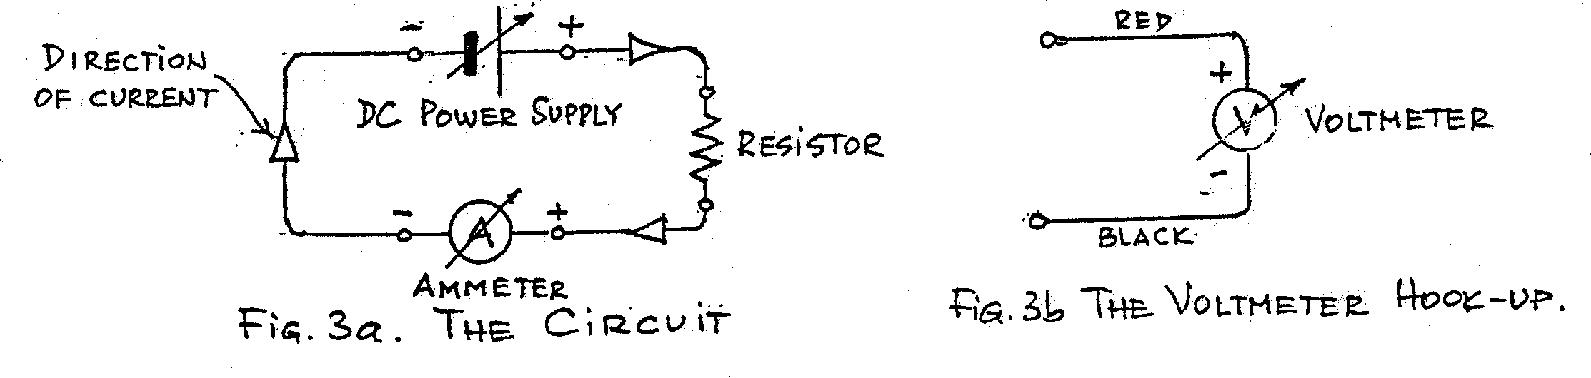

S.NO | R1 = |  |  | R2=
 | V(volts) | I(amp)  Measured | I(Amp)  Calculated | V(Volts) | I(amp)  Measured | I(Amp)  Calculated
1
2
3
4
5
6
7

Procedure Part II: Combinations of Resistors
- Now connect the circuit having different values of resistance.
- Turn on power supply and apply a fixed value of voltage in volts.
- Measure and calculate the current correspondingly.
- Plot a graph between current and resistance (I versus R).

S.NO | Voltage  V (volts) | Resistance  R (ohms)  Measured | Resistance  R (ohms)  Calculated | I(amp)  Measured | I(Amp)  Calculated
1
2
3
4
5

Conclusions:

Comments:

