Mineral Reaction Kinetics

Calcite Dissolution Kinetics
Calcite is one of the most common minerals on Earth's surface. Here we take calcite dissolution as an example to illustrate the Transition State Theory (TST) based kinetic rate law. The dissolution of calcite has been proposed to occur via three parallel reactions (Plummer, Wigley et al. 1978, Chou, Garrels et al. 1989):
CaCO3(s)+H+⇔Ca2++HCO3−CaCO3(s)+H+⇔Ca2++HCO3−
(1)
CaCO3(s)+H2CO03⇔Ca2++2HCO3−CaCO3(s)+H2CO30⇔Ca2++2HCO3−
(2)
CaCO3(s)⇔Ca2++CO32−CaCO3(s)⇔Ca2++CO32−
(3)
Each reaction pathway has its own reaction rate dependence on different chemicals. The rate of reaction (1) dominates under acidic conditions and depends on the activity of hydrogen ion. The rate of reaction (2) dominates under CO₂- rich conditions, while the rate of reaction (3) prevails under neutral pH conditions. The overall dissolution rate R (mol/s) is the summation of the rates of all three parallel reactions:
R=Ak1aH+(1−IAP1Keq,1)+Ak2aH2CO03(1−IAP2Keq,2)+Ak3(1−IAP3Keq,3)R=Ak1aH+(1−IAP1Keq,1)+Ak2aH2CO30(1−IAP2Keq,2)+Ak3(1−IAP3Keq,3)
(4)
Here , A is the reactive surface area A (m²) k₁, k₂, and k₃ are reaction rate constants (mol/m²/s) for the three parallel reactions, respectively; aH+aH+ and aH2CO03aH2CO30are the activities of hydrogen ion and carbonic acid: IAP and K_{eq} are the ion activity products and the reaction equilibrium constants for reactions (1), (2), and (3), respectively.
The equilibrium constants determine mineral solubility and depend on temperature, pressure, and salinity in ways similar to those discussed for aqueous complexation reactions. As indicated by Equation (4), the reaction rates depend on several factors, including the intrinsic mineral properties such as the amount of reactive surface area A and the intrinsic rate constants k, as well as external conditions such as the concentration of “catalyzing” species including H⁺ and H₂CO₃⁰, and how far away the reactions are from equilibrium (IAP/K_{eq}).
The rate dependence on pH is illustrated in Figure 1. The rates in the figure are normalized by the amount of surface area and therefore are in the units of mol/m²/s. Under low pH conditions with very fast dissolution rates, the dissolution rates can be transport-controlled even in well-mixed reactors, because the speed of mixing may not be as fast as dissolutin. In contrast, under closer to neutral pH conditions, the rates are much slower and the reactions are often kinetics controllled.

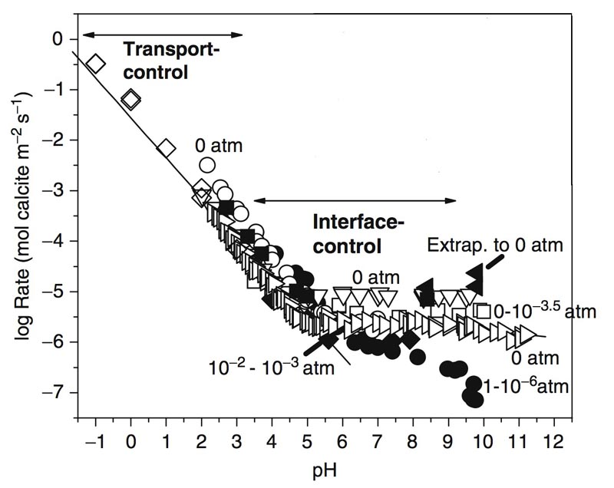
Figure 1. Calcite dissolution rates measured at 298 K and under various pH and CO₂ partial pressure conditions (Brantley, 2008). At low pH, rates are transport controlled and are not dependent upon CO₂ partial pressures, and the logarithm of rates linearly depend on pH. At pH>3.5, dissolution rates are nearly constant at relatively high CO2 partial pressure (0-10³ atm) whereas decrease with pH at low CO₂ partial pressure (e.g., 10⁻⁶ atm).

Generalized Transition State Theory (TST) Rate Law
A general TST rate law is as follows:
R=−∑j=1nkAkjanH+H+(∏aini)[1−(IAPjKeq,j)m2,j]m1,jR=−∑j=1nkAkjaH+nH+(∏aini)[1−(IAPjKeq,j)m2,j]m1,j
(5)
Here nk is the total number of parallel reactions, k_{j} is the rate constant of the parallel reaction j (mol/(m2⋅s))j (mol/(m2·s)), the term anH+H+aH+nH+describes the rate dependence on pH, and the term ainiaini describes the rate dependence on other aqueous species that potentially accelerate or limit reactions. In Equation (4) for calcite dissolution rates, aH2CO03aH2CO30 also accelerates calcite dissolution. The affinity term IAPj/Keq,jIAPj/Keq,j quantifies the distance of solution from the equilibrium state of the mineral reaction j. The exponents m_{1,j} and m_{2,j} describe the nonlinear rate dependency on the affinity term and are normally measured in experiments. Note that Equation (4) is a special case of the general reaction rate law in Equation (5).
Various factors affect reaction rates, including, for example, temperature, salinity, pH, organic ligands. Mineral dissolution rates are often accelerated by the presence of H⁺ or OH⁻. As a result, many minerals dissolve fast in acidic and alkaline conditions and slow down under neutral conditions. Figure 2 shows silicate dissolution rates as a function of pH.
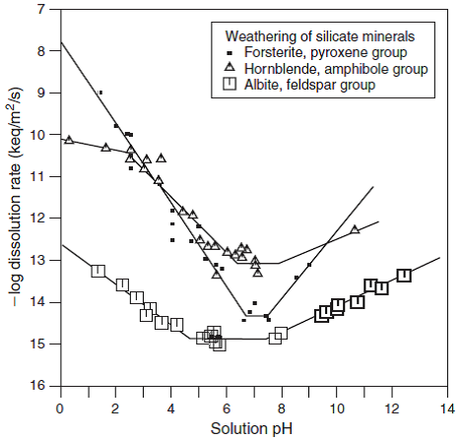
Figure 2. Dissolution rates of silicates as a function of pH (25 deg C).

The intrinsic dissolution rates of minerals vary significantly. Calcite dissolution is in the fast end of dissolution rate spectrum, while quartz dissolves the slowest. Table 1 shows the lifetime of a 1mm crystal of different minerals, indicating more than 5 orders of magnitude difference in dissolution rates of silicates and quartz.
Table 1. The mean lifetime of 1 mm crystals of minerals (years, calculated from the laboratory dissolution rates at 25 deg C and pH 5) [Lasaga, 1984].
Mineral | Lifetime
Quartz | 34,000,000
Muscovite | 2,700,000
Forsterite | 600,000
K-feldspar | 520,000
Albite | 80,000
Enstatite | 8,800
Diopside | 6,800
Nepheline | 211
Anorthite | 112

Rate Constant Dependence on Temperature
The Arrhenius equation is used to quantify the reaction rate dependence on temperature.
k=AFe(EaRT)k=AFe(EaRT)
(6)
Here A_{F} is the pre-exponential factor and is usually considered as a constant that is independent of temperature: the activation energy Ea(kcal/mol)Ea(kcal/mol) is always positive; here R is the ideal gas constant (1.987 cal/(mol⋅K))(1.987 cal/(mol·K)), T is the absolute temperature (K). If we take the logarithm of this equation, we obtain:
lnk=lnAF−EaRTlnk=lnAF−EaRT
(7)
This means if we draw lnk versus 1/T1/T, we get a straight line, as shown in Figure 2. For a particular reaction, if EaEa and k1k1 at the temperature T₁ is known, k2k2 at another temperature T₂ can be calculated by
kT2=kT1e[−EaR(1T2−1T1)]kT2=kT1e[−EaR(1T2−1T1)]
(8)
Figure 3 shows the dependence of calcite rate constants on temperature under different CO₂ partial pressure.
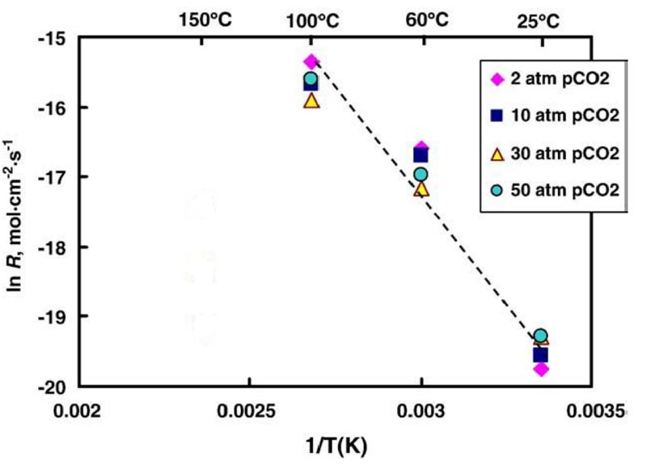
Figure 3. The effect of temperature (298-373 K) on calcite dissolution rates at constant stirring speed of 425 rpm, pH=4.0 in the solution of 0.1 M NaCl for 2, 10, 30 and 50 atm pCO2. The calcite dissolution rates increase with the increasing temperature.

