Subject : Pharmaceutical Analysis
Topic : Thermal Analysis
Date : 30-04-2020

Thermal Analysis
Definition :
“A group of techniques in which a physical property is measured as a function of
temperature, while the sample is subjected to a controlled temperature program
(heating, cooling or isothermal).”
Types :
It has three main types which are as follows :
- Differential Thermal Analysis (DTA) – temperature
- Differential Scanning Calorimetry (DSC) – energy
- Thermogravimetric Analysis (TGA) – mass

Thermogravimetric Analysis (TGA) – mass
Definition :
“A technique measuring the variation in mass of a sample undergoing temperature
scanning in a controlled atmosphere”
Uses :
TGA can provide information about following phenomenon
- Physical phenomena ( vaporization, sublimation, absorption, and desorption )
- Chemical phenomena (dehydration, decomposition and oxidation and reduction)
- Especially useful for the study of polymers, thermosets, plastics, coatings, paints
Note that :
TGA requires a high degree of precision in measuring mass change (accurate
balance) and programmable temperature and temperature change over time.
Therefore it needs precision balance, programmable furnace with constant or
programmable heating rate.

Instrumentation
It is comprised of several sub-units such as
- Electronic microbalance,
- Sample holder,
- Furnace,
- Thermocouple
- Temperature programmer and recorder
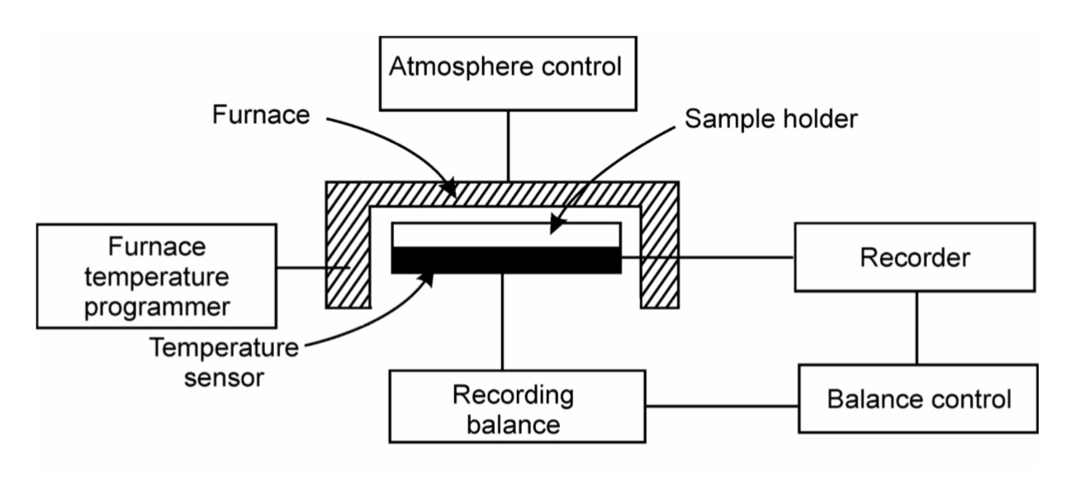
Electronic microbalance
Microbalance serves as the most significant component of a thermobalance. The

main purpose of a microbalance is to record the changes associated with sample

mass. The sample hangs from the balance inside the furnace and the balance is

thermally isolated from the furnace.

Sample holder
Sample holder is otherwise called as crucible. The sample to be subjected for
investigation or characterization is placed in the crucible which is attached to
weighing arm of microbalance. In general, the crucibles used for TGA vary in shape,
size and materials.
The main materials employed for making crucibles such include
aluminum, platinum and quartz. In addition to this, few other materials are also being
utilized occasionally such as stainless steel, glass and graphite. The utilization of
crucibles made of different materials in TGA depends on the temperature range
required for performing experiments. It is necessary that the crucible should possess
at least 100 °C higher thermal stability as compared to experimental temperature
conditions. Also, the crucible selected for a certain experiment should efficiently and
uniformly transfer heat to the sample.

Furnace

The furnace should be designed appropriately so that linear heating rate can be
achieved. The furnace consists of a hot zone in which both crucible and sample are
placed. It should be considered here that the temperature of crucible as well as sample
corresponds to the furnace temperature. It is known that internal atmosphere of furnace
can be affected by temperature regime maintained in the furnace.
Thermocouple
Thermocouple is used for measuring temperature. Similar to heating coil, various types
of material are used for fabrication of thermocouple which includes tungsten or
platinum alloys.
Platinum alloys namely chromal and alumel are used as thermocouple
for measuring temperature conditions below 1100 °C. For temperature conditions
above 1100 °C, tungsten material is used for making thermocouple.
Temperature programmer

Temperature programmer is basically used to control the heating rate when the

temperature tends to increase during the analysis. The heating rate is customized to be

recorded in degree/minute in terms of Kelvin or Celsius scale.

Data recording unit

The data recording unit is basically a chart recorder or microcomputer which is used

for recording the output provided by balance and furnace. The microcomputer enables

the provision to both save and plot the temperature versus weight loss curve using pre-

installed software while performing mathematical problems whereas this feature is not

present in chart recorder.

Evolved Gas Analysis (EGA) TGA-FT-IR
A Thermogravimetric Analyzer (TGA) combined with an Infrared Spectrometer (TG-
IR).
Heating a sample on the TGA, will release volatile materials or generate
combustion components as it burns.The components can be identified in the IR
cell.This technique is most useful when the evolved gases are known small compounds
such as water, carbon dioxide or common solvents which have characteristic IR spectra.
Evolved Gas Analysis (EGA) TGA-MS
The combination of a TGA with a MS allows you to detect very low levels of impurities
in real time. Heating a sample on the TGA, the sample will release volatile materials or
generate combustion components as it burns.These gases are transferred to the MS. This
technique is most useful when the evolved gases or breakdown products are known in
advance but are few mass in number.

Differential Scanning Calorimetry
Definition :
Differential scanning calorimetry is a thermo analytical technique in which the
difference in the amount of heat required to increase the temperature of a sample and
reference are measured as a function of temperature
Principle :
The basic principle underlying this technique is that, when the sample undergoes a
physical transformation such as phase transitions, more or less heat will need to flow
to it than the reference to maintain both at the same temperature. Whether less or more
heat must flow to the sample depends on whether the process is exothermic or
endothermic. For example, as a solid sample melts to a liquid it will require more heat
flowing to the sample to increase its temperature at the same rate as the reference.
This is due to the absorption of heat by the sample as it undergoes the
endothermic phase transition from solid to liquid. Likewise, as the sample undergoes
exothermic processes (such as crystallization) less heat is required to raise the sample
temperature. By observing the difference in heat flow between the sample and
reference, differential scanning calorimeters are able to measure the amount of heat
absorbed or released during such transitions.

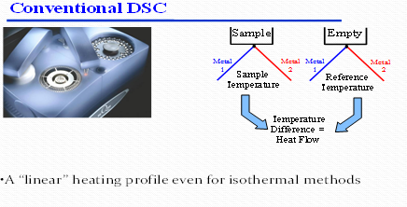
Application :
- Liquid crystals
DSC is used in the study of liquid crystals. As some forms of matter go from solid to
liquid they go through a third state, which displays properties of both phases. This
anisotropic liquid is known as a liquid crystalline or mesomorphous state. Using
DSC, it is possible to observe the small energy changes that occur as matter
transitions from a solid to a liquid crystal and from a liquid crystal to an isotropic
liquid.
- Oxidative stability
Using differential scanning calorimetry to study the stability to oxidation of samples
generally requires an airtight sample chamber. Usually, such tests are done
isothermally (at constant temperature) by changing the atmosphere of the sample.
First, the sample is brought to the desired test temperature under an inert atmosphere,
usually nitrogen. Then, oxygen is added to the system. Any oxidation that occurs is
observed as a deviation in the baseline. Such analysis can be used to determine the
stability and optimum storage conditions for a material or compound
- Safety Screening
DSC makes a reasonable initial safety screening tool. In this mode the sample will be
housed in a non-reactive crucible (often gold, or gold plated steel), and which will be
able to withstand pressure (typically up to 100 bar). The presence of an exothermic
event can then be used to assess the stability of a substance to heat.
However, due to a combination of relatively poor sensitivity, slower than
normal scan rates (typically 2-3 °/min – due to much heavier crucible) and unknown
activation energy, it is necessary to deduct about 75-100 °C from the initial start of
the observed exotherm to suggest a maximum temperature for the material. A much
more accurate data set can be obtained from an adiabatic calorimeter, but such a test
may take 2–3 days from ambient at a rate of a 3 °C increment per half hour
- Drug analysis
DSC is widely used in the pharmaceutical and polymer industries. For the polymer
chemist, DSC is a handy tool for studying curing processes, which allows the fine
tuning of polymer properties. The cross-linking of polymer molecules that occurs in
the curing process is exothermic, resulting in a positive peak in the DSC curve that
usually appears soon after the glass transition.
In the pharmaceutical industry it is necessary to have well-characterized drug
compounds in order to define processing parameters. For instance, if it is necessary to
deliver a drug in the amorphous form, it is desirable to process the drug at
temperatures below those at which crystallization can occur.
- Food science
In food science research, DSC is used in conjunction with other thermal analytical
techniques to determine water dynamics. Changes in water distribution may be
correlated with changes in texture. Similar to material science studies, the effects of
curing on confectionery products can also be analyzed.

- Polymers
DSC is used widely for examining polymers to check their composition. Melting
points and glass transition temperatures for most polymers are available from standard
compilations, and the method can show up possible polymer degradation by the
lowering of the expected melting point, T_{m}, for example. T_{m} depends on the molecular
weight of the polymer, so lower grades will have lower melting points than expected
- General chemical analysis
Freezing-point depression can be used as a purity analysis tool when analysed by
Differential scanning calorimetry. This is possible because the temperature range over
which a mixture of compounds melts is dependent on their relative amounts.
Consequently, less pure compounds will exhibit a broadened melting peak that begins
at lower temperature than a pure compound.

