Feldspar Mineral Chemistry
All minerals in the feldspar group fit the generalized chemical composition below:
X (Al, Si)₄O₈
In this generalized composition, X can be any one of the following seven ions: K+, Na+, Ca++, Ba++, Rb+, Sr++, and Fe++. Feldspars that include potassium, sodium and calcium ions are very common. Barium, rubidium, strontium and iron feldspars are very rare.

The accompanying triangular diagram illustrates two solid solution systems that comprise the feldspar group. The plagioclase feldspars form a solid solution series between the end members of pure albite (NaAlSi3O8) and pure anorthite (CaAl2Si2O8). The alkali feldspars form a solid solution series between pure albite and potassium sanidine (KAlSi3O8).

A list of feldspar minerals with their chemical compositions can be seen in Table 1

Table 1: Many Types of Feldspar
Mineral | Composition
Albite | NaAlSi₃O₈
Amazonite | KAlSi₃O₈
Andesine | (Na,Ca)(Al,Si)₄O₈
Anorthite | CaAl₂Si₂O₈
Anorthoclase | (Na,K)AlSi₃O₈
Banalsite | Na₂BaAl₄Si₄O₁₆
Buddingtonite | (NH₄)AlSi₃O₈
Bytownite | (Ca,Na)(Al,Si)₄O₈
Celsian | BaAl₂Si₂O₈
Dmisteinbergite | CaAl₂Si₂O₈
Filatovite | K(Al,Zn)₂(As,Si)₂O₈
Hexacelsian | BaAl₂Si₂O₈
Hyalophane | (K,Ba)(Al,Si)₄O₈
Kokchetavite | KAlSi₃O₈
Kumdykolite | NaAlSi₃O₈
Labradorite | (Ca,Na)(Al,Si)₄O₈
Microcline | KAlSi₃O₈
Oligoclase | (Na,Ca)(Al,Si)₄O₈
Orthoclase | KAlSi₃O₈
Paracelsian | BaAl₂Si₂O₈
Reedmergnerite | NaBSi₃O₈
Rubicline | (Rb,K)AlSi₃O₈
Sanidine | KAlSi₃O₈
Slawsonite | SrAl₂Si₂O₈
Stronalsite | Na₂SrAl₄Si₄O₁₆
Svyatoslavite | CaAl₂Si₂O₈

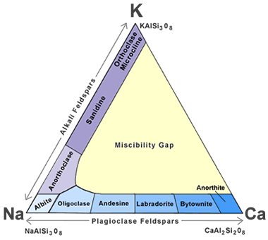
Feldspar mineral classification: This ternary diagram shows how feldspar minerals are classified on the basis of their chemical composition. The sequence of minerals along the left side of the triangle represents the solid solution series of the alkali feldspars. The sequence along the base is the solid solution series of the plagioclase feldspars.

The Plagioclase Feldspars
Albite and anorthite have an interesting relationship. Albite is a sodium feldspar, and anorthite is a calcium feldspar. Both of them form by crystallization from a melt. In nature, many melts contain abundant sodium or calcium, along with abundant aluminum, silicon and oxygen. As a result, most albite will contain some calcium substituting for sodium in its crystalline structure, and most anorthite will contain some substitution of sodium for calcium in its crystalline structure. If a sodium ion with a 1+ charge substitutes for a calcium ion with a 2+ charge, a balancing substitution of an aluminum ion with a 3- charge for a silicon ion with a 4- charge will also occur.

The relative abundance of sodium and calcium in melts varies greatly, and the full series of mineral compositions between pure sodium plagioclase and pure calcium plagioclase does occur. This continuum of compositions is known as a solid solution series because it is analogous to a melt with dissolved sodium and calcium ions suspended in various positions throughout the solution that we refer to as a melt.

Although the range of mineral compositions between pure albite and pure anorthite is made up of very similar minerals, there are differences in their chemistry and physical properties. To facilitate communication, names are given to the feldspar minerals at different positions in the plagioclase solid solution. These names are arbitrary and based upon the relative amounts of albite and anorthite in their composition. The names of these plagioclase minerals with intermediate compositions are summarized in the accompanying table. They can also be seen forming the plagioclase feldspar series along the base of the triangular diagram described above

Plagioclase Mineral Name | Percent NaAlSi₃O₈ | Percent CaAl₂Si₂O₈
Albite | 100-90% albite | 0-10% anorthite
Oligoclase | 90-70% albite | 10-30% anorthite
Andesine | 70-50% albite | 30-50% anorthite
Labradorite | 50-30% albite | 50-70% anorthite
Bytownite | 30-10% albite | 70-90% anorthite
Anorthite | 10-0% albite | 90-100% anorthite

The Alkali Feldspars
Feldspar minerals with compositions that range between NaAlSi3O8 and KAlSi3O8 are known as alkali feldspars. They include albite (NaAlSi3O8), anorthoclase ((Na,K)AlSi3O8), sanidine ((K,Na)AlSi3O8), orthoclase (KAlSi3O8), and microcline (KAlSi3O8).

Albite and sanidine form a solid solution series between NaAlSi3O8 and KAlSi3O8. Anorthoclase, with a composition of (Na,K)AlSi3O8, occupies the intermediate position between them.

Orthoclase and microcline usually have compositions that are very close to KAlSi3O8. Sanidine can also have a composition very close to KAlSi3O8. These three KAlSi3O8 minerals are polymorphs, meaning they have the same chemical compositions but different crystal structures. Sanidine has a monoclinic structure, orthoclase is monoclinic, and sanidine is triclinic. The determining factor for the formation of these three minerals with a KAlSi3O8 composition is temperature. Sanidine is the high-temperature form, orthoclase is the intermediate-temperature form, and microcline is the low-temperature form.

Feldspar in Sediments and Sedimentary Rocks
In sedimentary deposits produced from the weathering of feldspar-bearing igneous and metamorphic rocks, feldspars are usually most abundant close to the source area. Feldspars generally decline in abundance with distance from the source because during transport, they can be attacked by weathering and altered to clay minerals. In addition, their two directions of perfect cleavage make them vulnerable to mechanical weathering, which decreases their particle size and exposes a greater surface area to chemical weathering.

Arkose is a sedimentary rock that forms from the weathering of feldspar-rich igneous and metamorphic rocks. This origin is evident because arkose is a sandstone that contains at least 25% feldspar, usually in the form of grains that can be easily identified as feldspar. Arkose is usually found immediately down gradient and close to the outcrops from which the feldspar grains were weathered. Long transportation distances destroy the feldspar grains, and extended exposure to weathering converts the feldspars into clay minerals. Clay minerals are feldspar’s other contribution to the sedimentary record. They accumulate as mud or soil and often form sediments that become shales and mudrocks.
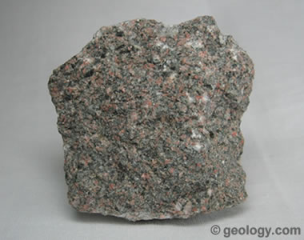
Arkose is a sedimentary rock that forms from the weathering of feldspar-rich igneous and metamorphic rocks. It is a sandstone that contains at least 25% feldspar.

Properties of Feldspar Minerals

Although there are many feldspar minerals, they all share a tight range of physical properties that are surprisingly consistent. Most of them exhibit two directions of perfect cleavage that intersect at or close to ninety degrees. An example of this type of cleavage can be seen in the accompanying photo.

Most feldspar minerals have a Mohs hardness of approximately 6 to 6.5 and a specific gravity between 2.5 and 2.8. They all have a vitreous luster that is often pearly on cleavage faces. The accompanying table shows the generalized physical properties of the feldspar mineral group.

These consistent properties of feldspar are extremely useful even when the feldspar crystals are very small. People who are familiar with feldspar cleavage can pick up an igneous rock that contains crystals of just a few millimeters in size, examine it with a hand lens, and easily differentiate the feldspars from other minerals in the rock. With minimal practice they can also use a set of mineral hardness picks and a hand lens to determine the Mohs hardness of such tiny grains

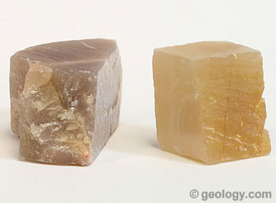

Right-angle cleavage: One of the most diagnostic properties of feldspar is its two directions of cleavage that usually intersect at or close to ninety degrees.

Generalized Physical Properties of Feldspar Minerals
Chemical Classification | Silicate
Color | Usually white, pink, gray or brown. Also colorless, yellow, orange, red, black, blue, green.
Streak | White
Luster | Vitreous. Pearly on some cleavage faces.
Diaphaneity | Usually translucent to opaque. Rarely transparent.
Cleavage | Perfect in two directions. Cleavage planes usually intersect at or close to a 90 degree angle.
Mohs Hardness | 6 to 6.5
Specific Gravity | 2.5 to 2.8
Diagnostic Properties | Perfect cleavage, with cleavage faces usually intersecting at or close to 90 degrees. Consistent hardness, specific gravity and pearly luster on cleavage faces.
Chemical Composition | A generalized chemical composition of X(Al,Si)₄O₈, where X is usually potassium, sodium, or calcium, but rarely can be barium, rubidium, or strontium.
Crystal System | Triclinic, monoclinic
Uses | Crushed and powdered feldspar are important raw materials for the manufacture of plate glass, container glass, ceramic products, paints, plastics and many other products. Varieties of orthoclase, labradorite, oligoclase, microcline and other feldspar minerals have been cut and used as faceted and cabochon gems.

