Economic Theory and Issues
Lecture # 2 and 3
Market Analysis
Market
What is a market?
Traditional concept Vs Modern Concept
“Market is set of all actual & potential buyers & sellers of any particular product irrespective of place”
There are two sides of market i.e. Demand (Buyers/consumers) & Supply (Producers/Suppliers, sellers)
Demand
- What is demand?
Concept
Desire – Willingness – Want – Need etc
Purchasing Power – Purchasing Capacity
Market value – Price
Single Vs Combination
Sole Wish, want, need etc or purchasing capacity does not mean anything
e.g. if you wish anything but do not have capacity to purchase then that will not be demand etc.
Definition
“Willingness plus ability to purchase” in simple words the quantity someone is willing and able to purchase at various prices”
- Factors affecting demand
- Price (-ve)
- Income (+ve)
- Price of related goods (i.e. substitutes (+ve) & complements (-ve))
- Weather (+ve)
- Taste (+ve)
- Fashion etc (+ve)
- Expectations about future prices (+ve)
- Law of demand
Demand for a product or service usually follows a specific pattern in relation to price of that product. That specific behavior is referred to as law of demand
This law states that “if price of a product or service increases demand decreases and vice versa keeping other factors constant”
What is meant by keeping other factors constant, Ceteris paribus, other things remaining same?
- Demand Function, Demand curve and demand schedule
The demand function for an individual consumer can be shown as follows:
Qd_{X} = f(P_{X}, I, P_{Y}, T)

Qd_{X} = quantity demanded of commodity X by an individual per time period
P_{X} = price per unit of commodity X
I = consumer’s income
P_{Y} = price of related (substitute or complementary) commodity
T = tastes of the consumer
The tabular presentation of law of demand is called demand schedule
P | Q
1 | 10
2 | 8
3 | 6
4 | 4
The graphical presentation of law of demand is called demand curve
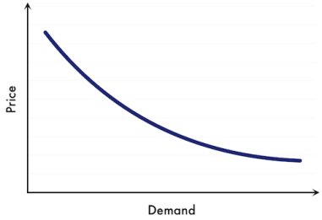
- Exceptions to Law of Demand
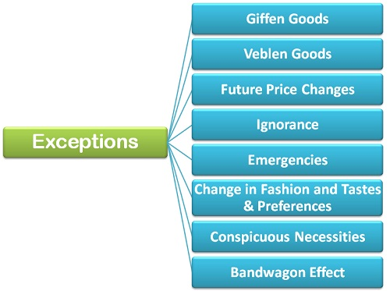
A product that people consume more of as the price rises and vice versa
A luxury item whose price does not follow usual laws of demand
Higher Future Expected Price increases current demand and vice versa
Ignorance may lead to higher demand even on higher prices
In emergencies demand for particular goods increase irrespective of price.
Change in fashion, taste & preferences lead to violation of law of demand
The demand for certain goods is affected by the demonstration effect of the consumption pattern of a social group to which an individual belongs. These goods, due to their constant usage, have become necessities of life
The bandwagon effect is a psychological phenomenon in which people do something primarily because other people are doing it, regardless of their own beliefs, which they may ignore or override
- Decomposition of Demand Effect
The effect of price on demand can be decomposed into two effects. i.e. Income Effect and Substitution Effect
Income Effect: When price of a good changes the purchasing capacity of a consumer changes. This effect of change in purchasing capacity is termed as change in real income that is why it is termed as Income effect
Substitution Effect: When price of a good changes it becomes relatively expensive or cheaper as compared to its substitutes which affects the demand of product that is why this effect is termed as substitution effect.
Example
Increase in price of Pepsi Decrease in Demand for Pepsi
Income Effect: Increase in price of Pepsi decreases purchasing capacity hence demand is decreased
Substitution Effect: Increase in price of Pepsi makes it relatively expensive as compared to its substitute e.g Coke that is why consumer decrease demand for Pepsi and prefer Coke.
- Change in Quantity Demanded Vs Change in Demand
The effect on demand for any product is categorized on the basis of the factors causing change. The categorization is done on the basis of effect due to change in own price and change effect due to change in factors other than price.
Change in Quantity Demanded: The effect on demand due to price is called change in quantity demanded. In this case adjustment is along the same demand curve
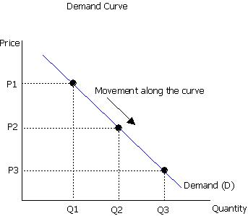
Change in Demand: The effect on demand due to factors other than price is called change in demand. E.g. due to change in weather, change in taste, fashion etc. In this case adjustment is along different demand curves i.e. demand curve shifts. If demand increases demand curve shifts to right and if demand is decreased demand curve shifts to left.
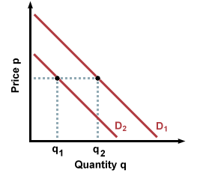
- Market Demand
The summation of demand of all the consumers in the market is called market demand.
Supply
- What is supply?
“Willingness plus ability to sell” in simple words the quantity someone is willing and able to sell at various prices.
- Factors affecting supply
- Own Price (+ve)
- Prices of raw material (slightly -ve)
- Availability of raw material (+ve)
- Production technology (+ve)
- Availability of Labor (+ve)
- Behavior of Labor (+ve)
- Transportation etc. (+ve)
- Natural conditions (+ve or –ve)
- Expectations about future prices (-ve)
- Government Policies (+ve or –ve)
- Other
- Law of supply
The supply of any product follows a specific pattern in relation to Price. This usual relation between price and supply is called law of Supply
This law states that “if price of a product or service increases supply increases and vice versa keeping other factors constant”
What is meant by keeping other factors constant, Ceteris paribus, other things remaining same?

- Supply Function, Supply Curve and Supply schedule
The supply function for an individual supplier can be shown as follows:
Qs_{X} = f(P_{X}, P_{inputs}, P_{Y}, H)
Qs_{X} = quantity supplied of commodity X by a firm per time period
P_{X} = price per unit of commodity X
P_{inputs} = Prices of Inputs
P_{Y} = price of related goods (jointly produced)
H = Other Factors
The tabular presentation of law of Supply is called supply schedule
P | Q
1 | 4
2 | 6
3 | 8
4 | 10
The graphical presentation of law of supply is called supply curve
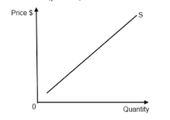
- Change in Quantity Supplied Vs Change in Supply
The effect on supply for any product is categorized on the basis of the factors causing change. The categorization is done on the basis of effect due to change in own price and change effect due to change in factors other than price.
Change in Quantity Supplied: The effect on supply due to price is called change in quantity supplied. In this case adjustment is along the same supply curve.
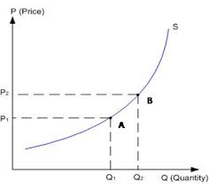
Change in Supply: The effect on supply due to factors other than price is called change in supply. In this case adjustment is along different supply curves i.e. supply curve shifts. If supply increases supply curve shifts to right and if supply is decreased supply curve shifts to left.
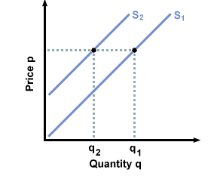
- Market Supply
The summation of supply of all the suppliers in the market is called market supply.
Market Equilibrium
- What is Market?
As stated above “Market is set of all actual & potential buyers & sellers of any particular product irrespective of place”
- What is Equilibrium?
Equilibrium is a state in which opposing forces or influences are balanced.
- What is Market Equilibrium?
The situation in which market forces of demand and supply are balanced i.e. market demand is equal to market supply is called market equilibrium. Graphically the point where demand curve and supply curves intersect each other is called market equilibrium.
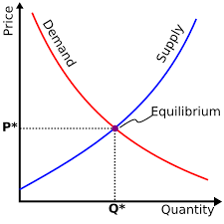
- Market Disequilibrium
The situation in which market forces of demand and supply are not balanced i.e. market demand and market supply are not equal. In case of disequilibrium the following situations may occur:
Shortage: When demand is greater than supply such situation is referred to as Shortage. Graphically shortage can be depicted as follows:
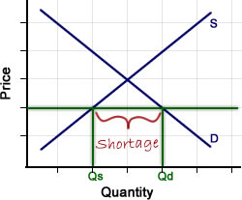
Shortage puts upward pressure on prices.
Surplus: When demand is less than supply such situation is referred to as Surplus. Graphically surplus can be depicted as follows:
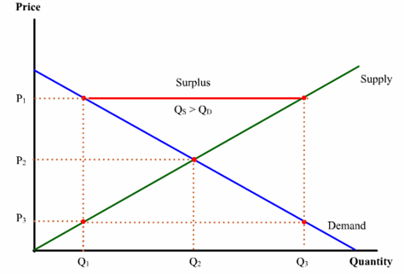
Surplus puts downward pressure on prices.
- Changes in Demand & Supply and their effect on Equilibrium
This topic may be performed in the following steps
- What is the change?
- Either it affects demand or supply or both
- How it affects demand or supply or both?
- How it affects market price and market quantity?

