TOPIC:Elastic fibronectin and Glycoprotein

Elastic fibronectin

ELASTIC FIBRES:

CONTENTS:

• INTRODUCTION

• DEVELOPMENT

• SITES

•TYPES

•FUNCTIONS

•HISTOLOGY

•AGE RELATED CHANGES

•DISORDERS

❖ INTRODUCTION:

DEFINITION:

“Elastic fibers (yellow fibers) are bundles of proteins (elastin) found in extracellular matrix of connective tissue and produced by smooth muscles cells in arteries.”

These fibers can stretch up to 1.5 times their length and snap back to their original length when relaxed. These include elastin, elaunin and oxytalan.

Elastic fiber system is an integral component of connective tissue and it forms a network that is responsible for elasticity of various organs.

• In normal individuals, elastic fibers form 3% of total dry weight of dermis.

• Elastic fibers store the energy during stretching and relaxing.

• Elastic fibers mainly composed of inner core of amorphous elastin and outer electron dense micro fibrils.

Elastic fiber is formed from the elastic microfibril (consisting of numerous proteins such as microfibrillar associated glycoprotein, fibrillin) and amorphous elastin.

The microfibril scaffolds and organizes the deposition of amorphous elastin. Amorphous elastin is formed from monomers of soluble tropoelastin which is insolubilized and cross linked into amorphous elastin by lysyl oxidase.

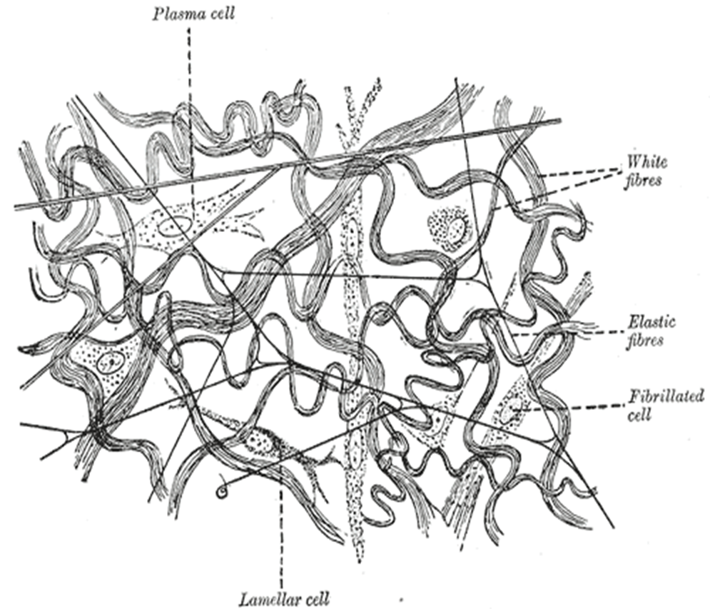

❖ DEVELPOMENT OF ELASTIC FIBRERS:

• First element of elastic fiber that forms consist of bundles of microfibril seen during the first trimester.

• The alignments of this microfibril are parallel so as to accommodate elastin and grow uniformly.

• During second trimester, fibers remain immature and branching in these fibers is seen.

• Initially elastic fibers show masses of peripheral microfibril surrounding a small amorphous core which is elastin with only few internal microfibrils.

• As the fetus matures the amount of elastin and the number of microfibril within the core increases whereas the number of peripheral microfibril decreases.

• At 32 weeks a well developed network of elastic fibers is present in both papillary and reticular dermis.

❖ SITES OF ELASTIC FIBER:

Elastic fibers are found in the skin, lungs, arteries, veins, connective tissues, elastic cartilage, fetal tissues and other structures. Walls of intestine, skin and bronchioles etc also contain elastic tissues.

The highest concentration of elastic fiber is seen in aorta and to some extent in papillary and reticulate dermis of skin.

TYPES OF ELASTIC FIBERE:

Elastic fibers are mainly of two types;

1.Oxytalan fibers

2.Elaunin fibers

1.Oxytalan fibers contain microfibrillary component with no elastin, it emerges from the basement membrane of stratum in a perpendicular orientation and goes deep into papillary dermis where it emerges with elaunin fibers.

2.Elaunin fibers contain microfibril with a small amount of elastin core parallel to dermo-epidermal junctions in papillary dermis.

A dense network of elastic fiber is found in the matrix of reticular dermis which primarily consist of elastin and very little much microfibril.

❖ FUNCTIONS OF ELASTIC FIBER:

• Cardiovascular system:

During systole the work of heart is absorbed by the expansion of great vessels mainly aorta which is rich in elastic tissue which during diastole maintain the blood pressure assuring perfusion of the tissues.

• Respiratory system:

Inspiration is an active energy consuming process, and the expiration occurs passively due to the elastic recoil of the respiratory process.

• Intestines:

The elastic coils dilate when the food comes into the segment and with peristalsis pushing the food forwards, the elastic recoil of the intestine brings back to its original shape.

• In skin elastic fiber is responsible for:

Tension; the resistance of the skin to deforming forces

Elasticity; ability of skin to resume its original shape after deforming forces. This is less in aged people.

Tensile strength; the degree to which skin can be elongated before it tears.

These properties help the skin to adapt local changes in body size and contour, to allow movements of head and limbs and a wide range of facial expressions.

❖ HISTOLOGY OF ELASTIC FIBERS:

Elastic fibers are not visible in routine stains.

Special stains required to demonstrate these fibers are;

• Luna stain: brilliant purple

• Weigert’s stain: purple – violet color

• Orcein stain: red brown color

• Gomori’s aldehyde fuchsin stain: blue black color

• Verhoeff van Giessen stain: black color

The permanganate-bisulfite-toluidine blue reaction is a highly sensitive and sensitive method for demonstrating elastic fibers under light.

This demonstrates highly ordered molecular structure of the elastin protein molecules in the elastic fiber. This is not readily apparent under normal amount of light.

❖ AGE RELATED CHANGES IN ELASTIC FIBERS:

Following changes occur inside a person in its elastic fibers due to enhancement of his/her aging process;

✓ After the age of 50, these fibers are loosely arranged.

✓ Elastic fibers fragments and develops into granular form and indistinct borders.

✓ The microfibrillary component goes on reducing and increase occurs in elastin portion.

✓ There is a considerable decrease in the number of elastic fibers in the papillary dermis and increase in the reticular dermis.

ELASTIC FIBER DISORDERS:

✓ Cutis laxa;

It is the fragmentation and loss of elastic fibers.

✓ Pseudoxanthoma elasticum;

It is the progressive calcification and fragmentation of elastic fibers.

✓ Wrinkly skin syndrome;

It is the decreased number and length of elastic fibers.

✓ Anetoderma;

It is the localized loss of elastic fibers in the dermis.

✓ Mid dermal elastolysis;

It is the loss of elastin in the middle dermis of the skin.

✓ Post inflammatory elastolysis;

It is the localized loss of elastic tissue secondary to insect bites.

✓ Marfans syndrome;

It is the genetic disease in which there comes mutation in the fibrillin in 1 gene with normal microfibril.

✓ Actinic elastosis;

It is the accumulation of irregularly thickened elastic fibers on long term sun radiation exposure.

✓ Elastoderma;

It is the accumulation of excessive and rearranged elastin proteins.

✓ Elastosis;

It is the buildup of elastic fibers in tissues, and is a form of degenerative disease.

There are multitude of causes, but the most common cause is Actinic elastosis of the skin, also known as solar elastosis, which is caused by prolonged and excessive sun exposure , a process known as Photo aging.

❖ SIGNIFICANCE OF ELASTIC FIBERS:

Elastic fibers are the most important resilient component of mammalian connective tissue.

Their presence is necessary for the proper structure and function of the cardiovascular, pulmonary and intestinal systems.

Their structural role is to endow tissues with recoil and resilience.

Studies on the degradation of elastic fibers are helpful to clarify the pathogenesis of the disease and to find out effective treatment methods.

GLYCOPROTEIN

Table of Contents

Glycoproteins;

Example;

Glycosylation;

Glycation;

Difference between glycoproteins and proteoglycans

percentage of carbohydrates in glycoprotein is highly variable;

Function of oligosaccharides chains of glycoproteins;

Types of glycolipids;

O linked glycoproteins;

Importance of o linked glycoproteins

Biosynthesis of O -linked glycosylation;

N linked glycoproteins;

Importance of N – linked glycoproteins;

Biosynthesis of N- linked glycoproteins;

Synthesis of precursor oligosaccharide;

Transfer of glycan to protein;

Processing of glycan;

Glycan processing in the ER and Golgi.

Enzymes in the Golgi

Functions of glycoproteins ;

Structural;

(2) protection;

(3)reproduction;

(4) adhesion ;

(5)hormones;

(6) Enzymes

(7) carriers;

(8) inhibitors ;

(9) defense;

(10) freezing point depression;

(11) vision;

(12) immunological ;

Glycoproteins;
A glycoprotein is type of protein molecule that has carbohydrate attached to it.
Glycoproteins are proteins which contain oligosaccharides chains that are attached by covalent bond to the side chain of amino acid .

Example;
Glycoprotein that found naturally are
- Mucins
- transferrin
- antibodies
- immunoglobulins

Glycosylation;
Enzymic attachment of sugar to protein in the most frequent post – translational modification of proteins.

Glycation;
Non – enzymic attachment of sugar to proteins also occur , and referred to as glycation.
Difference between glycoproteins and proteoglycans;
glycoproteins | proteoglycan
Carbohydrates are less in amount than proteins ( 1to 7%) | Carbohydrates are greater in amount than proteins (95%)
Length of carbohydrates is smaller (2-3 sugar residue) | Very long carbohydrates chain
No serial disaccharides repeats | Serial disaccharides repeats
Branching of carbohydrates chains | No branching of carbohydrates chain

The percentage of carbohydrates in glycoprotein is highly variable;
- The carbohydrates can be distributed fairly evenly along the polypeptide chain or concentrated in defined region.
- Some glycoproteins such as lgG contain low amount (4%) of carbohydrates by weight , while glycophorin , the human cell membrane glycoprotein , contains 60% carbohydrates

Function of oligosaccharides chains of glycoproteins;
- Provide Stabilization to protein structure;
- Increase polarity of proteins ;
- Prevent degradation of protein by proteinases
- Control of protein half life in blood
- Important in determining receptor – ligand binding

Types of glycolipids;
Based on nature of the linkage between their polypeptide chains and their oligosaccharide chains , glycoproteins can be divided into three major classes;
- O-linked
- N-linked

O linked glycoproteins;
Glycoproteins involving the hydroxyl side chain of serine or threonine and a sugar such as N-acetyl galactosamine .
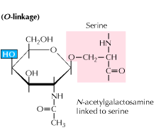
Fig; O linked glycoprotein

Importance of o linked glycoproteins;
- linked glycoproteins are found extensively in salivary secretion , mucins which consists of many short o-linked glycans with proteins.
- It increases the viscosity of fluid in which they are dissolved.
- It performs function in targeting and molecular and cellular identification
- Example; ABO blood group system
- Antarctic fish contains a glycoprotein that serves as “antifreeze “, preventing the freezing of body fluids in extreme cold environment.

Biosynthesis of O -linked glycosylation;
Biosynthesis of O -linked glycosylation occur in golgi lumen. Proteins which are present in ER lumen undergo modification. ER packed the proteins and send them to golgi apparatus.
In golgi apparatus the face of golgi vesicles towards the ER membrane is known as cis – face and the face away from the ER membrane is known as trans – face .
In O linked glycosylation four residue of oligosaccharides are attached to proteins. Now proteins are present in golgi lumen.
First of all sugar residue attached to protein is N- Acetyl glycosamine which is present in cytosol. When proteins enter into golgi lumen , these proteins activates some channels known as anti-portal channels. N- acetylglycosamine enters into golgi lumen via these anti-portal channels . sugar molecule is attached with proteins and energy is released UDP is break and UMP and Pi is released . UMP comes out by the same inter-portal channels and Pi is comes to cytosol by other channels.

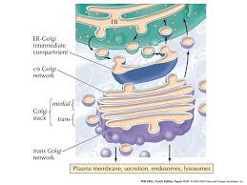
First moiety attached with protein in cis golgi . the complex formed at the result is transferred to trans golgi .Second sugar attached to the complex is known as glyctose . glyctose initially forms the complex with nucleotide in cytosol and then transferred to golgi lumen via anti-portal channels .where UDP is broken into UMP and Pi .similarly UMP go back to cytosol via same inter-portal channel and Pi via other channels.

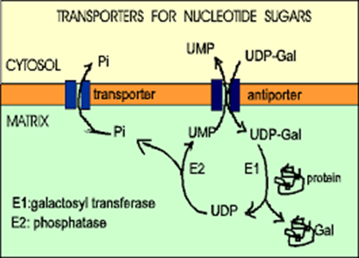
2 sugar residue N -acetyl neuramic acid in trans face of golgi vesicle and attached to complex.

N linked glycoproteins;
Glycoproteins involving the amide nitrogen of asparagine and N-acetylgalactosamine.
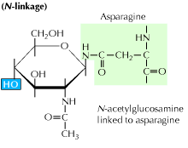
Figure ; N linked glycoprotein

Importance of N – linked glycoproteins;
- They are found in immunoglobulins
- Helps in intracellular targeting in eukaryotic organisms.
- Proteins that are destined for certain organelles or for the excretion from cell , are marked by oligosaccharides during post-translational processing to ensure they are arrive at the proper destination.

Biosynthesis of N- linked glycoproteins;
Biosynthesis pathway of N-linked glycoproteins: The synthesis of N-linked glycan starts in the endoplasmic reticulum, continues in the Golgi and ends at the plasma membrane, where the N-linked glycoproteins are either secreted or becomes embedded in the plasma membrane.
The biosynthesis of N-linked glycans occurs via 3 major steps:
- Synthesis of dolichol-linked precursor oligosaccharide
- transfer of precursor oligosaccharide to protein
- Processing of the oligosaccharide
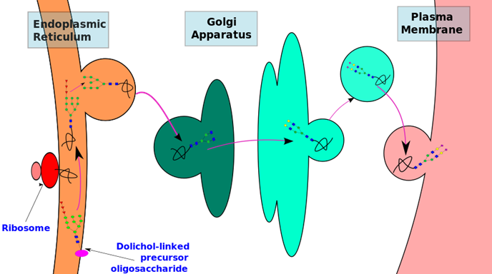

Synthesis, transfer and initial trimming of precursor oligosaccharide occurs in the endoplasmic reticulum (ER). Subsequent processing and modification of the oligosaccharide chain is carried out in the Golgi apparatus.
The synthesis of glycoproteins is thus spatially separated in different cellular compartments. Therefore, the type of N-glycan synthesized, depends on its accessibility to the different enzymes present within these cellular compartments.
However, in spite of the diversity, all N-glycans are synthesized through a common pathway with a common core glycan structure. The core glycan structure is essentially made up of two N-acetyl glucosamine and three mannose residues. This core glycan is then elaborated and modified further, resulting in a diverse range of N-glycan structures.

Synthesis of precursor oligosaccharide;
The process of N-linked glycosylation starts with the formation of dolichol-linked GlcNAc sugar. Dolichol is a lipid molecule composed of repeating isoprene units. This molecule is found attached to the membrane of the ER. Sugar molecules are attached to the dolichol through a pyrophosphate linkage (one phosphate was originally linked to dolichol, and the second phosphate came from the nucleotide sugar). The oligosaccharide chain is then extended through the addition of various sugar molecules in a stepwise manner to form a precursor oligosaccharide. The assembly of this precursor oligosaccharide occurs in two phases: Phase I and II.
Phase I takes place on the cytoplasmic side of the ER and Phase II takes place on the luminal side of the ER.
The precursor molecule, ready to be transferred to a protein, consist of 2 GlcNAc, 9 mannose and 3 glucose molecules

Transfer of glycan to protein;
- Once the precursor oligosaccharide is formed, the completed glycan is then transferred to the nascent polypeptide in the lumen of the ER membrane. This reaction is driven by .the energy released from the cleavage of the pyrophosphate bond between the dolichol-glycan molecule. There are three conditions to fulfill before a glycan is transferred to a nascent polypeptide:
  - Asparagine must be located in a specific consensus sequence in the primary structure (Asn–X–Ser or Asn–X–Thr or in rare instances Asn–X–Cys).
  - Asparagine must be located appropriately in the three dimensional structure of the protein (Sugars are polar molecules and thus need to be attached to asparagine located on surface of the protein and not buried within the protein)
  - Asparagine must be found in the luminal side of the endoplasmic reticulum for N-linked glycosylation to be initiated. Target residues are either found in secretory proteins or in the regions of transmembrane protein that faces the lumen.
Oligosaccharyltransferase is the enzyme responsible for the recognition of the consensus sequence and the transfer of the precursor glycan to a polypeptide acceptor which is being translated in the endoplasmic reticulum lumen. N-linked glycosylation is therefore, is a co-translational event

Processing of glycan;

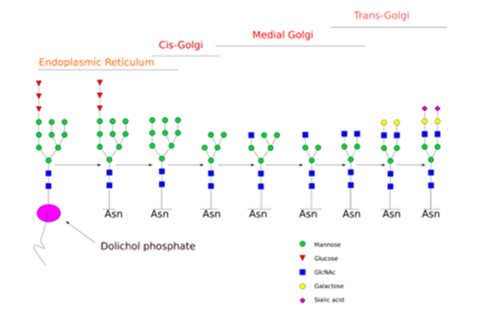

Glycan processing in the ER and Golgi.
N-glycan processing is carried out in endoplasmic reticulum and the Golgi body. Initial trimming of the precursor molecule occurs in the ER and the subsequent processing occurs in the Golgi.
Upon transferring the completed glycan onto the nascent polypeptide, two glucose residues are removed from the structure. Enzymes known as glycosidases remove some sugar residues. These enzymes can break glycosidic linkages by using a water molecule. These enzymes are exoglycosidases as they only work on monosaccharide residues located at the non-reducing end of the glycan. This initial trimming step is thought to act as a quality control step in the ER to monitor protein folding.
Once the protein is folded correctly, two glucose residues are removed by glucosidase I and II. The removal of the final third glucose residue signals that the glycoprotein is ready for transit from the ER to the cis-Golgi. ER mannosidase catalyse the removal of this final glucose

However, if the protein is not folded properly, the glucose residues are not removed and thus the glycoprotein can't leave the endoplasmic reticulum. A chaperone protein (calnexin/calreticulin) binds to the unfolded or partially folded protein to assist protein folding.
The next step involves further addition and removal of sugar residues in the cis-Golgi. These modifications are catalyzed by glycosyltransferases and glycosidases respectively. In the cis-Golgi, a series of mannosidases remove some or all of the four mannose residues in α-1,2 linkages. whereas in the medial portion of the Golgi, glycosyltransferases add sugar residues to the core glycan structure, giving rise to the three main types of glycans: high mannose, hybrid and complex glycans.

The three major types of glycans.
  - High-mannose is, in essence, just two N-acetylglucosamines with many mannose residues, often almost as many as are seen in the precursor oligosaccharides before it is attached to the protein.
  - Complex oligosaccharides are so named because they can contain almost any number of the other types of saccharides, including more than the original two N-acetylglucosamines.
  - Hybrid oligosaccharides contain a mannose residues on one side of the branch, while on the other side a N-acetylglucosamine initiates a complex branch.
The order of addition of sugars to the growing glycan chains is determined by the substrate specificities of the enzymes and their access to the substrate as they move through secretory pathway. Thus, the organization of this machinery within a cell plays an important role in determining which glycans are made.

Enzymes in the Golgi
Golgi enzymes play a key role in determining the synthesis of the various types of glycans. The order of action of the enzymes is reflected in their position in the Golgi stack:

Enzymes | Location within Golgi
Mannosidase I | cis-Golgi
GlcNAc transferases | medial Golgi
Galactosyltransferase and Sialyltransferase | trans-Golgi

Functions of glycoproteins ;
There are following functions of glycolipids

Structural;
- Glycoproteins are found throughout matrices . they act as a receptor on cell surface that brings other cells and proteins (collagen) together giving the strength and support to a matrix.
- Proteoglycan – linking glycoprotein cross links proteoglycan molecule and involved in formation of ordered structured within cartilage tissue.
- In nervous tissue glycoproteins are abundant in gray matter and appear to be associated with synaptosomes , axons, and microsomes.
- In certain bacteria the slime layer that surrounds thee outermost component of cell wall are made up of glycoproteins of high molecular weight.

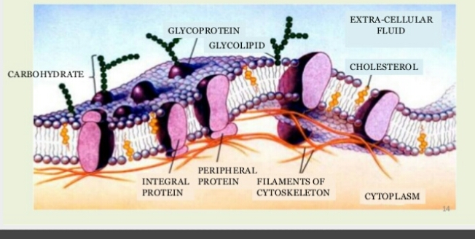
Figure glycoprotein in cell membrane

(2) protection;
- High molecular weight polymer called mucins are found on internal epithelial surfaces.
- They form a highly viscous gel that protect epithelial from chemical , physical , and microbial disturbance.
- Examples of mucins sites are human digestive tract , urinary tract , and respiratory tracts.
- Mucins are also present on the outer surface of the fish to protect the skin.
- Mucin not only acts as protection but also perform the function of lubricant .
- Human sweat glands produce glycoproteins which protects the skin from the other excretory products that could harm the skin.

(3)reproduction;
- Glycoprotein found on the surface of spermatozoa appear to increase sperm cell’s attraction towards the egg by altering the eletrophhoretic mobility of plasma membrane.
- Actual binding of sperm cell to egg cell is mediated by linked glycoproteins serving as a receptor on the surface of each the two membrane.

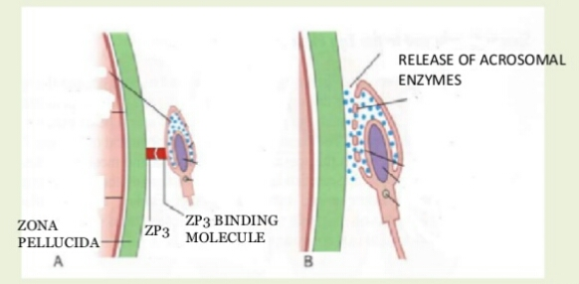
Figure ; zona pellucida allows entry of sperm
- The zona pellucida is an envelope that is made by glycoproteins ,it function is to prevent the egg from the polyspermy. It means that it prevents the entry of other sperms when one sperm is already penetrated into plasma membrane of egg.
- Hen ovalbumin is glycoprotein found in egg white that serves as food storage unit for embryo.

(4) adhesion ;
- Glycoprotein serves to adhere cell to cell and cell to substratum . cell to cell adhesion is basic for formation of tissues in body.
- In different domains of body , different glycoprotein are used to unite the cells
- Example ; nerve cells recognize and bind to one another with the glycoproteins known as N-CAM ( nerve cell adhesion molecule)
- N-CAM is also present in the muscles cells indicating the their role in formation of myoneural junction.
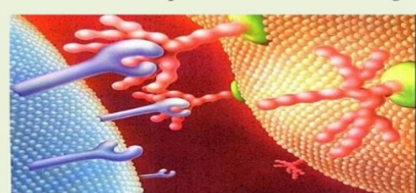
Figure ; receptors binding

(5)hormones;
- There are many glycoproteins that function as hormones ;
- Chorionic gonadotrophin hormone
- Thyroid stimulating hormone

(6) Enzymes
There are three types of enzymes that are glycoprotein in nature.
- Oxidoreductase
- Transferase
- Hydrolases

(7) carriers;
- Glycoproteins serve as a carrier for certain molecule . vitamins hormones, cation, and other substances can be bind with glycoproteins.

(8) inhibitors ;
- Many glycoproteins in blood plasma have shown anti-proteolytic activity.
- Example;
- glycoprotein a1 anti-chymotrypsin inhibits chymotrypsin.

(9) defense;
- In beetles pygidial gland secretes glycoproteins disinfecting paste that covers that covers the body and hardens.
- Shell provides protection against the bacteria and fungi.

(10) freezing point depression;
- Glycoproteins found in the sera of Antarctic fishes to decrease the freezing point due to their apparent interaction with water.

(11) vision;
- In bovine visual pigments a glycoproteins forms the outer membrane of retina.

(12) immunological ;
- The interaction of blood group substances with antibodies is determined by glycoprotein on erythrocytes.
- Many immunoglobulins are actually glycoproteins.
- Soluble immune mediator such as helper , suppressor, and activator cell have been shown to bind to glycoproteins found on the surface of their targeted cells .
- B and T cells contain surface glycoproteins that attract bacteria to sites and binds them.
- It can direct phagocytosis . Because the HIV virus recognizes the receptor protein CD4 , it binds to helper T cells which contain it.
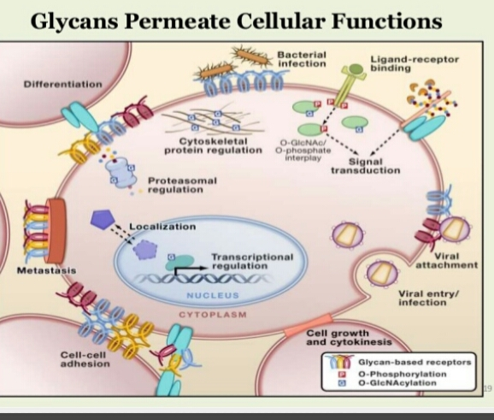
Figure;1glycoprotein performing various functions in cell

