PSYCHOLOGY OF ADVERTISEMENT

Who says? What? By what means? To whom?

Use of Emotions
- Fear is a very powerful emotion and nothing makes people more uncomfortable than fear. Advertising can use fear tactics to create an uncomfortable position or situation, then provide a solution manifested through a given product or service.
Example: One approach where fear is used is “the fear of missing out.” This approach can be identified by phrases such as “one day only,” “limited time only,” “only a few left.”

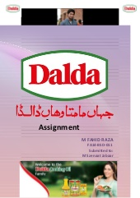
- Advertisements utilizing fun and pleasure show consumers having a good time and enjoying themselves, all made possible by a given product or service.
Example: The individuals in the ad are having fun, and the consumer is led to believe that they too will have a good time, but only if they purchase the product or service.

- Ads that feature love target consumers who want to provide for and take care of loved ones.
Example: Subjects of these ads are typically families, pets, newborns and mothers, or happy couples.

- Advertisements focused on vanity appeal to the consumer’s sense of well-being, pride, importance and relevance. Themes such as “the latest and greatest,” “you deserve,” new fashion trends and luxury drive this advertising. Society places significant importance on appearance and status, and by leveraging these themes advertising will drive awareness, interest and action for advertised brands.
Example: Industries that often use vanity include fashion, personal appearance, luxury goods, cars and more.

Use of Memories
- The ads are repeated to form the long-term memory of customers. Reminder ads are used to keep the memories of ads alive in the mind of customers.
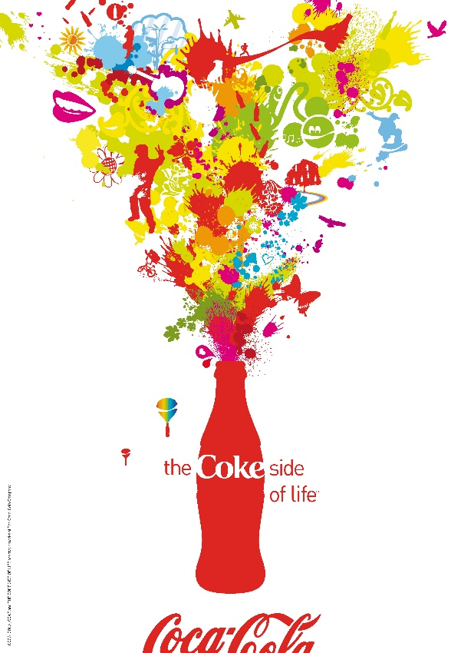
- Previous memories of a brand of a company are used to form new memories “relearning” of a new brand of the same company.

Use of Colors
- Red: passion, energy, strength, love, power, determination, intensity, anger, excitement.
- Blue: depth, stability, wisdom, trust, confidence, calming.
- Yellow: energy, happy, warming, attention, aggravation, joy.
- Purple: wisdom, wealth, royalty, power, luxury, magic, powerful, calming, strength.
- Green: growth, health, harmony, safety, nature, calm, refreshed.
- Orange: enthusiasm, heat, success, creativity, warmth, excitement.
- White: purity, light, clean, sterile, innocent, spacious, cold, unfriendly.
- Black: power, mystery, elegance, evil, mourning, death, confident, calm, stable, mysterious.
Use of Personality and Authority
- Consumers feel they know these celebrities and believe if a product or service is good enough for the celebrity, then it is good enough for them.
- “Experts” in a given field, or representations of a given consumer group, will be cited as a reason a consumer should trust or buy a product. Ads will use phrases like “9-out-of-10 doctors recommend”, “4 out of 5 dentists suggest”, or even “3 out of 4 moms trust” to drive consumer purchase behavior.
Use of Attention and Perception
- The ads are tested on the ability to catch “selective attention” instead of divided attention. Thus ads are made attractive, unique, attention seeking and adventurous.
- The content of the ad is tested on the merit of “true perceptions” in which the customers perceive that same thing which the marketers intended them to perceive.
- Subliminal messages (below the objective threshold) are used to change or form the unconscientious of customers. For example use of white color to show cleanliness motive in the ad of a medicine depicts a subliminal perception. These are hidden messages.
- Attractiveness is used for better recognition and inducing the feelings of familiarity which makes memorization an automatic processing.
- Music has attentional gaining value in ads. It can attract and hold attention.

Use of Persuasive Appeals
- Rational Appeals: Use of logic, reasoning, facts to convince customers.
- Emotional Appeals: Use of feelings, emotions, relationships and emotional messages.
- Humorous Appeals: Use of fun, excitement, humor and jokes to create positive impression of ad.

Use of Gender
- The selection of the models from men, women are both have importance in convincing customers.
- Consumers are more likely to believe in the health related messages from “male doctors” instead of female counterparts.
- Ads of household products usually contain female models but the male are included to show relationship satisfactions in partners and happy families.
- The ultimate beneficiaries of the products and services are mostly included in the ads.

