NEMATODE
The Greek word nematode means “Threadlike”Nemat=thread,ode=like
Nematodes are generally multicellular, microscopic, worm like, non-segmented animals having elongated cylindrical body shape that lives sprophytically in water or soil and as a parasite of plants and animals. They possess all the physiological systems except circulatory and respiratory system.

General Characteristics
- “Kingdom Animalia - Phylum Nematoda
- Most abundant animal life form.
- vermiform
- un-segmented roundworms
- bilaterally symmetrical invertebrates
- a body cavity or vacuoles
- a complete digestive system (mouth, intestine, anus)
- a triradiate pharynx,
- nerve ring and a well-developed nervous system
- Reproduction System: one or two tubular gonads,
- They lack: specialized respiratory and circulatory systems
- The emerging second-stage juvenile (J2) is the most common infective stage.
- Length of life cycle of plant parasitic nematodes can be anywhere from 20-40 days (on average 25 days at 22ºC).
Nematode Groups
- Marine, Fresh water, Soil (Trophicvores)
  - Animal Parasite
  - Vertebrate
- Invertebrate
- Plant Parasites
- Fungivores
- Omnivores (feed on multiple sources)
- Predators (On Nematodes, Protozoa)

Morphology
- These are small sized having diameter 300-1000um. With some up to 4mm long, 15-35um wide.
- These are invisible to naked eye because of their small diameter and only can be observed under microscope.
- These are eel shaped and round in cross section
- These have smooth and unsegmented body without legs or appendages.
- The females of some species become swollen at maturity which form pear-shaped bodies e.g. Meloidogyne sp. and Heterodera sp.
Anatomy
Transparent body covered by cuticle, muscular system helps in nematode movement. Body cavity contains a fluid, which responsible of circulation and respiration process.
- Digestive system: is a hollow tube, which consists of mouth with six lips, esophagus, intestine, rectum and anus.
- Reproduction system: one or two ovaries with an oviduct and uterus terminating in a vulva in case of female and testis with seminal vesicle in males.
Nutrition
There are two types: saprophytes and parasites. As plant parasites, these are divided into three groups
- Ecto-parasites: The nematode which do not enter the root tissues but feed only on outer surface.
- Endo-parasites: The nematode which enter the host tissue and feed within the cells.
- Semi endo-parasites: The nematodes enter their some of the frontal body portion into the root tissues but feed outside cells.
According to feeding habits these are divided into two groups
- Migratory: The nematodes which live and move within the host tissues for feeding.e.g. Ring nematode.
- Sedentary: The nematodes which attached to the host tissues and do not move e.g. Dagger nematode.

Feeding Organ
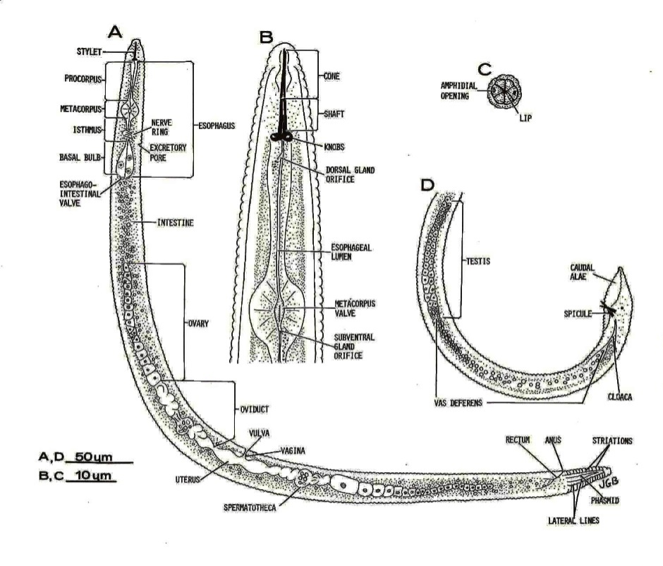
Feeding organ called hypodermal needle or stylet. These have hollow stylet or spear which is used to puncture plant cells, after puncturing the cell they inject saliva into the cells then suck part of the cell contents and move on within a few seconds. Females of some species may become permanently established in or on roots. Male nematode remains cylindrical throughout his life but the female is swollen at maturity and become pear and lemon shaped e.g. Meloidogynesp.

Nematode Mode of Reproduction
Reproduction is through eggs may be sexual crossing (Amphimixis), hermaphrodite or parthenogenetic. When conditions are, optimum nematodes are in juvenile phase and then developed to male or female depending upon temperature conditions and nutrition available.
- Amphimixis [syngamy] - cross fertilization (males and females).
- Parthenogenesis- nonsexual, males not required for reproduction.
- Hermaphroditism - male and female organs in one individual (some change sexes).
- Pseudogamy- Reproductive mechanism where sperm penetration stimulates completion of oocyte and meiosis, but no fusion with egg.
Life Cycle
- 5-Stages, 4-Molts
- Egg - J1 - M1 - J2 - (Hatch) - M2 - J3- M3 - J4 - M4 – Adult
- In all plant parasitic nematodes, the first molt occurs in the egg.
- The emerging second-stage juvenile (J2) is the most common infective stage.
- Length of life cycle plant parasitic nematode can be anywhere from 20-40 days (on average 25 days at 22ºC).
Juvenile: Larva of nematode is called juvenile. All the nematodes have four juvenile stages in its life. Only the second stage (J2) is infective stage. After the final stage the nematode differentiated into male and female. The life cycle of nematode from egg to egg is completed within 2-4 weeks.

