Anaerobic Respiration - Fermentation
! Be ready to discuss
- Why do we need oxygen?
KEY CONCEPT
Fermentation allows the production of a small amount of ATP without oxygen.
- If no oxygen is available, cells can obtain energy through the process of anaerobic respiration.
- A common anaerobic process is fermentation.
- Fermentation is not an efficient process and results in the formation of far fewer ATP molecules than aerobic respiration.

There are two primary fermentation processes:

  - Lactic Acid Fermentation
  - Alcohol Fermentation
Lactic acid fermentation occurs when oxygen is not available.

For example, in muscle tissues during rapid and vigorous exercise, muscle cells may be depleted of oxygen. They then switch from respiration to fermentation.
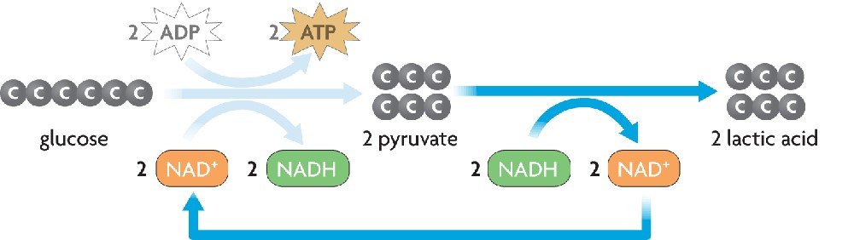
The pyruvic acid formed during glycolysis is broken down to lactic acid and energy is released (which is used to form ATP).

Glucose → Pyruvic acid → Lactic acid + energy
•The process of lactic acid fermentation replaces the process of aerobic respiration so that the cell can have a continual source of energy, even in the absence of oxygen.
•However this shift is only temporary and cells need oxygen for sustained activity.
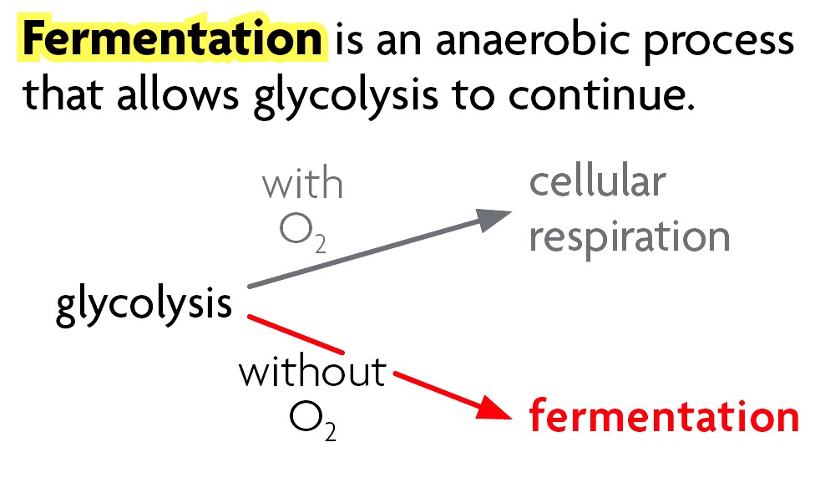
•Lactic acid that builds up in the tissue causes a burning, painful sensation.
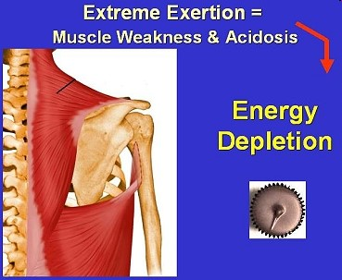
Alcohol fermentation occurs in yeasts and some bacteria.

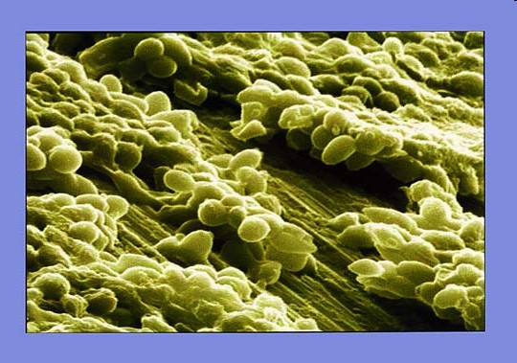
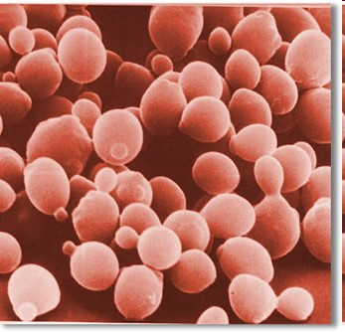
Pyruvic acid formed during glycolysis is broken down to produce alcohol and carbon dioxide and is released (which is used to form ATP).
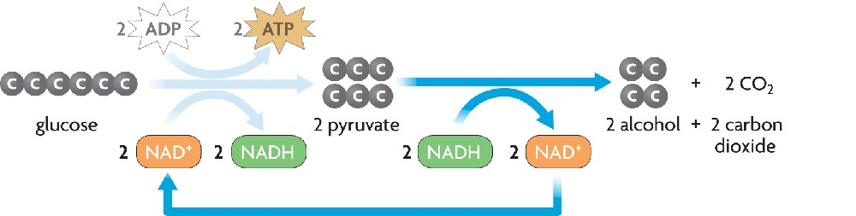
Glucose → Pyruvic acid → alcohol + carbon dioxide + energy
.
• Fermentation is used in food production.
- Yogurt - Soy Sauce
- Cheese - Vinegar
- Bread - Olives/Pickles
- Beer/ Meade - Wine/ Ale
- Sauerkraut - Malt
HW
•Complete Section 4.6 in the Study Guide workbook (p. 41-42)
•Study for Cellular Respiration Quiz on Friday!!

Anaerobic Respiration - Fermentation

