Topic: Cell Biology, Genetics and Evolution

GOLGI BODIES(Dictyosomes)

Discovery:
The existence of the cell organelle which is now known as Golgi apparatus or Golgi complex, or simply as 'the Golgi', was first reported by Camillo Golgi in 1898 In Golgi’s early studies of nervous tissue, he had established a staining technique that he referred to as reazione nera, meaning “black reaction”; today it is known as the Golgi stain.
In this technique nervous tissue is fixed with potassium dichromate and then suffused with silver nitrate. While examining neurons that Golgi stained using his black reaction, he identified an “internal reticular apparatus.” This structure became known as the Golgi apparatus, though some scientists questioned whether the structure was real and attributed the find to free-floating particles of Golgi’s metal stain. In the 1950s, however, when the came into use, the existence of the Golgi apparatus was confirmed. The Golgi apparatus was destined to become a protagonist of the research in cytology and cell biology pursued in the second half of the twentieth century. Golgi body, membrane-bound organelle of eukaryotic cells.
Evolution Of Golgi Complex:
An hypothesis for the origin of GA has been presented by Becker and Melkonian (1996). In most prokaryotes, biosynthesis of membrane proteins and lipids, as well as attachment of the single chromosome, are associated with the plasma membrane. In eukaryotes, these are functions of the ER/nuclear envelope, which is postulated to have arisen by invagination of a specialized part of the plasma membrane. Loss of continuity between the ER/nuclear envelope and the plasma membrane required a transfer system between the two compartments which resulted in the evolution of a GA. Interestingly, the lipid composition of the ER membrane resembles that of a prokaryotic plasma membrane (Becker and Melkonian, 1996). The diversity and complexity of form and function of GA are then suggested to result from the optimization of this basic system.
The Biogenesis of Golgi Apparatus:
Two opposing models have been suggested about the biogenesis of the GA; the Golgi matrix and the de novo Golgi formation. According to the first model, the GA is an autonomous organelle built on a pre-existing template which is proposed to be a Golgi matrix containing some Golgi matrix proteins and F-actin. These proteins including p115, GM130 might take part in building or maintaining Golgi stack architecture and ribbon formation. In the de novo Golgi formation model, the GA is considered as an ER outgrowth. The membrane at ER exit sites carries all the necessary molecular information to trigger the building of a GA by a mechanism of self-organization. In this model, it is the structural integrity of ER exit sites and anterograde transport that are crucial for Golgi stack formation. It is not clear whether the membrane flux from the ER is the major determinant of the formation and reorganization of the GA or the GA exhibits considerable anatomy.
It is a fact that the GA is a dynamic organelle. During the cell proliferation, first sign of the Golgi ribbon disintegration is the disconnection to yield seperate Golgi stacks (disruption of the intermembraneous bridges) . Then, stacks are transferred into tubular-reticular membranes, called “Golgi blobs”, which are dispersed throughout the cytoplasm. The “Golgi blobs” are then broken down to yield the “Golgi haze”, which is composed of small dispersed vesicles.

Morphology:
Golgi apparatus is made up of several flattened, stacked sacs referred to as cisternae”. The cisternae form Golgi stacks (one Golgi stack is formed via grouping of a number of cisternae in a parallel manner) themselves interconnected by lateral tubules to form the Golgi ribbon The Golgi ribbon displays a juxtanuclear localisation next to the microtubule organising center. The Golgi ribbon is intact in interphase and dispersed into tubular-reticular and vesicular elements in mitosis.
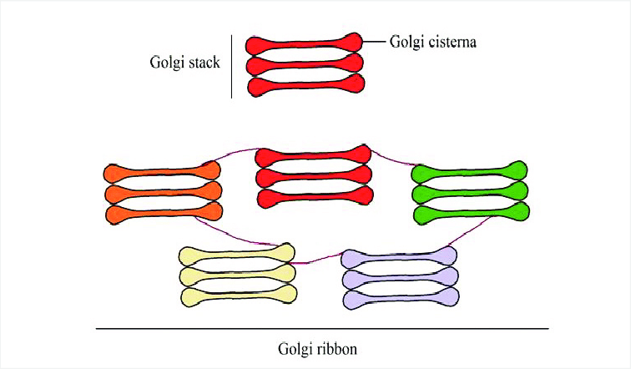

Depending on the type of cell, the number may vary from just a few to thousands. The cisternae are very small with a diameter ranging from 0.5 to 1.0 nm. Each of these is bound by a membrane and is held together by a matrix of proteins. On the other hand, the entire Golgi is helped by cytoplasmic microtubules and have also been found to contain a number of important compartments. Its main functions are to modify and sort proteins and lipids that are transported through this organelle en route to their final destinations, such as the extracellular medium, plasma membrane and the endosomal/ lysosomal compartments
Cis and Trans Golgi Network:
The Cis and trans are different faces of Golgi apparatus. The cis face, which is convex in appearance is closer to the endoplasmic reticulum and acts as the receiving compartment from the ER. On the opposite side is the trans face (also referred to as maturing face) which releases the modified, concentrated, sorted, packaged or labelled product into the cytoplasm. After having any modifications or additions to their structure, the products are packaged in vesicles and tagged with markers that indicate where the vesicle needs to end up. These tags can be molecules, such as phosphate groups, or special proteins on the surface of the vesicle. Once tagged, the vesicle is excreted from the Golgi apparatus, on its way to its final destination. The most salient hallmark of Golgi structure is the presence of multiple membranous compartments, differentiated into cis, medial, and trans-Golgi, and organized into flattened stacks, which Morphological studies suggest that cisternae form at the cis face of the GA, progress through the stack to the trans face, and ultimately dissipate . Indeed, detailed studies provided strong evidence that procollagen containing cisternae progress from the cis to the trans side of the stack . Because trans cisternae have a different resident protein composition than cis cisternae, the implication is that cis cisternae mature into trans cisternae . At the cis face of the Golgi ribbon, proteins and lipids are delivered from the ER via vesicular-tubular clusters (VTCs), which dock at the cis-cisternae.

Theory of Golgi Apparatus Function:
The most prevalent theory of how the Golgi apparatus forms is the cisternal maturation model. This model suggests that the sacs themselves tend to move from the cis face to the trans face of the Golgi apparatus over time. New sacs are formed closest to the endoplasmic reticulum. These sacs “age” as they move towards the trans face of the Golgi apparatus and their product becomes fully mature.
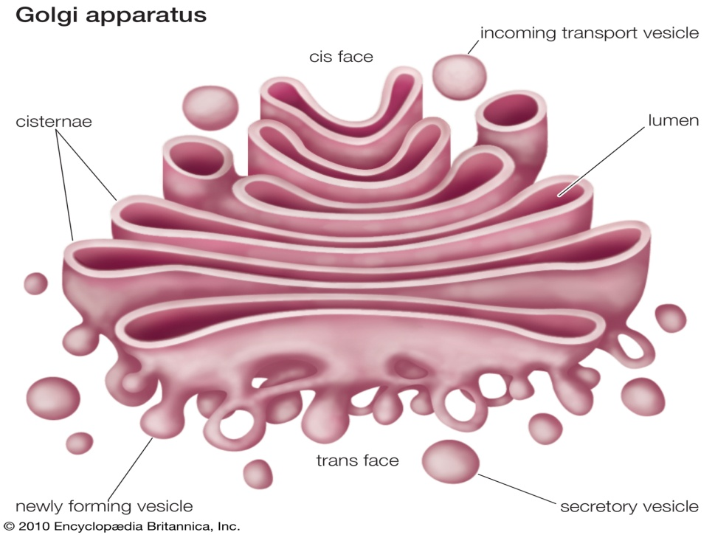

Functions of Golgi Bodies:
In general, the Golgi apparatus is made up of approximately four to eight cisternae, although in some single-celled organisms it may consist of as many as 60 cisternae. The cisternae are held together by matrix proteins, and the whole of the Golgi apparatus is supported by cytoplasmic microtubules. The apparatus has three primary compartments, known generally as “cis” (cisternae nearest the endoplasmic reticulum), “medial” (central layers of cisternae), and “trans” (cisternae farthest from the endoplasmic reticulum). Two networks, the cis Golgi network and the trans Golgi network, which are made up of the outermost cisternae at the cis and trans faces, are responsible for the essential task of sorting proteins and lipids that are received (at the cis face) or released (at the trans face) by the organelle.
The cisternae of Golgi body have four structural components i.e., cis-Golgi, endo-Golgi, medial-Golgi and trans-Golgi. The vesicles extending from endoplasmic reticulum fuse with network.
These vesicles then enter the stacks of Golgi body and finally reach the trans-Golgi. The different regions of Golgi apparatus contain different types of enzymes. These enzymes have certain specific tasks assigned to them. Vesicles leave the Golgi apparatus from the side of trans-face. The Golgi apparatus is an important organelle of eukaryotic cells. Directing the carbohydrates and proteins required by the body to their correct destination is the primary job of Golgi body.
Secretion:
The proteins and lipids received at the cis face arrive in clusters of fused vesicles. These fused vesicles migrate along microtubules through a special trafficking compartment, called the vesicular-tubular cluster that lies between the endoplasmic reticulum and the Golgi apparatus. When a vesicle cluster fuses with the cis membrane, the contents are delivered into the lumen of the cis face cisterna. As proteins and lipids progress from the cis face to the trans face, they are modified into functional molecules and are marked for delivery to specific intracellular or extracellular locations. Some modifications involve cleavage of oligosaccharide side chains followed by attachment of different sugar moieties in place of the side chain. Other modifications may involve the addition of fatty acids or phosphate groups (phosphorylation) or the removal of monosaccharides.
The different enzyme-driven modification reactions are specific to the compartments of the Golgi apparatus. For example, the removal of mannose moieties occurs primarily in the cis and medial cisternae, whereas the addition of galactose or sulfate occurs primarily in the trans cisternae. In the final stage of transport through the Golgi apparatus, modified proteins and lipids are sorted in the trans Golgi network and are packaged into vesicles at the trans face. These vesicles then deliver the molecules to their target destinations, such as lysosomes or the cell membrane. Some molecules, including certain soluble proteins and secretory proteins, are carried in vesicles to the cell membrane for exocytosis (release into the extracellular environment). The exocytosis of secretory proteins may be regulated, whereby a ligand must bind to a receptor to trigger vesicle fusion and protein secretion.
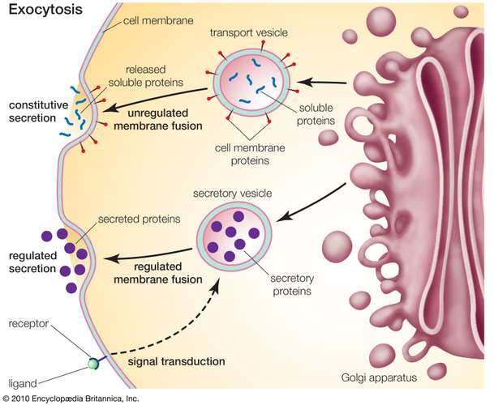

The Golgi complex is not only the core structure of the secretory pathway but is also essential to ensure lipid homeostasis, and plays a major role in signaling, autophagy, and apoptosis. As such it is involved in many human diseases and several Golgi-associated factors represent promising therapeutic targets. n plants, Golgi apparatus is mainly involved in the secretion of materials of primary and secondary cell walls (e.g., formation and export of glycoproteins, lipids, pectins and monomers for hemicellulose, cellulose, lignin, etc.)
Transportation Of protein:
The main function of Golgi apparatus is to carry out the processing of proteins generated in endoplasmic reticulum. Golgi apparatus also transports protein to the different parts of cell. The Golgi apparatus, or Golgi complex, functions as a factory in which proteins received from the ER are further processed and sorted for transport to their eventual destinations: lysosomes, the plasma membrane, or secretion. It is responsible for packaging proteins into vesicles prior to secretion and therefore plays a key role in the secretory pathway.
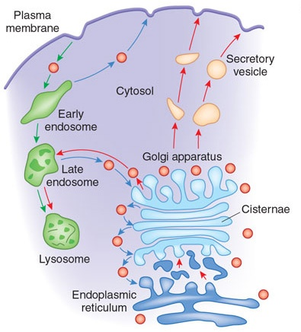
Phosphorylation
Incorporation of phosphate molecules onto molecules of proteins is also an important task carried out in the Golgi apparatus. The Golgi enzymes present in membranous disks of cisternae carry out the modification of cargo proteins. Modification of various substances is carried out by enzymes in cisternae with the help of processes like phosphorylation and glycosylation.: To carry out the glycosylation and phosphorylation processes, nucleotide sugars are imported by the Golgi apparatus from cytosol.
Phosphorylation allows cells to accumulate sugars because the phosphate group prevents the molecules from diffusing back across their transporter. Phosphorylation of glucose is a key reaction in sugar metabolism because many sugars are first converted to glucose before they are metabolized further.
Formation of Plasma membrane:
The Golgi apparatus, or Golgi complex, functions as a factory in which proteins received from the ER are further processed and sorted for transport to their eventual destinations: lysosomes, the plasma membrane, or secretion. In addition, as noted earlier, glycolipids are synthesized within the Golgi. In plant cells, the Golgi apparatus further serves as the site at which the complex polysaccharides of the cell wall are synthesized. The Golgi apparatus is thus involved in processing the broad range of cellular constituents that travel along the secretory pathway.
Secreation of Enzymes:
Proteins synthesized in the ER are packaged into vesicles, which then fuse with the Golgi apparatus. These cargo proteins are modified and destined for secretion via exocytosis or for use in the cell. Enzymatic reactions within the Golgi stacks occur exclusively near its membrane surfaces, where enzymes are anchored.
Lipid Transport:
They are also involved in the transport of lipid molecules around the cell. The Golgi complex also plays an important role in the production of proteoglycans. The proteoglycans are molecules that are present in the extracellular matrix of the animal cells. Transportation of lipids around cells and creation of lysosomes are the important functions carried out by Golgi apparatus.
Carbohydrates Synthesis:
It is also a major site of synthesis of carbohydrates. These carbohydratres include the synthesis of glycosaminoglycans, Golgi attaches to these polysaccharides which then attaches to a protein produced in the endoplasmic reticulum to form proteoglycans. Polysaccharides are attached with proteins in order to form carbohydrates. One of the tasks of Golgi apparatus is carrying out the breakdown of proteins and formation of small, active fragments. The process of carbohydrate synthesis involves production of polysaccharides and glycosaminoglycans (GAGs). Carbohydrates are synthesized in the Golgi body. The process of carbohydrate synthesis involves production of polysaccharides and glycosaminoglycans (GAGs).
Sulfation:
Sulfation is an important task carried out by the Golgi body. The sulfating of substances passing through the lumen of Golgi body is carried out with the help of sulfotransferases .sulfation is a posttranslational modification in which a tyrosine residue of a protein is sulfated by a tyrosylprotein sulfotransferase (TPST) typically in the Golgi apparatus. Secreted proteins and extracellular parts of membrane proteins that pass through the Golgi apparatus may be sulfated. Sulfate groups are added to protein molecules in the Golgi apparatus. The Golgi involves in the sulfation process of certain molecules. Golgi apparatus plays an important role in the prevention of destruction of cells (or apoptosis). The Bcl-2 genes present in the Golgi are used for this purpose.
Multiple choice Questions (Golgi bodies)
- Which one of the following organelles is located near the nucleus and contains a collection of flattened membrane bound cisternae?
- Mitochondria b) Centriole c) Ribosomes d)GolgiApparatus
- Golgi complex was first recognized in?
- Blood cells b)Root cells c) Nerve cells d) Bone cell
- Golgi apparatus is absent in?
- Higher plants b) Yeast c) Bacteria d) none
- Functions of Golgi apparatus in animal cells include
- Sorting and packaging b) exocytosis of melanin c) exocytosis of thyroxin
d) All of these
- Which of the following organelle is called as the sorting centre of the cell?
a) RER b) SER c) GA d) lysosome
6) Golgi apparatus is often seen associated with
a) Mitochondria b) RER c) Lysosome d) none
7) Which of the following organelle is called as the “traffic police” of the cell
a) Lysosome b) SER c) Golgi apparatus d) RER
8) The simplest unit, the saucer like closed compartments of golgi apparatus is called as;
a) Tubules b) vescicles c) Cristae d) cisternae
9) The region around golgi apparatus where other organelles are absent is called as;
a) zone of inhibition b) zone of exclusion c) organelle inhibition zone d) none of these
10) The outer cis face of golgi bodies is also known as
a) trans face b) Maturing face c) Forming face d) Both A and B

