Project report (Group no.11 Bs.botany 2nd semisrer)
Course name: Citizenship education and community engagement
Proposed title:
- Awareness about garbage management
- Awareness about corona virus in print form
- Rashan distribution
Submission date: June 7,2020
Group members: Only myself( Saira Mumtaz)
Sessions: 2019-23
University: Sargodha university bhakkar campus
Department: Biological science

(1)Title of projects:
- Awareness about garbage management
- Awareness about corona virus in print form
- Rashaan distribution
!……First project………!
- …Awareness about garbage management
(2)Introduction:
(2.1)Back ground of the problems:
1. Waste management include the action and activities required to managed waste from its inception to the final disposal. This including treatment, transport, collection and disposal of waste together in monitoring and regulations of waste management phenomena(www.Wikipedia.com).A particular part in any waste management is participation and public awareness in addition to adaptation strong support of technology.(www.Conservativefuture. Com) The waste k the result of human activities and it need to have proper understanding about garbage management Tissues.(www.save energy.com) Even the best waste management plan becomes questionable.(www.teachengenring.org)
Garbage in our surrounding area that created huge problem for people.(Saira Mumtaz.BBTF19BM010.Bs.Botany second semester. Biological science. University of Sargodha bhakkar campus).Similarly great of the history the amount of waste created by humans was mainly ashes and biodegradable of humans and these were released back into the street locally with minimum environmental impacts(www.Wikipedia.com). Similarly people who went to mosque to say the prayers were worry with the wastes spread in our streets and they faced hard problems.( Saira Mumtaz BBTF19BM010 Bs botany second semester biological department Sargodha university sub campus bhakkar).
(2.2)Present situation:
- In present situation there was a huge garbage in our surrounding street. People remained worry about smell of garbage.(www.garbage manage.org.com) The smell of garbage spreads all around.(Saira Mumtaz BBTF19BM010. BS. Botany second semester Sargodha university bhakkar campus. ). A large numbers of waste management try to deal with municipal solid waste management which is also bulk of the wastes that are created by humans, commercial and industrial activities.(Saira Mumtaz BBTF19BM010 Bs botany second semester biological science Sargodha university sub campus bhakkar).
(3)justification of project
a)Importance of project activities
1.The importance of project activities was great because awareness about garbage management is necessary in present situation(www.cleanliness.com). This project of awareness has decreased tension of people in area of garbage(Saira Mumtaz. BBTF19BM010. Bs botany. Second semester. Biological science. Sargodha university bhakkar campus). Examples of the techniques and method was be very helpful in establishing and increasing public awareness about garbage management issues(www.manuallycom). The other importance of this project is that it has give people of awareness how to keep the garbage in home and how to give to garbage collector who are responsible to take it away from areas where the people are living.( Saira Mumtaz BBTF19BM010 Bs botany second semester biological department Sargodha university sub campus bhakkar). It would briefly explain the major problems that waste can create for society like decease of many kind such as malaria, cholera and typhoid.( Saira Mumtaz BBTF19BM010 Bs botany second semester biological department Sargodha university sub campus bhakkar). It would describe step involved in garbage management(Saira Mumtaz BBTF19BM010. Bs botany. Second semester. Biological science. Sargodha university bhakkar campus).To decrease the problems of people who go to mosque was also main objective. ( Saira Mumtaz BBTF19BM010 Bs botany second semester biological department Sargodha university sub campus bhakkar).
(4)Objectives of project
1.The objectives of project was to diminished tension of people about smell of garbage because they remain worry. (Saira Mumtaz BBTF19BM010 Bs botany second semester. Biological science Sargodha university bhakkar campus).And to protect the people who became ill with decease through these waste by controlling this. Similarly the people who go to mosque to say the prayers to protect them from the dirtiness as spread in our surrounding area. ( Saira Mumtaz BBTF19BM010 Bs botany second semester biological department Sargodha university sub campus bhakkar).
(5)Plans of action
(a)How will you do this project activities
- According to my first project l have done project activities by going home in our surrounding area and talk with people that not throws your home garbage in streets and inform them how of caused deceased and tension of the people who go to these areas and inform them that this activitie cause problem for many people living in our surrounding area and also cause decease such as malaria due to generation a mosquito and Many other germs.( Saira Mumtaz BBTF19BM010 Bs botany second semester. Biological science Sargodha university bhakkar campus ).I gave them sense in this regard. I also advised them to keep dustbin in their homes to collect garbage.
(b)Needed resources and source of generation
The needed resources were help from person to go homes in our surrounding area with me to give them awareness about garbage management.( Saira Mumtaz BBTF19BM010 Bs botany second semester biological department Sargodha university sub campus bhakkar).
The sources of generation were my mother and sister.( Saira Mumtaz BBTF19BM010 Bs botany second semester biological department Sargodha university sub campus).

(c)Each person role in project
Myself: I went in house of my all neighborhood. I awared them about garbage that it is creating huge problems. (Saira Mumtaz BBTF19BM010 Bs botany second semester biological department Sargodha university sub campus bhakkar).
Sister:
My sister went with me in our surrounding homes and area to give people awareness about garbage management. She also helped me to aware people about garbage that how it can cause many big problems. ( Saira Mumtaz BBTF19BM010 Bs botany second semester biological department Sargodha university sub campus bhakkar).

(d)Proposed duration:
Proposed duration was be from two weeks. (Saira Mumtaz BBTF19BM010 Bs botany second semester biological science Sargodha university bhakkar campus).
(6)how will you evaluate your project for possible outcomes?
- The results about my project awareness about garbage management were great.
- People in my surrounding area stopped to throw the garbage in streets.
- They became responsible.
- They gave their garbage to scaffie.
- They do not throws it carelessly as they were done in past.
- Many deceases have became controlled.
- Smell has been ended from our streets.
- All my neighbors were happy from my project because it has caused a lot of benefit for them.( Saira Mumtaz BBTF19BM010 Bs botany second semester biological department Sargodha university sub campus bhakkar).
!.….Second project …..!
Awareness about corona virus:
(2). Introduction
(2.1).Back ground of the problems.
Corona virus is a common types of virus which infect human typically leading to upper respiratory infection. This virus is spread by air, coughing, sneezing, touching and surface contaminated with the virus.( Saira Mumtaz BBTF19BM010 Bs botany second semester biological department Sargodha university sub campus bhakkar).. The situation is very bad. It infected many people and also infecting in present day. ( www.who.com). Because of this virus many people are loosing their lives day by day. ( Saira Mumtaz BBTF19BM010 Bs botany second semester biological department Sargodha university sub campus bhakkar ).
(2.2).Present situation
The present situation of corona is dangerous in our country as well as in our city( Saira Mumtaz BBTF19BM010 Bs botany second semester biological department Sargodha university sub campus bhakkar). People did not pay heed to follow protection( ‘Saira Mumtaz BBTF19BM010 Bs botany second semester biological department Sargodha university sub campus bhakkar). Mostly people are ignoring to take protection ( Saira Mumtaz BBTF19BM010 Bs botany second semester biological department Sargodha university sub campus bhakkar). Due to their activities present situation of corona virus is increasing day by day. Due to corona virus our country also became weak economically.( Saira Mumtaz BBTF19BM010 Bs botany second semester biological department Sargodha university sub campus bhakkar).
(3)Justification of project.
(a).Importance of project activity.
Awareness about corona virus in print form gave information about corona virus to the people ( Saira Mumtaz BBTF19BM010 Bs botany second semester biological department Sargodha university sub campus bhakkar). Owing to this project people got information about corona virus in their homes, streets, bazaar, and mosques. ( Saira Mumtaz BBTF19BM010 Bs botany second semester biological department Sargodha university sub campus bhakkar). Mostly people in my surrounding area got benefit and information from my print work. ( Saira Mumtaz BBTF19BM010 Bs botany second semester biological department Sargodha university sub campus bhakkar). In this way many people kept themselves protect by following my instructions. ( Saira Mumtaz BBTF19BM010 Bs botany second semester biological department Sargodha university sub campus bhakkar).
( b).Project implications (who would get benefit from this project)
Common public for benefit from this project. Public including people in our surrounding area, in mosques, and in bazaar got benefit from this project. ( Saira Mumtaz BBTF19BM010 Bs botany second semester biological department Sargodha university sub campus bhakkar).
(4).Objectives of the project
The main objective were to provide people latest and important information about corona virus ( Saira Mumtaz BBTF19BM010 Bs botany second semester biological department Sargodha university sub campus bhakkar). In this way many people save their lives and also kept protect other by maintaining social distance ( Saira Mumtaz BBTF19BM010 Bs botany second semester biological department Sargodha university sub campus bhakkar).
(5). Plans of action
(a). How you did this project activity.
I have done this project activity by printing protection about corona virus ( Saira Mumtaz BBTF19BM010 Bs botany second semester biological department Sargodha university sub campus bhakkar). Then I with the help of my brother and father distributed these print form in homes, shops, Bazaar, and mosques in our surrounding area. ( Saira Mumtaz BBTF19BM010 Bs botany second semester biological department Sargodha university sub campus bhakkar.).
Some of these instructions are following.
- Daily Wash your hand for 20 seconds.
- Should keep distance of 1 meters.
- Should not going to populous places.
- Should avoid touching your eye, nose and mouth.
- It also thought the people stay bone and isolated even very minor symptoms like mid fever, cough and breathing problems. ( www.WHO.com).
( b).Needed resources and source of generation.
The needed resources were money which was required to make print form bazaar ( Saira Mumtaz BBTF19BM010 Bs botany second semester biological department Sargodha university sub campus bhakkar). A person who was done printing work from bazaar and helped me to distribute these print form in homes, bazaar and mosques ( Saira Mumtaz BBTF19BM010 Bs botany second semester biological department Sargodha university sub campus bhakkar). The source of generation of money would myself from my pocket money.
The person was my brother who done printing work from bazaar. ( Saira Mumtaz BBTF19BM010 Bs botany second semester biological department Sargodha university sub campus bhakkar).

( c).Each person role in the project.
Myself: I made diagrams and wrote prevention about corona virus on drawing papers. I also provide money to made copies from bazaar.( Saira Mumtaz BBTF19BM010 Bs botany second semester biological department Sargodha university sub campus bhakkar).
Brother: He helped me to distribute print form of awareness about corona virus in homes, bazaar and mosques( Saira Mumtaz BBTF19BM010 Bs botany second semester biological department Sargodha university sub campus bhakkar).
Father: He also helped me to distribute print form of awareness about corona virus in different places.
(d). Proposed duration.
Duration of this project was on
two weeks ( and will continue until corona virus ends).( Saira Mumtaz BBTF19BM010 Bs botany second semester biological department Sargodha university sub campus bhakkar).
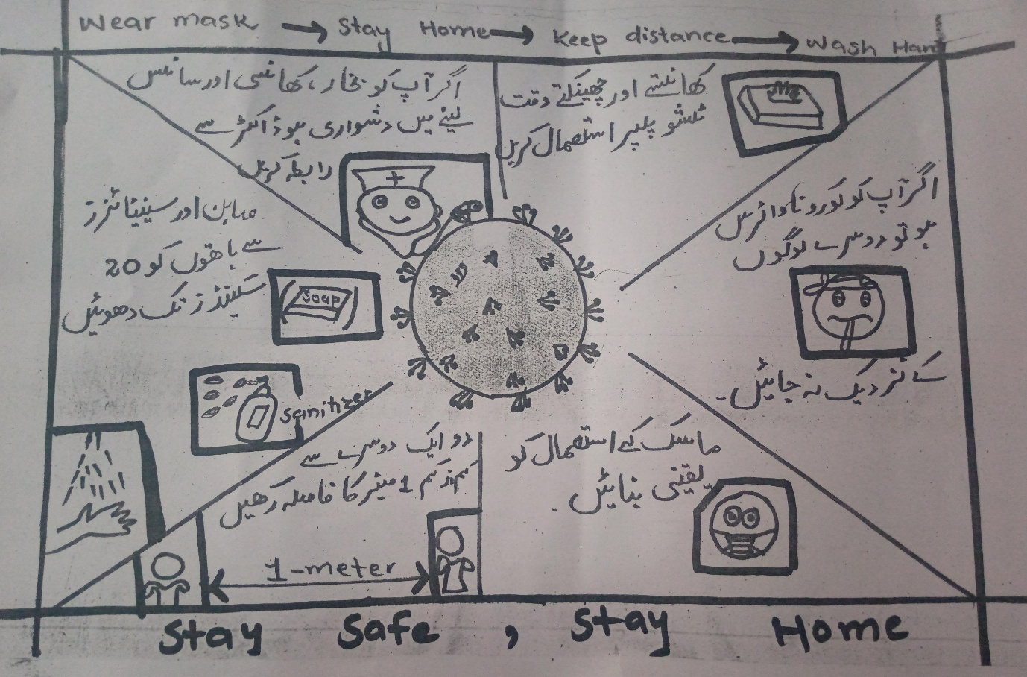
(6). How would you evaluate your project for possible outcomes
- People got awareness about corona virus in their homes, mosques and bazaar.
- This project provided needed information about corona virus.
- It saved lives of many people because they followed my instruction which I distributed in print form.
- People got a lot of benefit and they were happy by attaining awareness about corona virus.
- They also appreciated me.( ‘Saira Mumtaz BBTF19BM010 Bs botany second semester biological department Sargodha university sub campus bhakkar).

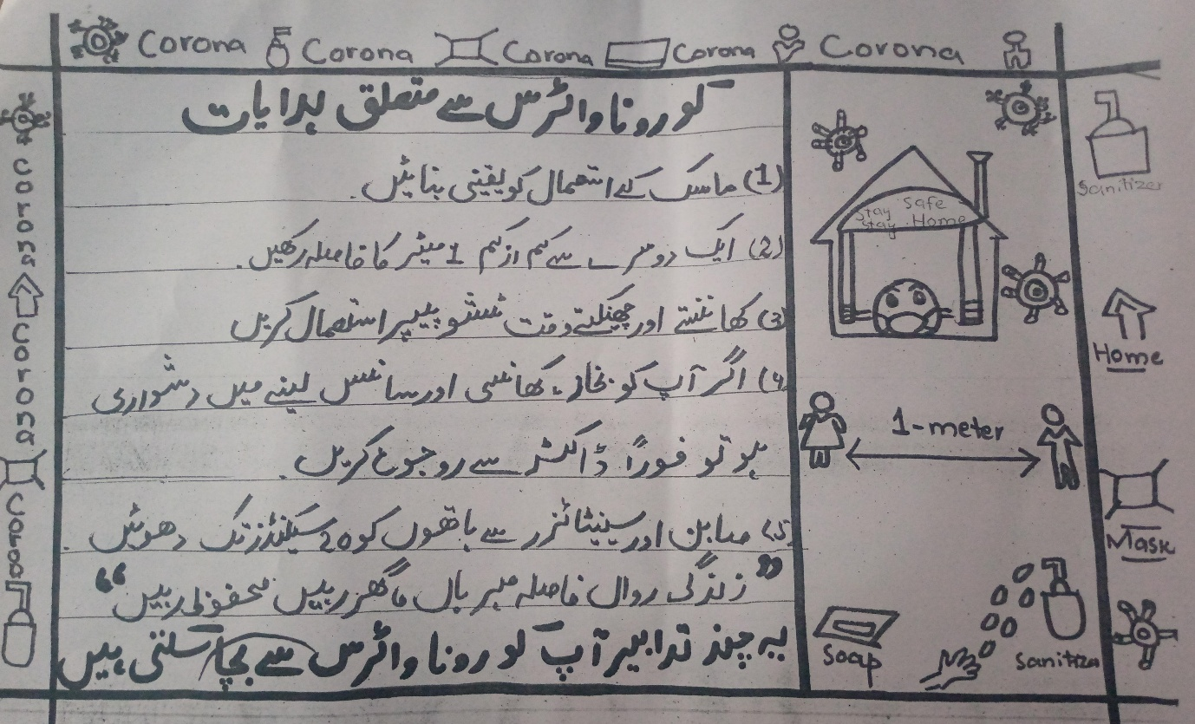

My brother hanged it within mosques

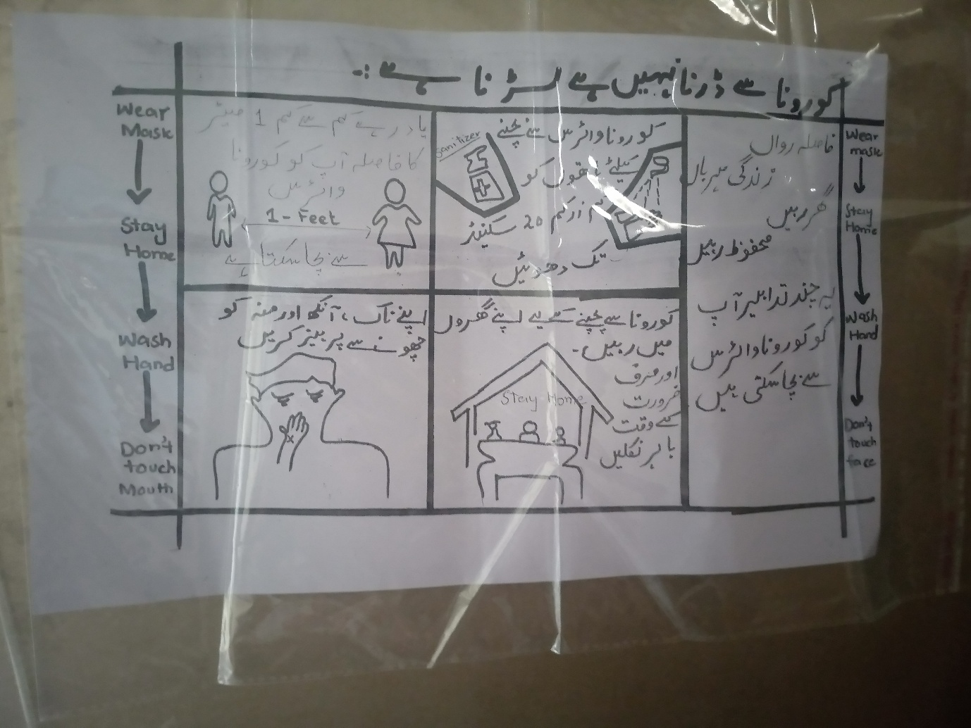

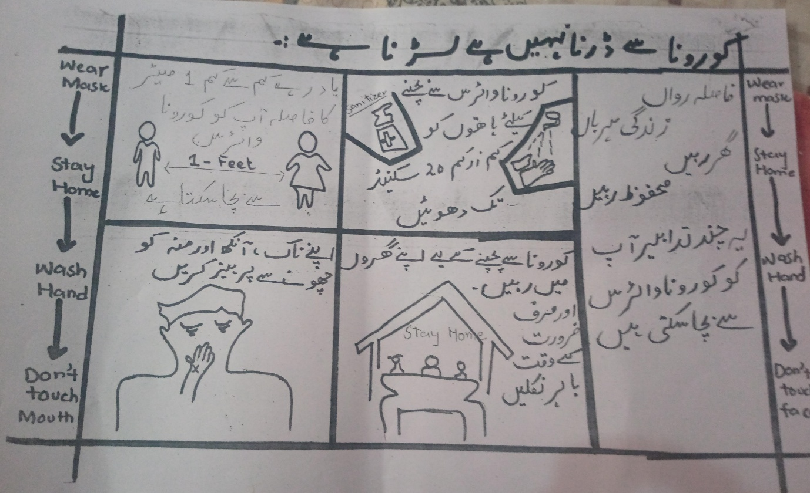

All are supporting pictures to my project

!……Third project......!
2.Introduction
(2.1).Back ground of the problems:
In our surrounding area some poor people remained worry about rashan like flour, daal,rise,sugar, Patti, and match because of corona virus. Because these poor people are daily wages. They earns and eat daily. They possess no resources of collection.( Saira Mumtaz BBTF19BM010 Bs botany second semester biological department Sargodha university sub campus bhakkar ).
(2.2).Present situation
In present situation of corona virus mostly people became work less especially daily wages. They need to fulfill their needs of living like rashan flour, daal,rise, sugar, match, Patti and soap. Mostly daily wages are unable to complete their needs. The present situation of these people are bad.( Saira Mumtaz BBTF19BM010 Bs botany second semester biological department Sargodha university sub campus bhakkar).
(3).Justification of project
(a).Importance of project activities
The activities of this project was very important as it has decreased the tension of daily wages about rashan. Due to this project people got benefit from rashan in their homes. They got needful things in their homes without any efforts. Moreover poor people who got rashan were happy.( Saira Mumtaz BBTF19BM010 Bs botany second semester biological department Sargodha university sub campus bhakkar).
(b). Project implications ( who would get benefit from this project)
- Poor people
- Daily wages
In my surrounding area
Got a lot of benefit from this project by gaining rashan in their homes.( Saira Mumtaz BBTF19BM010 Bs botany second semester biological department Sargodha university sub campus bhakkar).
(4).Objectives of project
The objectives were decrease the tension of daily wages and poor people by providing them important things of needs such as rashan in their homes. To help the poor people were also include in objective.( Saira Mumtaz BBTF19BM010 Bs botany second semester biological department Sargodha university sub campus bhakkar).
(5).Plan of action
(a).How would you do this project activities
I have done this project by providing rashan to poor and needy people in their homes. I kept in mind all needy things and also gave them these things in their homes.( Saira Mumtaz BBTF19BM010 Bs botany second semester biological department Sargodha university sub campus bhakkar).
(b). Needed resources and source of generation
The needed resources were money in purchasing rashan from bazaar and a person who purchased this rashan from bazaar.( Saira Mumtaz BBTF19BM010 Bs botany second semester biological department Sargodha university sub campus bhakkar).
The sources of generation of money and rashan distribution was myself. And the sources of generation in purchasing rashan from bazaar was my brother.( Saira Mumtaz BBTF19BM010 Bs botany second semester biological department Sargodha university sub campus bhakkar).
( c). Each person role in the project
Myself: I gave money for purchasing of rashan from bazaar from my own pocket money. I also distributed this rashan to poor people in my surrounding area.( Saira Mumtaz BBTF19BM010 Bs botany second semester biological department Sargodha university sub campus bhakkar).
Brother: He purchased rashan from bazaar.( Saira Mumtaz BBTF19BM010 Bs botany second semester biological department Sargodha university sub campus bhakkar).
(d). Project duration
I have done this project in one week from 13 may to 19 may. ( Saira Mumtaz BBTF19BM010 Bs botany second semester biological department Sargodha university sub campus bhakkar).
(6).How would you evaluate your project for possible outcomes
- The outcomes of this project are it has decreased tension of daily wages and poor people.
- They got benefit from rashan at their homes.
- They got a chance to fulfill their eating needs.
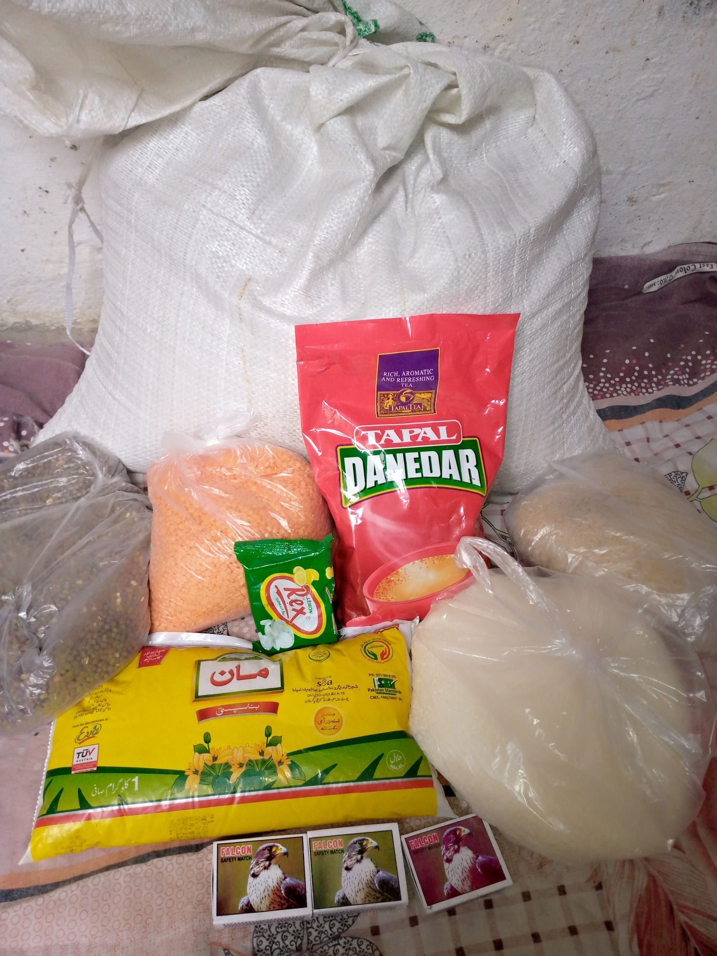
- They are happy. ( Saira Mumtaz BBTF19BM010 Bs botany second semester biological department Sargodha university sub campus bhakkar,).
Picture to support my project
References:
- www.who.com
- www.conservativefuture.com
- www.garbagendhf.com
- www.nerdgy.com
- www.cleanliness.com
- www.labourvdfv.com
- Saira Mumtaz. BBTF19BM010. Bs. botany second semester biological science. Sargodha university bhakkar campus.

