Kreb`s Cycle
The Kreb cycle take place in the tiny structures within the cell called mitochondria, it only occurs in only aerobic respiration. In Kreb cycle the high energy pyruvic acid pass through a series of reaction that generate more ATPs. At last pyruvic acid broke down completely to the simple end product CO₂ and H₂O.
- Formation of acetyl COA
In the presence of oxygen, 3-C pyruvic acid and molecule oxidized with NAD molecule again accepting to hydrogen and lose one carbon in the form of carbon dioxide. The remaining 2-C acetic acid unities with coenzyme A (COA) to form acetyle-COA.
- Formation of citric acid
The acetyl COA enters the Kreb`s cycle. The acetyl group separates from its COA enzyme, combines with of 4-C molecule called oxaloacetic acid and form 6-C citric acid.
- Cyclic changes in citric acid
The citric acid undergoes a series of cyclic changes and form first α-ketoglutaric acid, then succinic acid, malic acid, finally oxaloacetic acid which is recycled to pick up another acetyl group from the next acetyl COA.

Pyruvic Acid

Acetyl-COA

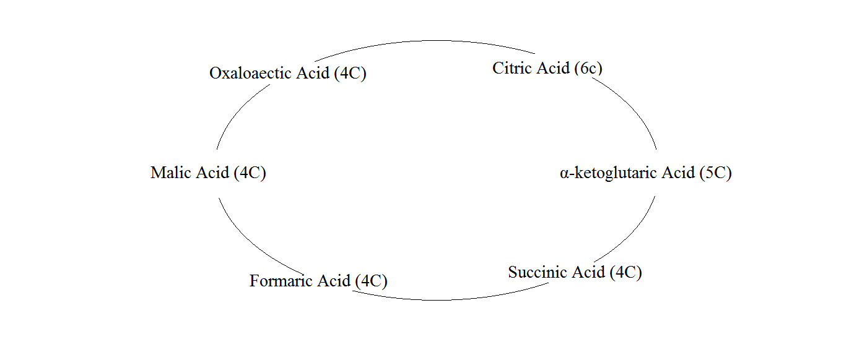

- Electron Transport Chain
In the Kreb cycle NADH and H⁺ are produced from NAD⁺, NADH then transfer the H⁺ atom to the respiratory chain (also called electron transport system) where electrons are transported in a series of molecular oxygen.
It is the last stage of the aerobic respiration which takes place in mitochondria. In this process electron accepted by the NAD and FAD molecules pass through a series of electron carries such as cytochrome “a”, “b”, “c” and “a₃”. These cytochromes can be alternately reduced and oxidized with an energy loss or gain accompanied is at low energy level then the proceeding one. In this process energy of the electron is freed in a step wise manner and then used to from ATP.
At the end of electron transport chain the electrons are accepted by oxygen and combine proton to produced water. Each time one pair of electron pass from NAD_{(red)} to oxygen, three molecules of ATP are formed from ADP and phosphate.

^{2e} Cyto b ^{2e} Cyto c ^{2e} Cyto a ^{2e} Cyto a₃ ^{2e}

