How Cells Release
Chemical Energy – Cellular Respiration.

Overview of Carbohydrate
Breakdown Pathways
▪
Photoautotrophs make ATP during
photosynthesis and use it to synthesize glucose
and other carbohydrates
▪
Most organisms, including photoautotrophs,
make ATP by breaking down glucose and other
organic compounds
Comparison of the Main Pathways
▪
Aerobic respiration
•
Aerobic
metabolic pathways (using oxygen) are
used by most eukaryotic cells
▪
Fermentation
•
Anaerobic
metabolic pathways (occur in the
absence of oxygen) are used by prokaryotes and
protists in anaerobic habitats

Comparison of the Main Pathways
- Aerobic respiration and fermentation both begin with glycolysis, which converts one molecule of glucose into two molecules of pyruvate
- After glycolysis, the two pathways diverge
  - Fermentation is completed in the cytoplasm, yielding 2 ATP per glucose molecule
  - Aerobic respiration is completed in mitochondria, yielding 36 ATP per glucose molecule
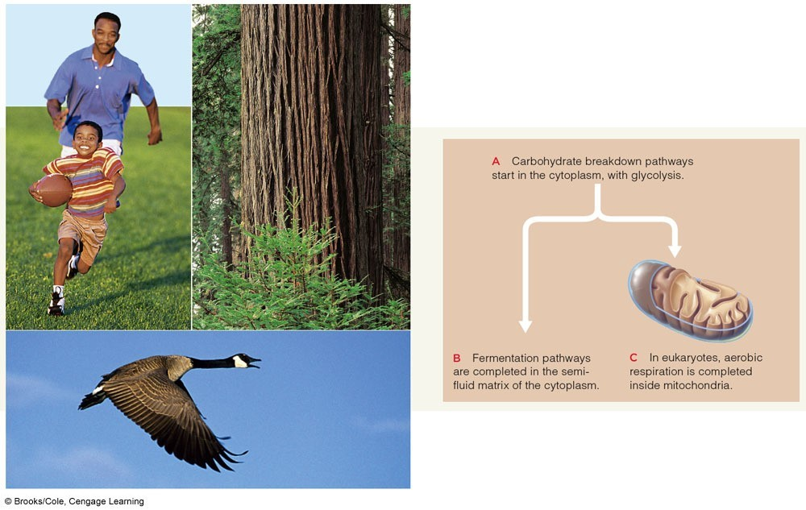
Comparison of the Main Pathways
Overview of Aerobic Respiration
▪
Three stages
•
Glycolysis
•
Acetyl-CoA formation and Krebs cycle
•
Electron transfer phosphorylation (ATP formation)
C
6
H
12
O
6
(glucose) + O
2
(oxygen)
→

CO
2
(carbon dioxide) + H
2
O (water)
•
Coenzymes NADH and FADH
2
carry electrons
and hydrogen
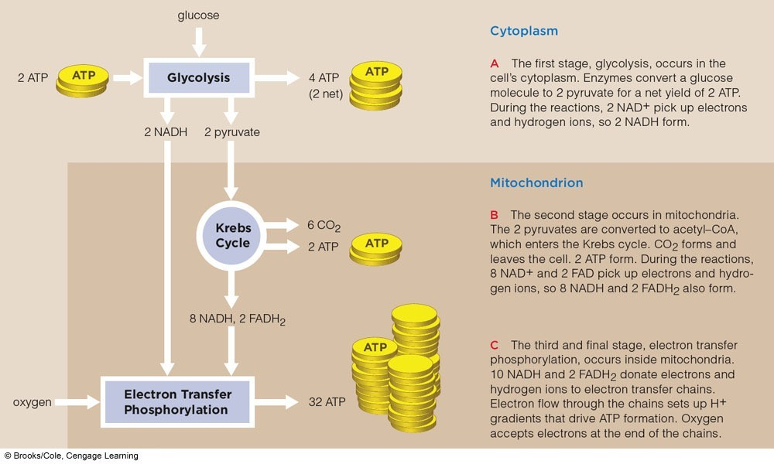
Overview of Aerobic Respiration

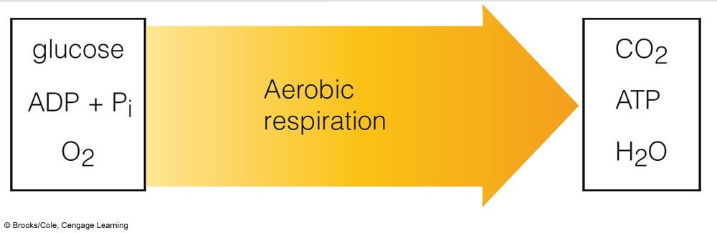

Animation: Overview of aerobic
respiration
http://
www.youtube.com/v/SoRyBftF3O
0
Key Concepts:

Energy From Carbohydrate Breakdown
- Various degradative pathways convert the chemical energy of glucose and other organic compounds to the chemical energy of ATP
- Aerobic respiration yields the most ATP from each glucose molecule; in eukaryotes, it is completed inside mitochondria

Glycolysis –
Glucose Breakdown Starts
▪
Glycolysis starts and ends in the cytoplasm of all
prokaryotic and eukaryotic cells
▪
An energy investment of ATP starts glycolysis
Glycolysis
▪
Two ATP are used to split glucose and form 2 PGAL,
each with one phosphate group
▪
Enzymes convert 2 PGAL to 2 PGA, forming 2 NADH
▪
Four ATP are formed by
substrate-level
phosphorylation
(net 2 ATP)
▪
Enzymes of glycolysis use two ATP to convert one
molecule of
glucose
to two molecules of three-carbon
pyruvate

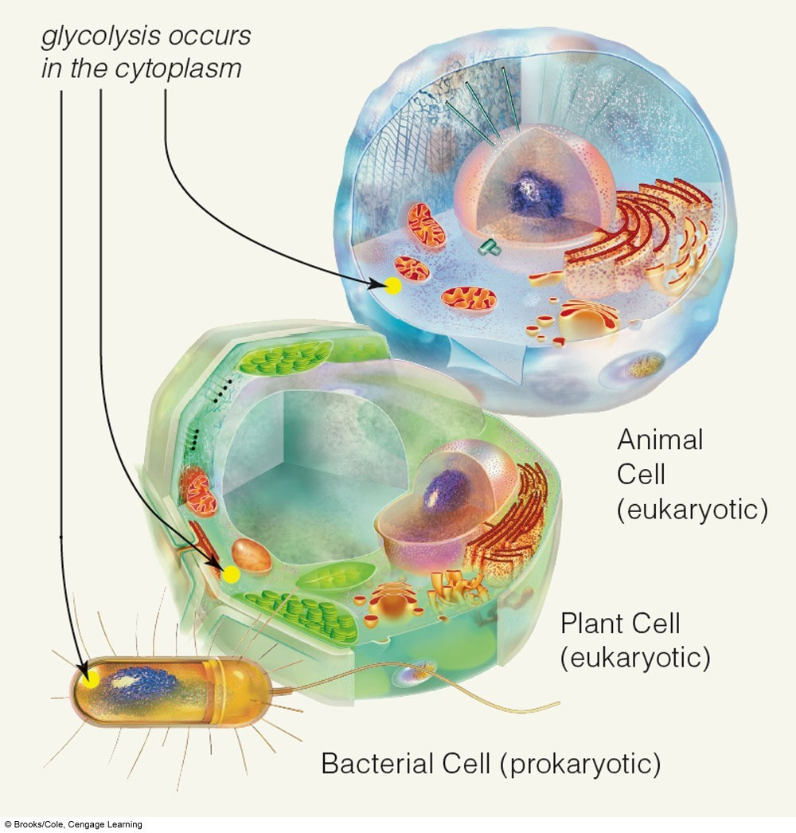
Glycolysis
Products of Glycolysis
▪
Net yield of glycolysis:
•
2
pyruvate, 2 ATP, and 2 NADH per glucose
▪
Pyruvate may:
•
Enter fermentation pathways in cytoplasm
•
Enter mitochondria and be broken down further in
aerobic respiration

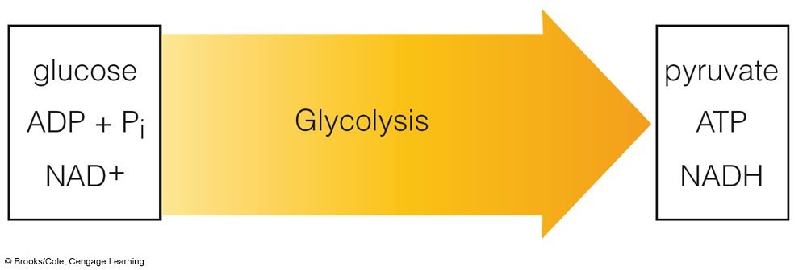

Glycolysis Occurs in Two Stages
- 1. Energy-requiring steps
  - ATP energy activates glucose and its sixcarbon derivatives
- 2. Energy-releasing steps
  - The products of the first part are split into three-carbon pyruvate molecules
  - ATP and NADH form
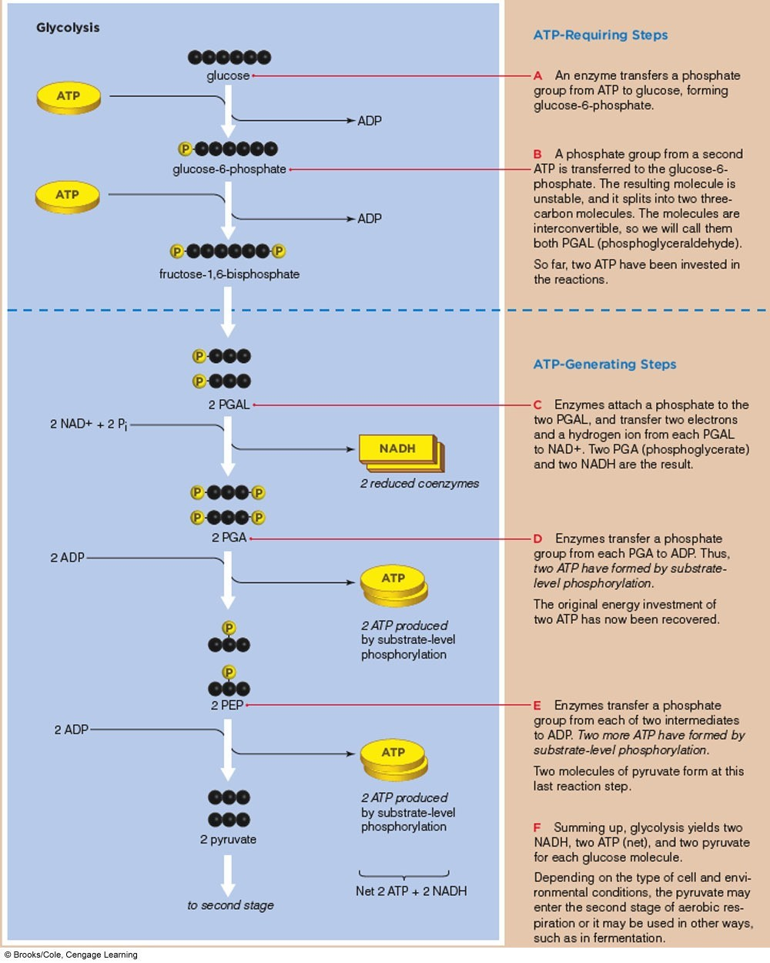 Fig. 8-4b, p. 127
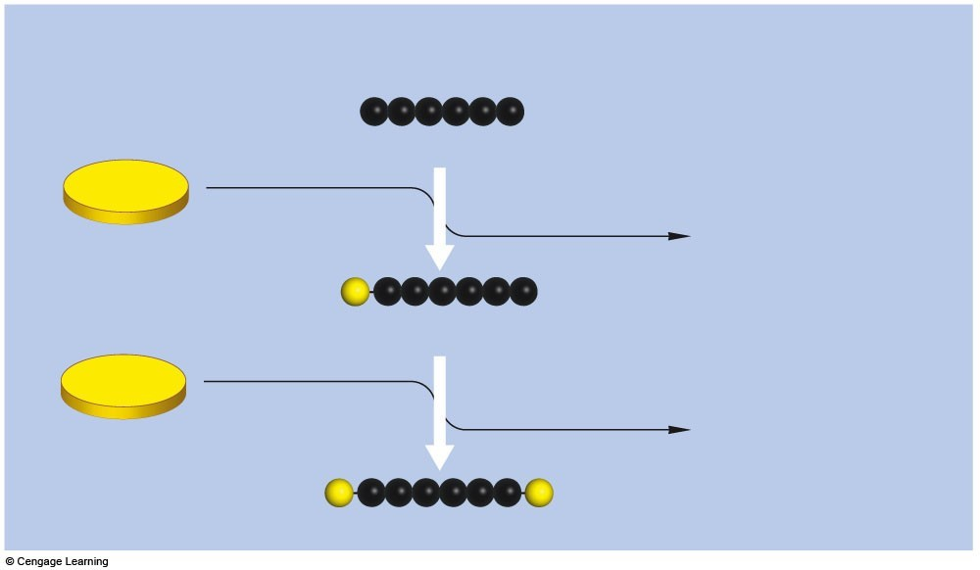
ATP
ATP
glucose
ADP
ADP
P
P
glucose–6–phosphate
fructose–1,6–bisphosphate
DHAP
Glycolysis
Energy-Requiring Steps
Fig. 7.4c1, p.111
Energy-
+
Releasing
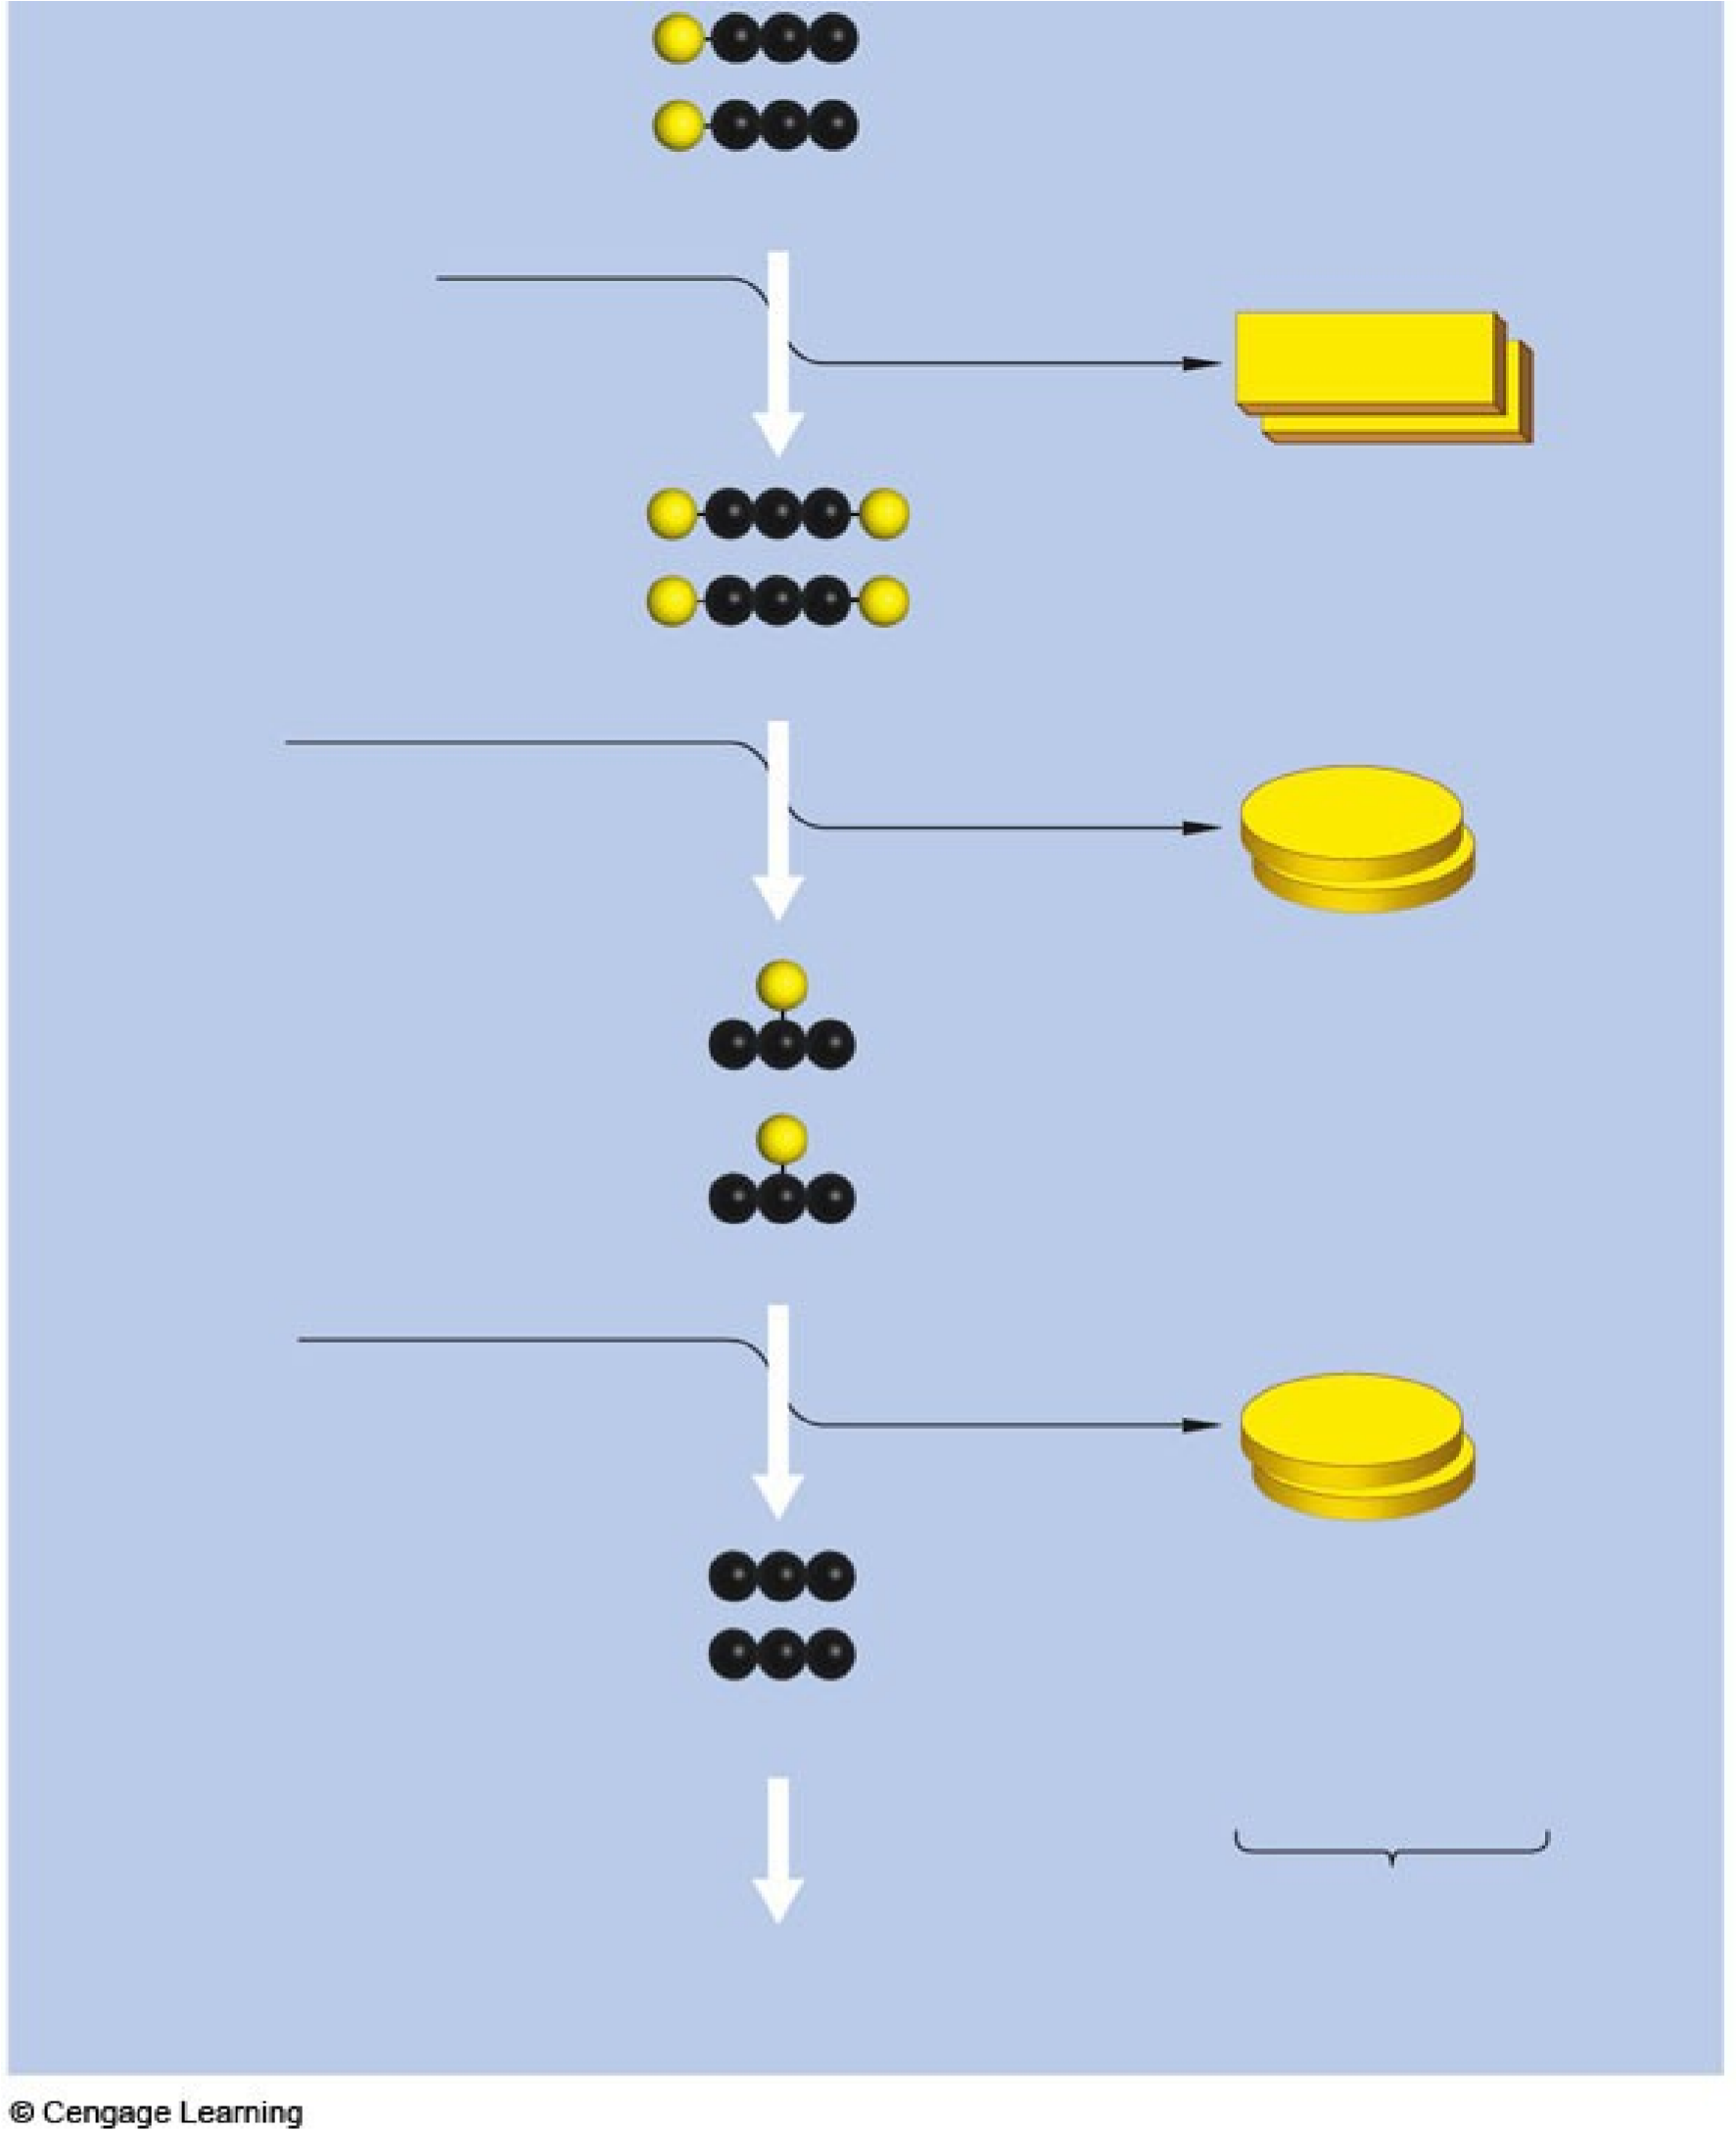
Steps
ATP
2
ADP
2
NAD
+
2 P
i
2
PGA
NADH
2
PGAL
ATP
2
pyruvate
PEP
2
2
ADP
to second stage
Net 2 ATP + 2 NADH
2
ATP produced
by substrate-level
phosphorylation
ATP produced
2
by substrate-level
phosphorylation
reduced coenzymes
2
Fig. 7.4c2, p.111

Key Concepts:
Glycolysis
▪
Glycolysis is the first stage of aerobic respiration and of
anaerobic routes such as fermentation pathways
▪
Enzymes of glycolysis convert glucose to pyruvate
▪
As enzymes break down glucose to pyruvate, the
coenzyme NAD
+
picks up electrons and hydrogen atoms
▪
Net energy yield is two ATP

Second Stage of Aerobic Respiration
▪
The second stage of aerobic respiration finishes
breakdown of glucose that began in glycolysis
▪
More ATP is formed
▪
More coenzymes are reduced
▪
Occurs in mitochondria
▪
Includes two stages: acetyl CoA formation and the Krebs
cycle (each occurs twice in the breakdown of one
glucose molecule)
Acetyl CoA Formation
▪
In the inner compartment of the mitochondrion,
enzymes split pyruvate, forming acetyl CoA and
CO
2
(which diffuses out of the cell)
▪
NADH is formed
The Krebs Cycle – 10.05, 10.06
▪
Krebs cycle
•
A sequence of enzyme-mediated reactions that
break down 1 acetyl CoA into 2 CO
2
•
Oxaloacetate is used and regenerated
•
3
NADH and 1 FADH
2
are formed
•
1
ATP is formed
•
DOUBLE THIS FOR EACH MOLECULE OF
GLUCOSE!!!
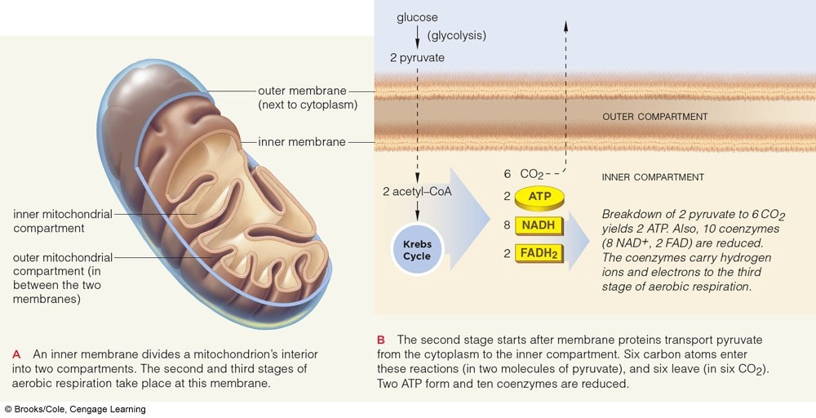
Inside a Mitochondrion
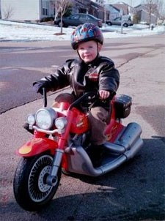
Krebs Cycle
▪
Each turn of the Krebs cycle,
one
acetyl-CoA
is converted to
two molecules of
CO
2

•
DOUBLE THIS FOR EACH
MOLECULE OF GLUCOSE!
▪
After two cycles
•
Two pyruvates are dismantled
•
Glucose molecule that entered
glycolysis is fully broken down
Little Johnny Krebs
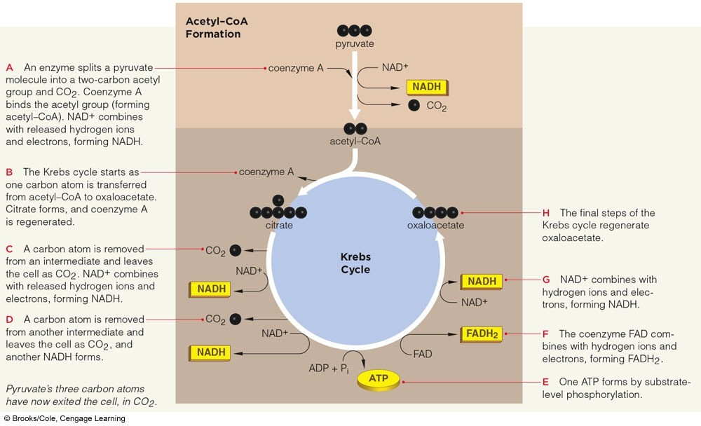
Acetyl CoA Formation
and the Krebs Cycle
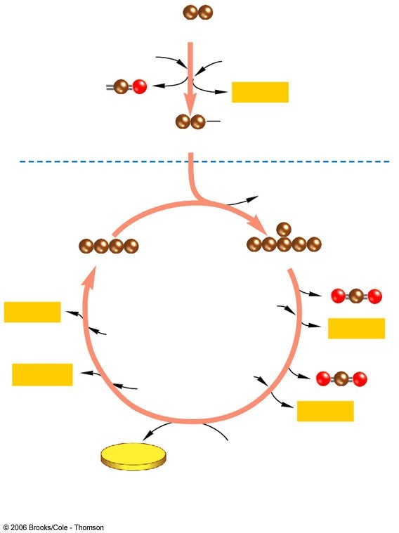
acetyl-CoA
CO
(
2
)
pyruvate
coenzyme A
NAD
+
NADH
CoA
Krebs Cycle
CoA
NADH
FADH
2
NADH
NADH
ATP
ADP +
phosphate
group
NAD
+
NAD
+
NAD
+
FAD
oxaloacetate
citrate
. Remember
1
that there are 2
pyruvate
molecules from
glycolysis!!!
Acetyl-CoA transfers
2
C to oxaloacetate,
forming citrate (6C)
CO
2
released
NAD
+

picks up
hydrogen and
electrons, forming
NADH
Ditto! – C’s of
pyruvate are now
all gone!
Substrate-level phosphorylation
FAD

picks up
hydrogen and
electrons,
forming FADH
2
You know the
drill!!!
Oxaloacetate is
regenerated

Net Results
- Second stage of aerobic respiration results in
  - Six CO₂, two ATP, eight NADH, and two FADH₂ for every two pyruvates
- Adding the yield from glycolysis, the total is
  - Twelve reduced coenzymes and four ATP for each glucose molecule
- Coenzymes deliver electrons and hydrogen to the third stage of reactions
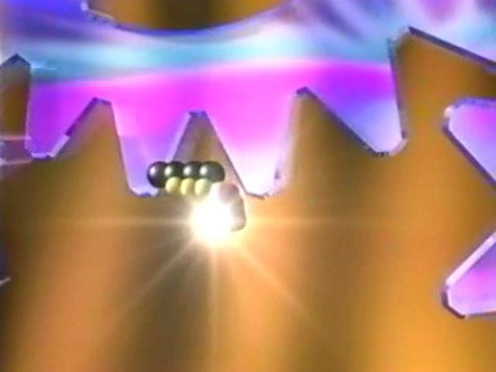
Animation: Krebs cycle overview
http://www.youtube.com/v/aCypoN3X7K
Q
Aerobic Respiration’s
Big Energy Payoff

▪
Many ATP are formed during the third and final
stage of aerobic respiration
▪
Electron transfer phosphorylation
•
Occurs in mitochondria
•
Results in attachment of phosphate to ADP to
form ATP

Electron Transfer Phosphorylation
- Coenzymes NADH and FADH₂ donate electrons and H⁺ to electron transfer chains
- Active transport forms a H⁺ concentration gradient in the outer mitochondrial compartment
- H⁺ follows its gradient through ATP synthase, which attaches a phosphate to ADP
- Finally, oxygen accepts electrons and combines with H⁺, forming water
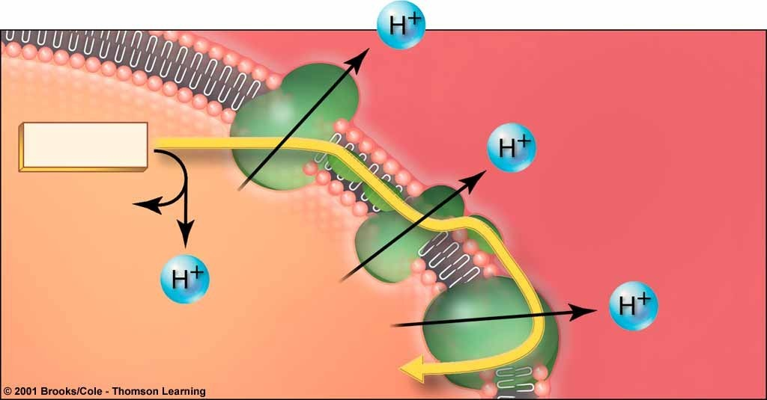
Creating an H
+
Gradient
NADH
OUTER COMPARTMENT
INNER COMPARTMENT
As electrons go through the transport chain (supplied by
NADH & FADH
2
)
, H
+

gets shuttled out
e
-
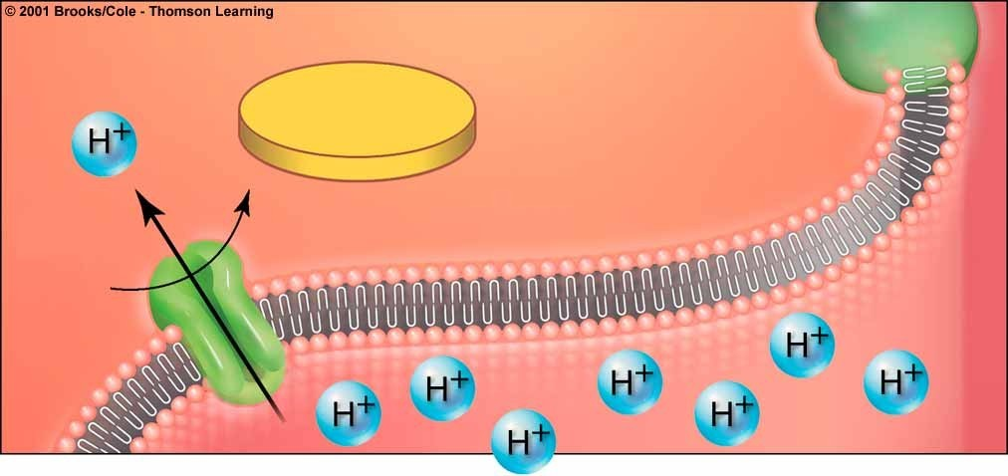
ATP Formation
ATP
ADP
+
P
i
INNER
COMPARTMENT
H
+
concnetration is now greater in the outer
compartment. H
+
follows these gradients through
ATP synthases to the interior, forming ATP

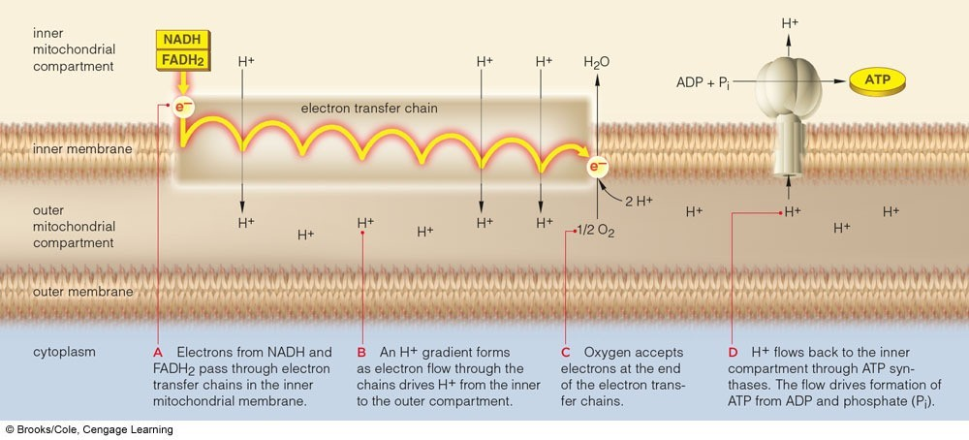
Electron Transfer Phosphorylation
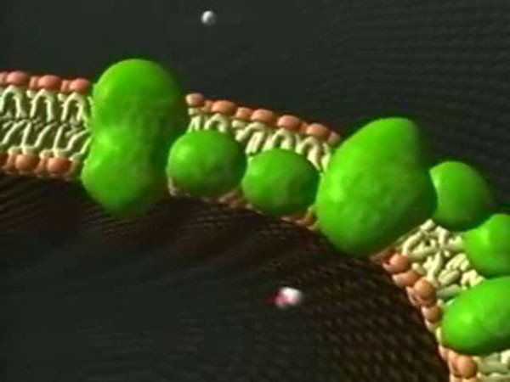
Animation: Electron transfer
phosphorylation
http://www.youtube.com/v/Idy2XAlZIV
A
Summary: The Energy Harvest
▪
Typically, the breakdown of one glucose
molecule yields 36-38 (for the class, we’ll call it
36)
ATP based on the type of cell.
•
Glycolysis: 2 ATP
•
Acetyl CoA formation and Krebs cycle: 2 ATP
•
Electron transfer phosphorylation: 32 ATP
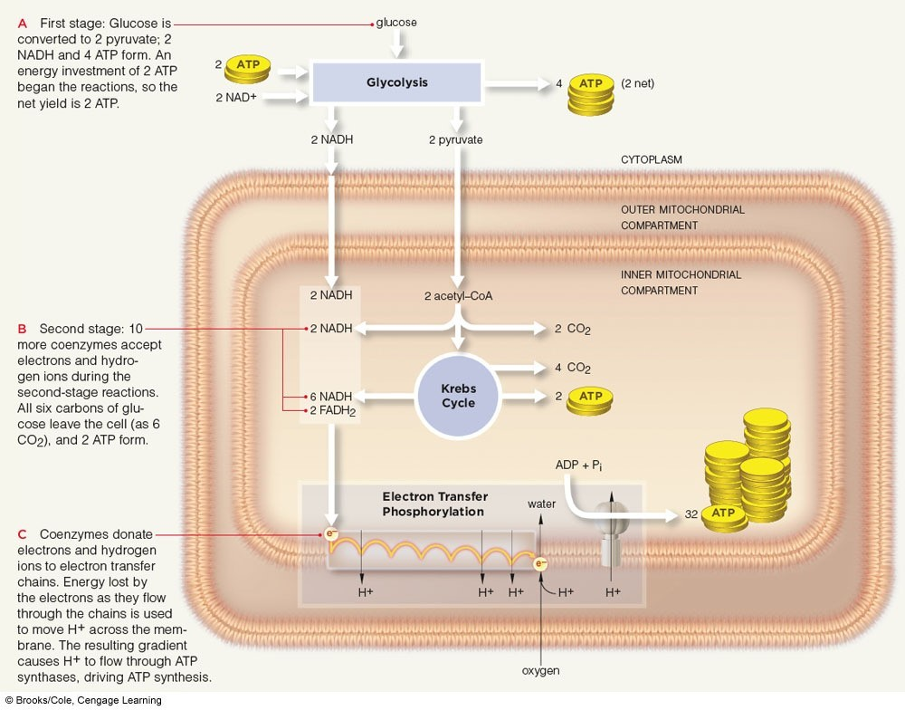
Summary: Aerobic Respiration
Key Concepts:

How Aerobic Respiration Ends
- The final stages of aerobic respiration break down pyruvate to CO₂
- Many coenzymes that become reduced deliver electrons and hydrogen ions to electron transfer chains; energy released by electrons flowing through the chains is captured in ATP
- Oxygen accepts electrons at ends of the chains
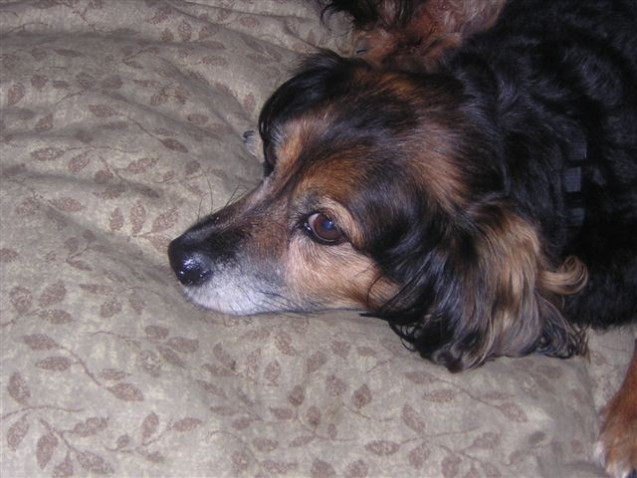

Anaerobic
Energy-Releasing Pathways
▪
Fermentation pathways break down
carbohydrates without using oxygen
▪
The final steps in these pathways regenerate
NAD
+
but do not produce ATP
X
▪
Only used by simple organisms. You’ll never
see an anaerobic Renfield

Fermentation Pathways
- Glycolysis is the first stage of fermentation
  - Forms 2 pyruvate, 2 NADH, and 2 ATP
- Pyruvate is converted to other molecules, but is not fully broken down to CO₂ and water
  - Regenerates NAD⁺ but doesn’t produce ATP
- Provides enough energy for some single-celled anaerobic species
Two Pathways of Fermentation
▪
Alcoholic fermentation
•
Pyruvate is split into acetaldehyde and CO
2
•
Acetaldehyde receives electrons and hydrogen
from NADH, forming NAD
+
and ethanol
▪
Lactate fermentation
•
Pyruvate receives electrons and hydrogen from
NADH, forming NAD
+
and lactate
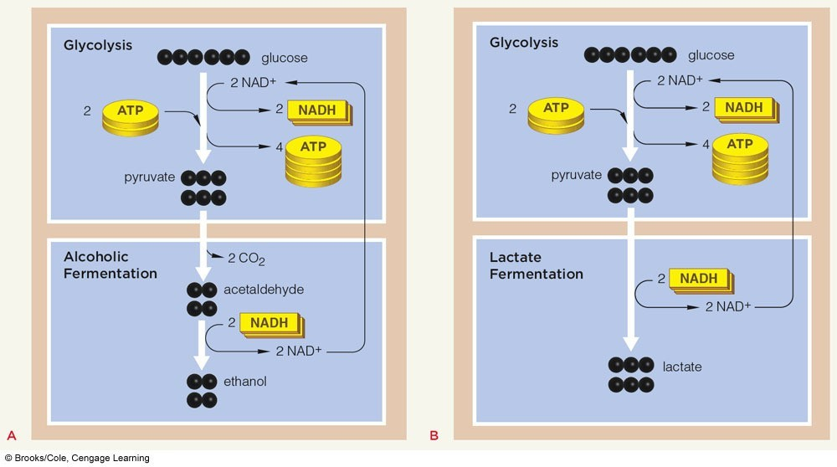
Two Pathways of Fermentation
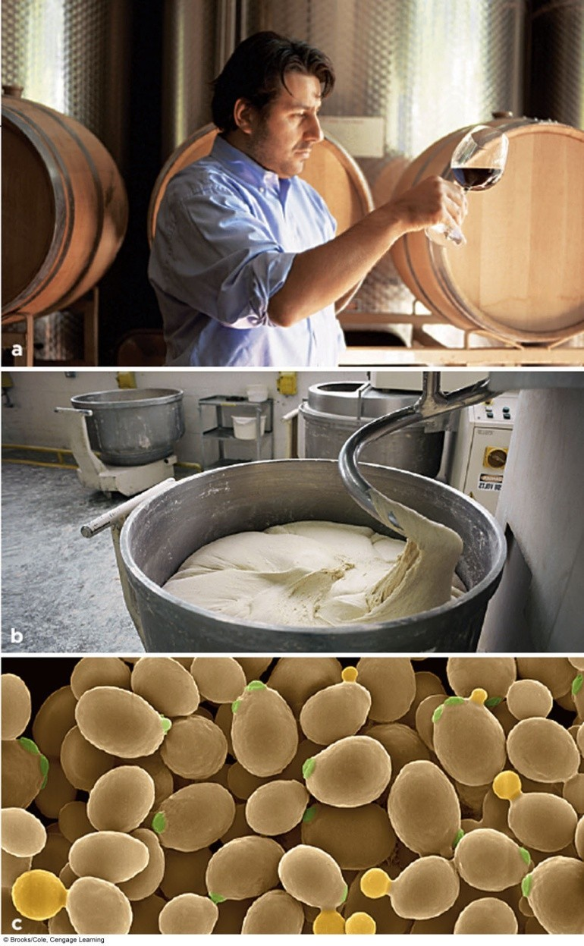
Alcoholic Fermentation

The Twitchers
▪
Slow-twitch muscle fibers (“red” muscles) make
ATP by aerobic respiration
•
Have many mitochondria
•
Dominate in prolonged activity
▪
Fast-twitch muscle fibers (“white” muscles) make
ATP by lactate fermentation
•
Have few mitochondria and no myoglobin
•
Sustain short bursts of activity
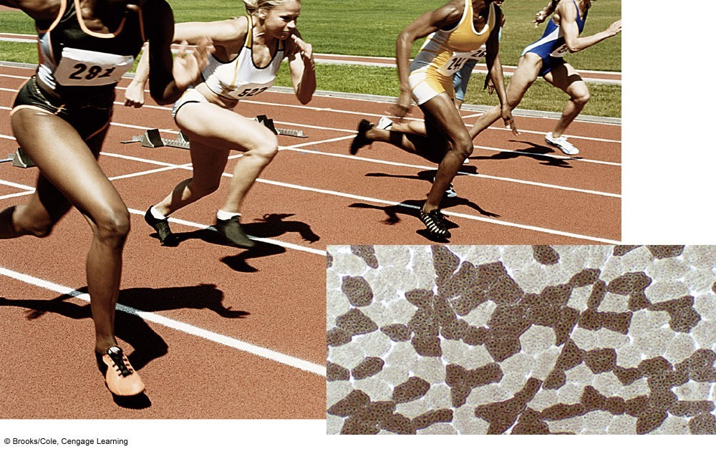
Sprinters and Lactate Fermentation
Key Concepts:
How Anaerobic Pathways End
▪
Fermentation pathways start with glycolysis
▪
Substances other than oxygen accept electrons
at the end of the pathways
▪
Compared with aerobic respiration, the net yield
of ATP from fermentation is small

Reflections on Life’s Unity
- Life’s diversity and continuity arise from unity at the level of molecules and energy
  - Energy inputs drive the organization of molecules into cells (one-way flow of energy)
- Energy from the sun sustains life’s organization
  - Photosynthesizers use energy from the sun to feed themselves and other forms of life
  - Aerobic respiration balances photosynthesis
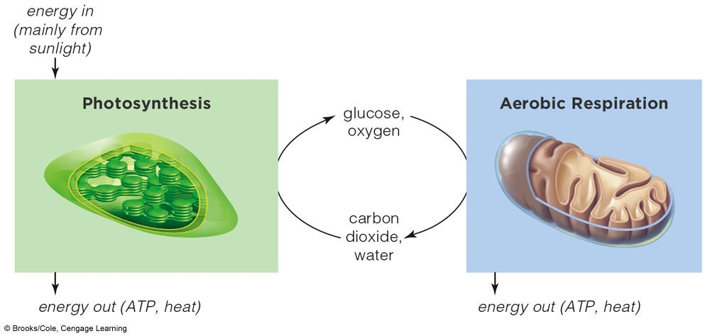
Links Between Photosynthesis
and Aerobic Respiration

