EXPERIMENT NO.3
Determine the coefficient of discharge C_{d}factor in venturi meter.
Theory:
Definition coefficient of discharge:
Coefficient of discharge is stated as the ratio between the actual flow discharge and theoretical flow discharge. It is also referred to as the ratio of mass flow rate at nozzle's discharge edge to the standard nozzle which enlarges an exact working fluid maintained at the similar initial conditions and pressures.
It has no dimensions and depends directly on the rate of flow and velocity of working fluid. It is symbolized by C_{d} and its value is different for each fluid depending on the kind of measurement of flow.
Venturi meter:
According to the Bernoulli equation:
For a non-viscous, incompressible fluid in steady flow, the sum of pressure, potential and kinetic energies per unit volume is constant at any point-
At any time per second, the discharge moving through a specific cross sectional area at two points is equal, therefore:
Continuity Equation: V1A1 = V2A2 = V3A3 = Q ___________(1)
Now, according to the continuity equation, for Q to remain same as point 1 with the decrease in cross sectional area, an increase in velocity is required.
Bernoulli Equation:(V²/2g + h1 + z1 )= (V²/2g + h2 + z2 )= (V²/2g + h3 + z3) ____ (2)
Where:
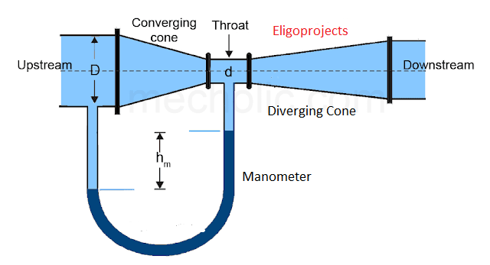

Apparatus:
Hydraulic bench, stopwatch, thermometer, venture apparatus
Procedure:

Calculation table:
Sr.no | H1(mm) | H2(mm) | Qact(lpm) | Qthr(lpm) | %Error
1
2
3
4

Conclusions:

