Proposal Group (2)

Bs Mathematics

Course: Citizenship Education and community Engagement.

Project Title:
Rashan and safety measures about Covid-19 through survey and print outs,how to made sanitizer (provide).

Submition Date ; 10 May,2020

Submitted to: Ma’am MehlahJabeen

Submitted by:
(Group Members)

Name | Roll No
Anam | BMAF19BM042
Ayesha | BMAF19BM052
Maheen | BMAF19BM039
Sidra | BMAF19BM025
Program: Bs-Math (4 year)
Semester: Second(2nd)
Session:. 2019 to2023

UoS sub- campus Bhakkar

1.projectTitle:
Rashan and safety measures about covid-19 through survey and print outs,How to made sanitizer (provide).

2.Introduction:

2.1Background ofproblem:
Cdc is responding to a pandemic orespiratory disease spreading from person to person caused by a new Corona virus.The disease has been named "Corona virus disease 2019"(abbreviated"covid-19").This situation poses a serious public health risk.The federal government is working closely with state,local,tribal and territorial partners as well as public health partners,to respond to this situation.(https://www.edu.europa.eu).
As Pakistan is the developing country and 25% of population belongs to a poor family in our country due to this covid-19.This problem become more severe.In our country people are so unemployed that they cannot even fulfilltheir hunger.They do not serious about this disease.The people does not know have to save from Coronavirus.They are unaware that how to use masks, Gloves, sanitizer and save us our life from covid-19. So we decided to help them.

2.2 present situation:
At the outset,we would point out that these days we are battling a disease like Corona virus which is very harmful disease.The disease has led to lockdown across the country which is causing a lot of hardship to the people.

The first case of Corona virus was reported in Pakistan February 15 and Corona virus increased day by day.Since then the number of Corona virus patients has risen to 24,073. The number of recoveries is 6,464 and the number of deaths is 547. And there are still high risk of this disease.we should all pray to God to get rid of this dangerous disease like Corona virus as soon as possible.Ameen.(Google.com).
3. Justification of the project:
- Importance of project activity:
This is a big project because it helps the poor people.Now-a-days people are much worried due to Corona virus.so we decided to help them by financially support.Even in Pakistan there is very bad conditions of people.If we financially help them then,they fulfill their needs.However people does not serious about this disease,so we decided to aware people through survey and print outs.And also we provide self made santizer.Our this work helps the poor and needy people in a current situation.(en.wikipedia.org).

- practical implications (who will get benefits of the activity)?
First of all,we will help a two poor families by a financially support.In this step two poor families are benefited.secondly,we distribute hard copies of preventive measure about covid-19. And also guide people how to save their lives.This step help the people to understand this disease and so that,they can protect himself and his families.Thirdly we will divide a self made sanitizer and guide people to use sanitizer and save himself and others in this disease.(en.wikipedia.org).

4.Objectives of the project:
By looking the current situation our project objectives are as follows:
- To help people through financially support.
- Every person helps the two poor houses.
- Every group member distribute 10kg flour,5kg Rice and 5kg sugar.
- To tell people about Corona virus.
- By distribute charts in public.
- By guide the people,how to save him self and others?
- To tell people wash your hands properly.
- To tell them,how to make self made sanitizer?
- By teachings,how to use sanitizer?

5.Plan ofaction:
In our group every person work equally.In first step we will help two houses in our neighborhood by financially support.we will decide to help a two families which are now unable to tolerate their experience because they are unemployed.The second step is that to awear peoples by prints out prevention tips against Corona virus.
- Anam Muneer:
Our group has decided that every member of the group work equally in our project.so after given my task,i observed my nearby people.After observation,I met two such families who are spending their lives in a bitterful condition.They have no proper mean of earning. The reason for unemployment is that the person who support their family working in a shop,due to a lock down (apedemic covid -19) all working places are closed.Thus I will decided to financially support those families by distributing 10kg flour and 5kg rice in both families. The other step of my project is that I will guide people how we save from covid-19 . People do not know how to save from Corona virus.So I will decided to guide them how to take precautions and save from this apedemic.In this regard,I will distribute 200 hard copies of prevention tips about covid-19 in my neighborhood and public.And I will also decided to distribute a sanitizer in my neighborhood and also guide a people how to make a sanitizer(Anam Muneer,BMAF19BM042, department of mathematics,uos bhakkar campus).
2. Ayesha Ashraf:
According to our group project,first of all I will observed such a two poor families in neighborhood areas.One of them is labour's house and the other is widow house.Due to lock down they are unemployed.So I will decided to help those families by financially support.I will distributed 5kg flour and 3 kg sugar in each house by pocket money and father's help.I also observed that people are unaware how to save us from covid-19 .I will decided to help them by prints out prevention tips against Corona virus.And I will distribute 200 copies of prevention tips in neighborhood areas and public.Further I will distribute home made sanitizer .I will told them how to use masks,and sanitizer.(Ayesha Ashraf,BMAF19BM052, department of mathematics,uos bhakkar campus).
3. Maheen Zahra:
According to our project,I will also chose two families who are spending their lives in a bitterful condition in my neighborhood area.They have no proper mean of earning.Due to a lock down, they are unemploymed.So I will decided to help those families by financiall support.One of them is rickshaw puller's house and other is labour's house.I will give 5kg rice and 3kg ghee in each house.
The other step of my project is that I will guide people how we save from covid-19 . People do not know how to save from Corona virus.So I will decided to guide them how to take precautions and save from this apedemic.In this regard,I will distribute 200 hard copies of prevention tips about covid-19 in my neighborhood and public.And I will also decided to distribute a sanitizer in my neighborhood and also guide a people how to make a sanitizer.(Maheen Zahra, BMAF19BM039,department of mathematics,uos Bhakkar campus).

4. Sidra:
According to our project,I will also chose two families,I will help two houses in my neighborhood. The house I will help have no one to help them because they are both widows and have no source of income.I will help these two houses for a thousand rupees.I will distribute rashan in these two houses which includes 2kg flour,2kg rice and1kg sugar in each house.In addition,I will look into the saftey of the Corona virus.I will take some pictures of Corona virus protection and print out and distribute them as well as people how to avoid Corona virus .And I will make a sanitizer myself and distribute as many pictures as I can about the protection against the virus to people .I will also told them how make sanitizer ,how it is used.(sidra, BMAF19BM025, department of mathematics,uos bhakkar campus).

a.How will do this activity:
In present situation,we are all facing a dangerous disease.first step of our group,we help them two poor families.we distribute a rashan in these two families.And another step of our group is to guide people how we save from Corona virus.Pepole does not know how to save from Corona virus and they are not serious about this disease.so we decided to guide them how to take pre-quations and save from this apdamic.we will distribute 300 hard copies of preventive measure about covid-19. 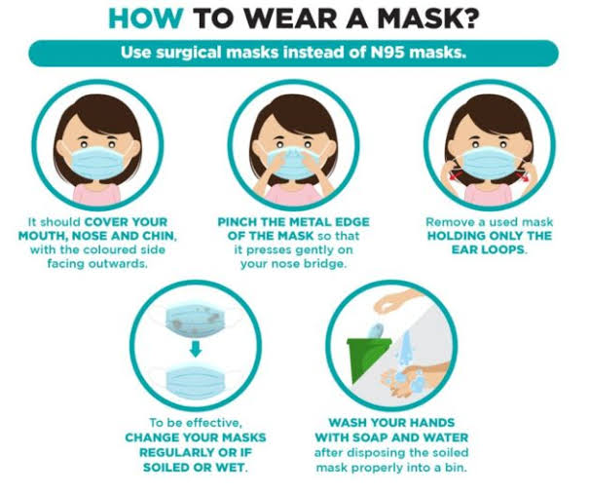

The third step of our group to distribute a self made sanitizer in our neighborhood and we also guide a people how to make a self made sanitizer.so
we will do these activities in these ways.

b.Needed Rescorses and source ofGeneration (financial,Human resources etc:
We will help people at our own expenses and our parents will helps us.we will take some pictures safety about Corona virus and then distribute these pictures in apublic.Our brothers will help us in this work. Inshallah,we will do this with complete honesty and antuisumm.(Anam Muneer,BMAF19BM942, department of mathematics,uos bhakkar campus).

c.Each person roll in the project:
In this project, Everyone will play a very important role.Every one is working equally.Everyone in the group will contribute a same amount.In group each member tells the people about safety about Corona virus and distribute sanitizer.Everyone is working very hard.(Ayesha Ashraf,BMAF19BM052, department of mathematics,uos bhakkar campus).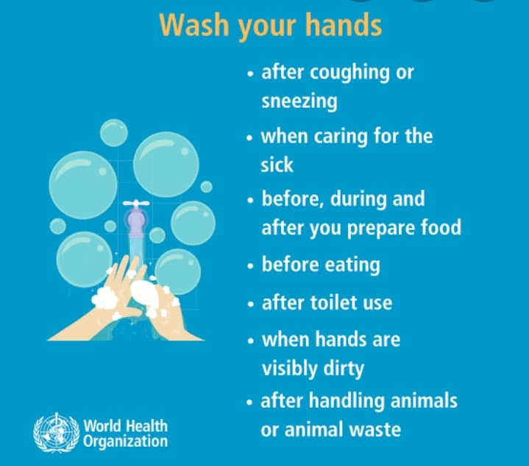

d.Proposed duration of project:
This project is not a small project that will be completed in a day or two.It is a big project and our group will complete this project in a month.(Maheen Zahra, BMAF19BM039, department of
mathematics,uos bhakkar campus).

6.How will you evaluate your project in a possible outcome:
First we will help two poor house holds who have no source of income then we will guide people on how to get rid of Corona virus. Then in a few days we will go these houses and ask them if what we have helped them you have benefited you so that we can evaluate our project.whether this project was successful. This project will remains a very successful.Our small efforts has helped many people.And we wil do this honestly and diligently.(Sidra,BMAF19BM025, department of mathematics,uos bhakkar campus).
7. References:
- (https://www.edu.europa.eu).
- (Google.com).
- (en.wikipedia.org).
- (Anam Muneer ,BMAF19BM042, department of mathematics, uos bhakkar campus).
- (Ayesha Ashraf ,BMAF19BM052, department of mathematics ,uos Bhakkar campus).
- (Maheen Zahra ,BMAF19BM039, department of mathematics,uos Bhakkar campus).
- (sidra, BMAF19BM025, department of mathematics,uos bhakkar campus).

Anna Morton says:
"I have a responsibility as a citizen to my community.It is both a responsibility and a privilege, because as I work to make my community a better place,I receive intrinsic benefits as well."
God willings

