Forest Mensuration
Lecture Notes
B.Sc Forestry 2nd Year 2nd Semester

Prepared by
Bishnu P Devkota
Lecturer
Institute of Forestry
Pokhara, Nepal

October 2012
Unit-1: Introduction
Forest Mensuration, Dasometrics or Dendrometrics, deals with the quantification of forests, trees, and forest products. We can distinguish in it techniques for direct or indirect measurement, estimation procedures using statistical relationships, and methods of prediction where the variable time takes part.
 | Measurement (Direct, Indirect) | Estimation (Statistical) | Prediction (Over Time)
Logs (Products) | Length, diameter  Cubiccation (Volume)  Log rules  Defect, Quality | Volume functions  Sawn timber conversion  Stacked wood
Trees | DBH, height, bark  Cubication  Stem analysis | Volume functions  Taper functions  Bark functions  Product assortment
Stands | Stand tables | Height-DBH  DBH distributions  Volume functions  Inventories | Site quality  Growth  Mortality

1.1 Definition and scope of forest mensuration
Forest
- An area set aside for the production of timber and other forest product.
- A plant community predominantly of trees and other woody vegetation usually with a closed canopy (Glossary).
- Forests are the lands of more than 0.5 ha with a tree canopy cover of more than 10% which are not primarily under agricultural or urban land use (FAO, 2000).

Mensuration
- It is derived from Latin word mensura which means measure. It means measurement of length, mass and time etc.
- It is an art and science of locating, measuring and calculating the length of lines, areas of planes, and volumes of solids
- It is that branch of mathematics which is concerned with the determination of lengths, areas and volumes.
Forest Mensuration
- Forest Mensuration deals with the determination of the volume of logs, trees, and stands, and with the study of increment and yield (Graves, 1906).
- Forest Mensuration is that branch of forestry which deals with the determination of dimensions (eg. Diameter, height, volume etc), form, age and increment of single trees, stands or whole woods, either standing or after felling ( Chaturvedi and Khanna, 1986)
- Forest Mensuration is the determination of dimensions, form, weight, growth, and age of trees individually or collectively, and of the dimensions of their products (Helms, 1998).
- It is a tool that provides facts about the forest crops or individual trees to sellers, buyers, planners, managers and researchers.

Objectives
Forest mensuration provides quantitative information regarding forest resources that will allow making reasonable decisions on its density, use and management.
Forest mensuration serves the following objects
- Basis for sale
- Basis for management
- Measurement for research
- Measurement for planning

Scope
- It is the branch of forestry which provides foundations of measurement principles applicable to any forest management problems (figure 1)
- Has a wide scope.
- Involves all stakeholders i.e. Labors, buyers, sellers, contractors, planners, managers/foresters and researchers.
- Applicable to any forest measurement problems of wildlife management, watershed management, insect and disease incidence, recreation, tourism and in fact, many of the mensurational aspects of multiple use forestry.
- Forest Mensuration is the application of measurement principles to obtain quantifiable information for forest management decision making.
- The application of statistical theory and use of electronic computer for data processing have brought about revolutionary changes in forest measurement problems.
- Forest mensuration should make full use of these tools but its principles must be based on sound biological knowledge.

Forest Mensuration
Individual trees
Sampling
Stands and forests
Tools
Measurement theory
Manager’s information needs
Errors
Forest change
Monitoring change
What is in the forest now?
Individual trees
Stands and forests

Figure 1: Scope of forest mensuration
Importance of Forest Mensuration
It is the keystone in the foundation of forestry. Forestry in the broadest sense is a management activity involving forestland, the plants and animals on the land, and the human as they use the land. Forest mensuration solves the following questions which justifies its importance in forestry.
- What silvicultural treatment will result in best regeneration and growth?
- What species is most suitable for reforestation?
- Is there sufficient timber to supply a forest industry and for an economic harvesting operation?
- What is the value of timber and land?
- What is the recreational potential?
- What is the wildlife potential?
- What is the status of biodiversity on the area?
- What is the status of the forest as a carbon sink?
- What is the status of forest now?
- How is the forest changing?
- What can we do to manage the forest properly?
- How can it be assessed?
- And for what purpose?
It helps to answer all these questions and concepts involved in forest management. “You can’t efficiently make, manage, or study anything if you don’t locate and measure”.

If you cannot measure it, you cannot manage it and good management decisions require good data; thus mensuration has vital role in forest management. Forest mensuration is concerned with the obtaining of information about forest resources. The ultimate objective of forest mensuration is to provide quantitative information regarding this resource that will allow making reasonable decisions on its density, use and management.
1.2 Bias, accuracy and precision
- The difference between a measurement and the true value of the quantity measured is the true error of the measurement, and is never known since the true value of the quantity is never known.
- A discrepancy is the difference between two measured values of the same quantity, it is not an error.
Sources of errors
- Instrumental
- Personal
- Natural- temperature, humidity, gravity, wind, magnetic declination

Kinds of errors
- Mistake
- Systematic errors (cumulative errors)
- Accidental errors (compensating errors)
Bias
  - It refers to the systematic errors that may result from faulty measurements procedures, instrumental errors, flaws in the sampling procedure, errors in the computations, mistakes in recording and so on.
Common sources of bias
  - Flaw in measurement instrument or tool, e.g. survey tape 50 cm short
  - Flaw in the method of selecting a sample, e.g. some observers always count the boundary trees while others always exclude it
  - Flaw in the technique of estimating a parameter, e.g. stand volume: using a volume function or model in a forest without prior check of its suitability for application in that forest; inappropriate assumptions about the formulae and
  - Subjectivity of operators etc.
How to minimize bias
  - Continual check of instruments and assumptions
  - Meticulous training
  - Care in the use of instruments and application of methods
Accuracy
  - Accuracy is the degree of perfection obtained. It is the closeness of a measurement to the true value.
  - It is the success of estimating the true value of a quantity
  - It refers to the size of the deviation of a simple estimate from the true population
  - The ultimate objective is to obtain accurate measurement.

Accuracy depends on
  - Precise instruments
  - Precise methods
  - Good planning
Precision
  - Precision is the degree of perfection used in the instruments, the methods and the observations. It is the degree of agreement in a series of measurements.
  - It is the closeness of a measurement to the average value
  - It refers to the deviation of sample values about their mean.
  - It is also used to describe the resolving power of a measuring instrument or the smallest unit in observing a measurement. In this sense, the more decimal places used in a measurement, the more precise the measurement.

In sampling, accuracy refers to the size of the deviation of a sample estimate from the true population value. Precision, expressed as a standard deviation, refers to the deviation of sample values about their mean, which, if biased, does not correspond to the true population value. It is possible to have a very precise estimate in that the deviations from the sample mean are very small; yet at the same time, the estimate may not be accurate if it differs from the true value due to bias.

For example: One might carefully measure a tree diameter repeatedly to the nearest millimeter, with a caliper that reads about 5mm low. The results of this series of measurements are precise because there is little variation between readings, but they are biased and inaccurate because of faulty adjustment of the instrument. The relation between accuracy A, bias B, and precision P can be expressed as A² =B²+P^{2.} This means that if we reduce B² to zero, accuracy equals precision

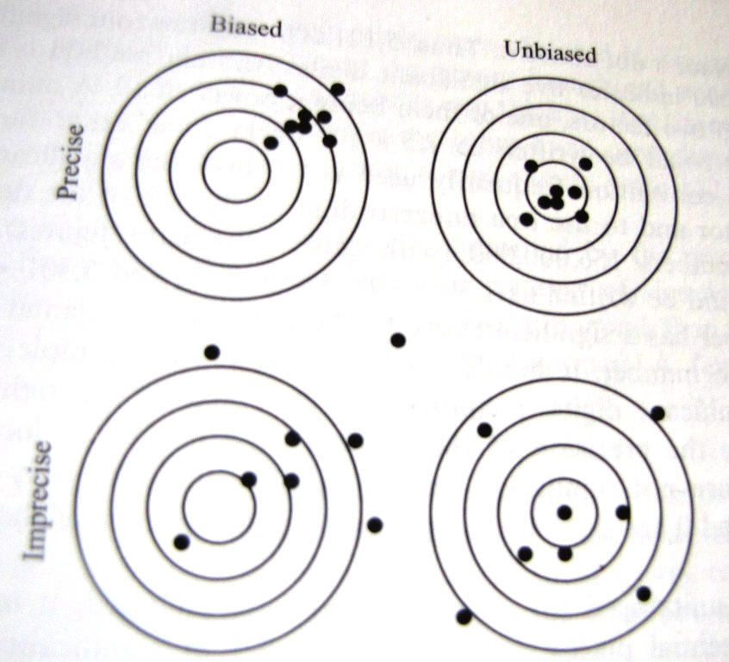
Figure 2: Precision, bias and accuracy of a target shooter. The target's bull's eye is analogous to the unknown true population parameter, and the hole represent parameter estimates based on different samples. The goal is accuracy, which is the precise, unbiased target (Adapted from Shiver and Borders, 1996).

Accuracy in Forest Mensuration
- Though mensuration is the branch of mathematics, forest mensuration does not attempt to secure absolute accuracy.
- Forest mensuration aims at reasonable or relative accuracy, i.e. maximum accuracy which is profitable and possible to obtain in practice. For the following reasons, foresters are compelled to be content with relative accuracy.
- Characteristics of trees
- Varying methods and conditions of felling and conversion
- Instruments and conditions in which they are used
- Personal bias of the estimator
- Biological character of the forest
- The use to which the measurements are to be put Cost

