Topic Cytoskeleton
Cytoskeleton
Cyto 'means Cell. So, cytoskeleton means a cell's Skeleton system. It is the framework of cell. The cytoskeleton of prokaryotic cell was originally thought not existed it was not discovered until 1990s.
Definition
The cytosol of cells contains fibers that help to maintain cell shape and mobility and that probably provide anchoring points for the other cellular structures.
OR
It is three dimensional network of fibrous proteins found in the cytoplasm of cell. It plays important role in the following processes;
- Meiosis
- Cytokenesis
- Movement
- Cell division
- Shape of cell and differentiation of cell to form different parts of cell.
It forms "infrastructure" of eukaryotic cells and cells. In eukaryotic cells, these fibers consist of a complex mesh of protein filaments and motor proteins that aid in cell movement and stabilize the cell.
The skeletal and muscles of cell
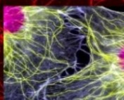
- Cell need skeleton
- To create shape
- To change shape
- To allow movement

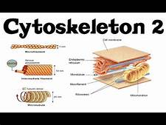
Function of cytoskeleton
- It gives cell shape. This is especially important in cells that do not get their shape.
- They from thick outer layer.
- It also gives the cell movement. The microfilaments and microtubules can disassemble.
- They Reassemble, and contract, allowing cells to crawl and migrate, and microtubules
- They help in the formation of structure like cilia and flagella that allow for cell movement.
- The cytoskeleton organizes cell and keeps the cell organelles in place but also aids in the movement of organelles throughout cell.
- For example
- During endocytosis when a cell engulfs a molecule, microfilaments pull the Vesicle containing engulfed particles into cell.
- It helps the chromosomes during cell division.
- It is building frame of cell, keeping structure in place, providing support and giving cell a definite shape.
- Component of cytoskeleton
- Cytoskeleton is made up of three types of elements;
- Microtubules
- Microfilaments
- Intermediate filaments

Microtubules

These are thickest fibers consisting on 2nm of diameter.
Long, straight, hollow cylinder like structure made up of a protein called Tubulin.Their single microtubule layer consists on the subunits of tubulin. This tubulin is arranged in 13 columns called proto-filaments.
Structure
- In 1800, microscopists have reported that cells and their extensions often contain a fibrous component. This was especially noticeable in cilia and flagella. In 1963, D. Slautterback coined the term microtubules. These are found virtually in all eukaryotic cells.
- 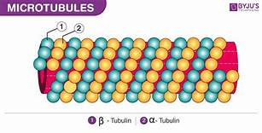
- In animal cells, they usually radiate from a centrosome located near the nucleus. In plant cells they are more near the plasma membrane. They appear in longitudinal sections as long, thin rods. In cross-sections, appear as hollow tubes ringed by 13 subunits.
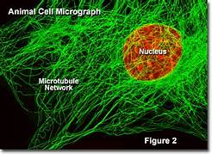
- The outer and inner diameter of these tubules is 30nm and 14nm respectively. Therefore, wall thickness is 8nm.
- 5-20nm in width often surrounds the outer wall of the microtubule. The length of microtubules varies between species and cell type. The wall of a microtubule is made up of 13 identical protofilaments. These protofilaments are made up of dimmers of tubulin protein.
- Tubulin of microtubules
- Microtubules are made up
- of polymers of tubulin protein subunits, which are of two types:
- α tubulin molecules
- β tubulin molecules
- Dimers of tubulin have a molecular weight of 1, 10,000, an alternating monomer of 55,000 molecular weight each (termed α and β).
These two polymers have a similar amino acid sequence (half of their sequences are common) but are not identical. In fact, the basic structure of this molecule and the microtubule itself is the same across the kingdoms of organisms.
The polymerization takes place in head to tail fashion so that microtubule has a definite polarity having ends as (+) plus and (-) minus destinations. This polarity helps in the assembly of the organelles.
In addition to the tubulin, several microtubule-associated proteins (MAPs) are present in different tissues. Most of the MAPs are present in brain tissue. MAP1 and MAP2 have characterized in brain tissue as the HMW (high molecular weight ) MAPs. The tubulin-binding domain of these proteins lies in the carboxyl-terminal region.
Function
- Microtubule provides an internal skeleton or scaffold. It provides structural support.
- It helps to maintain the position of cytoplasmic organelles.
- Serve as the primary component of the machinery responsible for mitosis and meiosis. The movement of chromosome and spindle formation during cell division is mediated by microtubules.
- They form principal elements of cilia and flagella as motile cell projections.
- It also helps in the movement of cilia and flagella.
- It helps the chromosomes during cell division.
- The microtubules form spindle fibers which are attached to chromosomes and help in the movement of chromosomes away from each other towards the opposite side of nuclear spindle.
They are part of the machinery that moves organelles and materials from one part to another part of the cell. Transport of vesicles from one membrane to another. This transport is dependent on the presence of the microtubule because the disruption of this cytoskeleton element will bring the movement to a halt.
- Microfilament
- These are solid tube like structure made up of actin protein. Their diameter is 7nm. Each microfilament consists of two actin chains, arranged in helical manner.
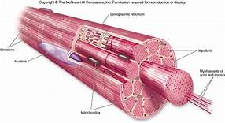They are made up of thinnest globular actin proteins so microfilaments are also known as actin filaments.
Actin is powered by ATP to assemble its filamentous form, which serves as a track for the movement of a motor protein called myosin.
- This enables actin to engage in cellular events requiring motion such as cell division in animal cells and cytoplasmic streaming.
- Microfilaments have a tough, flexible framework which helps the cell in movement.

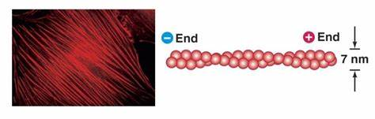
- Microfilaments are flexible and relatively strong, resisting buckling by multi-pico-newton compressive forces and filament fracture by nano-newton tensile forces. In inducing cell motality, one end of the actin filament elongates while the other end contracts, presumably by myosin II molecular motors.
Structure
- Microfilaments are composed of two strands of subunits of the protein actin (hence the name actin filaments) wound in a spiral. Specifically, the actin subunits that come together to form a microfilament are called globular actin (G-actin), and once they are joined together they are called filamentous actin (F-actin). Like microtubules, microfilaments are polar. Their positively charged, or plus end, is barbed and their negatively charged minus end is pointed. Polarization occurs due to the molecular binding pattern of the molecules that make up the microfilament. Also like microtubules, the plus end grows faster than the minus end.
- Microfilaments are the thinnest filaments of the cytoskeleton, with a diameter of about 6 to 7 nanometers. A microfilament begins to form when three G-actin proteins come together by themselves to form a trimer. Then, more actin binds to the barbed end. The process of self-assembly is aided by autoclampin proteins, which act as motors to help assemble the long strands that make up microfilaments. Two long strands of actin arrange in a spiral in order to form a microfilament.
- 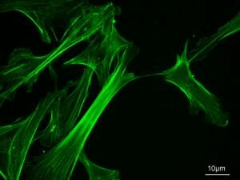
This is a micrograph of microfilaments in a mouse embryo.
- Function of microfilament
- Muscle contraction
- One of the most important roles of microfilaments is to contract muscles. There is a high concentration of microfilaments in muscle cells, where they form myofibrils, the basic unit of the muscle cell. Actin is an indispensable protein for muscle movement, and microfilaments are often called actin filaments because actin is so prominent in the muscular system of the body. In muscle cells, actin works together with the protein myosin to allow the muscles to contract and relax.
- Cell movement: Microfilaments play a role in causing cells to move. This occurs throughout the body and it is also very important for organisms whose entire body consists of one cell, such as amoebae; without microfilaments, they would not be motile. Actomyosin plays a role here just as it does in muscle cells. In order for cells to move, one end of a microfilament must elongate while the other end must shorten, and myosin acts as a motor to make this happen.
- Microfilaments help in internal cell motion
- They help in muscle contraction
- They help in movement of pseudopodia.
- They maintain cell shape.
- White bloods cells can move to the site of infection engulf the pathogen due to microfilament.
It play role in contracting molecular motors driven by the actomyosin.In such process, lean filaments become expanding platforms for pulling action of myosins.it occurs mostly during pseudopodia development.
- Cell division: microfilaments are to help divide the cell during mitosis (cell division). Microfilaments aid the process of cytokinesis, which is when the cell “pinches off” and physically separates into twodaughter cells. During cytokinesis, a ring of actin forms around the cell that is separating, and then myosin proteins pull on the actin and cause it to contract. The ring gets narrower and narrower around the cell, dragging the cell membrane with it, until it splits into two cells. The microfilaments depolymerize, or break down, into actin molecules, causing the ring to dissemble when it is no longer needed.
- Intermediate filament
- These are smooth surfaced, solid and unbranched filaments. They have a diameter of 7-11 nm. It lies between those of microtubules and microfilaments. Unlike microfilament and microtubules, intermediate filaments are chemically heterogeneous in structure, composition, and solubility. They are a target for autoantibodies made by both rabbits and humans. In humans, there are at least 60 different genes that code for the polypeptide subunit of intermediate filament, which can be divided into six major classes.
Filament class | IF protein | Tissue distribution
I | Keratin(acidic) | Epithelia
II | Keratin (basic, neutral) | epithelia
III | Desmin  Peripherin  Vimentin  Glial fibrillary | Muscle  Neurons  Mesenchyme  Glial cells
IV | Lemin proteins | Nuclear envelopes
V | Neurofilaments | Neurons
VI | Nestin | Neuronal stem cells
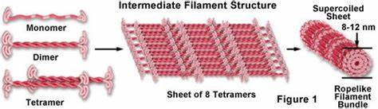The various intermediate filaments is different from each other but they show remarkable homology in their overall structure. All of them have 310 amino acid, a central, rod-like, helical region. The central region is surrounded by amino and carboxyl termini of varying lengths and sequences, which do not have interchain interactions.

Structure
- The basic unit of intermediate filament is the ‘two-chain coil’ which are identical (homopolymer) and are formed from helix interactions. On the other hand, cytokeratin is heterodimers, with one chain of one type and the other of a different type. Once the dimer has formed, it interacts with a second dimer to form a tetramer(in parallel fashion). After that, two of these units associate in anti-parallel fashion to form a protofilament.
- Four protofilaments make up the 10 nm diameter filament seen in cells. In all, about 25,000 individual proteins associate to form a 40µm filament (So huge to count but very small to see).
- There is often a linkage between intermediate filament and nuclear envelope. This leads to the suggestion that the nuclear envelope is involved in filament polymerization.

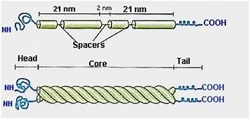

Function
Intermediate filaments play a significant role as motility molecules within the cytoplasm of different classes of cells.
- The keratin filaments of epithelial cells form a network around the nucleus. It also ramifies through the cytoplasm. Its role is to hold the organelles into place.
- Desmin (in skeletal muscles) filament forms an organized network at the Z-line. They help to integrate muscle function.
- Neurofilaments play an integral part in axon transport of different macromolecules including synaptic protein towards the presynaptic membrane.
Intermediate filaments provide the clues to the clinicians with cell markers to determine the identity of the tumor.
Terms of biology
- Actin – The protein that spontaneously comes together to form microfilaments.
- Actomyosin – A complex of the proteins actin and myosin that is responsible for muscle movement.
- Cytoplasmic streaming – The flow of cytoplasm throughout the cell; it transports molecules and organelles within the cell from one place to another.
Quiz
  - Microfilaments have roles in _____.
A. Cytoplasmic streaming
B. Muscle contraction
C. Cell movement
D. All of the above
Answer (a)
  - Are microfilaments wider than, thinner than or the same size as microtubules?
A. Wider
B. Thinner
C. The same size
Answer (b)
  - . What protein forms a complex with actin in muscle cells?
A. Lamin
B. Autoclampin
C. Myosin
D. Actomyosin
Answer(c)
  - Cytoskeleton is foun in cell
A. Nuculus
B. Cyosol
C. Cytoplasm
D. Golgi vesicles
Answer (b,c)
  - Microtubules are made up of
A. Myosin protein
B. Tubulin protein
C. Noneof above
D. Actin
Answer (b)
  - Intermediate filament size is
A.2nm
B.7nm
C.In between microtubules and microfilament
Answer(c)
  - Which type of filament help in internal cell motion
A. Intermediate
B. Microfilament
C. Microtubules
D. None
Answer (b)
  - Actomyosin is responsible for
A. Streaming movement
B. Muscle movement
C. Cytoplasmic movement
D. Nucleus movement
Answer (b)
  - Microtubules are made up of subunit polymers
A. 2
B. 3
C. 1
D. 4
Answer (a)
. Cytoskeleton consists on how many elements or components
A. 2
B. 4
C. 3
D. 5
Answer (c)

The
End

