Gravity

1. Introduction
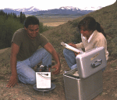
Gravity Survey: Measurements of the gravitational field at a series of different locations over an area of interest. The objective in exploration work is to associate variations with differences in the distribution of densities and hence rock types. Occasionally the whole gravitational field is measured or derivatives of the gravitational field, but usually the difference between the gravity field at two points is measured.

  - Gravitational Force

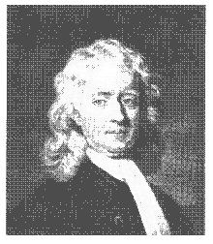
Geophysical interpretations from gravity surveys are based on the mutual attraction experienced between two masses as first expressed by Isaac Newton in his classic work Philosophiae naturalis principa mathematica (The mathematical principles of natural philosophy). Newton's law of gravitation states that the mutual attractive force between two point masses, m1 and m2, is proportional to one over the square of the distance between them. The constant of proportionality is usually specified as G, the gravitational constant. Thus, we usually see the law of gravitation written as shown below where F is the force of attraction, G is the gravitational constant, and r is the distance between the two masses, m1 and m2.

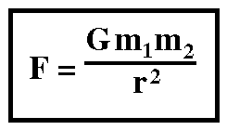
1.2 Gravitational Acceleration
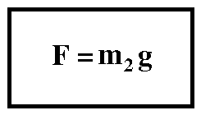
When making measurements of the earth's gravity, we usually don't measure the gravitational force, F. Rather, we measure the gravitational acceleration, g. The gravitational acceleration is the time rate of change of a body's speed under the influence of the gravitational force. That is, if you drop a rock off a cliff, it not only falls, but its speed increases as it falls. In addition to defining the law of mutual attraction between masses, Newton also defined the relationship between a force and an acceleration. Newton's second law states that force is proportional to acceleration. The constant of proportionality is the mass of the object.
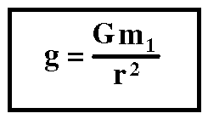
Combining Newton's second law with his law of mutual attraction, the gravitational acceleration on the mass m2 can be shown to be equal to the mass of attracting object, m1, over the squared distance between the center of the two masses, r.

1.3 Units Associated with Gravitational Acceleration
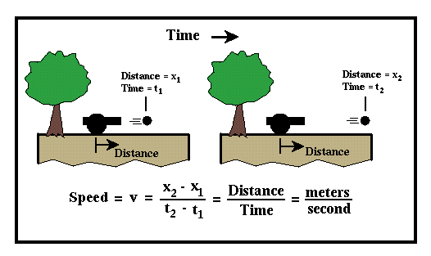
As described on the previous page, acceleration is defined as the time rate of change of the speed of a body. Speed, sometimes incorrectly referred to as velocity, is the distance an object travels divided by the time it took to travel that distance (i.e., meters per second (m/s)). Thus, we can measure the speed of an object by observing the time it takes to travel a known distance.
If the speed of the object changes as it travels, then this change in speed with respect to time is referred to as acceleration. Positive acceleration means the object is moving faster with time, and negative acceleration means the object is slowing down with time. Acceleration can be measured by determining the speed of an object at two different times and dividing the speed difference by the time difference between the two observations. Therefore, the units associated with acceleration is speed (distance per time) divided by time; or distance per time per time, or distance per time squared.
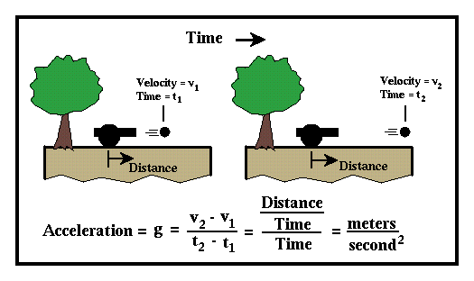

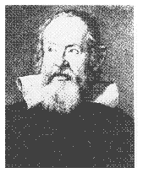
If an object such as a ball is dropped, it falls under the influence of gravity in such a way that its speed increases constantly with time. That is, the object accelerates as it falls with constant acceleration. At sea level, the rate of acceleration is about 9.8 meters per second squared. In gravity surveying, we will measure variations in the acceleration due to the earth's gravity. As will be described next, variations in this acceleration can be caused by variations in subsurface geology. Acceleration variations due to geology, however, tend to be much smaller than 9.8 meters per second squared. Thus, a meter per second squared is an inconvenient system of units to use when discussing gravity surveys.

The units typically used in describing the gravitational acceleration variations observed in exploration gravity surveys are specified in milliGals. A Gal is defined as a centimeter per second squared. Thus, the Earth's gravitational acceleration is approximately 980 Gals. The Gal is named after Galileo Galilei. The milliGal (mgal) is one thousandth of a Gal. In milliGals, the Earth's gravitational acceleration is approximately 980,000.

2. Gravity and Geology

2.1 Gravitational Acceleration & Geology
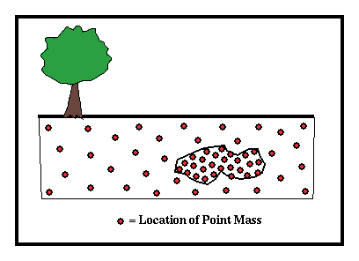
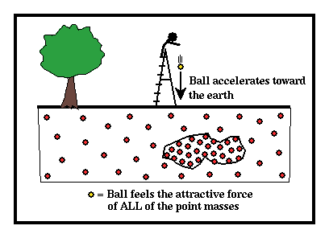
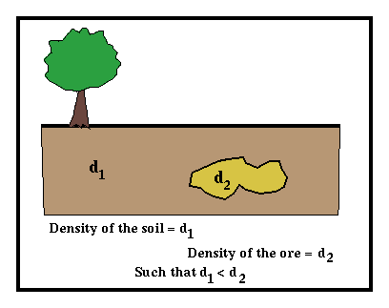
Density is defined as mass per unit volume. For example, if we were to calculate the density of a room filled with people, the density would be given by the average number of people per unit space (e.g., per cubic foot) and would have the units of people per cubic foot. The higher the number, the more closely spaced are the people. Thus, we would say the room is more densely packed with people. The units typically used to describe density of substances are grams per centimeter cubed (gm/cm³); mass per unit volume. In relating our room analogy to substances, we can use the point mass described earlier as we did the number of people.

Consider a simple geologic example of an ore body buried in soil. We would expect the density of the ore body, d2, to be greater than the density of the surrounding soil, d1.

The density of the material can be thought of as a number that quantifies the number of point masses needed to represent the material per unit volume of the material just like the number of people per cubic foot in the example given above described how crowded a particular room was. Thus, to represent a high-density ore body, we need more point masses per unit volume than we would for the lower density soil.

Now, let's qualitatively describe the gravitational acceleration experienced by a ball as it is dropped from a ladder. This acceleration can be calculated by measuring the time rate of change of the speed of the ball as it falls. The size of the acceleration the ball undergoes will be proportional to the number of close point masses that are directly below it. We're concerned with the close point masses because the magnitude of the gravitational acceleration varies as one over the distance between the ball and the point mass squared.

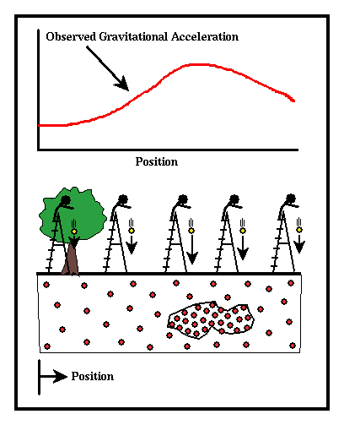
The closer point masses there are directly below the ball, the larger its acceleration will be. We could, therefore, drop the ball from a number of different locations, and, because the number of point masses below the ball varies with the location at which it is dropped, map out differences in the size of the gravitational acceleration experienced by the ball caused by variations in the underlying geology. A plot of the gravitational acceleration versus location is commonly referred to as a gravity profile. This simple thought experiment forms the physical basis on which gravity surveying rests.

2.2 Density Contrast
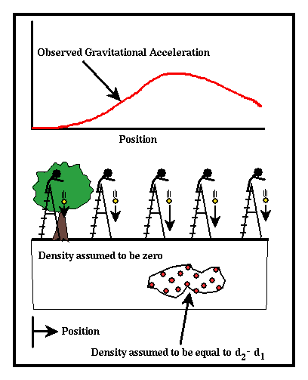
Contrary to what you might first think, the shape of the curve describing the variation in gravitational acceleration is not dependent on the absolute densities of the rocks. It is only dependent on the density difference, or what is referred to as density contrast, between the ore body and the surrounding soil. That is, the spatial variation in the gravitational acceleration generated from the previous example would be exactly the same if we were to assume different densities for the ore body and the surrounding soil, as long as the density contrast, d2 - d1, between the ore body and the surrounding soil were constant. One example of a model that satisfies this condition is to let the density of the soil be zero and the density of the ore body be d2 - d1.

The only difference in the gravitational accelerations produced by the two structures shown above (one given by the original model and one given by setting the density of the soil to zero and the ore body to d2 - d1) is an offset in the curve derived from the two models. The offset is such that at great distances from the ore body, the gravitational acceleration approaches zero in the model which uses a soil density of zero rather than the non-zero constant value the acceleration approaches in the original model. For identifying the location of the ore body, the fact that the gravitational accelerations approach zero away from the ore body instead of some non-zero number is unimportant.

What is important is the size of the difference in the gravitational acceleration near the ore body and away from the ore body and the shape of the spatial variation in the gravitational acceleration. Thus, the latter model that employs only the density contrast of the ore body to the surrounding soil contains all of the relevant information needed to identify the location and shape of the ore body.

2.3 Rock Densities
Thus far it sounds like a fairly simple proposition to estimate the variation in density of the earth due to local changes in geology. There are, however, several significant complications. The first has to do with the density contrasts measured for various earth materials. The densities associated with various earth materials are shown below.
Material | Density (gm/cm³)
Air | ~0
Water | 1
Sediments | 1.7-2.3
Sandstone | 2.0-2.6
Shale | 2.0-2.7
Limestone | 2.5-2.8
Granite | 2.5-2.8
Basalts | 2.7-3.1
Metamorphic Rocks | 2.6-3.0

Notice that the relative variation in rock density is quite small, ~0.8 gm/cm³, and there is considerable overlap in the measured densities. Hence, knowledge of rock density alone will not be sufficient to determine rock type. This small variation in rock density also implies that the spatial variations in the observed gravitational acceleration caused by geologic structures will be quite small and thus difficult to detect.

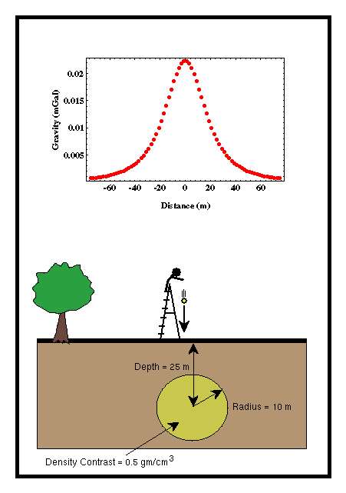
2.4 A Simple Model
Consider the variation in gravitational acceleration that would be observed over a simple model. For this model, let's assume that the only variation in density in the subsurface is due to the presence of a small ore body. Let the ore body have a spherical shape with a radius of 10 meters, buried at a depth of 25 meters below the surface, and with a density contrast to the surrounding rocks of 0.5 grams per centimeter cubed. From the table of rock densities, notice that the chosen density contrast is actually fairly large. The specifics of how the gravitational acceleration was computed are not, at this time, important.

There are several things to notice about the gravity anomaly produced by this structure. (The term gravity

anomaly is used to describe variations in the background gravity field produced by local geologic structure or a model of local geologic structure).

- The gravity anomaly produced by a buried sphere is symmetric about its center.
- The maximum value of the anomaly is quite small. For this example, 0.025 mgals.
- The magnitude of the gravity anomaly approaches zero at small (~60 meters) horizontal distances away from the center of the sphere.

Later, we will explore how the size and shape of the gravity anomaly is affected by the model parameters such as the radius of the ore body, its density contrast, and its depth of burial. At this time, simply note that the gravity anomaly produced by this reasonably-sized ore body is small. When compared to the gravitational acceleration produced by the earth as a whole, 980,000 mgals, the anomaly produced by the ore body represents a change in the gravitational field of 1 part in 40 million.

Clearly, a variation in gravity this small is going to be difficult to measure. Also, factors other than geologic structure might produce variations in the observed gravitational acceleration that are as large, if not larger.

3. Measuring Gravity

As you can imagine, it is difficult to construct instruments capable of measuring gravity anomalies as small as 1 part in 40 million. There are, however, a variety of ways it can be done, including:

- Falling body measurements. These are the types of measurements we have described up to this point. One drops an object and directly computes the acceleration the body undergoes by carefully measuring distance and time as the body falls.
- Pendulum measurements. In this type of measurement, the gravitational acceleration is estimated by measuring the period oscillation of a pendulum.
- Mass on spring measurements. By suspending a mass on a spring and observing how much the spring deforms under the force of gravity, an estimate of the gravitational acceleration can be determined.

As will be described later, in exploration gravity surveys, the field observations usually do not yield measurements of the absolute value of gravitational acceleration. Rather, we can only derive estimates of variations of gravitational acceleration.

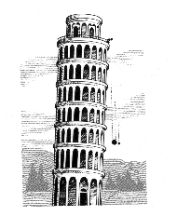
3.1 Falling Body Measurements
The gravitational acceleration can be measured directly by dropping an object and measuring its time rate of change of speed (acceleration) as it falls. By tradition, this is the method we have commonly ascribed to Galileo Galilei. In this experiment, Galileo is supposed to have dropped objects of varying mass from the leaning tower of Pisa and found that the gravitational acceleration an object undergoes is independent of its mass. He is also said to have estimated the value of the gravitational acceleration in this experiment.

While it is true that Galileo did make these observations, he didn't use a falling body experiment to do them. Rather, he used measurements based on pendulums.

It is easy to show that the distance a body falls is proportional to the time it has fallen squared. The proportionality constant is the gravitational acceleration, g. Therefore, by measuring distances and times as a body falls, it is possible to estimate the gravitational acceleration. To measure changes in the gravitational acceleration down to 1 part in 40 million using an instrument of reasonable size (say one that allows the object to drop 1 meter), we need to be able to measure changes in distance down to 1 part in 10 million and changes in time down to 1 part in 100 million!! As you can imagine, it is difficult to make measurements with this level of accuracy.
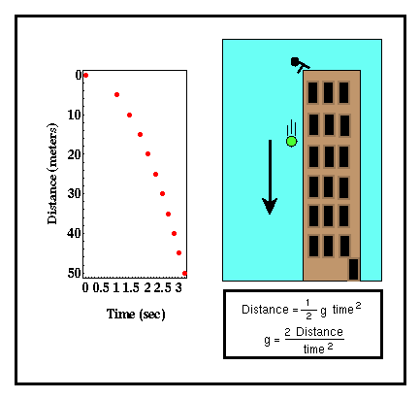
It is, however, possible to design an instrument capable of measuring accurate distances and times and computing the absolute gravity down to 1 microgal (0.001 mgals; this is a measurement accuracy of almost 1 part in 1 billion!!). Micro-g Solutions is one manufacturer of this type of instrument, known as an Absolute Gravimeter. Unlike the instruments described next, this class of instruments is the only field instrument designed to measure absolute gravity. That is, this instrument measures the size of the vertical component of gravitational acceleration at a given point. As described previously, the instruments more commonly used in exploration surveys are capable of measuring only the change in gravitational acceleration from point to point, not the absolute value of gravity at any one point.

Although absolute gravimeters are more expensive than the traditional, relative gravimeters and require a longer station occupation time (1/2 day to 1 day per station), the increased precision offered by them and the fact that the looping strategies described later are not required to remove instrument drift or tidal variations may outweigh the extra expense in operating them. This is particularly true when survey designs require large station spacings or for experiments needing the continuous monitoring of the gravitational acceleration at a single location. As an example of this latter application, it is possible to observe as little as 3 mm of crustal uplift over time by monitoring the change in gravitational acceleration at a single location with one of these instruments.

3.2 Pendulum Measurements
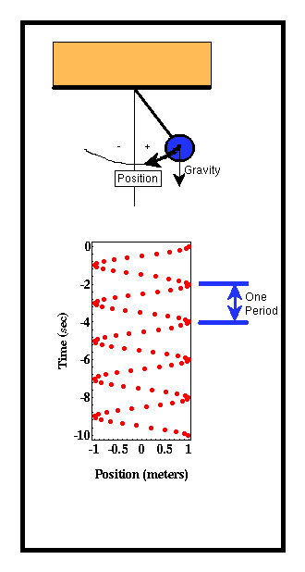
Another method by which we can measure the acceleration due to gravity is to observe the oscillation of a pendulum, such as that found on a grandfather clock. Contrary to popular belief, Galileo Galilei made his famous gravity observations using a pendulum, not by dropping objects from the Leaning Tower of Pisa.

If we were to construct a simple pendulum by hanging a mass from a rod and then displace the mass from vertical, the pendulum would begin to oscillate about the vertical in a regular fashion. The relevant parameter that describes this oscillation is known as the period of oscillation. The period of oscillation is the time required for the pendulum to complete one cycle in its motion. This can be determined by measuring the time required for the pendulum to reoccupy a given position. In the example shown to the right, the period of oscillation of the pendulum is approximately two seconds.

The reason that the pendulum oscillates about the vertical is that if the pendulum is displaced, the force of gravity pulls down on the pendulum. The pendulum begins to move downward. When the pendulum reaches vertical it can't stop instantaneously. The pendulum continues past the vertical and upward in the opposite direction. The force of gravity slows it down until it eventually stops and begins to fall again. If there is no friction where the pendulum is attached to the ceiling and there is no wind resistance to the motion of the pendulum, this would continue forever.

Because it is the force of gravity that produces the oscillation, one might expect the period of oscillation to differ for differing values of gravity. In particular, if the force of gravity is small, there is less force pulling the pendulum downward, the pendulum moves more slowly toward vertical, and the observed period of oscillation becomes longer. Thus, by measuring the period of oscillation of a pendulum, we can estimate the gravitational force or acceleration.

It can be shown that the period of oscillation of the pendulum, T, is proportional to one over the square root of the gravitational acceleration, g. The constant of proportionality, k, depends on the physical characteristics of the pendulum such as its length and the distribution of mass about the pendulum's pivot point.
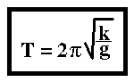

Like the falling body experiment described previously, it seems like it should be easy to determine the gravitational acceleration by measuring the period of oscillation. Unfortunately, to be able to measure the acceleration to 1 part in 50 million requires a very accurate estimate of the instrument constant k. K cannot be determined accurately enough to do this.

All is not lost, however. We could measure the period of oscillation of a given pendulum at two different locations. Although we can not estimate k accurately enough to allow us to determine the gravitational acceleration at either of these locations because we have used the same pendulum at the two locations, we can estimate the variation in gravitational acceleration at the two locations quite accurately without knowing k.

The small variations in pendulum period that we need to observe can be estimated by allowing the pendulum to oscillate for a long time, counting the number of oscillations, and dividing the time of oscillation by the number of oscillations. The longer you allow the pendulum to oscillate, the more accurate your estimate of pendulum period will be. This is essentially a form of averaging. The longer the pendulum oscillates, the more periods over which you are averaging to get your estimate of pendulum period, and the better your estimate of the average period of pendulum oscillation.

In the past, pendulum measurements were used extensively to map the variation in gravitational acceleration around the globe. Because it can take up to an hour to observe enough oscillations of the pendulum to accurately determine its period, this surveying technique has been largely supplanted by the mass on spring measurements described next.

3.3 Mass and Spring Measurements
The most common type of gravimeter (A gravimeter is any instrument designed to measure spatial variations in gravitational acceleration) used in exploration surveys is based on a simple mass-spring system. If we hang a mass on a spring, the force of gravity will stretch the spring by an amount that is proportional to the gravitational force. It can be shown that the proportionality between the stretch of the spring and the gravitational acceleration is the magnitude of the mass hung on the spring divided by a constant, k, which describes the stiffness of the spring. The larger k is, the stiffer the spring is, and the less the spring will stretch for a given value of gravitational acceleration.
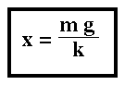

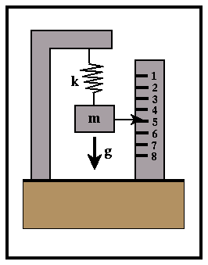
Like pendulum measurements, we can not determine k accurately enough to estimate the absolute value of the gravitational acceleration to 1 part in 40 million. We can, however, estimate variations in the gravitational acceleration from place to place to within this precision. To be able to do this, however, a sophisticated mass-spring system is used that places the mass on a beam and employs a special type of spring known as a zero-length spring.

Instruments of this type are produced by several manufacturers; LaCoste and Romberg, Texas Instruments (Worden Gravity Meter), and Scintrex. Modern gravimeters are capable of measuring changes in the Earth's gravitational acceleration down to 1 part in 100 million. This translates to a precision of about 0.01 mgal. Such a precision can be obtained only when the recommended field procedures are carefully followed.

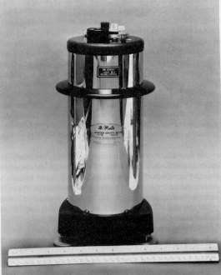
Worden Gravity Meter
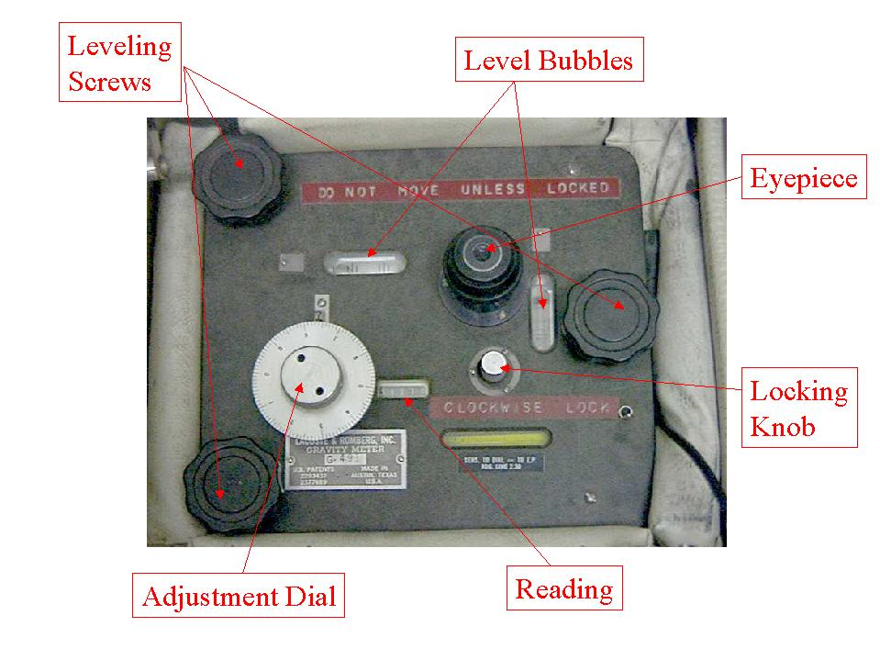
LaCoste and Romberg Gravity Meter

4. Sources of Noise
Thus far we have shown how variations in the gravitational acceleration can be measured and how these changes might relate to subsurface variations in density. We've also shown that the spatial variations in gravitational acceleration expected from geologic structures can be quite small.

Because these variations are so small, we must now consider other factors that can give rise to variations in gravitational acceleration that are as large, if not larger, than the expected geologic signal. These complicating factors can be subdivided into two categories: those that give rise to temporal variations and those that give rise to spatial variations in the gravitational acceleration.
- Temporal Based Variations: These are changes in the observed acceleration that are time dependent. In other words, these factors cause variations in acceleration that would be observed even if we didn't move our gravimeter.
- Instrument Drift: Changes in the observed acceleration caused by changes in the response of the gravimeter over time.
- Tidal Affects: Changes in the observed acceleration caused by the gravitational attraction of the sun and moon.

- Spatial Based Variations: These are changes in the observed acceleration that are space dependent. That is, these change the gravitational acceleration from place to place, just like the geologic affects, but they are not related to geology.
- Latitude Variations: Changes in the observed acceleration caused by the ellipsoidal shape and the rotation of the earth.
- Elevation Variations: Changes in the observed acceleration caused by differences in the elevations of the observation points.
- Slab Effects: Changes in the observed acceleration caused by the extra mass underlying observation points at higher elevations.
- Topographic Effects: Changes in the observed acceleration related to topography near the observation point.

4.1 Temporal Based Variations

4.1.1 Instrument Drift
Instrumental Drift is a gradual and unintentional change in the reference value with respect to which measurements are made. Although constructed to high-precision standards and capable of measuring changes in gravitational acceleration to 0.01 mgal, problems do exist when trying to use a delicate instrument such as a gravimeter.

Even if the instrument is handled with great care, the properties of the materials used to construct the spring can change with time. These variations in spring properties with time can be due to stretching of the spring over time or to changes in spring properties related to temperature changes. To help minimize the later, gravimeters are either temperature controlled or constructed out of materials that are relatively insensitive to temperature changes. Even still, gravimeters can drift as much as 0.1 mgal per day.
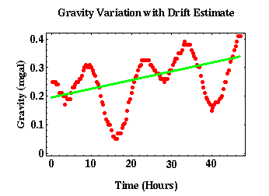

Shown above is an example of a gravity data set collected at the same site over a two-day period. There are two things to notice from this set of observations. First, notice the oscillatory behavior of the observed gravitational acceleration. This is related to variations in gravitational acceleration caused by the tidal attraction of the sun and the moon. Second, notice the general increase in the gravitational acceleration with time. This is highlighted by the green line. This line represents a least-squares, best-fit straight line to the data. This trend is caused by instrument drift. In this particular example, the instrument drifted approximately 0.12 mgal in 48 hours.

4.1.2 Tides
Tidal Effect is the variation in gravity observations resulting from the attraction of the moon and sun and the distortion of the earth so produced. Superimposed on instrument drift is another temporally varying component of gravity. Unlike instrument drift, which results from the temporally varying characteristics of the gravimeter, this component represents real changes in the gravitational acceleration. Unfortunately, these are changes that do not relate to local geology and are hence a form of noise in our observations.

Just as the gravitational attraction of the sun and the moon distorts the shape of the ocean surface, it also distorts the shape of the earth. Because rocks yield to external forces much less readily than water, the amount the earth distorts under these external forces is far less than the amount the oceans distort. The size of the ocean tides, the name given to the distortion of the ocean caused by the sun and moon, is measured in terms of meters. The size of the solid earth tide, the name given to the distortion of the earth caused by the sun and moon, is measured in terms of centimeters.

This distortion of the solid earth produces measurable changes in the gravitational acceleration because as the shape of the earth changes, the distance of the gravimeter to the center of the earth changes (recall that gravitational acceleration is proportional to one over distance squared). The distortion of the earth varies from location to location, but it can be large enough to produce variations in gravitational acceleration as large as 0.2 mgals. This effect would easily overwhelm the example gravity anomaly described previously.

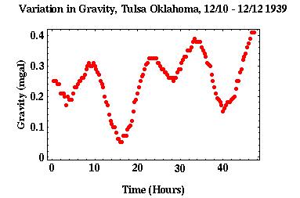

An example of the variation in gravitational acceleration observed at one location is shown above. These are raw observations that include both instrument drift (notice how there is a general trend in increasing gravitational acceleration with increasing time) and tides (the cyclic variation in gravity with a period of oscillation of about 12 hours). In this case the amplitude of the tidal variation is about 0.15 mgals, and the amplitude of the drift appears to be about 0.12 mgals over two days.

4.1.3 Instrument Drift and Tides Correction
The result of the drift and the tidal portions of our gravity observations is that repeated observations at one location yield different values for the gravitational acceleration. The key to making effective corrections for these factors is to note that both alter the observed gravity field as slowly varying functions of time.

One possible way of accounting for the tidal component of the gravity field would be to establish a base station (A reference station that is used to establish additional stations in relation thereto. Quantities under investigation have values at the base station that are known accurately. Data from the base station may be used to normalize data from other stations) near the survey area and to continuously monitor the gravity field at this location while other gravity observations are being collected in the survey area. This would result in a record of the time variation of the tidal components of the gravity field that could be used to correct the survey observations. This procedure is rarely used for a number of reasons:
- It requires the use of two gravimeters. For many gravity surveys, this is economically infeasible.
- The use of two instruments requires the mobilization of two field crews, again adding to the cost of the survey.
- Most importantly, although this technique can be used to remove the tidal component, it will not remove instrument drift. Because two different instruments are being used, they will exhibit different drift characteristics. Thus, an additional drift correction would have to be performed. Since, as we will show below, this correction can also be used to eliminate earth tides, there is no reason to incur the extra costs associated with operating two instruments in the field.
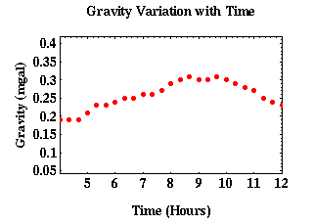

Instead of continuously monitoring the gravity field at the base station, it is more common to periodically reoccupy (return to) the base station. This procedure has the advantage of requiring only one gravimeter to measure both the time variable component of the gravity field and the spatially variable component. Also, because a single gravimeter is used, corrections for tidal variations and instrument drift can be combined.

Shown above is an enlargement of the tidal data set shown previously. Notice that because the tidal and drift components vary slowly with time, we can approximate these components as a series of straight lines. One such possible approximation is shown below as the series of green lines. The only observations needed to define each line segment are gravity observations at each end point, four points in this case. Thus, instead of continuously monitoring the tidal and drift components, we could intermittently measure them. From these intermittent observations, we could then assume that the tidal and drift components of the field varied linearly (that is, are defined as straight lines) between observation points, and predict the time-varying components of the gravity field at any time.
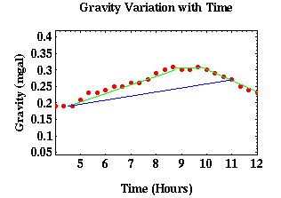
For this method to be successful, it is vitally important that the time interval used to intermittently measure the tidal and drift components not be too large. In other words, the straight-line segments used to estimate these components must be relatively short. If they are too large, we will get inaccurate estimates of the temporal variability of the tides and instrument drift. For example, assume that instead of using the green lines to estimate the tidal and drift components we could use the longer line segments shown in blue. Obviously, the blue line is a poor approximation to the time-varying components of the gravity field. If we were to use it, we would incorrectly account for the tidal and drift components of the field. Furthermore, because we only estimate these components intermittently (that is, at the end points of the blue line) we would never know we had incorrectly accounted for these components.

4.1.3.1 Field Procedures
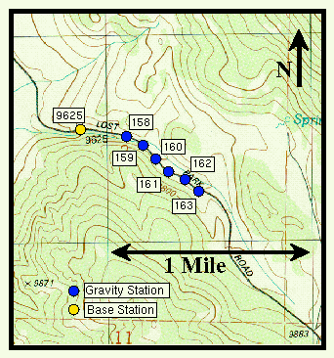
Let's now consider an example of how we would apply this drift and tidal correction strategy to the acquisition of an exploration data set. Consider the small portion of a much larger gravity survey shown to the right. To apply the corrections, we must use the following procedure when acquiring our gravity observations:
- Establish the location of one or more gravity base stations. The location of the base station for this particular survey is shown as the yellow circle. Because we will be making repeated gravity observations at the base station, its location should be easily accessible from the gravity stations comprising the survey. This location is identified, for this particular station, by station number 9625 (This number was chosen simply because the base station was located at a permanent survey marker with an elevation of 9625 feet).
- Establish the locations of the gravity stations appropriate for the particular survey. In this example, the location of the gravity stations are indicated by the blue circles. On the map, the locations are identified by a station number, in this case 158 through 163.
- Before starting to make gravity observations at the gravity stations, the survey is initiated by recording the relative gravity at the base station and the time at which the gravity is measured.
- We now proceed to move the gravimeter to the survey stations numbered 158 through 163. At each location we measure the relative gravity at the station and the time at which the reading is taken.
- After some time period, usually on the order of an hour, we return to the base station and re-measure the relative gravity at this location. Again, the time at which the observation is made is noted.
- If necessary, we then go back to the survey stations and continue making measurements, returning to the base station every hour.
- After recording the gravity at the last survey station, or at the end of the day, we return to the base station and make one final reading of the gravity.

The procedure described above is generally referred to as a looping procedure with one loop of the survey being bounded by two occupations of the base station. The looping procedure defined here is the simplest to implement in the field. More complex looping schemes are often employed, particularly when the survey, because of its large aerial extent, requires the use of multiple base stations.

4.1.3.2 Data Reduction
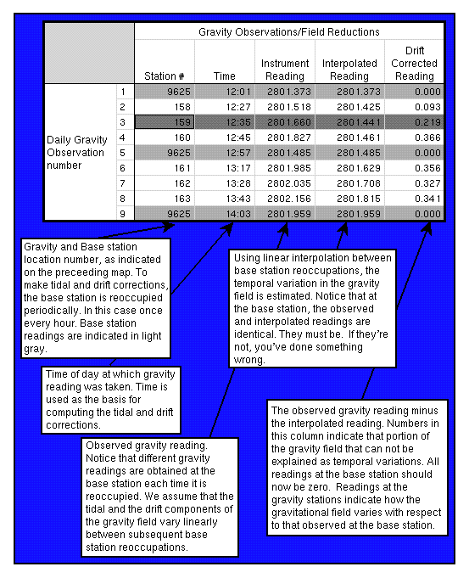
Using observations collected by the looping field procedure, it is relatively straight forward to correct these observations for instrument drift and tidal effects. The basis for these corrections will be the use of linear interpolation to generate a prediction of what the time-varying component of the gravity field should look like. Shown to the right is a reproduction of the spreadsheet used to reduce the observations collected in the survey defined on the last page.

The first three columns of the spreadsheet present the raw field observations; column 1 is simply the daily reading number (that is, this is the first, second, or fifth gravity reading of the day), column 2 lists the time of day that the reading was made (times listed to the nearest minute are sufficient), column 3 represents the raw instrument reading (although an instrument scale factor needs to be applied to convert this to relative gravity, and we will assume this scale factor is one in this example).

A plot of the raw gravity observations versus survey station number is shown below. Notice that there are three readings at station 9625. This is the base station, which was occupied three times. Although the location of the base station is fixed, the observed gravity value at the base station each time it was reoccupied was different. Thus, there is a time varying component to the observed gravity field.
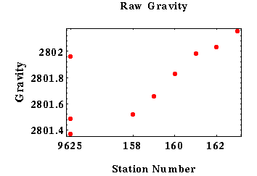

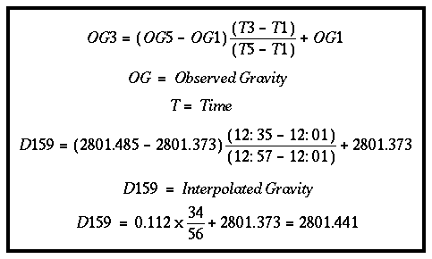
To compute the time-varying component of the gravity field, we will use linear interpolation between subsequent reoccupations of the base station. For example, the value of the temporally varying component of the gravity field at the time we occupied station 159 (dark gray line) is computed using the expressions given below.

After applying corrections like these to all of the stations, the temporally corrected gravity observations are plotted.
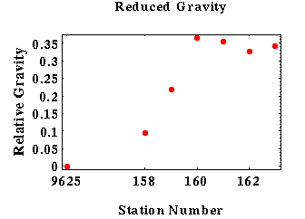
There are several things to note about the corrections and the corrected observations.
- One check to make sure that the corrections have been applied correctly is to look at the gravity observed at the base station. After application of the corrections, all of the gravity readings at the base station should all be zero.
- The uncorrected observations show a trend of increasing gravitational acceleration toward higher station number. After correction, this trend no longer exists. The apparent trend in the uncorrected observations is a result of tides and instrument drift.

4.2 Spatial Based Variations

4.2.1 Latitude Variations
Two features of the earth's large-scale structure and dynamics affect our gravity observations: its shape and its rotation. To examine these effects, let's consider slicing the earth from the North Pole to the South Pole. Our slice will be perpendicular to the equator and will follow a line of constant longitude between the poles.

- Shape: To a first-order approximation, the shape of the earth through this slice is elliptical, with the widest portion of the ellipse aligning with the equator. This model for the earth's shape was first proposed by Isaac Newton in 1687. Newton based his assessment of the earth's shape on a set of observations provided to him by a friend, named Richer, who happened to be a navigator on a ship. Richer observed that a pendulum clock that ran accurately in London consistently lost 2 minutes a day near the equator. Newton used this observation to estimate the difference in the radius of the earth measured at the equator from that measured at one of the poles and came remarkably close to the currently accepted values.

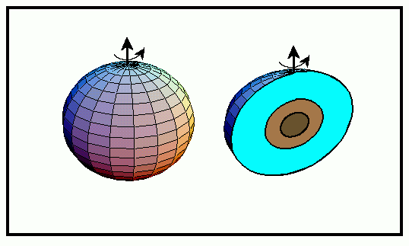
An Introduction to Geophysics Mohamed Rashed
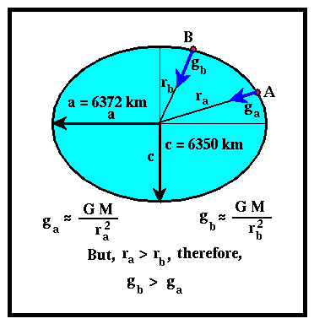
Although the difference in earth radii measured at the poles and at the equator is only 22 km (this value represents a change in earth radius of only 0.3%), this, in conjunction with the earth's rotation, can produce a measurable change in the gravitational acceleration with latitude. Because this produces a spatially varying change in the gravitational acceleration, it is possible to confuse this change with a change produced by local geologic structure.

Fortunately, it is a relatively simple matter to correct our gravitational observations for the change in acceleration produced by the earth's elliptical shape and rotation.

To first order the elliptical shape of the earth causes the gravitational acceleration to vary with latitude because the distance between the gravimeter and the earth's center varies with latitude (You should have noticed by now that expressions like "to first order" or "to a first order approximation" have been used rather frequently in this discussion. But, what do they mean? Usually, this implies that when considering a specific phenomena that could have several root causes, we are considering only those that are the most important). As discussed previously, the magnitude of the gravitational acceleration changes as one over the distance from the center of mass of the earth to the gravimeter squared. Thus, qualitatively, we would expect the gravitational acceleration to be smaller at the equator than at the poles, because the surface of the earth is farther from the earth's center at the equator than it is at the poles.

- Rotation: In addition to shape, the fact that the earth is rotating also causes a change in the gravitational acceleration with latitude. This affect is related to the fact that our gravimeter is rotating with the earth as we make our gravity reading. Because the earth rotates on an axis passing through the poles at a rate of once a day and our gravimeter is resting on the earth as the reading is made, the gravity reading contains information related to the earth's rotation.

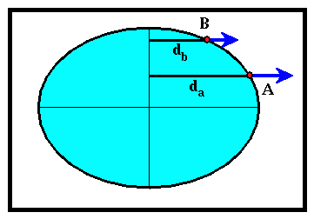
We know that if a body rotates, it experiences an outward directed force known as a centrifugal force. The size of this force is proportional to the distance from the axis of rotation and the rate at which the rotation is occurring. For our gravimeter located on the surface of the earth, the rate of rotation does not vary with position, but the distance between the rotational axis and the gravity meter does vary. The size of the centrifugal force is relatively large at the equator and goes to zero at the poles. The direction this force acts is always away from the axis of rotation. Therefore, this force acts to reduce the gravitational acceleration we would observe at any point on the earth, from that which would be observed if the earth were not rotating.

4.2.2 Latitude Corrections
Correcting observations of the gravitational acceleration for latitude dependent variations arising from the earth's elliptical shape and rotation is relatively straight forward. By assuming the earth is elliptical with the appropriate dimensions, is rotating at the appropriate rate, and contains no lateral variations in geologic structure (that is, contains no interesting geologic structure), we can derive a mathematical formulation for the earth's gravitational acceleration that depends only on the latitude of the observation. By subtracting the gravitational acceleration predicted by this mathematical formulation from the observed gravitational acceleration, we can effectively remove from the observed acceleration those portions related to the earth's shape and rotation.
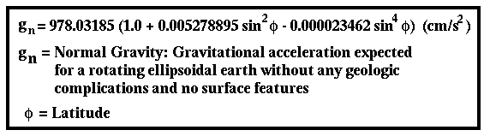

The mathematical formula used to predict the components of the gravitational acceleration produced by the earth's shape and rotation is called the Geodetic Reference Formula of 1967. The predicted gravity is called the normal gravity.

How large is this correction to our observed gravitational acceleration? And, because we need to know the latitudes of our observation points to make this correction, how accurately do we need to know locations? At a latitude of 45 degrees, the gravitational acceleration varies approximately 0.81 mgals per kilometer. Thus, to achieve an accuracy of 0.01 mgals, we need to know the north-south location of our gravity stations to about 12 meters.

4.2.3 Elevation Effects
Imagine two gravity readings taken at the same location and at the same time with two perfect (no instrument drift and the readings contain no errors) gravimeters; one placed on the ground, the other place on top of a stepladder, as shown in the figure below. Would the two instruments record the same gravitational acceleration?

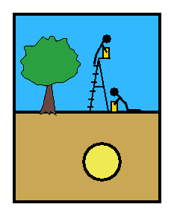
No, the instrument placed on top of the stepladder would record a smaller gravitational acceleration than the one placed on the ground. Why? Remember that the size of the gravitational acceleration changes as the gravimeter changes distance from the center of the earth. In particular, the size of the gravitational acceleration varies as one over the distance squared between the gravimeter and the center of the earth. Therefore, the gravimeter located on top of the stepladder will record a smaller gravitational acceleration, because it is positioned farther from the earth's center than the gravimeter resting on the ground.

Therefore, when interpreting data from our gravity survey, we need to make sure that we don't interpret spatial variations in gravitational acceleration that are related to elevation differences in our observation points as being due to subsurface geology. Clearly, to be able to separate these two effects, we are going to need to know the elevations at which our gravity observations are taken.

4.2.4 Elevation Corrections
To account for variations in the observed gravitational acceleration that are related to elevation variations, we incorporate another correction to our data known as the Free-Air Correction. In applying this correction, we mathematically convert our observed gravity values to ones that look like they were all recorded at the same elevation, thus further isolating the geological component of the gravitational field.

To a first-order approximation, the gravitational acceleration observed on the surface of the earth varies at about -0.3086 mgal per meter in elevation difference. The minus sign indicates that as the elevation increases, the observed gravitational acceleration decreases. The magnitude of the number says that if two gravity readings are made at the same location, but one is done a meter above the other, the reading taken at the higher elevation will be 0.3086 mgal less than the lower. Compared to size of the gravity anomaly computed from the simple model of an ore body, 0.025 mgal, the elevation effect is huge!

To apply an elevation correction to our observed gravity, we need to know the elevation of every gravity station. If this is known, we can correct all of the observed gravity readings to a common elevation (usually chosen to be sea level) by adding -0.3086 times the elevation of the station in meters to each reading. This common elevation to which all of the observations are

corrected to is usually referred to as the datum elevation. Given the relatively large size of the expected corrections, how accurately do we actually need to know the station elevations?

If we require a precision of 0.01 mgals, then relative station elevations need to be known to about 3 cm. To get such a precision requires very careful location surveying to be done. In fact, one of the primary costs of a high-precision gravity survey is in obtaining the relative elevations needed to compute the Free-Air correction.

4.2.5 Slab Effects
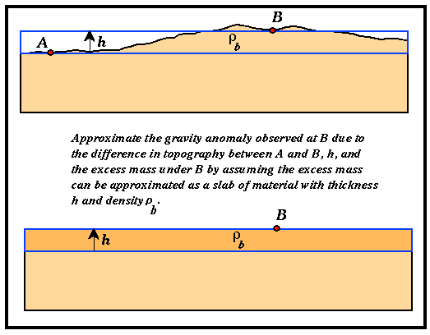
The free-air correction accounts for elevation differences between observation locations. Although observation locations may have different elevations, these differences usually result from topographic changes along the earth's surface. Thus, unlike the motivation given for deriving the elevation correction, the reason the elevations of the observation points differ is because additional mass has been placed underneath the gravimeter in the form of topography. Therefore, in addition to the gravity readings differing at two stations because of elevation differences, the readings will also contain a difference because there is more mass below the reading taken at a higher elevation than there is of one taken at a lower elevation.

Gravity

As a first-order correction for this additional mass, we will assume that the excess mass underneath the observation point at higher elevation, point B in the figure above, can be approximated by a slab of uniform density and thickness. Obviously, this description does not accurately describe the nature of the mass below point B. The topography is not of uniform thickness around point B and the density of the rocks probably varies with location. At this stage, however, we are only attempting to make a first-order correction. More detailed corrections will be considered next.

4.2.6 Slab Corrections
Although there are obvious shortcomings to the simple slab approximation to elevation and mass differences below gravity stations, it has two distinct advantages over more complex (realistic) models.
- Because the model is so simple, it is rather easy to construct predictions of the gravity produced by it and make an initial, first-order correction to the gravity observations for elevation and excess mass.
- Because gravitational acceleration varies as one over the distance to the source of the anomaly squared and because we only measure the vertical component of gravity, most of the contributions to the gravity anomalies we observe on our gravimeter are directly under the meter and rather close to the meter. Thus, the flat slab assumption can adequately describe much of the gravity anomalies associated with excess mass and elevation.

Corrections based on this simple slab approximation are referred to as the Bouguer Slab Correction. It can be shown that the vertical gravitational acceleration associated with a flat slab can be written simply as -0.04193ρh. Where the correction is given in mgals, ρ is the density of the slab in gm/cm³, and h is the elevation difference in meters between the observation point and elevation datum. h is positive for observation points above the datum level and negative for observation points below the datum level.

Notice that the sign of the Bouguer Slab Correction makes sense. If an observation point is at a higher elevation than the datum, there is excess mass below the observation point that wouldn't be there if we were able to make all of our observations at the datum elevation. Thus, our gravity reading is larger due to the excess mass, and we would therefore have to subtract a factor to move the observation point back down to the datum. Notice that the sign of this correction is opposite to that used for the elevation correction.

Also notice that to apply the Bouguer Slab correction we need to know the elevations of all of the observation points and the density of the slab used to approximate the excess mass. In choosing a density, use an average density for the rocks in the survey area. For a density of 2.67 gm/cm³, the Bouguer Slab Correction is about 0.11 mgals/m.

4.2.7 Topographic Effects
Although the slab correction described previously adequately describes the gravitational variations caused by gentle topographic variations (those that can be approximated by a slab), it does not adequately address the gravitational variations associated with extremes in topography near an observation point. Consider the gravitational acceleration observed at point B shown in the figure below.
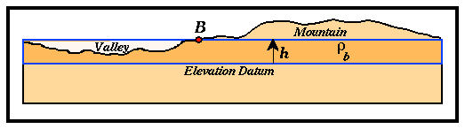

In applying the slab correction to observation point B, we remove the effect of the mass surrounded by the blue rectangle. Note, however, that in applying this correction in the presence of a valley to the left of point B, we have accounted for too much mass because the valley actually contains no material. Thus, a small adjustment must be added back into our Bouguer corrected gravity to account for the mass that was removed as part of the valley and, therefore, actually didn't exist.

The mass associated with the nearby mountain is not included in our Bouguer correction. The presence of the mountain acts as an upward directed gravitational acceleration. Therefore, because the mountain is near our observation point, we observe a smaller gravitational acceleration directed downward than we would if the mountain were not there. Like the valley, we must add a small adjustment to our Bouguer corrected gravity to account for the mass of the mountain.

These small adjustments are referred to as Terrain Corrections. As noted above, Terrain Corrections are always positive in value. To compute these corrections, we are going to need to be able to estimate the mass of the mountain and the excess mass of the valley that was included in the Bouguer Corrections. These masses can be computed if we know the volume of each of these features and their average densities.

4.2.8 Topography Corrections
Like Bouguer Slab Corrections, when computing Terrain Corrections we need to assume an average density for the rocks exposed by the surrounding topography. Usually, the same density is used for the Bouguer and the Terrain Corrections. Thus far, it appears as though applying Terrain Corrections may be no more difficult than applying the Bouguer Slab Corrections. Unfortunately, this is not the case.

To compute the gravitational attraction produced by the topography, we need to estimate the mass of the surrounding terrain and the distance of this mass from the observation point (recall, gravitational acceleration is proportional to mass over the distance between the observation point and the mass in question squared). The specifics of this computation will vary for each observation point in the survey because the distances to the various topographic features vary as the location of the gravity station moves. As you are probably beginning to realize, in addition to an estimate of the average density of the rocks within the survey area, to perform this correction we will need a knowledge of the locations of the gravity stations and the shape of the topography surrounding the survey area.

Estimating the distribution of topography surrounding each gravity station is not a trivial task. One could imagine plotting the location of each gravity station on a topographic map, estimating the variation in topographic relief about the station location at various distances, computing the gravitational acceleration due to the topography at these various distances, and applying the resulting correction to the observed gravitational acceleration. A systematic methodology for performing this task was formalized by Hammer in 1939. Using Hammer's methodology by hand is tedious and time consuming. If the elevations surrounding the survey area are available in computer readable format, computer implementations of Hammer's method are available and can greatly reduce the time required to compute and implement these corrections.

Although digital topography databases are widely available, they are commonly not sampled finely enough for computing what are referred to as the near-zone terrain corrections in areas of extreme topographic relief or where high-resolution (less than 0.5 mgals) gravity observations are required. Near-zone corrections are terrain corrections generated by topography located very close (closer than 558 ft) to the station. If the topography close to the station is irregular in nature, an accurate terrain correction may require expensive and time-consuming topographic surveying. For example, elevation variations of as little as two feet located less than 55 ft from the observing station can produce Terrain Corrections as large as 0.04 mgals.

An Introduction to Geophysics Mohamed Rashed

4.3 Correction Summary
We have now described the host of corrections that must be applied to our observations of gravitational acceleration to isolate the effects caused by geologic structure. The wide variety of corrections applied can be a bit intimidating at first and has led to a wide variety of names used in conjunction with gravity observations corrected to various degrees. Let's recap all of the corrections commonly applied to gravity observations collected for exploration geophysical surveys, specify the order in which they are applied, and list the names by which the resulting gravity values go.
- Observed Gravity (gobs): Gravity readings observed at each gravity station after corrections have been applied for instrument drift and tides.
- Latitude Correction (gn): Correction subtracted from gobs that accounts for the earth's elliptical shape and rotation. The gravity value that would be observed if the earth were a perfect (no geologic or topographic complexities), rotating ellipsoid is referred to as the normal gravity.
- Free Air Corrected Gravity (gfa): The Free-Air correction accounts for gravity variations caused by elevation differences in the observation locations. The form of the Free-Air gravity anomaly, gfa, is given by;
gfa = gobs - gn + 0.3086h (mgal)

where h is the elevation at which the gravity station is above the elevation datum chosen for the survey (this is usually sea level).
- Bouguer Slab Corrected Gravity (gb): The Bouguer correction is a first-order correction to account for the excess mass underlying observation points located at elevations higher than the elevation datum. Conversely, it accounts for a mass deficiency at observations points located below the elevation datum. The form of the Bouguer gravity anomaly, gb, is given by;
gb = gobs - gn + 0.3086h - 0.04193ρh (mgal)

where ρ is the average density of the rocks underlying the survey area.
- Terrain Corrected Bouguer Gravity (gt): The Terrain correction accounts for variations in the observed gravitational acceleration caused by variations in topography near each observation point. The terrain correction is positive regardless of whether the local topography consists of a mountain or a valley. The form of the Terrain corrected, Bouguer gravity anomaly, gt, is given by;

gt = gobs - gn + 0.3086h - 0.04193ρh + TC (mgal)
where TC is the value of the computed Terrain correction.

Assuming these corrections have accurately accounted for the variations in gravitational acceleration they were intended to account for, any remaining variations in the gravitational acceleration associated with the Terrain Corrected Bouguer Gravity, gt, can now be assumed to be caused by geologic structure.

5. Isolating Gravity Anomalies of Interest

5.1 Local and Regional Gravity Anomalies
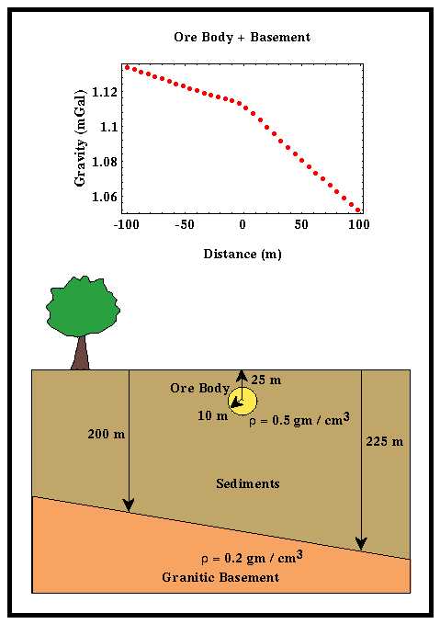
In addition to the types of gravity anomalies defined on the amount of processing performed to isolate geological contributions, there are also specific gravity anomaly types defined on the nature of the geological contribution. To define the various geologic contributions that can influence our gravity observations, consider collecting gravity observations to determine the extent and location of a buried, spherical ore body. An example of the gravity anomaly expected over such a geologic structure has already been shown.

Obviously, this model of the structure of an ore body and the surrounding geology has been greatly over simplified. Let's consider a slightly more complicated model for the geology in this problem. For the time being we will still assume that the ore body is spherical in shape and is buried in sedimentary rocks having a uniform density. In addition to the ore body, let's now assume that the sedimentary rocks in which the ore body resides are underlain by a denser granitic basement that dips to the right. This geologic model and the gravity profile that would be observed over it are shown in the figure to the right.
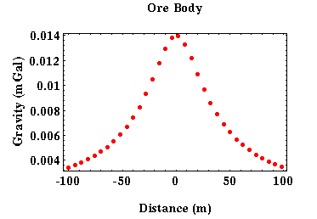
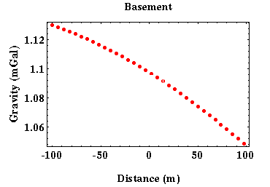
Notice that the observed gravity profile is dominated by a trend indicating decreasing gravitational acceleration from left to right. This trend is the result of the dipping basement interface. Unfortunately, we're not interested in mapping the basement interface in this problem; rather, we have designed the gravity survey to identify the location of the buried ore body. The gravitational anomaly caused by the ore body is indicated by the small hump at the center of the gravity profile.

The gravity profile produced by the basement interface only is shown to the right. Clearly, if we knew what the gravitational acceleration caused by the basement was, we could remove it from our observations and isolate the anomaly caused by the ore body. This could be done simply by subtracting the gravitational acceleration caused by the basement contact from the observed gravitational acceleration caused by the ore body and the basement interface. For this problem, we do know the contribution to the observed gravitational acceleration from basement, and this subtraction yields the desired gravitational anomaly due to the ore body.

From this simple example you can see that there are two contributions to our observed gravitational acceleration. The first is caused by large-scale geologic structure that is not of interest. The gravitational acceleration produced by these large-scale features is referred to as the Regional Gravity Anomaly. The second contribution is caused by smaller-scale structure for which the survey was designed to detect. That portion of the observed gravitational acceleration associated with these structures is referred to as the Local or the Residual Gravity Anomaly.

Because the regional gravity anomaly is often much larger in size than the local gravity anomaly, as in the example shown above, it is imperative that we develop a means to effectively remove this effect from our gravity observations before attempting to interpret the gravity observations for local geologic structure.

5.2 Sources of Local and Regional Gravity Anomalies
Notice that the Regional Gravity Anomaly is a slowly varying function of position along the profile line. This feature is a characteristic of all large-scale sources. That is, sources of gravity anomalies large in spatial extent (by large we mean large with respect to the profile length) always produce gravity anomalies that change slowly with position along the gravity profile. Local Gravity Anomalies are defined as those that change value rapidly along the profile line. The sources for these anomalies must be small in spatial extent (like large, small is defined with respect to the length of the gravity profile) and close to the surface.
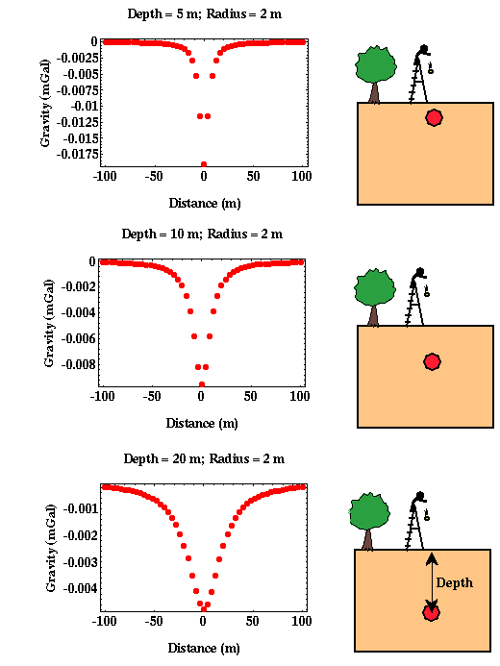
As an example of the effects of burial depth on the recorded gravity anomaly, consider three cylinders all having the same source dimensions and density contrast with varying depths of burial. For this example, the cylinders are assumed to be less dense than the surrounding rocks.

Notice that at as the cylinder is buried more deeply, the gravity anomaly it produces decreases in amplitude and spreads out in width. Thus, the more shallowly buried cylinder produces a large anomaly that is confined to a region of the profile directly above the cylinder. The more deeply buried cylinder produces a gravity anomaly of smaller amplitude that is spread over more of the length of the profile. The broader gravity anomaly associated with the deeper source could be considered a Regional Gravity Contribution. The sharper anomaly associated with the more shallow source would contribute to the Local Gravity Anomaly.

In this particular example, the size of the regional gravity contribution is smaller than the size of the local gravity contribution. As you will find from your work in designing a gravity survey, increasing the radius of the deeply buried cylinder will increase the size of the gravity anomaly it produces without changing the breadth of the anomaly. Thus, regional contributions to the observed gravity field that are large in amplitude and broad in shape are assumed to be deep (producing the large breadth in shape) and large in aerial extent (producing a large amplitude).

5.3 Separating Local and Regional Gravity Anomalies
Because Regional Anomalies vary slowly along a particular profile and Local Anomalies vary more rapidly, any method that can identify and isolate slowly varying portions of the gravity field can be used to separate Regional and Local Gravity Anomalies. The methods generally fall into three broad categories:

- Direct Estimates: These are estimates of the regional gravity anomaly determined from an independent data set. For example, if your gravity survey is conducted within the continental US, gravity observations collected at relatively large station spacings are available from the National Geophysical Data Center. Using these observations, you can determine how the long-wavelength gravity field varies around your survey and then remove its contribution from your data.
- Graphical Estimates: These estimates are based on simply plotting the observations, sketching the interpreter's estimate of the regional gravity anomaly, and subtracting the regional gravity anomaly estimate from the raw observations to generate an estimate of the local gravity anomaly.
- Mathematical Estimates: This represents any of a wide variety of methods for determining the regional gravity contribution from the collected data through the use of mathematical procedures. Examples of how this can be done include:
- Moving Averages: In this technique, an estimate of the regional gravity anomaly at some point along a profile is determined by averaging the recorded gravity values at several nearby points. Averaging gravity values over several observation points enhances the long-wavelength contributions to the recorded gravity field while suppressing the shorter-wavelength contributions.
- Function Fitting: In this technique, smoothly varying mathematical functions are fit to the data and used as estimates of the regional gravity anomaly. The simplest of any number of possible functions that could be fit to the data is a straight line.
- Filtering and Upward Continuation: These are more sophisticated mathematical techniques for determining the long-wavelength portion of a data set. Those interested in finding out more about these types of techniques can find descriptions of them in any introductory geophysical textbook

5.4 Separation Example
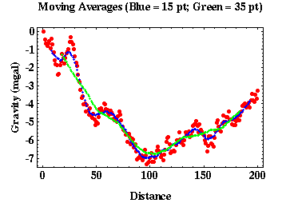
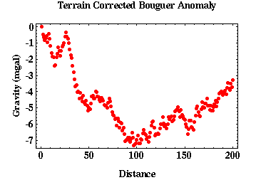
As an example of estimating the regional anomaly from the recorded data and isolating the local anomaly with this estimate consider using a moving average operator. With this technique, an estimate of the regional gravity anomaly at some point along a profile is determined by averaging the recorded gravity values at several nearby points. The number of points over which the average is calculated is referred to as the length of the operator and is chosen by the data processor. Averaging gravity values over several observation points enhances the long-wavelength contributions to the recorded gravity field while suppressing the shorter-wavelength contributions. Consider the sample gravity data shown to the right.

Moving averages can be computed across this data set. To do this the data processor chooses the length of the moving average operator. That is, the processor decides to compute the average over 3, 5, 7, 15, or 51 adjacent points. As you would expect, the resulting estimate of the regional gravity anomaly, and thus the local gravity anomaly, is critically dependent on this choice. Shown to the right are two estimates of the regional gravity anomaly using moving average operators of lengths 15 and 35.

Depending on the features of the gravity profile the processor wishes to extract, either of these operators may be appropriate. If we believe, for example, the gravity peak located at a distance of about 30 on the profile is a feature related to a local gravity anomaly, notice that the 15 length operator is not long enough. The average using this operator length almost tracks the raw data, thus when we subtract the averages from the raw data to isolate the local gravity anomaly the resulting value will be near zero. The 35 length operator, on the other hand, is long enough to average out the anomaly of interest, thus isolating it when we subtract the moving average estimate of the regional from the raw observations. The residual gravity estimates computed for each moving average operator are shown below.
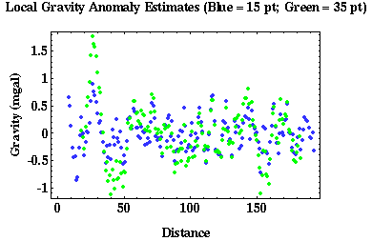

As expected, few interpretable anomalies exist after applying the 15 point operator. The peak at a distance of 30 has been greatly reduced in amplitude and other short-wavelength anomalies apparent in the original data have been effectively removed. Using the 35 length operator, the peak at a distance of 30 has been successfully isolated and other short-wavelength anomalies have been enhanced. Data processors and interpreters are free to choose the operator length they wish to apply to the data. This choice is based solely on the features they believe represent the local anomalies of interest. Thus, separation of the regional from the local gravity field is an interpretive process.

Although the interpretive nature of the moving average method for estimating the regional gravity contribution is readily apparent, you should be aware that all of the methods described previously require interpreter input of one form or another. Thus, no matter which method is used to estimate the regional component of the gravity field, it should always be considered an interpretational process.

6. Gravity Anomalies over Simple Shapes

6.1 Point Mass Gravity
Previously we defined the gravitational acceleration due to a point mass as:
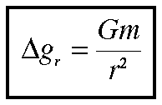

where G is the gravitational constant, m is the mass of the point mass, and r is the distance between the point mass and our observation point. The figure below shows the gravitational acceleration we would observe over a buried point mass. Notice, the acceleration is highest directly above the point mass and decreases as we move away from it.

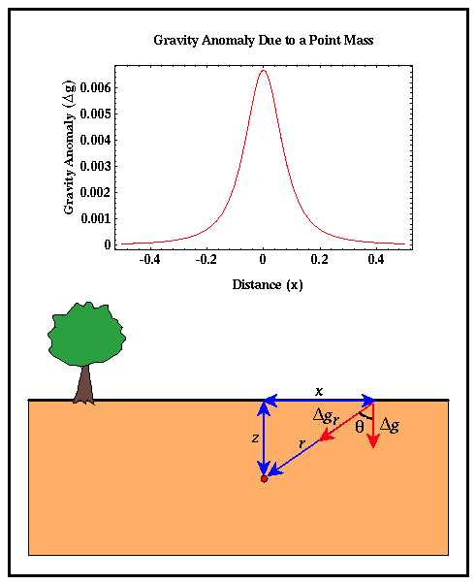
Computing the observed acceleration based on the equation given above is easy and instructive. First, let's derive the equation used to generate the graph shown above. Let z be the depth of burial of the point mass and x is the horizontal distance between the point mass and our observation point. Notice that the gravitational acceleration caused by the point mass is in the direction of the point mass; that is, it's along the vector r. Before taking a reading, gravimeters are leveled so that they only measure the vertical component of gravity; that is, we only measure that portion of the gravitational acceleration caused by the point mass acting in a direction pointing down. The vertical component of the gravitational acceleration caused by the point mass can be written in terms of the angle θ as:
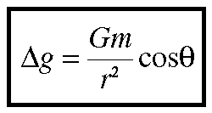

Now, it is inconvenient to have to compute r and θ for various values of x before we can compute the gravitational acceleration. Let's now rewrite the above expression in a form that makes it easy to compute the gravitational acceleration as a function of horizontal distance x rather than the distance between the point mass and the observation point r and the angle θ.

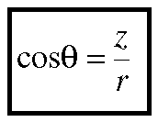
θ can be written in terms of z and r using the trigonometric relationship between the cosine of an angle and the lengths of the hypotenuse and the adjacent side of the triangle formed by the angle.

Likewise, r can be written in terms of x and z using the relationship between the length of the hypotenuse of a triangle and the lengths of the two other sides known as Pythagorean Theorem.
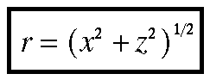
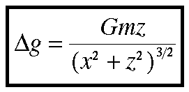
Substituting these into our expression for the vertical component of the gravitational acceleration caused by a point mass, we obtain:

Knowing the depth of burial, z, of the point mass, its mass, m, and the gravitational constant, G, we can compute the gravitational acceleration we would observe over a point mass at various distances by simply varying x in the above expression. An example of the shape of the gravity anomaly we would observe over a single point mass is shown above.

Therefore, if we thought our observed gravity anomaly was generated by a mass distribution within the earth that approximated a point mass, we could use the above expression to generate predicted gravity anomalies for given point mass depths and masses and determine the point mass depth and mass by matching the observations with those predicted from our model.

Although a point mass doesn't appear to be a geologically plausible density distribution, as we will show next, this simple expression for the gravitational acceleration forms the basis by which gravity anomalies over any more complicated density distribution within the earth can be computed.

6.2 Sphere Gravity
It can be shown that the gravitational attraction of a spherical body of finite size and mass m is identical to that of a point mass with the same mass m. Therefore, the expression derived on the previous page for the gravitational acceleration over a point mass:

The above equation also represents the gravitational acceleration over a buried sphere. For application with a spherical body, it is convenient to rewrite the mass, m, in terms of the volume and the density contrast of the sphere with the surrounding earth using

where v is the volume of the sphere, Δρ is the density contrast of the sphere with the surrounding rock, and R is the radius of the sphere. Thus, the gravitational acceleration over a buried sphere can be written as:
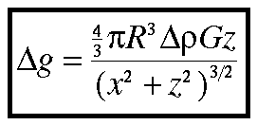
Although this expression appears to be more complex than that used to describe the gravitational acceleration over a buried sphere, the complexity arises only because we've replaced m with a term that has more elements. In form, this expression is still identical to the gravitational acceleration over a buried point mass.

6.3 Model Indeterminacy
We have now derived the gravitational attraction associated with a simple spherical body. The vertical component of this attraction was shown to be equal to:
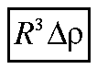
Notice that our expression for the gravitational acceleration over a sphere contains a term that describes the physical parameters of the spherical body; its radius, R, and its density contrast, Δρ, in the form:

R and Δρ are two of the parameters describing the sphere that we would like to be able to determine from our gravity observations (the third is the depth to the center of the sphere z). That is, we would like to compute predicted gravitational accelerations given estimates of R and Δρ, compare these to those that were observed, and then vary R and Δρ until the predicted acceleration matches the observed acceleration.

Gravity

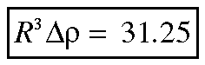
This sounds simple enough, but there is a significant problem: there is an infinite number of combinations of R and Δρ that produce exactly the same gravitational acceleration! For example, let's assume that we have found values for R and Δρ that fit our observations such that:

Any other combination of values for R and Δρ will also fit the observations as long as R cubed times Δρ equals 31.25. Examples of the gravity observations produced by four of these solutions are shown below.
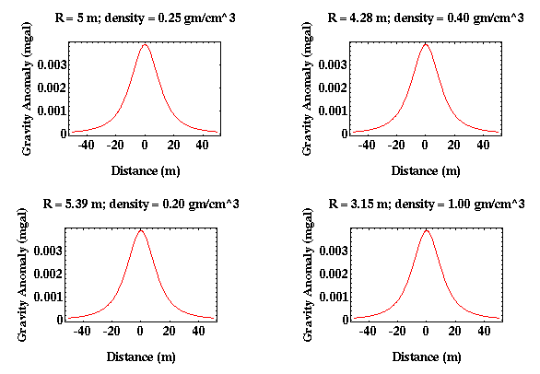

Our inability to uniquely resolve parameters describing a model of the earth from geophysical observations is not unique to the gravity method but is present in all geophysical methods. This is referred to using a variety of expressions: Model Indeterminacy, Model Equivalence, and Nonuniqueness to name a few. No matter what it is called, it always means the same thing; a particular geophysical method can not uniquely define the geologic structure underlying the survey. Another way of thinking about this problem is to realize that a model of the geologic structure can uniquely define the gravitational field over the structure. The gravitational field, however, can not uniquely define the geologic structure that produced it.

If this is the case, how do we determine which model is correct? To do this we must incorporate additional observations on which to base our interpretation. These additional observations presumably will limit the range of acceptable models we should consider when interpreting our gravity observations. These observations could include geologic observations or observations from different types of geophysical surveys.

6.4 Complex Calculations
Although it is possible to derive analytic expressions for the computation of the gravitational acceleration over additional bodies with simple shapes (cylinders, slabs, etc.), we already have enough information to describe a general scheme for computing gravity anomalies over bodies with these and more complex shapes. The basis for this computation lies in the approximation of a complex body as a distribution of point masses.

Previously, we derived the vertical component of the gravitational acceleration due to a point mass with mass m as

We can approximate the body with complex shape as a distribution of point masses. The gravitational attraction of the body is then nothing more than the sum of the gravitational attractions of all of the individual point masses as illustrated below.

Gravity
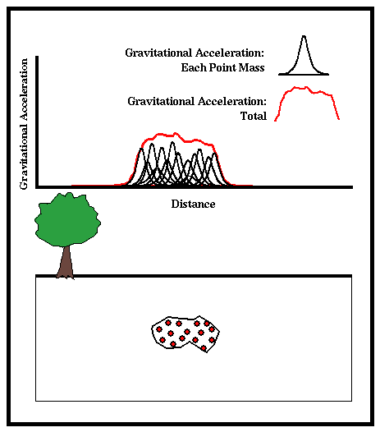

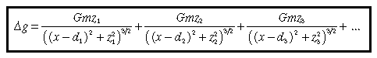
In mathematical notation, this sum can be written as

where z represents the depth of burial of each point mass, d represents the horizontal position of each point mass, and x represents the horizontal position of the observation point. Only the first three terms have been written in this equation. There is, in actuality, one term in this expression for each point mass. If there are N point masses, this equation can be written more compactly as:

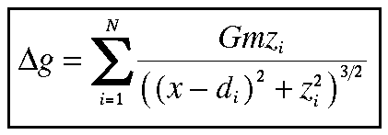
For more detailed information on the computation of gravity anomalies over complex two- and three- dimensional shapes look at the following references.
- Talwani, Worzel, and Landisman, Rapid Gravity Computations for Two-Dimensional Bodies with Application to the Mendocino Submarine Fraction Zone, Journal Geophysical Research, 64, 49-59, 1959.
- Talwani, Manik, and Ewing, Rapid Computation of Gravitational Attraction of Three-Dimensional Bodies of Arbitrary Shape, Geophysics, 25, 203-225, 1960.

7. Gravity Survey

7.1 Field survey
In designing a gravity survey for a particular application, there are several design parameters that must be chosen or known such as gravity station spacing, location of the base station, time interval between base station re-occupations, and the level of reading error inherent to the basic observations.

- Reoccupation Interval: The time interval between subsequent gravity readings at the base station is an important parameter in controlling the effectiveness of the drift and tidal corrections computed from the field observations. There is an inherent tradeoff between survey cost and survey accuracy in choosing this parameter.

- Short Time Intervals: The use of a short time interval between subsequent base station readings will produce better estimates of the tidal and drift components of the observed field so that they can be more accurately removed. More frequent base station readings, however, allow for fewer gravity stations to be surveyed during a given time period. Thus, the smaller the base station reoccupation interval, the longer it takes to complete a given survey, and the more the survey costs.

- Long Time Intervals: By reoccupying the base station less frequently, more gravity stations can be surveyed during a given time period. Hence, the cost of the survey can be reduced. If the time interval between subsequent base station readings is too long, however, the drift and the tidal component of the observed field can not be correctly removed from the data set. Thus, residual drift and tides will corrupt the final data.

To estimate what the optimum time interval between subsequent base station reoccupation given the cost/accuracy tradeoff, we will use the earth tide data that was presented in the notes and is reproduced to the right. Given that this data set was acquired at a single location, it directly shows the gravitational variation resulting from tides and instrument drift without geologic complications. Thus, we can use this data set to estimate the optimal base station reoccupation interval. In this case, as is the case with choosing parameters for all geophysical surveys, optimal depends on the specifics of the target that is being sought.

- Observation Resolution: All measures involve an inherent error. That is, no measure can be made with absolute accuracy. This is indeed true with measurements of the Earth's gravitational acceleration. These errors could be due to inaccurate leveling of the instrument, motion of the instrument caused by traffic, microseisms, or people walking about, or errors in reading the output of the instrument. In the tidal data set shown above, for example, the author reported a reading error of 0.01 to 0.02 mgal. This level of reading error is quite good, being near the resolution possible with the instrumentation. Exploration gravity surveys usually have reading errors larger than this. The exception, surveys that are designed to minimize this error, are referred to as micro-gravity surveys.

One common method of reducing these errors is to make multiple readings at a single location and averaging the result. If the errors associated with the readings are random, it can be shown that the reading error is reduced by the square root of the number of observations made. Thus, if the error associated with one reading is 0.02 mgals, averaging 4 readings will reduce the error to 0.01 mgals, averaging 16 readings will reduce the error to 0.005 mgals, etc. Notice that because this technique requires multiple observations at each station, relying on reading averaging to reduce reading errors will increase the cost of the survey.

7.2 Survey Design
A gravity survey is based on the premise that a target is limited in space and has a different density from the surrounding geology. The problem is to remove all of the other sources of gravity variations, or noise (tides, instrument drift, regional gravity contributions, etc.), so that you can interpret the anomaly in terms of the geological and geophysical parameters of the localized target.

A common mistake made by geologists and engineers and even many geophysicists is assuming that a gravity survey will work in any case where the target has an anomalous density. Geophysicists compound this mistake by choosing survey parameters such as station spacing based on intuition (they call it experience). Often the particular combination of size, depth, and density contrast produces a gravity anomaly smaller than the resolution of the survey. In other cases, the noise level masks the anomaly. A systematic approach to planning the survey and validating the design will overcome many of these failures.

Planning a gravity survey is done by reversing the interpretive process. We predict the noise from sources not of interest in the survey, estimate the standard deviation of the random (operator and instrument) noise, calculate the shape of the signal (the theoretical anomaly produced by the assumed source), then decide whether the noise can be reduced to the point where the signal will be interpretable. If the answer is affirmative, then we determine the survey parameters that will produce the best compromise between cost and data quality.

7.3 Data Interpretation
Geologists and engineers often perceive the interpretation of geophysical data as "geomagic" because of the mathematical complexity of the underlying theory. This need not be the case if all of the partners in a project (geologists, engineers, and geophysicists) concentrate on the exploration process.

Perhaps the most common failing of data interpreters is to become committed to their first interpretation too quickly. Once they have settled on their first interpretation, they tend to try to force all of the data to fit that interpretation. Unfortunately, because of the inherent uncertainty in geophysical data, it often is possible to force a set of data to fit a number of different models. Even though the data fits their first interpretation, there is no guarantee that it is the most likely interpretation. Using a well-defined, structured approach to the interpretive process can minimize the chance of delivering the wrong interpretation, or can at least demonstrate that the preferred interpretation is suspect. This sort of "honesty" is what leads to trust between client and contractor, and both gain in the end.

8. References

- Burger, H. R., Exploration Geophysics of the Shallow Subsurface, Prentice Hall P T R, 1992.
- Robinson, E. S., and C. Coruh, Basic Exploration Geophysics, John Wiley, 1988.
- Telford, W. M., L. P. Geldart, and R. E. Sheriff, Applied Geophysics, 2nd ed., Cambridge University Press, 1990.
- Cunningham, M. Gravity Surveying Primer. A nice set of notes on gravitational theory and the corrections applied to gravity data.
- Wahr, J. Lecture Notes in Geodesy and Gravity
- Hill, P. et al. Introduction to Potential Fields: Gravity. USGS fact sheet, written for the general public, on using gravity to understand subsurface structure.
- Bankey, V. and P. Hill. Potential-Field Computer Programs, Databases, and Maps. USGS fact sheet describing a variety of resources available from the USGS and the NGDC applicable for the processing of gravity observations.
- NGDC Gravity Data on CD-ROM, land gravity data base at the National Geophysical Data Center. Useful for estimating regional gravity field.
- Glossary of Gravity Terms.

