Immune-Mediated Liver Injury (hepatotoxicity)

Submitted by:

Hafiz Muhammad Usman
M.Phil. Pharmacology (1st Semester)

Muhammad Ajmal khan
M.Phil. Pharmacology (1st Semester)

Submitted to:

Taseer Ahmad

MPhil (Pharmacology)

Lecturer: Pharmacology

College of Pharmacy
University of Sargodha
Sargodha Pakistan

IMMUNE-MEDIATED LIVER INJURY (HEPATOTOXICITY)

Hepatotoxicity is the injury or liver damage caused by exposure to drugs; it is an adverse drug reaction that may be rare but serious and is the most common cause of drug removal from the pharmaceutical market. The hepatic injury can be classified into hepatocellular, cholestatic and mixed, caused by increase in alanine aminotransferase and alkaline phosphatase than upper limit of normal. (Paniagua, et al., 2017).

RISK FACTORS
The risk factors include idiosyncrasy, age, gender, alcohol consumption, concomitant use of other drugs, foregoing or underlying liver disease, genetic and environmental factors. (Paniagua, et al., 2017)[1].
Immune-mediated idiosyncratic liver injury is another factor which is not yet elucidated well. Polygonum multiflorum Thunb. A well-known Chinese herbal medicine, is recently drawn growing attention because of its hepatotoxicity. According to the clinical and experimental studies, P. multiflorum-induced liver injury (PM-DILI) is considered to be immune-mediated idiosyncratic liver injury. The current epidemiological, clinical and investigational evidence is existed about the likely role of innate and adaptive immunity in the idiosyncratic hepatotoxicity of P. multiflorum. (Rao, et al., 2020)[2]
Mechanisms of Hepatotoxicity
The mechanisms by which most drugs cause liver injury are still ill understood and subsequently delay the detection of the hepatotoxic potential of drugs during preclinical and early clinical development. However, relevant processes and mechanism which are involved in hepatotoxicity are following; 1.Mitochondrial dysfunction, 2.Reactive metabolites, 3.Lysosomal impairment (steatosis and phospholipidosis), 4.BSEP (bile salt export pump) inhibition, 5.Immune-mediated, (Innate/adaptive immune activation.) (Dragovic, and Sanja, et al.2016)[3]
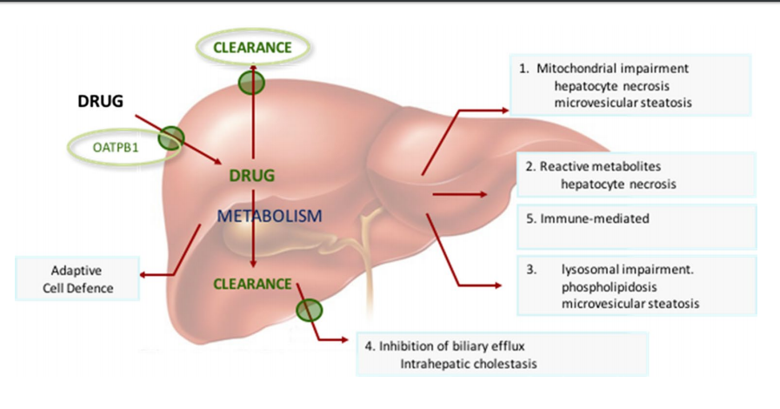
Mitochondrial impairment (mechanism 1)
Changes in mitochondrial homoeostasis can have a variety of deleterious consequences, such as oxidative stress, energy depletion, accumulation of triglycerides, and cell death. Mechanisms of mitochondrial dysfunction include membrane permeabilization, oxidative phosphorylation (OXPHOS) impairment, fatty acid β-oxidation (FAO) inhibition and mtDNA depletion.
Reactive metabolites (mechanism 2)
Process of drug bioactivation to CRMs is believed to be among the number of initiating events of many drug-related liver toxicities. The formation of chemically reactive metabolites (CRMs) can interact with critical intracellular macromolecules leading to toxicity or further interaction with hepatoprotective substances such as glutathione (GSH). CRMs are typically electron deficient molecules (electrophiles) and if not detoxified these electrophiles react with electron rich macromolecules such as proteins, nucleic acids and lipids with the potential to cause a change in biochemical function, or modified such that these modified proteins are processed by the immune antigen presenting cells. CRMs include quinone-imines, quinones, epoxides and reactive oxygen species and other free radicals.

Lysosomal impairment (steatosis and phospholipidosis; mechanism 3)
Microvesicular steatosis or microsteatosis is a form of liver toxicity which is associated with liver failure, pronounced hypoglycemia and encephalopathy in patients (Farrell 2002; Stravitz and Sanyal 2003)[4,5]. The mechanisms associated with macrovacuolar and microvesicular steatosis remain to be confirmed, but steatosis arises from either an increased availability of free fatty acids to the liver and stimulation of de novo hepatic lipogenesis (Begriche et al. 2006; Moreau et al. 2009).[6] Drugs known to cause steatosis can be largely divided into those with steatosis and steatohepatitis with well-characterized mechanisms of hepatotoxicity, for example, amiodarone, fialuridine and perhexiline.
Cholestasis, inhibition of biliary efflux and BSEP (mechanism 4)
Among various transport proteins, BSEP is believed to play a pivotal role for DILI and inhibition of this transport protein leading to cholestatic injury. Bile acid accumulation in hepatocytes as a result of BSEP inhibition is proposed as a mechanism for the hepatotoxicity of several drugs including cyclosporine, troglitazone and bosentan. (Morgan et al. 2010)[7]

Adaptive immunity (mechanism 5)
It is clear from the literature that immune responses and associated autoimmunity play an important role in both predictive (acute) and idiosyncratic DILI . There is an increased weight of evidence for the role of immune cells in hepatic pathology. The inflammatory phenotype has been attributed to the innate immune response generated by Kupffer cells, monocytes, neutrophils, and lymphocytes. The adaptive immune system is also influenced by the innate immune response leading to liver damage. Basic mechanisms of activation of lymphocytes, macrophages, and neutrophils and their unique mechanisms of recruitment into the liver vasculature, particular role of adhesion molecules and various inflammatory mediators and the mechanisms of liver cell damage by these inflammatory cells are critical for predictive and idiosyncratic drug-induced liver injury. (Adams, David H., et al)[8]
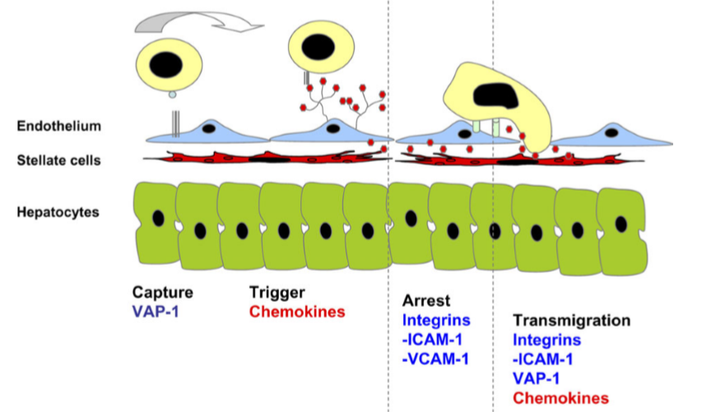
Immune mediated liver injury pictorial illustration.

PATHOGENESIS OF IMMUNE MEDIATED HEPATOTOXICITY
Although many of these mechanisms can directly lead to cell death, there is growing support for the hypothesis that immune cells play a critical role in drug hepatotoxicity. Emergent evidence suggests that, in many cases, the direct effects of drugs on liver cells may be an initiating event for an immune response, which determines the extent of liver damage.

LYMPHOCYTE RECRUITMENT TO THE LIVER
The human liver contains up to 1010 resident lymphocytes (Racanelli and Rehermann, 2006) comprised of B cells, T cells, and natural killer (NK) and natural killer T (NKT) cells. Lymphocyte recruitment increases in response to inﬂammation and which determines the pattern of disease. The mechanisms by which drugs activate immune-mediated mechanisms are multiple and often poorly understood, but liver inﬁltration by effector lymphocytes is a common effector pathway leading to hepatocyte and cholangiocyte destruction and persistent liver injury. (Adams, David H., et al)[8]

The Hepatic Vasculature Is a Unique Environment for Lymphocyte Recruitment
The liver has a unique dual blood supply from the hepatic arteries and portal venous blood that drains the gut. Both hepatic artery and portal vein drain into the hepatic sinusoids and then into hepatic venules at the center of the hepatic lobule, which connect to form the hepatic veins that drain into the inferior vena cava. Inﬂammatory responses to infection and injury are characterized by increased lymphocyte binding to and migration across sinusoidal endothelial cells that line the hepatic sinusoidal microvasculature (Adams and Eksteen, 2006).[9]
Although leukocytes are capable of adhesion and migration across different regions of the hepatic microvasculature, the majority enters the parenchyma via hepatic sinusoids. Hepatic sinusoidal endothelial cells (HSECs) display differences in adhesion molecule expression compared with other endothelial cells including a lack of P-selectin and significantly reduced E-selectin expression.

Endothelial Adhesion Molecules Involved in Lymphocyte Recruitment to the Liver

Lymphocytes interact with sinusoidal endothelium by adhesion receptors including intercellular adhesion molecule-1 (ICAM-1), and vascular cell adhesion molecule-1 (VCAM-1). (Lalor et al., 2002; Lee and Kubes, 2008)
The liver sinusoids also express other adhesion receptor including vascular adhesion protein-1 (VAP-1), which mediates lymphocyte recruitment to the liver. VAP-1 is expressed constitutively on hepatic sinusoids but largely absent from other noninﬂamed vessels (Lalor et al., 2002)
Another adhesion molecule which plays a particular role in the liver is CD44 which mediate sequestration of neutrophils in hepatic sinusoid during sepsis as a result of increased deposition of serum-derived hyaluronan-associated protein on sinusoidal endothelium (McDonald et al., 2008).[13]

Role of Chemokines in the Recruitment of Lymphocytes.

Chemokines secreted by liver cells involve in the recruitment of lymphocyte within the liver. The CC chemokine receptor (CCR) 5 ligand CC chemokine ligand (CCL) 3–5 are strongly expressed in portal vascular endothelium where they mediate lymphocyte recruitment in a range of inﬂammatory diseases including graft versus host disease, immune-mediated liver disease, and graft rejection.
These chemokines are not only secreted by endothelium but also by cholangiocytes, hepatocytes, and stellate cells in the inﬂamed liver. These chemokines are not only secreted by endothelium but also by cholangiocytes, hepatocytes, and stellate cells in the inﬂamed liver (Holt et al., 2008a)[14]
Lymphocytes isolated from inﬂamed human liver express CXCR3 and migrate to CXCR3 ligands in vitro and undergo transmigration across HSEC (Curbishley et al., 2005), and murine studies suggest that CXCR3 and its ligands play a signiﬁcant role in recruitment of virus-speciﬁc CD8þ T cells to the liver (Hokeness et al., 2007).[15]

The Role of Other Cells in the Hepatic Microenvironment.
Kupffer cells (KCs), resident liver macrophages, guard the sinusoids and phagocytose foreign particles, and they also release proinﬂammatory cytokines that promote leukocyte adhesion. KCs also play a direct role in leukocyte adhesion by trapping leukocytes within the sinusoids and by providing adhesive ligands Hepatic stellate cells are ﬁbroblasts that act as pericytes surrounding the sinusoidal endothelium. When activated, they are the major mediators of matrix formation in response to injury.
Involvement of T Helper 17 Cells in Autoimmune hepatotoxicity
T helper 17 (Th17) cell are major component of the immune response in autoimmune reactions A distinctive cytokine produced by Th17 cells is interleukin (IL)-17. It would be expected that in some cases of hepatotoxicity patients would have elevated levels of IL-17. In a model of acute holthane hepatotoxicity, anti-IL-17 antibodies lessened the increase in plasma ALT levels (Kobayashi et al., 2009). However, some patients with acetaminophen (APAP)-induced liver failure also had elevated IL-17 levels, and it has been found that other innate immune cells such as NK cells and cd-T cells also produce IL-17 (Roark et al., 2008).
Role of Hepatic Macrophages in hepatotoxicity
Resident macrophages, KCs, NK cells, and NKT cells are present in liver, Aside from these resident innate immune cells, other leukocytes, such as neutrophils and monocytes, can be recruited into the liver during inﬂammation. However, the exact role of these cells in the pathogenesis of injury leftovers controversial. Hepatic macrophages contribute to APAP-induced hepatotoxicity, through the production of pro-inﬂammatory cytokines and mediators, including tumor necrosis factor (TNF)-a, IL-1b, and nitric oxide (NO). However, hepatic macrophages also play a hepatoprotective role through the production of cytokines and mediators, such as IL-10–, IL-6–, and IL-18–binding protein, which counter inﬂammatory events and promote liver regeneration (Ju et al., 2002).[17]
Role of neutrophils in hepatotoxicity
Neutrophils are readily activated by cytokines and other inﬂammatory mediators, they accumulate mainly in sinusoids, and after receiving a chemotactic signal, can extravasate and attack troubled hepatocytes. Generation of reactive oxygen species by neutrophils, especially hypochlorous acid, triggers an intracellular oxidant stress in the target cell and causes cell death. The pathogenic role of neutrophils is well established in a number of liver diseases. However, evidence for the involvement in DILI is limited to a few examples such as a-naphthylisothiocyanate and halothane. In the case of APAP hepatotoxicity, the vast majority of experiments do not support a relevant contribution of neutrophils to the liver injury in murine models. (Adams, et al)[18]
Role of OPN in hepatic inflammation
OPN has a role in hepatic macrophage, lymphocyte, and neutrophilic inﬁltration. The mechanisms by which OPN mediates hepatic inﬂammation can be partly attributed to the synthesis and secretion of OPN by a variety of immune and nonimmune cells and its interactions through its integrin-binding RGD and nonRGD sequences The conﬁrmation of the role of OPN using knockout mice and neutralizing antibodies against OPN integrin-binding sites have revealed a signiﬁcant proinﬂammatory role of OPN in hepatic inﬂammation. However, complete mechanisms that facilitate inﬂammatory cell inﬁltration into liver by OPN are not completely understood. (Adams. et al)[18]

Potential targets of hepatotoxicity
The liver is the most important drug metabolising organ in the body. During drugs and xenobiotics metabolism in the liver, bilirubin, cholesterol, bile, and other hepatic metabolic pathways are activated. These metabolic pathways may include nuclear receptors, metabolic enzymes, transporters, and signaling molecules, which come to be vital targets of hepatotoxicity, which will play a crucial role in the reduction and control of hepatotoxicity. (Pan., et al 2020)[19]

Nuclear receptors
Nuclear receptors, one of the most abundant transcriptional regulators in cells, play important roles in metabolism, cell differentiation, and homeostasis regulation. Nuclear receptors, especially pregnane X receptor (PXR) and constitutive androstane receptor (CAR), are increasingly recognized for their role in drug metabolism and transport (Chen et al., 2012). Farnesoid X receptor (FXR), a ligand-activated transcription factor, plays a protective role in the maintenance of liver metabolism homeostasis. Triptolide-induced liver toxicity is reduced by the activation of FXR (Jin et al., 2015). Apigenin, curcumol, and praeruptorin-A are identified as potent activators of PXR, and praeruptorin A was also a ligand of CAR. (Pan., et al 2020)[19]

Drug transporters
Drug transporters exercise important effects on drug absorption, distribution, metabolism, excretion, and drug interaction. Drug transporters can be divided into two types based on the different transport directions: influx transporters (organic anion-transporting polypeptide (OATP), organic cation transporter (OCT), and oligopeptide transporter) that transports substrates into cells, following intracellular substrate concentration increase, and efflux transporters (breast cancer resistance protein (BCRP), lung resistance protein (LRP), and P-glycoprotein (P-gp)) that depend on the release of ATP, pumping the substrate out of cells, and reducing the concentration of intracellular substrates. Furthermore, a coordinate regulation between metabolic enzymes and transporters exists in human liver. For instance, the extensive correlation of CYP450 families (CYP1A2, CYP2C9, CYP2C19, CYP2D6, CYP2E1, and CYP3A4) and transporters (OATP-C, MRP2, MRP3, and MDR1) are involved in drug metabolism in diseased human liver. (Pan., et al 2020)[19]
OATP1A1, OATP1B2, and MRP2 in rats are significantly inhibited by PMR, which may be an important cause of PMR hepatotoxicity (Li et al., 2017b). Triptolide induces hepatotoxicity by enhancing the expression of hepatic influx transporters OATPs and efflux transporters P-gp and MRP2 (Hou et al., 2018). (Pan., et al 2020)[19]

Metabolic enzymes
The toxicity effects of xenobiotics on the liver are anticipated in CYP450 functional study (Hou et al., 2016). The inhibition of CYP450 is proved to be an early indicator of DILI. Rutaecarpine is converted by CYP450 into highly active metabolites that covalently bind to the catalytic sites of the enzyme itself, thereby causing mechanism-based inhibition (Feng and He, 2013; Zhang et al., 2015). In high CYP3A4-expressed HepG2 cells, diosbulbin B can induce significant cytotoxicity, which may involve the activation of CYP3A4 (Jiang et al., 2017a). PMR induces hepatotoxicity through the inhibition of CYP1A2 or CYP2E1 activity in clinical practice (Li et al., 2017a). The decreased protein levels of CYP450 isoforms 3A, 2C9, 2C19, and 2E1 exist in triptolide-induced liver injury (Lu et al., 2017). (Pan., et al 2020)[19]

Signaling pathways
Signaling pathways include a series of enzymatic reaction pathways that send extracellular molecular signals to cells across cell membrane, which may involve various signaling molecules, including hormones, growth factors, cytokines, neurotransmitters, nuclear transcription factors, protein kinases, and other small molecular compounds. Among them, protein kinases and transcription factors contribute to the antagonism or promotion of drug
Induced and immune mediated liver injury. Nuclear factor erythroid 2-related factor 2 (Nrf2) that regulates cellular oxidative stress is a central regulator of the maintenance of intracellular redox homeostasis. Activation of Nrf2 signal protects against triptolide-induced hepatotoxicity (Li et al., 2014). Nrf2 also contributes to the protection of monocrotaline-induced liver injury in rats (Jing et al., 2018).
Nuclear factor kB (NF-κB) regulates the expression of numerous genes that are critical for the regulation of apoptosis, viral replication, tumorigenesis, inflammation, and various autoimmune diseases. Scutellarin prevents diosbulbin B-induced liver damage by attenuating NF-κB-mediated hepatic inflammation (Niu et al., 2015).
Quercetin protects the mouse liver against triptolide-induced hepatic injury by restoring Th17/Treg balance through NF-κB pathway (Wei et al., 2017).
Protein kinase catalyzes the phosphorylation of proteins, which is the endpoint during the transmission of neural signal in cells. Oxymatrine can cause hepatotoxicity in mice, which is related to the cJun N-terminal kinase (JNK) signaling pathway activation (Lu et al., 2016). Bavachinin induces HepaRG cell death via stress-activated kinase JNK/p38 signaling pathways (Wang et al., 2018b) (Pan., et al 2020)[19]

REFERENCES
- Paniagua, Alejandra Cano, and Pedro Amariles. "Hepatotoxicity by Drugs." Pharmacokinetics and Adverse Effects of Drugs-Mechanisms and Risks Factors (2017).
- Rao, Tai, et al. "The hepatotoxicity of Polygonum multiflorum: The emerging role of the immune-mediated liver injury." Acta Pharmacologica Sinica (2020): 1-9.
- Dragovic, Sanja, et al. "Evidence-based selection of training compounds for use in the mechanism-based integrated prediction of drug-induced liver injury in man." Archives of toxicology 90.12 (2016): 2979-3003.
- Farrell, Geoffrey C. "Drugs and steatohepatitis." Seminars in liver disease. Vol. 22. No. 02. Copyright© 2002 by Thieme Medical Publishers, Inc., 333 Seventh Avenue, New York, NY 10001, USA. Tel.:+ 1 (212) 584-4662, 2002.
- Patel, Vaishali, and Arun J. Sanyal. "Drug-induced steatohepatitis." Clinics in liver disease 17.4 (2013): 533-546.
- Moreau, Amélie, et al. "A novel pregnane X receptor and S14‐mediated lipogenic pathway in human hepatocyte." Hepatology 49.6 (2009): 2068-2079.
- Morgan, Ryan E., et al. "Interference with bile salt export pump function is a susceptibility factor for human liver injury in drug development." Toxicological Sciences 118.2 (2010): 485-500.
- Adams, David H., et al. "Mechanisms of immune-mediated liver injury." Toxicological Sciences 115.2 (2010): 307-321.
- Adams, David H., and Bertus Eksteen. "Aberrant homing of mucosal T cells and extra-intestinal manifestations of inflammatory bowel disease." Nature Reviews Immunology 6.3 (2006): 244-251.
- Lalor, Patricia F., et al. "Vascular adhesion protein-1 mediates adhesion and transmigration of lymphocytes on human hepatic endothelial cells." The Journal of Immunology 169.2 (2002): 983-992.
- Lee, Woo-Yong, and Paul Kubes. "Leukocyte adhesion in the liver: distinct adhesion paradigm from other organs." Journal of hepatology 48.3 (2008): 504-512.
- Lalor, Patricia F., et al. "Vascular adhesion protein-1 mediates adhesion and transmigration of lymphocytes on human hepatic endothelial cells." The Journal of Immunology 169.2 (2002): 983-992.
- McDonald, Braedon, et al. "Interaction of CD44 and hyaluronan is the dominant mechanism for neutrophil sequestration in inflamed liver sinusoids." The Journal of experimental medicine 205.4 (2008): 915-927.
- Holt, Michael P., LinLing Cheng, and Cynthia Ju. "Identification and characterization of infiltrating macrophages in acetaminophen‐induced liver injury." Journal of leukocyte biology 84.6 (2008): 1410-1421.
- Hokeness, Kirsten L., et al. "CXCR3-dependent recruitment of antigen-specific T lymphocytes to the liver during murine cytomegalovirus infection." Journal of virology 81.3 (2007): 1241-1250.
- Roark, C. L., Simonian, P. L., Fontenot, A. P., Born, W. K., & O’Brien, R. L. (2008). γδ T cells: an important source of IL-17. Current opinion in immunology, 20(3), 353-357.
- Ju, C., Reilly, T. P., Bourdi, M., Radonovich, M. F., Brady, J. N., George, J. W., & Pohl, L. R. (2002). Protective role of Kupffer cells in acetaminophen-induced hepatic injury in mice. Chemical research in toxicology, 15(12), 1504-1513.
- Adams, D. H., Ju, C., Ramaiah, S. K., Uetrecht, J., & Jaeschke, H. (2010). Mechanisms of immune-mediated liver injury. Toxicological Sciences, 115(2), 307-321.
- Pan, X., Zhou, J., Chen, Y., Xie, X., Rao, C., Liang, J., ... & Peng, C. (2020). Classification, hepatotoxic mechanisms, and targets of the risk ingredients in traditional Chinese medicine-induced liver injury. Toxicology Letters.

