How to Appreciate Conceptual Art?
by Milica Jovic March 18, 2019
Many people simply don’t get conceptual art. Why are snow shovels and a stack of oranges even considered art, they wonder? With artworks as unusual and versatile as these, it’s no wonder that many people find it difficult to understand what it’s all about.

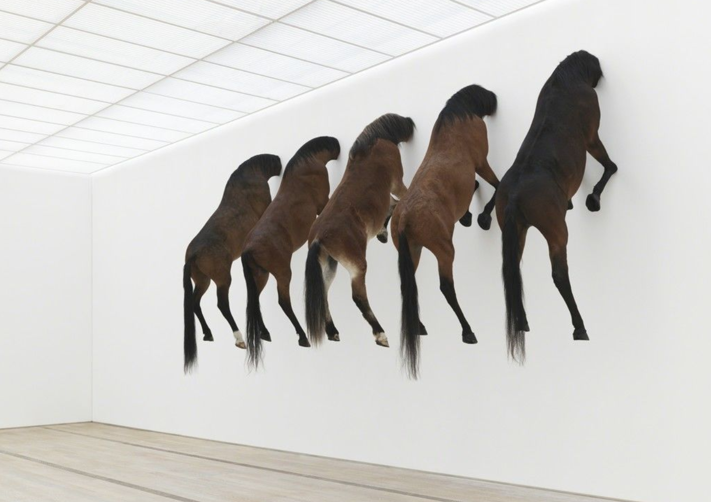
by Maurizio Cattelan, Kaputt, Fondation Bayeler via Artsy

What is Conceptual Art?
Conceptual art is an art movement based on the notion that idea or concept is the essence of art. Art doesn’t even have to take on a physical form. It can be something the artist says or does or a document of the artist’s thinking. As Sol LeWitt put it “the idea itself is a work of art”. So when looking at Conceptual art instead of focusing on how the art looks like, you should focus on the artist’s thinking process and the idea behind it.
Since ideas appear in many shapes and forms, conceptual art can take a myriad of manifestations. It can be a photograph, a sculpture, a drawing, a document, an installation but it can also be a performance and a happening. But conceptual art doesn’t have to be difficult to understand. Even in all of its versatility, there are a few things that bring all conceptual artworks together.

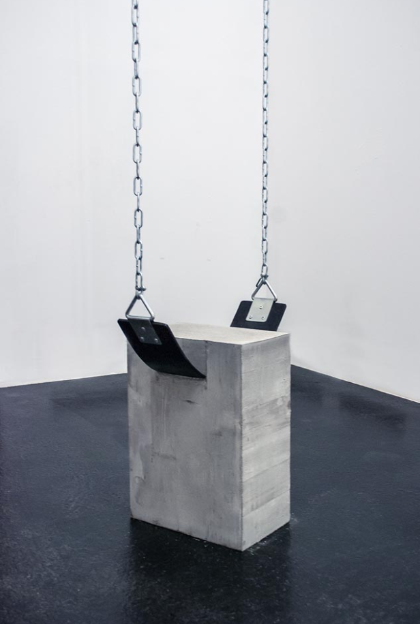
by Fabian Bürgy via Laughing Squid

Art that Gets You Thinking
Conceptual art is there to get you thinking. Often experiencing the artwork completely requires a lot of imagination from the viewers.
Many conceptual artists, most notably Sol LeWitt worked hard to separate the concept of the artwork from the physical artwork itself. Instead of making big wall drawings, Sol LeWitt spent his career creating detailed instructions about how these drawings should look like.
He would describe the artwork’s creation process and appearance in an elaborate document. Then he would exhibit these documents in galleries and sell them on auctions instead of actual artworks. That way anyone could create a Sol LeWitt artwork just by following the instructions on the documents. Although only the ones who bought a certified Sol LeWitt document could call it an original.
So what does this mean for people who show up to the exhibition and see a bunch of papers exhibited on the walls? Well, just that they’ll have to use their imagination and create the image of the artwork in their mind. So instead of staring at a page on a conceptual art exhibition, read it and imagine the described artwork in your mind. If it looks like something you would like to see in a gallery, the artist definitely did a good job.

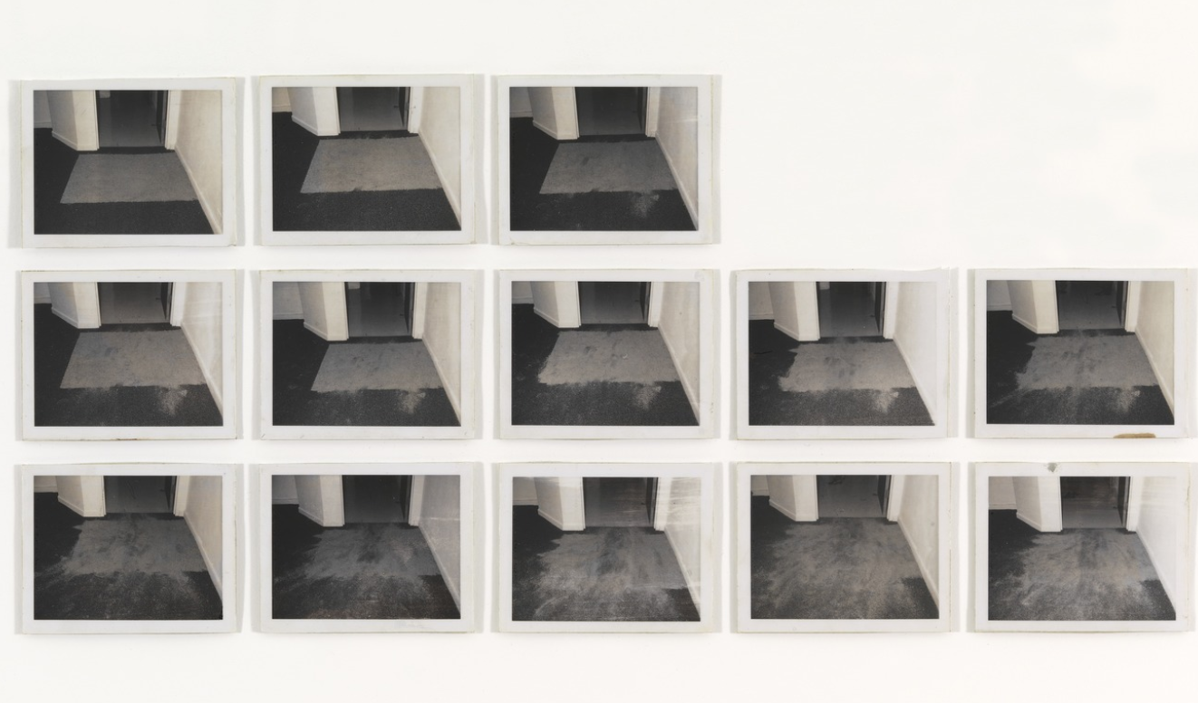
by Douglas Huebler via MoMA

Consider the Concept of Time...
Conceptual artists are also interested in different ways we organize concepts – most notably space and time. An array of conceptual artworks was created to make us think about how things evolve or change with the passing of time. For example, artist Mary Kelly documented the evolving relationship between her and her son in an artwork titled Post-Partum Document, by keeping a journal of everyday events and conversations with her child for over 6 years.
Douglas Huebler’s Duration Piece #6, consists of images of a rectangle of dirt placed in front of the door. Every time someone walked over it, the dirt would crumble and disperse all over the floor. Photographs of dirt (that becomes more and more scattered over time) are turned into prints and exhibited alongside the document explaining the process of creating art.

... and The Concept of Space
The same goes for our notion of space. Every piece of art exists in a certain space. It can be a gallery, museum, your living room or the outdoors. But instead of using space to exhibit artworks, many conceptual artists used their artworks to draw attention to the surrounding space. In Martin Creed’s Work, No. 227, lights turn on an off every 5 seconds, in an empty gallery, making people painstakingly aware of the room they are in.
Eleanor Antin’s 100 Boots documents the journey of boots all over America - from California to New York. Despite displaying the exact same black boots in every one of these places, the appearance of the artwork radically changes every time the boots change location. Therefore the location, not the boots becomes the main topic of the artwork.
So when you look at a work of conceptual art make sure to pay attention to how it relates to the space it’s exhibited in. What does it tell you about the exhibiting space? What does it tell you about your position in space? Does it change its location in space? Or maybe it outlines a portion of empty space? These are just some of the things you should consider next time you enter a conceptual art show.

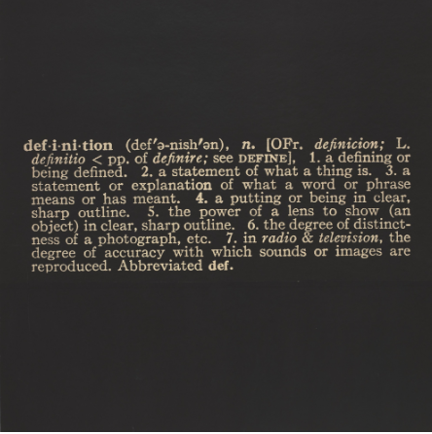
by Joseph Kosuth via MoMA

Did It Make You Laugh?
Conceptual artists often use humor to convey ideas. Joseph Kosuth turned the definition of the definition into an artwork. That’s kind of funny, but not as entertaining as artwork byMaurizio Cattelan. The Italian artist convinced his gallerist to wear a penis-like costume, to question the relationship and the power distribution between the gallery owner and the artist.
Although funny art doesn’t necessarily translate into good art, the capability of artwork to make you laugh, demonstrate its capacity to evoke emotions in viewers. And only truly powerful art can do that.

To Sum It Up
When it comes to conceptual art, it’s the thought that really counts. So instead of looking at shapes, colors and lines to decipher conceptual artworks, try thinking about what reactions it evokes. Does it make you think? Does it make you laugh? What does it tell you about different categories like space and time? By answering these questions you’ll be a step closer to understanding and appreciating conceptual art.

