Experiment no#9
Objective:
To investigate the result on discharge and total heat of operating pump in series pump.
Apparatus:
Series and parallel pumps demonstration unit.
Theory:
Putting your centrifugal pumps in series, or connected along a single line, will let you add the head from each together and meet your high head, low flow system requirements. This is because the fluid pressure increases as the continuous flow passes through each pump, much like how a multistage pump works. For example, if two of the same pumps are in series, the combined performance curve will have double the head of a single pump for a given flow rate. For two different pumps, the head will still be added together on the combined pump curve, but the curve will most likely have a piecewise discontinuity.
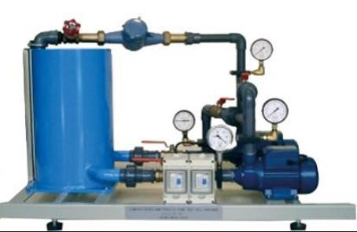
Procedure

𝑝𝑜𝑤𝑒𝑟 𝑜𝑓 𝑓𝑙𝑢𝑖𝑑
𝜂 = × 100
𝑒𝑙𝑒𝑐𝑡𝑟𝑖𝑐 𝑝𝑜𝑤𝑒𝑟 𝑜𝑓 𝑝𝑢𝑚𝑝
Observations:
Sr  # | Flow rate  (lpm) | P₁Bar | P2 Bar | P3 Bar | Flow rate m³/sec | Pump  head  H | Density  𝜌 | Power  of fluid  W | Electric power  W | Efficiency  𝜂
1
2
3

Calculations:
𝑚3
𝑄 = 1𝐿𝑃𝑀 = 1.667 × 10−5
𝑠𝑒𝑐
𝐻 = 10.197 × 𝑃₃
𝑝𝑜𝑤𝑒𝑟 𝑜𝑓 𝑓𝑙𝑢𝑖𝑑
𝜂 = × 100
𝑒𝑙𝑒𝑐𝑡𝑟𝑖𝑐 𝑝𝑜𝑤𝑒𝑟 𝑜𝑓 𝑝𝑢𝑚𝑝
𝑒𝑙𝑒𝑐𝑡𝑟𝑖𝑐 𝑝𝑜𝑤𝑒𝑟 = 𝐼 × 𝑉
Gravitational acceleration g=9.8 ms⁻²

Conclusions:

