ADMINISTRATION OF JUSTICE
Administration of Justice
Administration of Justice in Pakistan
Administration of Justice in Civil matters
Administration of Justice in Criminal Cases
Alternative Dispute Resolution (ADR)
Conclusion
References
(Table of Judicial Hierarchy in Pakistan)

Administration of Justice
Among many other purposes of law, administration of Justice in the most important. Laws are made to create harmony and balance within the society. If someone goes against the law, he might be punished or fined, in order to maintain the social balance and decorum of laws. This all is possible by administration of Justice. The administration of justice is the process by which the legal system of a government is executed. The presumed goal of such administration is to provide justice for all those accessing the legal system. Justice is the maintenance or administration of what is just by law, as by judicial or other proceedings. Every society has its own ways of implementation of Justice however, in developed and modern world, justice is being administered by Courts through law enforcement agencies depending upon the legislative guidelines.

Administration of Justice in Pakistan
Constitution of Pakistan have following provision about administration of justice.
Article 4(1) and (2) No person shall be deprived of life or liberty save in accordance with law
Article 9 All citizens are equal before law and are entitled to equal protection of law.
Article 25(1) There shall be no discrimination on the basis of sex alone.
Article 25(2) The state shall ensure inexpensive and expeditious justice
Article 37(2) No property shall be compulsorily acquired or taken possession of save for a public purpose and save by authority of law ...
Article 24(2) Recognition of the inherent dignity and of the equal and inalienable rights
of all members of the human family is the foundation of freedom, justice and peace in the world.
In Pakistan, administration of justice is intercepted in two system. One is civil justice system and another is criminal Justin system as follow;

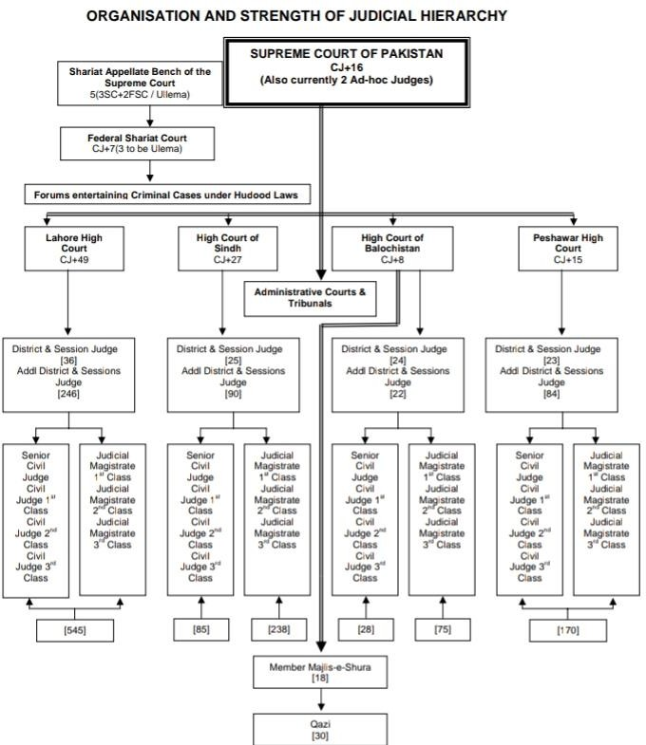

Administration of Justice in civil matters

Justice system of Pakistan is similar to that of British system. However, Pakistani justice system mostly rely on statutory provision as compared to English Common Law. Though common law is also applicable in Pakistani civil courts. Civil matters are those matter which are totally related between the people. These are the matter in which state does not interfere. For resolution of civil disputes, Civil District Courts have original jurisdiction to administer the justice. Since, in civil disputes, bar of evidence is out on the plaintiff so that it is the duty of the plaintiff to provide evidence for his claim. If the court finds the claim right, court pronounce awards l of damages incurred due to act of the defendant. Pakistani courts are messed with civil cases and cases continues for years , from generation to generation. This all because of the old and parochial approach in civil matters and transportations. In Cases of Law of Tort, damages are very rarely awarded. Court are either reluctant or the lawyer tries to put the trials as long as possible. judiciary and lawyers equally responsible for this deterioration of the judicial system. According to Law and Justice Commission of Pakistan, there are more than 1.8 million cases currently pending with the superior and subordinate courts in the country. This year’s Rule of Law Index report released by the World Justice Project also paints a gloomy picture of Pakistan’s judicial system. Currently, Pakistan stands at 106th position in terms of administration of civil justice among the 113 assessed countries.
Certainly, it is extremely deplorable. Worryingly, Pakistan’s civil justice system is one of the worsts in the world, and simply the worst in Asia. The Code of Civil Procedure, 1908 is the bible of civil procedure in Pakistan. It essentially divides a civil trial in a number of stages or phases that generally start from instituting a civil suit and precede each other in a fixed and definite order e.g. the service of summons, submission of reply, framing of issues, evidence, arguments, and finally the pronouncement of judgment by a judge.
The CPC has fixed the specific time periods within which a civil court is supposed to conclude the intended proceedings of each stage of this civil litigation. It also prescribes a number of penal measures against a party to the suit which fails to act as required by

the court during the trial. So, if this procedure is strictly followed by the civil court, a civil case can by all means be disposed of within 6 to 12 months. Strangely, instead of reforming or improving the colonial-era civil procedure after getting independence, we just chose to interpret and practice it in a manner which eventually led to its decay and deterioration. Indeed, an ‘Anglo-Pakistani garnishing’ to this Anglo-Indian enactment simply proved disastrous. Initially, through various judgements, the superior courts prescribed that the civil courts should decide a case on merits instated of procedural technicalities after affording parties a full opportunity of being heard. However, these judgements have eventually given rise to a novel civil procedure characterized by an unending series of adjournments, thanks to the adjournment-seeking lawyers and adjournment-happy judicial officers. At each stage of the civil litigation, a judge frequently adjourns the proceedings in rather a mechanical fashion to enable the litigants to fully avail the ‘pool of opportunities’— “first opportunity”, “second opportunity”, “another opportunity”, “final opportunity”, “last opportunity”, “absolute last opportunity”, and so forth. Thus, a single stage in the trial sometimes takes years without contributing anything substantial to the judicial record of the case. Hierarchy of the course in Pakistan is given in above table.

Administration of Justice in Criminal Cases

Criminal justice system(CJS) is the set of laws and principles which are applied on convicted ones on their transgressions. An individual will be treated, if finds guilty, as with the awarding of life- imprisonment or short period of time or sentenced with execution based on the crime. Further, it aims to furnish the peace, to eradicate the crimes and to deliver justice to the victims.
The criminal justice system in Pakistan is comprised of three factors: police, prosecution and judiciary. Sadly, Pakistan’s progression concerning the justice system has not been full- fledged. Police is a paramount institution for people because it forfends them from evil and wicked ones. But here is the inverse of it, criminals are being unleashed and victims are given more sorrows. Only money can decide on which side they are rather than being neutral. In Pakistan, police are more extensively hated, feared and untrusted institution, which is thoroughly plagued by corruption reported by redress institutions and public survey. Negligency and malfeasance of police have encouraged the crimes

and offences which cause people unrest and uncomfortable to live. The prosecution is referred to public prosecutor appointed by government who stands against its private opponent lawyer to prove the suspected as guilty. Many powers have added in its authority like not to put up lighter cases in court, to investigate without intervening of police and judging the minor cases, which don’t need to put up in court. Prosecution institution was added in 2007 in Pakistan but have not given such above mentioned authorities. They just perform one function to stand for the state against its private opponent. If they will be given the authorities, like in abroad to them, can get the law courts reduced by the huge number of pending cases and verdicts. However, Imran’s government wanted to make some reforms but still, a root has not been grown. Let’s cast an eye on the domestic judicial system of Pakistan which is too of like mourning on it. Judicial system of Pakistan is surviving millions of cases on pending yet has not been resolved. It is alarming drastically in delaying justice. A man is innocent till finds guilty but here suspected individual with guilt-ridden suffers a lot as guilty man and after over the years, he is again brought to court for trial and acquitted.

  - Alternative Dispute Resolution or ADR

Since our mainstream judicial system has miserably failed in providing “inexpensive and expeditious justice to the masses, the very tool of Alternative Dispute Resolution (ADR) is being portrayed by many as the only significant remedy for the country’s ailing justice system. So, this informal system of dispute resolution is keenly being tried to be introduced and promoted in the country. To ensure “inexpensive and speedy dispensation of justice”, the Alternative Dispute Resolution Act, 2017 was passed and promulgated last year. Under this act, the court can refer, with the consent of the parties, the specified civil matters to a notified “Neutral” who shall dispose of a matter within a period of thirty days. A number of ADR centres have also been made functional in all lower courts throughout Punjab. Alternative Dispute Resolution is an informal dispute resolution process or technique whereby disagreeing parties comes to an agreement short of litigation. In fact, ADR is an umbrella term for a variety of legal techniques to resolve a dispute, mostly with the help of third party, such as negotiation, mediation, arbitration, and conciliation. Indeed, this is an expeditious and inexpensive method of dispute resolution. Nevertheless, ADR can’t be a substitute for a formal judicial process. The ADR system inherently lacks the capacity to decide a dispute involving some complex legal and factual questions. It can only work if both parties to a dispute agree to settle their dispute through this method. Moreover, a civil suit is usually instituted in a civil court when both parties fail to resolve their dispute through negotiation or mediation. Therefore, when an aggrieved person approaches a court for the determination of his rights or the redressal of his grievances, it should be the duty of the court to expeditiously adjudicate this matter in accordance with the law after hearing both parties rather than advising him to mediate with the very person who has infringed his legal rights. As a matter of fact, the much-hyped ‘game-changing’ ADR system has yet not succeeded in providing any significant relief to numerous litigants.

Conclusion

Justice system of any society or country is said its backbone but it is can be said that backbone of Pakistan is bent and needs a spinal surgery. Pakistan is the only country with immense policies and null implications on it. To me, improvements in justice system can achieve only on the basis of reforms, policies and its full implications. It needs the concerns, insights and pragmatic measures by judicial reformer and policymakers. For further rectifications, the government should emphasize on police, to be honest, and sincere with its duties, the prosecution should be given its actual authorities to deal with the cases and should bring the competent and capacitated judges to deal with the pending cases as hurriedly as they can. By these remedial measures contributes much improvement in the criminal justice system in Pakistan.

References

- Administration of Justice and its kinds. (1970, January 1). Retrieved from https://thelawstudy.blogspot.com/2015/02/administration-of-justice-and-its-kinds.html

- Administration of Justice: Definition & Overview. (n.d.). Retrieved from https://study.com/academy/lesson/administration-of-justice-definition-lesson.html
انصاف کی فراہمی کیلئے پولیس اور محکمہ پراسیکیوشن میں باہمی تعاون بڑھانا 15). January (2014, S. Amjad, 3.

ہوگا. Express News. Retrieved from https://www.express.pk/story/217658/?amp=1

4. Butt, M. R. (2007). Constitution of the Islamic Republic of Pakistan, 1973. Lahore: Mansoor Book House.

انصاف کی فراہمی کیلئے تمام وسائل موجود نہیں عدلیہ کو ریاستی مشینری 25). April (2011, A. I. Choudri, 5.

from Retrieved Waqat. Nawai A. ریگولیٹ کرنیکا اختیار ہے :چیف جسٹس

https://www.nawaiwaqt.com.pk/25-Apr-2011/71099

- Code of civil procedure (V of 1908): amendments incorporated, Law reforms ordinance, Xii of 1972, Federal adaptation of laws order, 4 of 1975, Code of civil procedure (amendment) act, Xv of 1976. (1976).

https://www.google.com/url?sa=t&source=web&rct=j&url=https://www.ma-

law.org.pk/pdflaw/CODE%20OF%20CIVIL%20PROCEDURE%201908.pdf&ved=2ahUKEwiqkpG

Z2InpAhVCSRUIHX67ALYQFjAAegQIAhAB&usg=AOvVaw20IKXMtz6KG2QcL8hitSgM

- Crowe, J. (2019). Natural law and the nature of law. Cambridge: Cambridge University Press.

Retrieved from https://books.google.com.pk/books?id=r22MDwAAQBAJ&printsec=frontcover&dq=nature+
of+law&hl=en&sa=X&ved=0ahUKEwj_yYby3onpAhVJDGMBHe6DA24Q6AEIIzAA#v=onepage

&q=nature%20of%20law&f=false

- Giudice, M. (2015). Understanding the nature of law: a case for constructive conceptual explanation. Cheltenham, UK: Edward Elgar Publishing. Retrieved from https://books.google.com.pk/books?id=n-
_ECQAAQBAJ&printsec=frontcover&dq=understanding+the+nature+of+law&hl=en&sa=X&v

ed=0ahUKEwil8szflofpAhXoWhUIHdj0DJsQ6AEIIzAA#v=onepage&q=understanding%20the%

20nature%20of%20law&f=false

- Hussain, D. F. (n.d.). The Judicial System of Pakistan. Www.ljcp.gov.pk Web Result with Site Links Law and Justice Commission of Pakistan. Retrieved from http://www.ljcp.gov.pk/Menu%20Items/Articles%20on%20Law/JUDICIAL%20SYSTEM%20OF
%20PAKISTAN%20%20-%20%20FAQIR%20HUSSAIN.pdf

- Mailk, M. R. (1n.d.). Reforming our civil justice. Nation News. Retrieved from https://nation.com.pk/16-Oct-2018/reforming-our-civil-justice

- POLLOCK, F. R. E. D. E. R. I. C. K. (1918). A First Book of Jurisprudence (4th ed.). LONDON, England: MACMILLAN AND CO., LIMITED ST. . Retrieved from https://www.google.com/url?sa=t&source=web&rct=j&url=http://podcaststorage.weebly.c
om/uploads/1/2/8/9/12897302/first_book.pdf&ved=2ahUKEwjMhszw5InpAhV6A2MBHRhh

ALAQFjAAegQIAhAB&usg=AOvVaw1xoTZAKDyjQb_YwLXuWlem

- Rana, M. W. (2019, April 3). Administration of justice. Business Recorder. Retrieved from https://fp.brecorder.com/2019/04/20190403460631/

- Rao, M. S. R. (n.d.). Class-room live lectures edited, enlarged and updated. Class-room live lectures edited, enlarged and updated. Msrlawbooks. Retrieved from https://www.academia.edu/37963863/PUBLIC_INTERNATIONAL_LAW_Class-
room_live_lectures_edited_enlarged_and_updated_Msrlawbooks

- Salmond, J. W. (1913). Jurisprudence. London, England: The BALLANTYNE Press. Retrieved from https://epdfkitabain.blogspot.com/2016/12/jurisprudence-john-william-
salmond.html?m=1

15. Sehgal, I. (2019, January 8). ہے؟ کرتا فراہم انصاف قانون ہمارا کیا. Express News. Retrieved from https://www.express.pk/story/1495583/268/?amp=1

- Siddiqi, F. (2016, April 23). Is legal reform possible? Dawn News. Retrieved from https://www.dawn.com/news/1253780/is-legal-reform-possible

- The Code of criminal procedure (v. of 1898) as adopted in Pakistan and amended up-to- date. (1960). Retrieved from

https://www.google.com/url?sa=t&source=web&rct=j&url=https://www.oecd.org/site/adb

oecdanti-

corruptioninitiative/39849781.pdf&ved=2ahUKEwjWrPTR14npAhW0RhUIHYjnAXwQFjAbeg

QICBAB&usg=AOvVaw0AJJHTC22bmTUpyHGEoXx7

- Mahajan. VD. (1987). Jurisprudence and Legal Hisstory (5th ed.). Lucknow, India: Eastern Book company Law Publishers and Booksellers.
- Which is the best doctrine for Pakistan’s criminal administration of justice? (n.d.). Daily Times. Retrieved from https://dailytimes.com.pk/461973/which-is-the-best-doctrine-for-
pakistans-criminal-administration-of-justice/amp/

- Yadugiri, M. A., & Bhasker, G. (2005). English for law. New Delhi: Foundation Books.

Retrieved from https://books.google.com.pk/books?id=WICJXkESAAgC&printsec=frontcover&dq=nature+of
+law&hl=en&sa=X&ved=0ahUKEwj_yYby3onpAhVJDGMBHe6DA24Q6AEIOjAD#v=onepage&

q=nature%20of%20law&f=false

