Educational leadership
- Educational leadership is usually associated with formal organisational position in schools.
- leadership is both a shared and an individual enterprise and should be distributed and exercised at every level. Teachers are viewed as having significant leadership potential (MacBeath and Dempster, 2009).
- So discussions about school leadership tend to refer to one or more of the following:
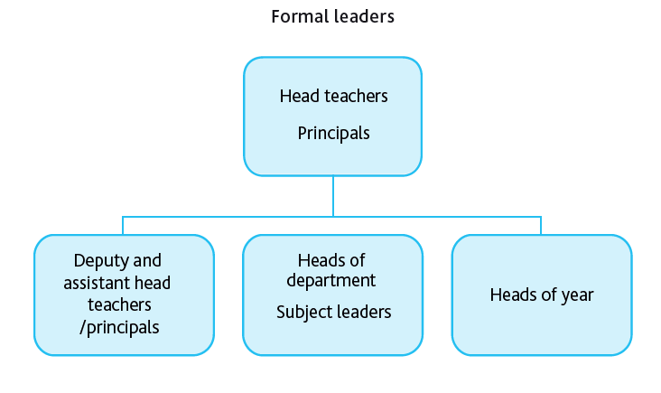
Informal leaders
However, there are also informal leaders such as specialist leaders whose influence stems from their subject knowledge or skills with groups of learners, or individuals who have social influence with their peers and sway views and attitudes.
Leadership is not necessarily attached to a role and can be viewed as a process rather than a position of authority. Leadership for Learning: for example, was created with the aim of connecting leadership and learning in schools.
The concept of educational leadership can also be extended to include developing student leadership as one goal of the educational process. This is increasingly recognised as an important life skill.
Schools also have a role to play as leaders in their community, supporting learning beyond the school boundaries.
Theory behind educational leadership
- Leadership is seen as a prime factor in improving school effectiveness. Leadership makes a difference. Effective leadership improves schools.
- Good leadership is not only important in itself; it is also a powerful way to improve classroom teaching.
- Learner achievement in a school rarely exceeds the quality of its leadership. Three (of the many) factors that influence learners’ achievements are: parental involvement, the quality of teaching, and school leadership. Leadership is strongly associated with school performance. Inspection reports from organisations such as Ofsted (Office for Standards in Education, Children’s Services and Skills in England) suggest that there are no instances of a failing school being ‘turned around’ in the absence of good leadership.
Challenges of educational leadership?
Not only is there a diversity of theory about leadership, it also varies according to context. For example, in some countries, schools have high levels of autonomy; in other countries, there may not be as much autonomy. In some systems, principals do not appoint teaching staff; in others they do. Ensuring that leadership is sensitive to context and that leadership development activities reflect local circumstances is important.
While leadership is widely understood as making a difference, measuring an individual leader’s impact is very difficult. This is because their influence is indirect – they work with and through others, most obviously their teacher colleagues.
How can schools support educational leadership?
In schools there is a need to prepare, train and develop leaders. Effective leadership development is school-based and on-the-job. However, this should be supplemented by out-of-school activities including increasing individuals’ knowledge of a range of leadership approaches, reading, reflection, and interaction with peers in other schools and settings.
Mentoring and coaching can benefit newly appointed leaders.
Using the skills and expertise of leaders, with a proven track record of success in schools, can help to support newly appointed leaders – although highly effective leaders do not always make good mentors or coaches.
- Identifying leadership talent and potential should be seen as a part of every school principal’s responsibilities. Leadership involves the liberation of talent. Some organisations are poor at managing talent; they stifle potential. Leaders need to ensure they positively manage talent.
Develop leadership teams. Distributing leadership is important. Schools need lots of leaders, at all levels. However, when leadership is distributed it needs to be co-ordinated.
- Consider student leadership programmes to widen student participation in the running of the school.
4 MAJOR TYPES OF EDUCATIONAL LEADERSHIP
There are four major styles of leadership which apply well in the educational setting. While each of these styles has its good points, there is a wide berth of variation, and in fact transformational leadership is truly an amalgamation of the best attributes of the other three. Let’s explore how servant leadership, transactional leadership and emotional leadership compare to transformational leadership.
1. Servant Leadership
Servant Leadership takes the focus from the end goal to the people who are being led. There is no sense of self interest on the part of the leader, who steps back and supports only the interests of the followers. Guidance, empowerment and a culture of trust are hallmarks of this style of leadership. A servant leader put complete trust in the process and in his or her followers, assuming that those within the organization will align with it’s goal.
The primary issue with servant leadership is that it’s not viable on an organizational level, in large part because it does not keep its eye on the prize. With the focus being so entirely upon the needs of the people within the organization, the goal of the organization is nearly completely lost and therefore not attained. Education happens in the real world, where unfortunately people have shortcomings and quite often need guidance in order to get things going in the right direction. Transformational Leadership offers that same focus on the individual, while building an investment in the end goal of the organization and thereby creating a momentum to achieve it. Transformational Leadership takes Service Leadership to the next level.
2. Transactional Leadership
Give and take is the hallmark of transactional leadership – it is indeed modeled just like a business transaction. Of course the employer/employee relationship is largely transactional as is. Employers need work done and employees do that work in exchange for money. That “quid pro quo” (“something for something”) is the heart of the workplace, and everyone is generally happy with this arrangement, but it only works if everyone involved sees it that way. In education, there is often more at stake for employees who quite often understand their jobs to be more than just a simple exchange of services for money, but rather see their higher purpose. Money is therefore not the motivating factor.
This is where transformational leadership can step in to compliment transactional leadership, taking the whole process as step further by building upon other forms of motivation outside of simply the exchange of goods and services for money. However transformational leadership only really works of the leader is able to keep up the charisma and interpersonal relationships which are required for it to work. When transformational leadership fails, the last resort is quite often transactional leadership, which is easy and straightforward, if less than effective in the long term.
Perhaps the biggest contrast between transformational and transactional leadership is that the latter is laissez faire, in which the leader allows employees to do as they like, whereas the former is completely hands on and intrusive in its nature.
3. Emotional Leadership
Where transactional leadership was concerned primarily with the exchange of goods and services, emotional leadership is concerned with the feelings and motivations of followers. It takes the focus completely to the other side of the spectrum – demanding that leaders be emotionally intelligent themselves and then to motivate through the use of that emotional intelligence.
Emotional leadership and transformational leadership have a great deal in common with each other. With emotional leadership, the leader taps into their emotional center in order to find the path to guiding their followers. People sometimes argue that transformational leadership requires that same level of influence over emotions, however there is a fundamental difference in the two in that transformational leadership is by necessity a rational process rather than an emotional one.
4. Transformational Leadership
Transformational leadership takes from each of the other kinds of leadership its best qualities and then uses those, along with a deep sense of shared purpose, to motivate subordinates. While the other forms of leadership focus on one singular aspect or another, transformational leadership takes a broad view of the issues surrounding leadership and then uses those as a driving force for meeting the overall goals of the organization. For education in particular, transformational leadership offers the best of everything – from tapping into the emotions of workers to offering the compensatory core that is the case for all forms of business, to guiding from a place of support.
However since transformational leadership is informed by all of these various types of leadership, it’s always a good idea for leaders to learn more about these other styles so as to offer a deeper understanding of these forms so as to offer those in whose service they are the best support and guidance possible.

