Human Rights in Pakistan
Contents
Introduction 01
Instruments of Human Rights adopted by Pakistan 01
  - International Instruments 01
  - National Instruments 01
Prospects of Human Rights in Pakistan 02
The Rule of Law 02
Enforcement of Laws, Acts and policies 02
Independence of Judiciary 02
Promotion of Democracy 03
The Commissions 03
Challenges in Context of Pakistan 03
Extra Judicial Killings 03
Custodial Torture and Deaths 04
Political Violence 04
Corruption 05
Freedom of Media 05
Border Killings 05
Violence Against Women 05
Freedom of Peaceful Assembly and Association 05
Rights Violation of Garments Workers 06
Conclusion 06
Recommendations 06
References 07

List of Abbreviations

CEDAW | Convention on the Elimination of Discrimination Against Women
CRC | Convention on the Rights of the Childs
CSO | Civil Society Organization
ICCPR | International Covenant on Civil and Political Rights
ICESCR | International Covenant on Economic, Social and Cultural Rights
NGO | Non-Governmental Organization
UDHR | Universal Declaration of Human Rights
UN | United Nations

- | P a g e

Introduction:
The assignment is specially focused on the state of Human Rights in terms of prospects and challenges in Pakistan and so it requires a comprehensive analysis of existing situation of Human Rights, it prospects and upcoming challenges for promotion and protection of human rights of the people in Pakistan.
The term “Human Rights” contains a set of legal and moral rights that can be claimed by any person as human being. These rights come with birth and applicable to all people throughout the world irrespective of their race, colour, sex, language, political or other opinion. Human rights therefore characterize as universal, inalienable, inherent and indivisible that have a common focus of protecting life of human being with dignity. The concept of human rights firstly revealed in the Universal Declaration of Human Rights (UDHR) in 1948 by UNO where 30 articles about human rights are declared. Human rights are stipulated in the Constitution of Pakistan, written in 1973 provides for fundamental rights, which include freedom of speech, freedom of thought, freedom of information, freedom of religion, freedom of association, freedom of the press, freedom of assembly etc. Therefore, the Constitutional obligations made a platform for Pakistan government to ratify the core international human rights conventions and treaties for the protection and promotion of human rights. It enables Government of Pakistan to translate international agreements into domestic law. It obliges all branches (i.e. Executive, Legislative and Judiciary) of government to respect and ensure the rights it enunciates.

Instruments of Human Rights adopted by Pakistan:
Pakistan adopted a number of international and national legal frameworks to promote and protect human rights and fundamental freedom of all citizens.

International Instruments:
    - Pakistan acceded to the International Covenant on Civil and Political Rights (ICCPR) on June 23, 2010.
    - Pakistan acceded to the International Covenant on Economics, Social and Cultural Rights (ICESCR) on April 17, 2008.
    - Pakistan acceded to the Convention against Torture and Other Cruel Inhuman or Degrading Treatment or Punishment (CAT) on June 03, 2010.
    - Pakistan ratified the Convention on the Rights of Children (CRC) on November 12, 1990.
    - Pakistan accessed to the Convention on the Elimination of All forms of Discrimination against Women (CEDAW) on March 12, 1996.

National Instruments:
National legal rights are protected by the constitution, national laws and national rules and regulations of Pakistan. It can be articulated with:
    - Constitution of Pakistan guaranteed fundamental rights of all its citizens without making any distinctions.

- | P a g e

- National law of Pakistan protect every citizen as part of their civil rights. Civil rights are set out in the Civil Codes, the Penal Code and the Labour Code.
- The rules and regulations of Government that provides detail description of some specific rights of the people such as: rules and regulations on the local government functionaries and various acts.
- There are some cultural and social norms and values, which are linked with specific rights of the people.

Prospects of Human Rights in Pakistan:
The prospects of human rights in Pakistan can be articulated through the following dynamics:

The Rule of Law:
“Rule of Law” is the most essential element for the protection of Human Rights. It implies the absence of arbitrariness in the governance of a country. Law is considered as supreme and none can claim exemption or immunity from it. Chapter 01 Article 09 of the Constitution of Pakistan guarantees fundamental rights, a person’s right to life and liberty. But the reality is that the state of rule of law in Pakistan is unquestionable terrible. There can be sited thousands of examples of the deteriorated image of rule of law currently occurring in Pakistan. The most dangerous thing is even the law enforcing the agencies or defence officials get into involved in various forms of crimes. Law is being violated with the sponsorship of ruling political party or parties.

Enforcement of laws, acts and policies:
Pakistan has introduced a number of laws, acts and legal policies (i.e. National Commission for Human Rights Bill 2012, Punjab Free and Compulsory Education Act 2014) in relation to promotion and protection of human rights of the people.
Examples:
- Pakistan has promulgated a special law to provide for the employment rehabilitation and welfare of disabled persons, namely “Disabled Persons (rehabilitation and employment) Ordinance on December 24, 1981.
- Anti-Rape laws (Criminal Laws Amendment) Bill, 2013.
- Hindu Marriage Bill, 2015.
- Protection against Harassment of Women at Workplace (Amendment) Bill, 2014.
In spite of these laws, acts and policies, the trend of violence and crimes is increasing day by day in Pakistan. This is because there is a serious lack of enforcement of the law, the police, by the lawyers and other relevant authorities. The poor enforcement of laws is always victimizing the poor people of the country to get protection of the laws.

Independence of Judiciary:

- | P a g e

Independence of Judiciary means a fair and neutral judicial system of a country. This can afford to take its decisions without any interference of executive and legislative branch of government. The independence of judiciary is affirmed and declared by Article 09, 25, 175 and 203 of the Constitution of Pakistan. The reality is that the independence of judiciary is on the paper, and still the Judges are appointed and promoted based on their ‘loyalty’ to the ruling political party. This is, however, not creates a new trend of judiciary in Pakistan.

Promotion of Democracy:
Democratic system assures the scope of people’s participation to choose their leadership and government. Democracy failed exceptionally quickly after independence because Pakistan possessed a weak and fragmented political party that was unable to resolve key governing conflicts. In the wake of intensifying political instability, the civilian bureaucracy and military assumed governing power in 1958. Since its independence, Pakistan’s democratic system has fluctuated between civilian and military governments at various times throughout its political history, mainly due to political instability, civilian military conflicts, political corruption and by the military establishment against weak civilian governments, resulting in the enforcement of Martial Law across the country (occurring in 1958, 1977 and 1999, led by chief martial-law administrator-generals Ayub Khan, Zia- ul-Haq and Pervaiz Musharraf respectively). Democracy in Pakistan, however imperfect, has been allowed to function to varying degrees. Until 2013, Pakistan did not experience even one democratic transfer of power from one democratically elected government that had completed its tenure to another.

The Commissions:
An independent commission for prevention of deep rooted corruption and gross violation of human rights was necessary for Pakistan to reinforce the country wide action against corruption and violation of human rights. As per requirements, Pakistan has introduced a separate structure in the name of independent “National Accountability Bureau” and “Human Rights Commission of Pakistan (HRCP)” but the both commission is directly or indirectly functional under the control of government. The HRCP can only investigates human rights abuses and make recommendations to the government, which is not enough for strong movement against rights violation.

Challenges in context of Pakistan:
There are a number of challenges prevailing in Pakistan, which is denying the national image and rights of a person as a human being. Some of these challenges are given bellow:

Extra Judicial Killing:
The “extra judicial killing” is a severe form of human rights violation that often denying justice. It has become as an integral part of law enforcement system in Pakistan. Through the Constitution of Pakistan and UN’s Universal Declaration of Human Rights strongly defined this act as violation of human rights, it is still

- | P a g e

continues in Pakistan. The government is failing to keep its commitment to end extra judicial killings, torture and other by the Counter Terrorism Department and Police towards assuring their accountability. In spite of High Courts ruling’s, extra judicial killings are continued that violates the rule of law of the country. After becoming independent, Pakistan inherited a more than 80 years old police system from British India, the one that was designed just to keep check and balance on the people of colonized subcontinent. It was not created for fair and just enforcement of law. The main problem in our police department is that it still operates like colonial police rather than the police meant for a free democratic state.

Custodial Torture and Deaths:
Custodial torture and death are strongly prohibited by the national and international laws. But in Pakistan it has seen as a routine procedure to extract information from the accused persons in detention. In some cases, the victims simply ‘disappear’. In several of the cases of death in custody allegedly due to torture, the police said that the detained person committed suicide or that the victim died of natural causes. In some of them, there is evidence that the police tried to cover up the commission of crimes, sometimes by interfering with police records or by ensuring that the text of the post mortem or medical reports reflected the police version of the detainee’s death. In several cases, relatives were threatened with reprisal if they tried to bring the police officers concerned to justice.

Political Violence:
The political violence is another form of human rights violation in Pakistan like other third world countries. It has been observed that political domination, lack of democratic culture among political parties, mistrust, and un-law full exercise of power are the main contributing factors in the political violence in Pakistan.
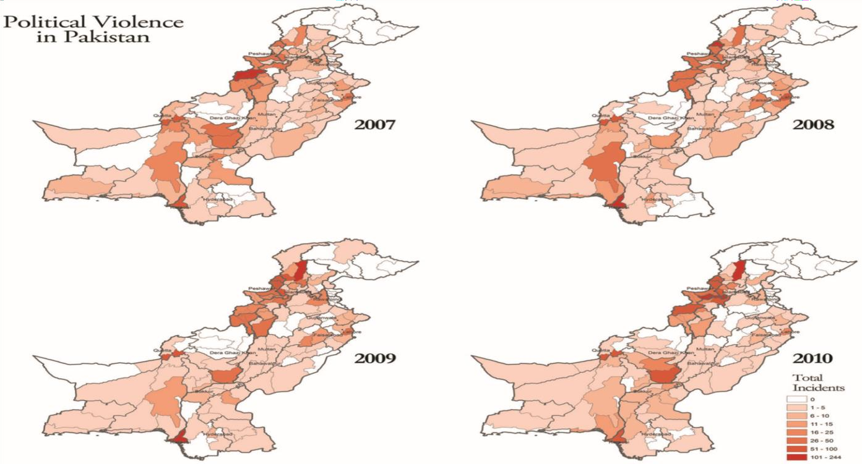

- | P a g e

Corruption:
Corruption is another restricting force in advancing rule of law and human rights in Pakistan. It is often denying the enforcement of law against the powerful perpetrators and limiting the hope of justice for the mass people. Due to corrupt officials in the border security agencies, children and women are trafficked to other countries and are brought to Pakistan. Such as in 2011, about 300 disabled children were reported to be trafficked to Iran for forced begging; which means these people are exploited, abused and tortured and sometimes killed. In result of corrupt police officials, criminals are walking free and killing people incessantly; the police in Pakistan is the most corrupt agency which is one of the major source of unrest in the society and deprivation from basic human rights. Due to corrupt judicial officials which has been highlighted by various high or apex court judges, common people do not get justice on time or deprived of justice and their rights.

Freedom of Media:
Qaid-e-Azam, the founder of Pakistan says “I expect press for complete fearless.” Regrettably, press in Pakistan has been unsuccessful to appreciate the goal of Qaid- e-Azam. The constitution provides for freedom of speech and press, but government frequently failed to respect these rights in practice. In recent time, the attack on journalists has come out as a concern. There was an increase in individuals affiliated with the government or ruling party harassing, arresting and assaulting journalists. At least 61 journalists have been killed since 2010 with at least 14 journalists killed in 2014 alone. In 2018 Press Freedom Index and Reporters without border ranked Pakistan number 139 out of 180 countries based on freedom of the press.

Border Killing:
Border killing by border forces is another miserable issue for the border lying people in Pakistan. The poor and marginalized people in border lying areas are often crossing the border for serving works and commence. While some of those killed are engaged in smuggling goods and contraband, border force systematically use lethal force without justification. In spite of repeated complain of Pakistan Government, the border killing is still continued.

Violence against Women:
Violence against women is alarming in context of traditional socio-legal structures in Pakistan. It is observed that the women and girls are mainly becoming the victim of violence. Violence against women is occurring in public and private places, it has many forms, ranging from domestic and intimate partner violence to sexual harassment and assault, trafficking and sexual violence and gender related killing. Its impact spams from immediate to long-term multiple physical, sexual and mental consequences for women and girls, including death.

Freedom of peaceful Assembly and Association:
In spite of the constitutional provisions for freedom of assembly and association, the law enforcing agencies to some extend making some restriction in certain areas

- | P a g e

in the name of traffic and security concern. The restriction is ultimately blaming to the government as violation of freedom of assembly.

o Rights Violation of Garments Workers:
It is frequently reported that the rights of garments workers are violated in term of minimum wage for their labor and safe working environment. The leader of the garments workers are often claiming their rights issues and often declaring strikes to achieve it. The process is often creating mistrust between the garments owners and the workers that turns into a conflicting situation. In September 2012, a fire at the Ali Enterprises garment factory in Karachi killed at least 255 workers and injured more than 100.

Conclusion:
Human Rights are simply a theoretical perspective in context of recent Pakistan, in practical its violation is seen in every spheres of lives that restricting the rule of law and advancement of the country as a civilized nation. A variety of social, economic, cultural and political factors are contributing to the violation of human rights.
The present reality of Pakistan proves again that while a representative government is essential for democratic practice, is not enough if the Executive, Judiciary and the Legislative fail to play their respective roles to ensure constitutional and international norms of human rights. In such situation an undemocratic and dictatorial nature of power manifests in different ways and abuses the state machinery for partisan and narrow political gain. We need to minimize the inequality in resource allocations (between rich and poor and even men and women), decentralization of power, uphold the rule of law, removal of political biasness, reinforce the functionality of state institutions and assure transparency and accountably in all functions. Though it is dream for current state of human rights in Pakistan, the days will come to Pakistan with the leadership of committed generation who will be able to ensure everyone’s rights and respect as frame of a civilized nation.

Recommendations:
The analytical findings have led to the development of a recommended actions that may be affected in attaining equality in all spheres of lives in context of Pakistan.
- The government should have to practice democratic culture in all forms of decision making process (in national interest), establish respect on other’s opinions and remove political biasness in the state functionaries, unethical influence in the judiciary and reinforce the political representation with committed and corruption free leadership.
- Pakistan government should take all necessary measures to end extra judicial killings, torture and other human rights violations. It should ensure that all allegations of human rights violations by any official are thoroughly investigated and prosecute all those responsible, regardless of rank or position.
- Pakistan is required more efforts for strengthening and consolidating the institutional structures, including National Human Rights Commission, the National Accountability

- | P a g e

Bureau, the Election Commission and the local government institutions, which promote good governance, democracy, human rights and the rule of law.
- Pakistan should have to maintain its obligations under the international treaties and conventions to which it is a party, and to invest more efforts in effective implementation of relevant national programs.
- Pakistan should have to strengthen the partnership between public and private institutions (including CSO, NGO and Media) in the promotion and protection of human rights for all.

References:
  - https://www.ohchr.org/en/countries/asiaregion/pages/pkindex.aspx
  - https://www.amnesty.org/download/Documents/196000/asa330051991en.pdf
  - https://www.researchgate.net/publication/312639730_Democracy_in_Pakistan_Proble ms_and_Prospects_in_Making_Informed_Choices
  - http://www.isj.org.pk/wp-content/uploads/2013/01/The-Negative-Impact-of-Corruption- on-Human-Rights-in-Pakistan.doc
  - http://asiapacific.unwomen.org/en/countries/pakistan/evaw-pakistan
  - https://www.hrw.org/news/2019/01/23/pakistan-garment-workers-rights-risk

View publication stats

