Proteins
Proteins highly complex substance that is present in all living organisms. Proteins are of great nutritional value and are directly involved in the chemical processes essential for life. The importance of proteins was recognized by chemists in the early 19th century, including Swedish chemist Jöns Jacob Berzelius, who in 1838 coined the term protein, a word derived from the Greek prōteios, meaning “holding first place.” Proteins are species-specific; that is, the proteins of one species differ from those of another species. They are also organ-specific; for instance, within a single organism, muscle proteins differ from those of the brain and liver.
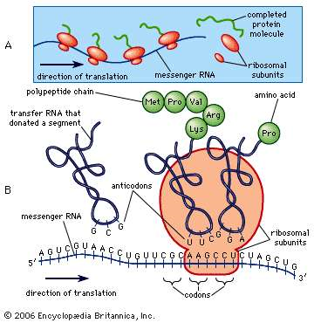

Figure 1: protein synthesis

A protein molecule is very large compared with molecules of sugar or salt and consists of many amino acids joined together to form long chains, much as beads are arranged on a string. There are about 20 different amino acids that occur naturally in proteins. Proteins of similar function have similar amino acid composition and sequence. Although it is not yet possible to explain all of the functions of a protein from its amino acid sequence, established correlations between structure and function can be attributed to the properties of the amino acids that compose proteins.
Plants can synthesize all of the amino acids; animals cannot, even though all of them are essential for life. Plants can grow in a medium containing inorganic nutrients that provide nitrogen, potassium, and other substances essential for growth. They utilize the carbon dioxide in the air during the process of photosynthesis to form organic compounds such as carbohydrates. Animals, however, must obtain organic nutrients from outside sources. Because the protein content of most plants is low, very large amounts of plant material are required by animals, such as ruminants (e.g., cows), that eat only plant material to meet their amino acid requirements. Nonruminant animals, including humans, obtain proteins principally from animals and their products—e.g., meat, milk, and eggs. The seeds of legumes are increasingly being used to prepare inexpensive protein-rich food.

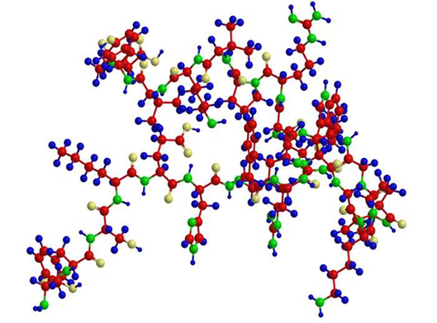

The high protein content of some organs does not mean that the importance of proteins is related to their amount in an organism or tissue; on the contrary, some of the most important proteins, such as enzymes and hormones, occur in extremely small amounts. The importance of proteins is related principally to their function. All enzymes identified thus far are proteins. Enzymes, which are the catalysts of all metabolic reactions, enable an organism to build up the chemical substances necessary for life—proteins, nucleic acids, carbohydrates, and lipids—to convert them into other substances, and to degrade them. Life without enzymes is not possible.

There are several protein hormones with important regulatory functions. In all vertebrates, the respiratory protein hemoglobin acts as oxygen carrier in the blood, transporting oxygen from the lung to body organs and tissues. A large group of structural proteins maintains and protects the structure of the animal body.
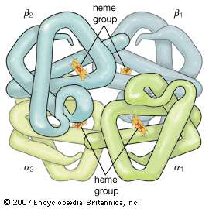

Amino Acids

Amino acid, any of a group of organic molecules that consist of a basic amino group (―NH2), an acidic carboxyl group (―COOH), and an organic R group (or side chain) that is unique to each amino acid. The term amino acid is short for α-amino [alpha-amino] carboxylic acid. Each molecule contains a central carbon (C) atom, called the α-carbon, to which both an amino and a carboxyl group are attached. The remaining two bonds of the α-carbon atom are generally satisfied by a hydrogen (H) atom and the R group. The formula of a general amino acid is:
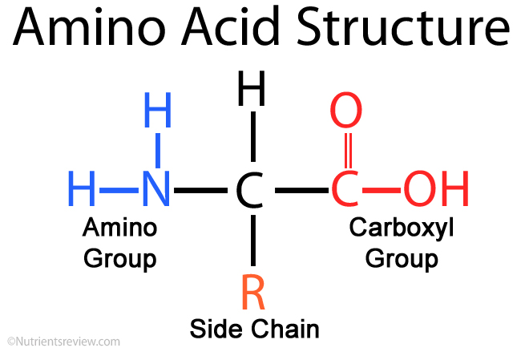

The amino acids differ from each other in the particular chemical structure of the R group.
Building blocks of proteins

Proteins are of primary importance to the continuing functioning of life on Earth. Proteins catalyze the vast majority of chemical reactions that occur in the cell. They provide many of the structural elements of a cell, and they help to bind cells together into tissues. Some proteins act as contractile elements to make movement possible. Others are responsible for the transport of vital materials from the outside of the cell (“extracellular”) to its inside (“intracellular”).

Proteins, in the form of antibodies, protect animals from disease and, in the form of interferon, mount an intracellular attack against viruses that have eluded destruction by the antibodies and other immune system defenses. Many hormones are proteins. Last but certainly not least, proteins control the activity of genes (“gene expression”).

This plethora of vital tasks is reflected in the incredible spectrum of known proteins that vary markedly in their overall size, shape, and charge. By the end of the 19th century, scientists appreciated that, although there exist many different kinds of proteins in nature, all proteins upon their hydrolysis yield a class of simpler compounds, the building blocks of proteins, called amino acids.
The simplest amino acid is called glycine, named for its sweet taste (glyco, “sugar”). It was one of the first amino acids to be identified, having been isolated from the protein gelatin in 1820. In the mid-1950s scientists involved in elucidating the relationship between proteins and genes agreed that 20 amino acids (called standard or common amino acids) were to be considered the essential building blocks of all proteins. The last of these to be discovered, threonine, had been identified in 1935.

Types of Amino Acids:

Amino acids can be placed in three different groups:

1.Nonessential amino acids:
These are produced naturally by your body and have nothing to do with the food you eat.
The following are examples of nonessential amino acids:
- Alanine
- Asparagine
- Aspartic acid
- Glutamic acid

2.Essential amino acids:
These can't be produced by the body and must come from the food you eat.
If you don't eat foods that contain essential amino acids, your body won't have them.

The following are essential amino acids:
- Histidine
- Isoleucine
- Leucine
- Lysine
- Methionine
- Phenylalanine
- Threonine
- Tryptophan
- Valine
It isn't necessary to eat essential amino acids at every meal. You can get healthy amounts by eating foods containing them throughout the day.
Animal-based foods such as meat, milk, fish, and eggs provide essential amino acids.
Plant-based foods such as soy, beans, nuts, and grains also contain essential amino acids.
Over the years, there has been controversy about whether vegetarian diets can provide adequate amounts of essential amino acids.
Many experts believe that while it may be harder for vegetarians to maintain an adequate intake, they should be able to do so if they follow the American Heart Association's guidelines of 5 to 6 servings of whole grains, and 5 or more servings of vegetables and fruits, per day.

3.Conditional amino acids:
These are usually not essential to everyday living but are important when you're sick, injured, or stressed.
Conditional amino acids include:
- Arginine
- Cysteine
- Glutamine
- Tyrosine
- Glycine
- Ornithine
- Proline
- Serine
When you're ill or injured, your body may not be able to produce enough conditional amino acids, and you may need to give your body what it needs through diet.

Structures of Protein

1. Primary Structure:
Primary Structure describes the unique order in which amino acids are linked together to form a protein. Proteins are constructed from a set of 20 amino acids. Generally, amino acids have the following structural properties:
A carbon (the alpha carbon) bonded to the four groups below:
- A hydrogen atom (H)
- A Carboxyl group (-COOH)
- An Amino group (-NH2)
- A "variable" group or "R" group

All amino acids have the alpha carbon bonded to a hydrogen atom, carboxyl group, and an amino group. The "R" group varies among amino acids and determines the differences between these protein monomers. The amino acid sequence of a protein is determined by the information found in the cellular genetic code. The order of amino acids in a polypeptide chain is unique and specific to a particular protein. Altering a single amino acid causes a gene mutation, which most often results in a non-functioning protein.

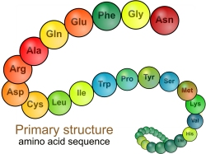

2. Secondary Structure:
Secondary Structure refers to the coiling or folding of a polypeptide chain that gives the protein its 3-D shape. There are two types of secondary structures observed in proteins. One type is the alpha (α) helix structure. This structure resembles a coiled spring and is secured by hydrogen bonding in the polypeptide chain.
The second type of secondary structure in proteins is the beta (β) pleated sheet. This structure appears to be folded or pleated and is held together by hydrogen bonding between polypeptide units of the folded chain that lie adjacent to one another.

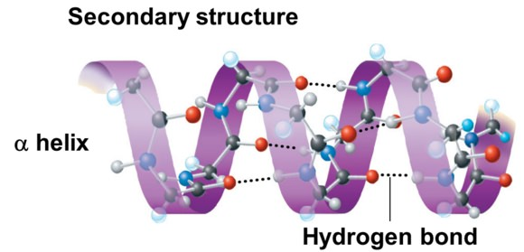

3. Tertiary Structure:
Tertiary Structure refers to the comprehensive 3-D structure of the polypeptide chain of a protein. There are several types of bonds and forces that hold a protein in its tertiary structure.

Hydrophobic interactions greatly contribute to the folding and shaping of a protein. The "R" group of the amino acid is either hydrophobic or hydrophilic. The amino acids with hydrophilic "R" groups will seek contact with their aqueous environment, while amino acids with hydrophobic "R" groups will seek to avoid water and position themselves towards the center of the protein. ​
Hydrogen bonding in the polypeptide chain and between amino acid "R" groups helps to stabilize protein structure by holding the protein in the shape established by the hydrophobic interactions.

Due to protein folding, ionic bonding can occur between the positively and negatively charged "R" groups that come in close contact with one another.
Folding can also result in covalent bonding between the "R" groups of cysteine amino acids. This type of bonding forms what is called a disulfide bridge.
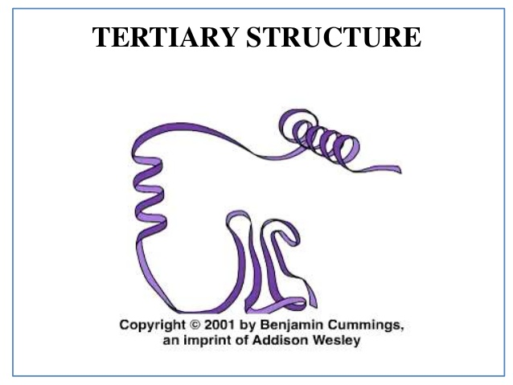

4. Quaternary Structure:
Quaternary Structure refers to the structure of a protein macromolecule formed by interactions between multiple polypeptide chains. Each polypeptide chain is referred to as a subunit. Proteins with quaternary structure may consist of more than one of the same type of protein subunit. They may also be composed of different subunits. Hemoglobin is an example of a protein with quaternary structure. Hemoglobin, found in the blood, is an iron-containing protein that binds oxygen molecules. It contains four subunits: two alpha subunits and two beta subunits.

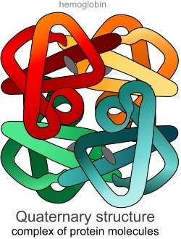

Types of Proteins

- Structural:
The largest class of proteins are structural proteins. These protein types serve as essential components to your body's construction. Keratin and collagen are the most common structural proteins. These are strong, fibrous proteins. Keratin forms the structure of your skin, nails, hair and teeth. While, collagen serves as a connective structure for your tendons, bones, muscles, cartilage and skin in particular.

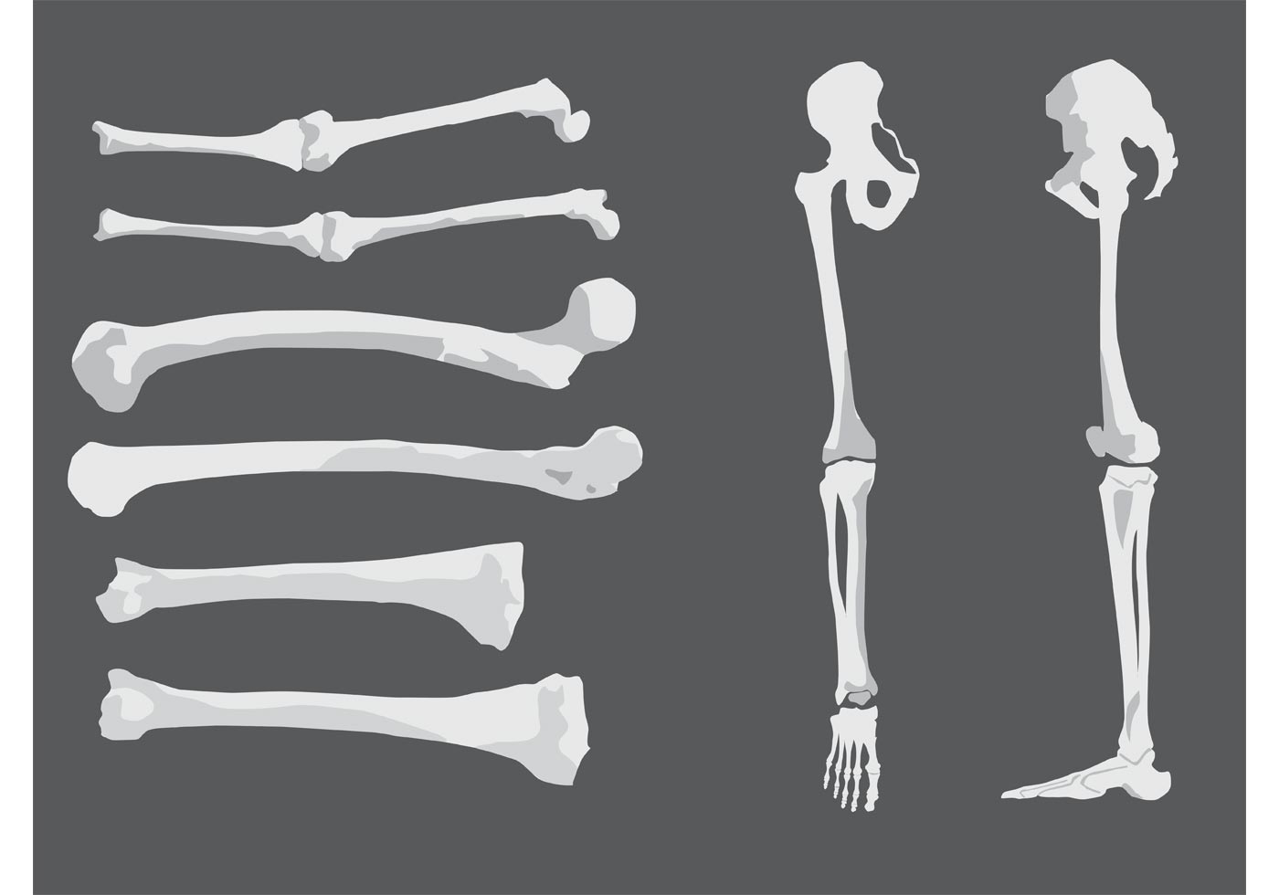
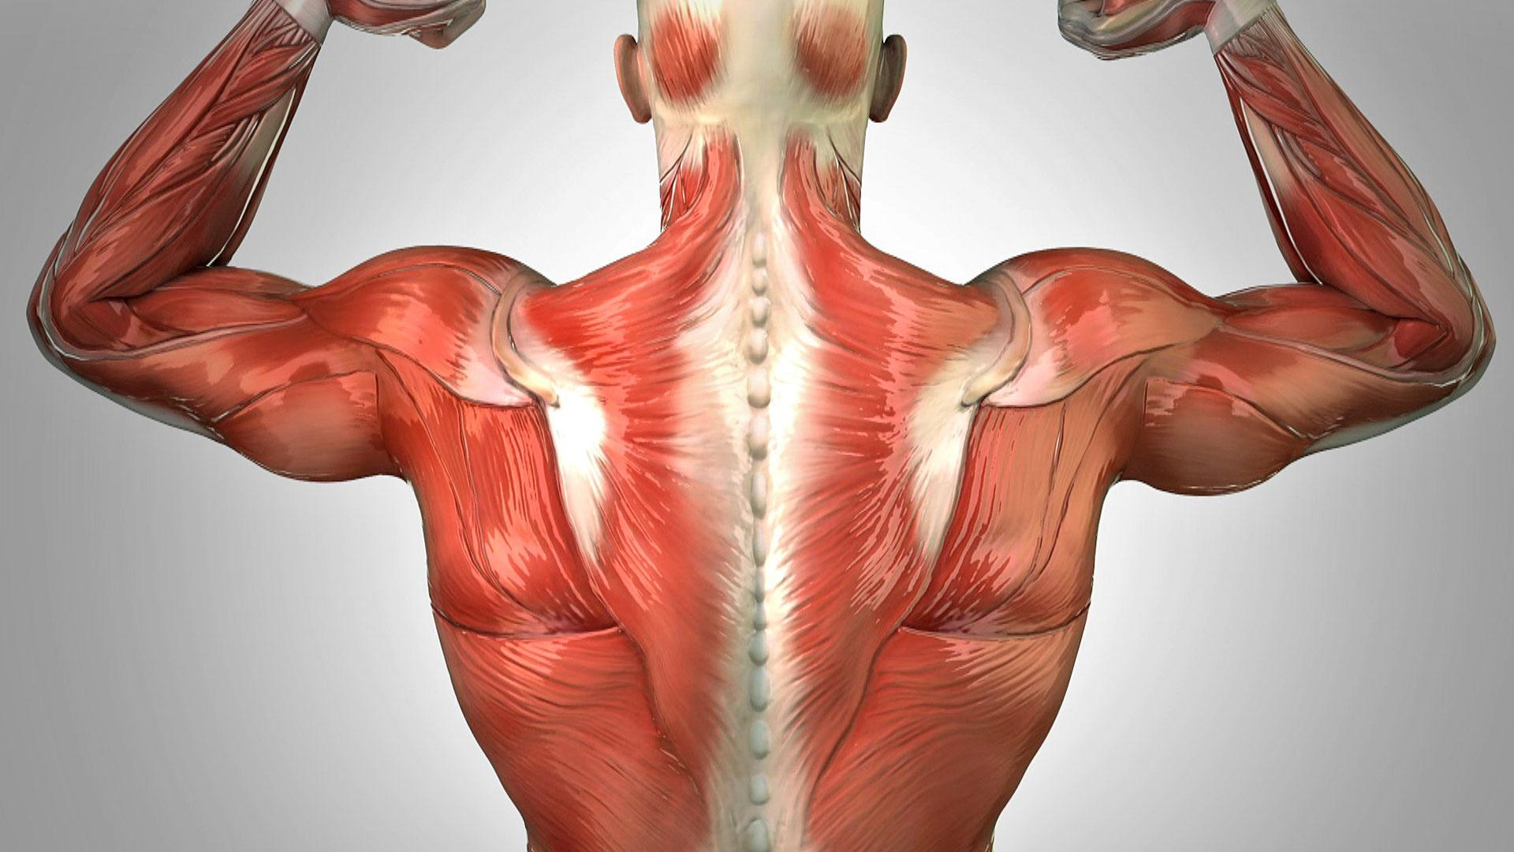

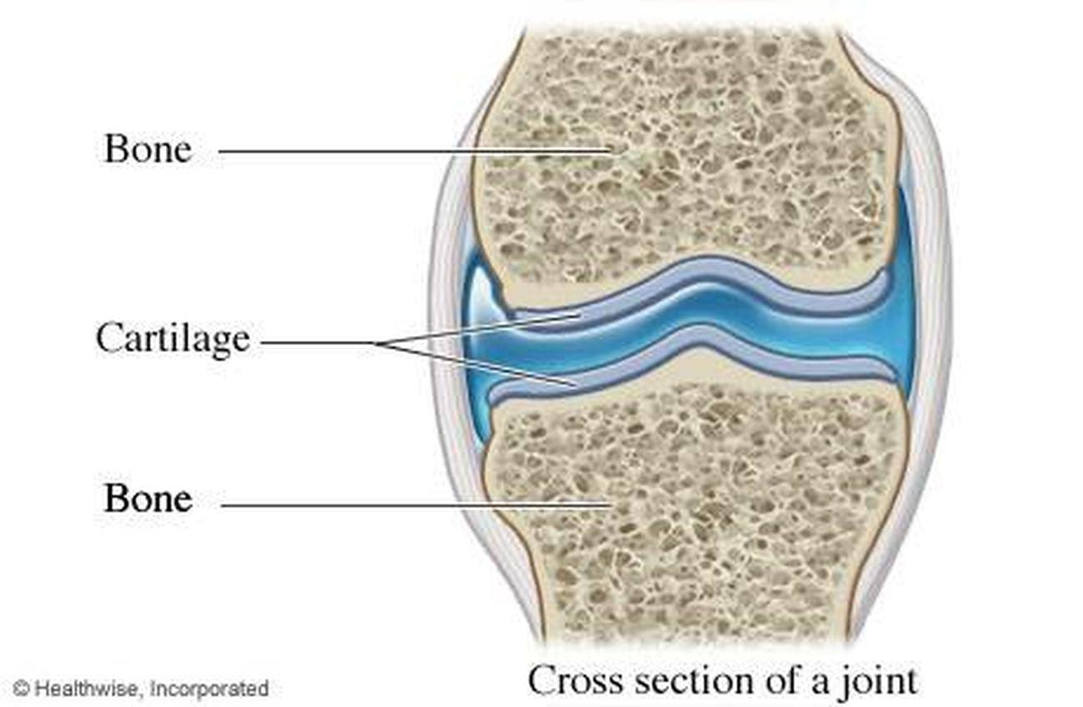

Storage:
Storage proteins house critical elements that your cells need. Hemoglobin is a vital protein that stores oxygen in your red blood cells. This critical protein is transported to all of your cells and tissues as your blood circulates. Ferritin is a storage protein that houses the crucial element iron, which helps your body make healthy red blood cells. It is composed of complex polypeptide chains and is released when needed.

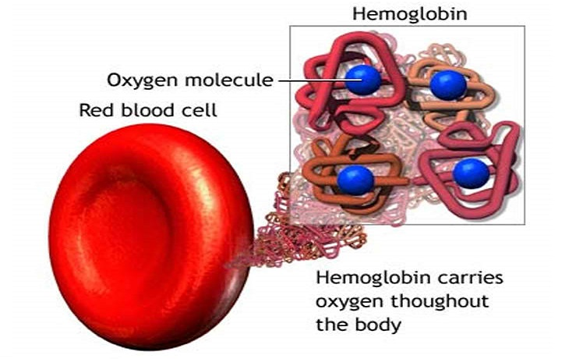

Hormonal:
Hormonal proteins act as chemical messengers. They carry signals through a complex communication process known as your endocrine and exocrine system. This system is composed of hormone producing glands and cells. Your pancreas excretes the hormone insulin, which is released in response to your blood sugar levels.
For example: Insulin is transported through your bloodstream to remove sugar when your blood sugar levels are elevated.
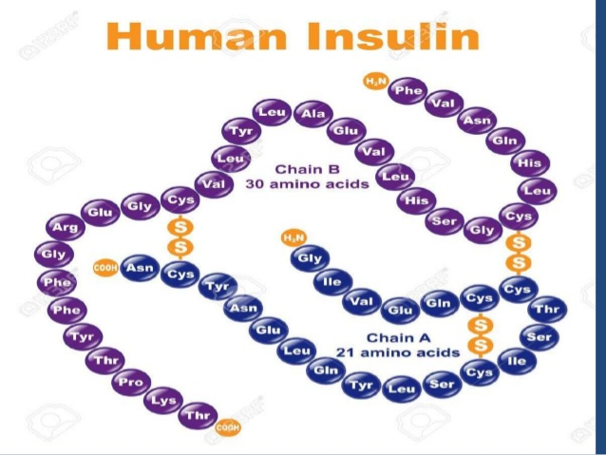

Enzyme:
Enzymes serve as biological catalysts needed for chemical reactions. Digestive enzymes help your body digest food, for instance. They split complex molecules into simple forms for your body to use. Amylolytic digestive enzymes reduce carbohydrates and starches to glucose and proteolytic enzymes reduce proteins to amino acids.

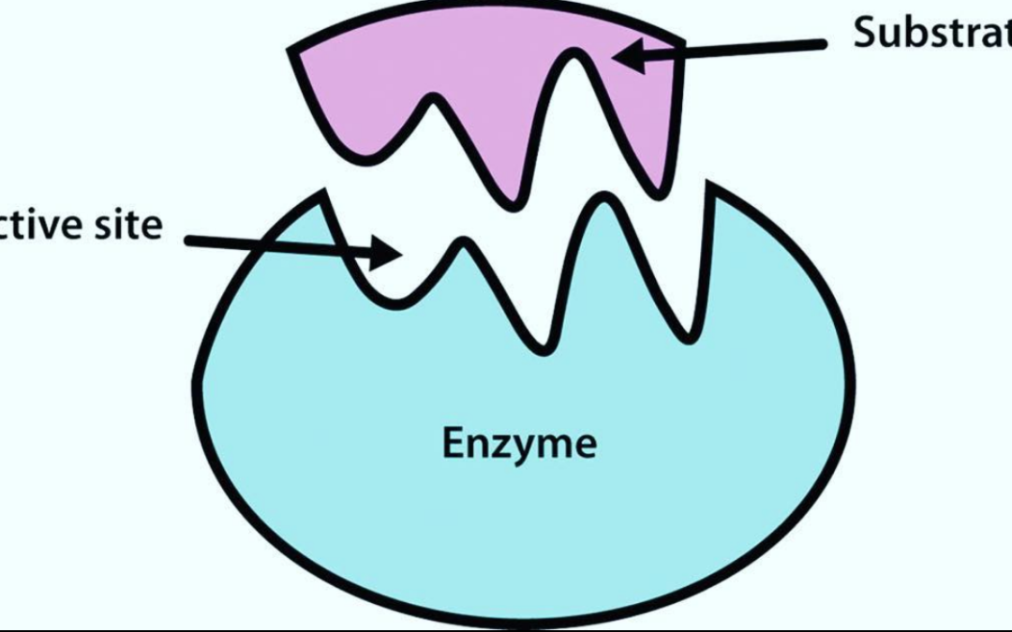

Immunoglobulins:
Your body must protect itself from invaders and other foreign substances. Immunoglobulins serve this purpose. They act as antibodies, release in response to antigen recognition. Each immunoglobulin protects against a different antigen type. Immunoglobulin A provides protection against mucosal antigens. These are bacteria or viruses found in your saliva for example.
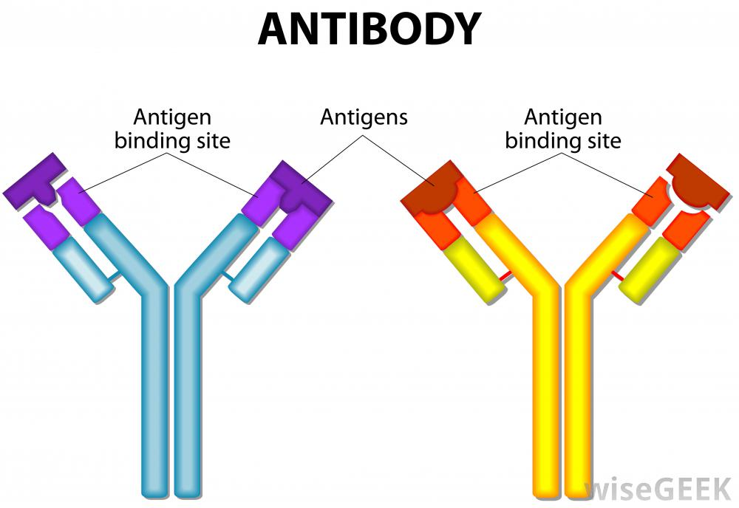

Functions of Proteins

Protein is crucial to good health.
In fact, the name comes from the Greek word proteos, meaning “primary” or “first place.”
Proteins are made up of amino acids that join together to form long chains. You can think of a protein as a string of beads in which each bead is an amino acid.
There are 20 amino acids that help form the thousands of different proteins in your body.
Proteins do most of their work in the cell and perform various jobs.

Here are 9 important functions of protein in your body:

1. Growth and Maintenance:

Our body needs protein for growth and maintenance of tissues.
Yet, our body’s proteins are in a constant state of turnover.
Under normal circumstances, our body breaks down the same amount of protein that it uses to build and repair tissues. Other times, it breaks down more protein than it can create, thus increasing our body’s needs.
This typically happens in periods of illness, during pregnancy and while breastfeeding.
People recovering from an injury or surgery, older adults and athletes require more protein as well.
Protein is required for the growth and maintenance of tissues. Your body’s protein needs are dependent upon your health and activity level.

2. Causes Biochemical Reactions:
Enzymes are proteins that aid the thousands of biochemical reactions that take place within and outside of our cells.
The structure of enzymes allows them to combine with other molecules inside the cell called substrates, which catalyze reactions that are essential to our metabolism.
Enzymes may also function outside the cell, such as digestive enzymes like lactase and sucrase, which help digest sugar.
Some enzymes require other molecules, such as vitamins or minerals, for a reaction to take place.
Bodily functions that depend on enzymes include:
- Digestion
- Energy production
- Blood clotting
- Muscle contraction

Lack or improper function of these enzymes can result in disease.
Enzymes are proteins that allow key chemical reactions to take place within your body.

3. Acts as a Messenger:
Some proteins are hormones, which are chemical messengers that aid communication between our cells, tissues and organs.
They’re made and secreted by endocrine tissues or glands and then transported in your blood to their target tissues or organs where they bind to protein receptors on the cell surface.
Hormones can be grouped into three main categories:

- Protein and peptides:
These are made from chains of amino acids, ranging from a few to several hundred.
- Steroids:
These are made from the fat cholesterol. The sex hormones, testosterone and estrogen, are steroid-based.
- Amines:
These are made from the individual amino acids tryptophan or tyrosine, which help make hormones related to sleep and metabolism.
- Protein and polypeptides make up most of your body’s hormones.
Some examples include:

- Insulin: Signals the uptake of glucose or sugar into the cell.
- Glucagon: Signals the breakdown of stored glucose in the liver.
- HGH (human growth hormone): Stimulates the growth of various tissues, including bone.
- ADH (antidiuretic hormone): Signals the kidneys to reabsorb water.
- ACTH (adrenocorticotropic hormone): Stimulates the release of cortisol, a key factor in metabolism.

Amino acid chains of various lengths form protein and peptides, which make up several of our body’s hormones and transmit information between cells, tissues and organs.

4. Provides Structure:
Some proteins are fibrous and provide cells and tissues with stiffness and rigidity.
These proteins include keratin, collagen and elastin, which help form the connective framework of certain structures in our body.
Keratin is a structural protein that is found in skin, hair and nails.
Collagen is the most abundant protein in body and is the structural protein of bones, tendons, ligaments and skin.
Elastin is several hundred times more flexible than collagen. Its high elasticity allows many tissues in your body to return to their original shape after stretching or contracting, such as your uterus, lungs and arteries.
A class of proteins known as fibrous proteins provide various parts of body with structure, strength and elasticity.

5. Maintains Proper pH:
Protein plays a vital role in regulating the concentrations of acids and bases in blood and other bodily fluids.
The balance between acids and bases is measured using the pH scale. It ranges from 0 to 14, with 0 being the most acidic, 7 neutral and 14 the most alkaline.
Examples of the pH value of common substances include (18):
- pH 2: Stomach acid
- pH 4: Tomato juice
- pH 5: Black coffee
- pH 7.4: Human blood
- pH 10: Milk of magnesia
- pH 12: Soapy water

A variety of buffering systems allows your bodily fluids to maintain normal pH ranges.
A constant pH is necessary, as even a slight change in pH can be harmful or potentially deadly.
One way body regulates pH is with proteins. An example is hemoglobin, a protein that makes up red blood cells.
Hemoglobin binds small amounts of acid, helping to maintain the normal pH value of our blood.
The other buffer systems in body include phosphate and bicarbonate.
Proteins act as a buffer system, helping your body maintain proper pH values of the blood and other bodily fluids.

6. Balances Fluids:
Proteins regulate body processes to maintain fluid balance.
Albumin and globulin are proteins in blood that help maintain body’s fluid balance by attracting and retaining water.
If you don’t eat enough protein, levels of albumin and globulin eventually decrease.
Consequently, these proteins can no longer keep blood in blood vessels, and the fluid is forced into the spaces between cells.
As the fluid continues to build up in the spaces between your cells, swelling or edema occurs, particularly in the stomach region
This is a form of severe protein malnutrition called kwashiorkor that develops when a person is consuming enough calories but does not consume enough protein.
Kwashiorkor is rare in developed regions of the world and occurs more often in areas of starvation.
Proteins in your blood maintain the fluid balance between your blood and the surrounding tissues.

7: . Bolsters Immune Health:
Proteins help form immunoglobulins, or antibodies, to fight infection.
Antibodies are proteins in your blood that help protect your body from harmful invaders like bacteria and viruses.
When these foreign invaders enter your cells, your body produces antibodies that tag them for elimination.
Without these antibodies, bacteria and viruses would be free to multiply and overwhelm your body with the disease they cause.
Once your body has produced antibodies against a particular bacteria or virus, your cells never forget how to make them.
This allows the antibodies to respond quickly the next time a particular disease agent invades your body.
As a result, your body develops immunity against the diseases to which it is exposed.
Proteins form antibodies to protect your body from foreign invaders, such as disease-causing bacteria and viruses.

8. Transports and Stores Nutrients:
Transport proteins carry substances throughout your bloodstream — into cells, out of cells or within cells.
The substances transported by these proteins include nutrients like vitamins or minerals, blood sugar, cholesterol and oxygen.
For example, hemoglobin is a protein that carries oxygen from your lungs to body tissues. Glucose transporters (GLUT) move glucose to your cells, while lipoproteins transport cholesterol and other fats in your blood.
Protein transporters are specific, meaning they will only bind to specific substances. In other words, a protein transporter that moves glucose will not move cholesterol.
Proteins also have storage roles. Ferritin is a storage protein that stores iron.
Another storage protein is casein, which is the principal protein in milk that helps babies grow.
Some proteins transport nutrients throughout your entire body, while others store them.

9. Provides Energy:
Proteins can supply your body with energy.
Protein contains four calories per gram, the same amount of energy that carbs provide. Fats supply the most energy, at nine calories per gram.
However, the last thing your body wants to use for energy is protein since this valuable nutrient is widely used throughout your body.
Carbs and fats are much better suited for providing energy, as your body maintains reserves for use as fuel. Moreover, they’re metabolized more efficiently compared to protein.
In fact, protein supplies your body with very little of its energy needs under normal circumstances.
However, in a state of fasting (18–48 hours of no food intake), your body breaks down skeletal muscle so that the amino acids can supply you with energy.
Your body also uses amino acids from broken-down skeletal muscle if carbohydrate storage is low. This can occur after exhaustive exercise or if you don’t consume enough calories in general.
Protein can serve as a valuable energy source but only in situations of fasting, exhaustive exercise or inadequate calorie intake.
Protein has many roles in our body:

- It helps repair and build your body’s tissues, allows metabolic reactions to take place and coordinates bodily functions.
- In addition to providing your body with a structural framework, proteins also maintain proper pH and fluid balance.
- Finally, they keep your immune system strong, transport and store nutrients and can act as an energy source, if needed.
- Collectively, these functions make protein one of the most important nutrients for your health

