A manufacturing company produced two types of paints p1 and p2. It needs two basic raw material, m1 and m2 two manufacture the paints. The maximum availability of material m1 is 12 tons daily and that of m2 18 tons daily. The data showing the daily requirement of the raw material are given in the following table”
Raw material | Paints |  | Availability  In tons
 | P1 | p2
M1 | 3 | 7 | 12
M2 | 5 | 9 | 18

A market survey has shown that (i) the demand per day of paints p2 cannot exceed that of p1 by more than 1.5 tons and(ii) the maximum demand for p2 is limited to 3.5 tons per day. The wholesale price per ton is RS.3500 for p1 and RS.1800 for p2.
Read the problem carefully and formulate it as an LP model to maximize the income.
Solution
Max Z= 3500X1+1800X2
The constraints are;
s/t 3X1+7X2≤12
5X1+9X2≤18
X2≤1.5+X1
X2≤3.5
With X1,X2≥0.
Max Z= 3500X1+1800X2
s/t 3X1+7X2≤12
5X1+9X2≤18
-X1 + X2≤1.5
X2≤3.5
With X1,X2≥0.

Question # 15(by corner point method)

C part
Minimize C= 3X1 + 4X2
Subject to
3X1 + 4X2 ≥ 24
2X1 + X2 ≥ 20
5X1 + 3X2 ≥ 29
X1, X2 ≥ 0
We can write it as
3X1 + 4X2 =24
if we put first x2=0 and then x1=0 we get these co-ordinates (8, 0) (0, 6)
2X1 + X2 =20
if we put first x2=0 and then x1=0 we get these co-ordinates (10, 0) (0, 20)
5X1 + 3X2 =29
if we put first x2=0 and then x1=0 we get these co-ordinates (5.8, 0) (0, 9.67)
now the graph.

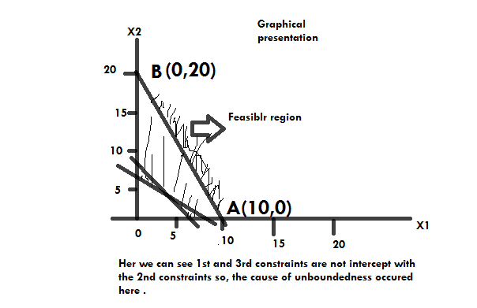

Corner points | Co-ordinates (x1, x2) | Values of objective function  C= 3x1= 4x2
A | ( 10, 0) | C= 30
B | (0, 20) | C=80

minimum c=30 optimal solution of x1=10 and x2=0 .

D part
Minimize C= 10X1 + 12X2
Subject to
3X1 + 2X2 ≥ 10
X1 -3X2 ≥ 8
2X1 - X2 ≤6
X1, X2 ≥ 0
We can write it as
3X1 + 2X2 = 10
put x2=0 then x1=0 we get (3.33, 0) (0, 5)
X1 - 3X2 = 8
put x2=0 then x1=0 we get (8, 0) (0, -2.67)
2X1 - X2 =6
put x2=0 then x1=0 we get (3, 0) (0, -6)
from 1st equation (3.33, 0) (0, 5)
from 2nd equation (8, 0) (0, -2.67)
from 3rd equation (3, 0) (0, -6)

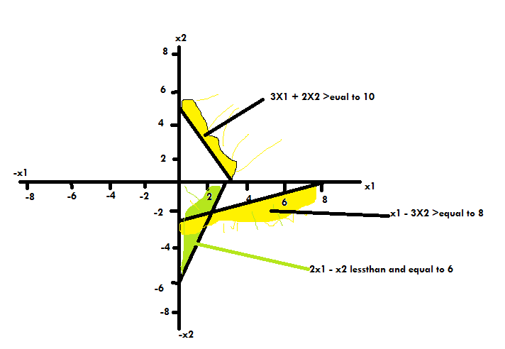

the 1st special case ( infeasibility) occurring here if we plote it on graph the feasible regeion we got two sides positive and negative side of the graph there is no suitable feasible region 0n graph.

