TORSION IN ROUND SHAFTS

Learning Objectives
At the end of this chapter you should be able to complete torsion calculations using:
- General torsion equation
- Polar moment of inertia
- Modulus of elasticity in shear
Shafts are mechanical components, usually of circular cross-section, used to transmit power/torque through their rotational motion. In operation they are subjected to:
- Torsional shear stresses within the cross-section of the shaft, with a maximum at the outer surface of the shaft
- bending stresses (for example a transmission gear shaft supported in bearings)
- vibrations due to critical speeds
This chapter will focus exclusively on evaluating shear stresses in a shaft.
General torsion equation
In the field of solid mechanics, torsion is the twisting of an object due to an applied torque. Torsion is expressed in either the Pascal (Pa), an SI unit for Newton per square meter or in pounds per square inch (psi) while torque is expressed in Newton meters (Nm) or foot-pound force (ft lbf). In sections perpendicular to the torque axis, the resultant shear stress in this section is perpendicular to the radius.
In non-circular cross-sections, twisting is accompanied by a distortion called warping, in which transverse sections do not remain plane. All torsion problems that you are expected to answer can be solved using the following formula:
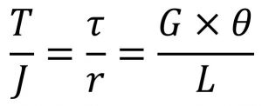
Where:
- T = torque or twisting moment, [N×m, lb×in]
- J = polar moment of inertia or polar second moment of area about shaft axis, [m⁴, in⁴]
- τ = shear stress at outer fibre, [Pa, psi]
- r = radius of the shaft, [m, in]
- G = modulus of rigidity or shear modulus, [Pa, psi]
- θ = angle of twist, [rad]
- L = length of the shaft, [m, in]
Most common torsion problems will indicate the transmitted power (kW) at a certain rotational speed (rad/s or RPM). The equivalent torque can be found with:
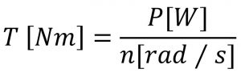
Where n[rad/s] = N[rev/min]×2π/60.
Polar moment of inertia
Similar to the moments of inertia, the polar moment of inertia represents a resistance to twisting deformation in the shaft. Note the difference between bending moments of inertia I_{c} and polar moments of inertia J, and use them appropriately. For instance, if you are dealing with a circular bar:
- I_{c} = π d⁴ / 64, if the bar is used as a beam
- J = π d⁴ / 32, if the bar is used as a shaft
Shear modulus
Called Modulus of Rigidity or shear modulus is defined (similarly as E) as ratio of shear stress to the shear strain. It is expressed in GPa or psi and typical values are given in Textbook Appendix B. Typical values are lower than Young’s Modulus E, for instance ASTM A36 steel has E_{A36} = 207 GPa and G_{A36} = 83 GPa.
Angle of twist
The torque deformation of a shaft due is measured by the twist angle at the end of the shaft. This angle of twist depends on the length of the shaft, as shown in the following figure:
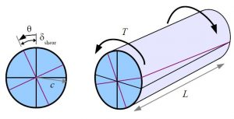
The angle of twist, [radians] is used in the general torsion equation and in estimating the shear strain, γ (gamma), non-dimensional.
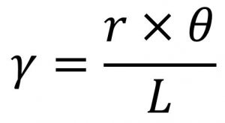
Torsional Deformation
Torque is a moment that twists a structure. Unlike axial loads which produce a uniform, or average, stress over the cross section of the object, a torque creates a distribution of stress over the cross section. When a torque is applied to the structure, it will twist along the long axis of the rod, and its cross section remains circular.
To visualize, imagine that the cross section of the rod is a clock with just an hour hand. When no torque is applied, the hour hand sits at 12 o'clock. As a torque is applied to the rod, it will twist, and the hour hand will rotate clockwise to a new position (say, 2 o'clock). The angle between 2 o'clock and 12 o'clock is referred to as the angle of twist, and is commonly denoted by the Greek symbol phi. This angle lets us determine the shear strain at any point along the cross section.
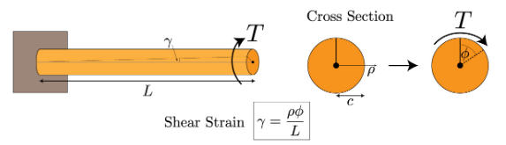
The relationship between torque and shear stress is detailed in section 5.2 of your textbook, and it results in the following relation:
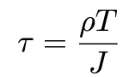
J denotes the second polar moment of area of the cross section. This is sometimes referred to as the "second moment of inertia".
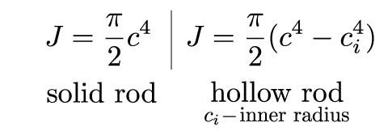
The equation for the angle of twist is given as follows
