Lecture No 04
Energy Sources
Battery or Cell
Battery or cells are referred to as the parallel combination of electrochemical cells. The major difference between a primary cell and the secondary cell is that primary cells are the ones that cannot be charged but secondary cells are the ones that are rechargeable.

Primary cell
Primary cells have high density and get discharged slowly. Since there is no fluid inside these cells they are also known as dry cells. The internal resistance is high and the chemical reaction is irreversible. Its initial cost is cheap and also primary cells are easy to use.

Secondary cell
Secondary cells have low energy density and are made of molten salts and wet cells. The internal resistance is low and the chemical reaction is reversible. Its initial cost is high and is a little complicated to use when compared to the primary cell.

Difference Between Primary Cell and Secondary Cell
Primary Cell | Secondary Cell
Have high energy density and slow in discharge and easy to use | They are smaller energy density
There are no fluids in the cells hence it is also called as dry cells | There are made up of wet cells (flooded and liquid cells) and molten salt (liquid cells with different composition)
It has high internal resistance | It has a low internal resistance
It has an irreversible chemical reaction | It has a reversible chemical reaction
Its design is smaller and lighter | Its design is more complex and heavier
Its initial cost is cheap | Its initial cost is high

Dry Cell
A dry cell is one type of electric battery, which is generally used for the home and portable electronic devices. A battery is a device that consists of one or more electrochemical cells, which converts chemical energy into electrical energy. Nowadays, the most commonly used batteries are dry cell batteries, which vary from large flashlight batteries to minimized flashlight batteries and are mostly used in wristwatches or calculators.
A dry cell is an electrochemical cell consisting of low moisture immobilized electrolytes in the form of a paste, which restricts it from flowing. Due to this, it is easily transportable.

Working principle and types of dry cells
Depending on the nature of the dry cell, it can be classified as a primary cell and the secondary cell. A primary cell is the one which is neither reusable nor rechargeable. Once the electrochemical reactions consume all the chemical reagents, they fail to produce electricity. On the other hand, a secondary cell can be rechargeable by using battery charges, to regenerate the chemical reactions.
Voltage and current of a cell
The voltage rating of a cell is given by its open circuit voltage i.e. voltage it can produce when not connected to a load circuit. This voltage depends on the type of the material used and not on the physical size of the cell. The capacity of the cell depends upon the amount of current it can supply to the external load.
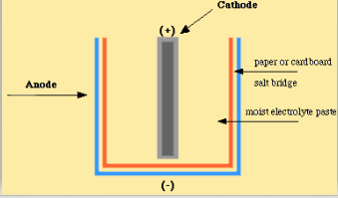

1. Zinc-Carbon cell
A dry cell consists of a metal container in which a low moisture electrolyte paste covers the graphite rod or a metal electrode. Generally, the metal container will be zinc, whose base acts as a negative electrode (anode) and a carbon rod acts as a positive electrode (cathode). It is surrounded by manganese dioxide and low moisture electrolyte like ammonium chloride paste, which will produce a maximum of 1.5V of voltage, and they are not reversible.
Size and voltage
These cells are available in different sizes and have open circuit voltage from 1.4 to 1.6 V regardless of size. Larger cells with more zinc, electrolyte have a higher current up to 0.25 a or 250 mA.

Alkaline Battery
An alkaline battery is a type of primary battery which derives its energy from the reaction between zinc metal and manganese dioxide.
Compared with zinc-carbon batteries of the types, alkaline batteries have a higher energy density and longer shelf life, yet provide the same voltage.
Alkaline batteries are used in many household items such as MP3 players, CD players, digital cameras, toys, flashlights, and radios.
The capacity of an alkaline battery is greater than an equal size Leclanché cell or zinc chloride cell because the manganese dioxide is purer and denser, and less space is taken up by internal components such as electrodes. An alkaline cell can provide between three and five times the capacity of an acidic cell. The nominal voltage of a fresh alkaline cell as established by manufacturer standards is 1.5 V

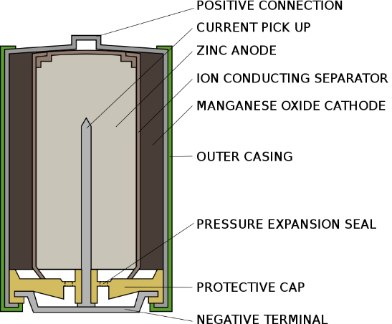

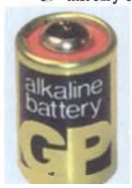
- Manganese Alkaline Cell
It is a primary cell having zinc as anode and manganese dioxide as cathode in a leak-proof steel can. Due to high conductivity of electrolyte, this cell has higher current rating than a carbon-zinc cell. It provides an output voltage of 1.5 V.

- Mercury Cell
The Mercury cell, also called “Mercury battery, Mercury oxide battery” is a primary cell, which is a non-rechargeable, non-reusable electrochemical battery. The Mercury cell is a type of dry cell consisting of zinc anode, mercuric oxide cathode and potassium hydroxide as electrolyte.

Working Principle of Mercury Cell
The Mercury cell is a type of primary cell which is non-reusable, non-rechargeable, that is the electric cell produces current by irreversible chemical reactions. In a mercury cell, mercury compound acts as a cathode where reduction reaction occurs and the zinc compound acts as an anode, where oxidation reaction takes place. Sodium hydroxide or potassium hydroxide used as an electrolyte that ionizes in a molten state to conduct electricity.
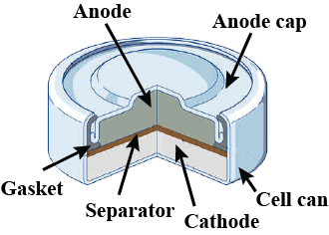

Such cells are available in wide range of shapes and sizes. The smallest being about 3 mm thick and 12.5 mm in diameter. It open circuit voltage is 1.4 V.
Lead Acid Battery
Lead-acid batteries can be classified as secondary batteries. The chemical reactions that occur in secondary cells are reversible. The reactants that generate an electric current in these batteries can be regenerated by passing current through the battery (recharging).
The chemical process of extracting current from a secondary battery (forward reaction) is called discharging. The method of regenerating active material is called charging.
- The sealed lead-acid battery consists of six cells mounted side by side in a single case. The cells are coupled together, and each 2.0V cell adds up to the overall 12.0V capacity of the battery.
- Despite being relatively heavy, lead-acid batteries are still preferred over other lightweight options owing to their ability to deliver large surges of electricity (which is required to start a cold engine in an automobile).
- A completely charged lead-acid battery is made up of a stack of alternating lead oxide electrodes, isolated from each other by layers of porous separators.
- All these parts are placed in a concentrated solution of sulfuric acid. Intercell connectors connect the positive end of one cell to the negative end of the next cell hence the six cells are in series.

Photoelectric Devices
Photoelectric transducers are devices capable of converting light energy into electrical energy. In this respect only a limited number of photoelectric components comply with such a definition—that is, photovoltaic devices, which specifically generate electricity when light falls on them. We consider only semiconductor devices which are self-generating (1) photovoltaic cell (2) solar cell
Photovoltaic Cell
In this type of cell light energy is used to create a potential difference which is directly proportional to the frequency and intensity of incident light. It consists of piece of semiconductor material such as Si(silicon),Se (selenium) or Ge(germanium) bounded to metal plate.
When light falls on the semiconductor, holes and electrons are produced from the crystal structure. These electrons flow out of the semiconductor into the metal and holes flow in the opposite direction. That it creates the p.d between semiconductor and metal, thus current flow through the load.

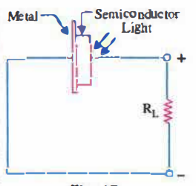

Solar Cell
A solar cell is a sandwich of n-type silicon (blue) and p-type silicon (red). It generates electricity by using sunlight to make electrons hop across the junction between the different flavors of silicon:
1.When sunlight shines on the cell, photons (light particles) bombard the upper surface.
2.The photons carry their energy down through the cell.
3.The photons give up their energy to electrons in the lower, p-type layer.
4.The electrons use this energy to jump across the barrier into the upper, n-type layer and escape out into the circuit.
5.Flowing around the circuit, the electrons make the lamp light up. The current is directly proportional to the illumination (mW/cm²). It also depends upon the surface area being illuminated. The open-circuit voltage is also function of illumination.
6. Solar cells are available in flat strip to cover large surface area.
