Project Idea Report
Citizenship Education and
Community Engagement
BS Botany
Name of Student:
ZIA ULLAH
Roll No:
BBTF19BM007
Group:
(10)
Program:
BS-BOTANY (2nd SEMESTER)
Session:
2019-23
-----------------------------------------------------------------------------
Project #01
- Title of the Project: -
Free tuition for up to fifth class.
- Introduction: -
As everyone knows that, schools are closed due to pandemic outbreak of covid-19.the students of the schools especially primary school students are wondering here and there in these vacations and they are spending their most important time in unconcern activities like playing Ludo. So, I have decided to study these students freely at my home.in this way they will be concentrated to their studies and will be safe from concern activities.so that their precious time will be spend in good activities. I will also motivate them for good activities to enhance their self-confidence.
- Background of the problem: -
Coronavirus disease had become the problem of many countries. First confirmed case of covid-19 traced back to november17, 2019 in Wuhan, China. Then it broke out many other countries resulting in an ongoing pandemic. By 20 January there were reports of confirmed cases from three countries outside china; Thailand, Japan and South Korea. As of 15 April 2020, all countries started to adjust their response measures. Its first two cases in Pakistan were reported on 26 February which one was in Sindh when a student in Karachi tested positive and second patient was from federal territory of country. Both patients had recently returned from Iran. By 18 march cases had been registered in all four provinces, the two autonomous territories, and the federal territory of Islamabad. Then, it broke out in whole country. The country put under a nation-wide lockdown until 9 may. On 21 May, the number of positive cases passed 48,000, and death toll reached 1,017, as the number of recoveries reached 14,155. Due to the lockdown all educational institution was closed.

  - Present situation: -
As of 5 June 2020, there have been about 89,200 confirmed cases with 31,200 recoveries and 1,840 deaths in the country. Sindh has recorded the most cases at over 33,500, while Punjab has reported the most deaths in the country, a total of 629. A lockdown is imposed in country till 9 May and then extend for two times. Due to this lockdown educational institution were closed, and children were wasting their time in playing with each other in playgrounds whole day. Because children were relaxed from studies. They did not pay heed to online classes on television (tele school channel) where teacher was physically absent and due to lack of resources. So, they were wasting their precious time. Their interest in studies will tend to become nil.

- Justification of the Project: -
In justification of my project I will say that the children who were wandering here and there in these days so I did this activity so that they remain in control and save their lives by following lockdown. I taught all the students so that they did not waste their time and full concentration to their studies. I motivated them to study hard to get lectures from myself. I forced them to do their homework daily. I gave their performance to their parents. I will I will say their parents to control their activities of life and way to do their homework in their homes. In this way I satisfied not only children’s but also their parents. Second children followed lockdown by my awareness and adapt the safety measures about corona. They remained in contact with their studies. When I preformed this activity many youngsters of my area impressed from this activity and told me that they also started free tuition for children. This activity not only covered their studies loss but also kept them away to go in playgrounds and met with other children.

- Importance of the Project Activity:
Students of our area got benefit from this activity. I prepared lectures for them and delivered lectures to them. Indirectly, I supported the students and their parents financially. Before this activity children were roaming here and there in their leisure time. They came out of their houses in order to spend their free time. So, after this activity they stayed in their houses and spend their free time in learning. They followed the rules of lockdown and precautions measures of corona due to my efforts such as awareness about corona and guidance to follow lockdown. Finally, with this project I proved myself an active citizen, satisfied the children, relaxed their parents, decrease the loss of children in studies and save children from pandemic corona.
When I saw the interest of students and following lockdown and safety measure, I realized that we should become an active citizen by doing such kinds of activities not only for purpose of a project but only for sake of humanity.
- Practical implications: -
- (Who got benefits of the activity?): -
Children got benefit because I provided them lectures. I also got benefit from this activity because due to reparation of lectures for children I also increased my knowledge. The parents of these children also got benefit because I minimized their stress which was due to loss of their children studies. I provided them motivation that they should stay at home and pay heed to their studies and not go out. Community also got benefit because when children follow safety measures and not met to each other, stay at home then whole community got protection. I also decided to aware the children about the covid-19 due to which they maintained social distance, wear masks and sanitized their hands
- Objectives of the Project: -
Main object of the project was that I wanted to indulge children in their studies. Indirectly, I wanted to help my community to keep protect them from Covid-19 by convincing them to stay home. Indirectly, I wanted to decrease the illiteracy rate of my area. I also wanted to relax their parent who was worried about their studies. I also wished to motivate other citizens for such activities so that they also do such kinds of activities as a good citizen. I also wanted to reduce the pressure of parents and tension of students.
- Plan of Action: -
- How I did this project activity?
  - First of all, I took complete information about tele school channel from u tube. Then I made a survey of area on 15 April, with help of my elder brother because he recognized the people of area well. We went to their houses and met with their parents. We told them about the present situation of corona and asked them to send their children to me for learning. I asked them about the tele school channel and ensured that it is not applicable in our area or for your children due to lack of resources. Some parents were thinking that I am doing all that for purpose of money. So, I satisfied them I wanted to help these students and reduced the pressure of parents I did not want fee. Some of them were not ready to send their children due to corona. So, I ensured that I would keep social distance and cared their students. So due to our efforts 14 students were ready for learning. I told them about time and guided them to be punctual.
  - I saw the first telescope lectures to children on 17 April by using laptop. As they entered in our home a guided them to wash their hands and made it their routine. Then I provided them mask and said to them they should wear it daily. I sat them with distance and guided them to follow social distance at every place not only here.
  - I guided them to do Work assigned by me through channel. On next day I checked the previous homework. When I saw the interest of students and following lockdown and safety measure I realized that we should become an active citizen by doing such kinds of activities not only for purpose of a project but only for sake of humanity and I realized that I got the purpose of my project to greater extent.

TEST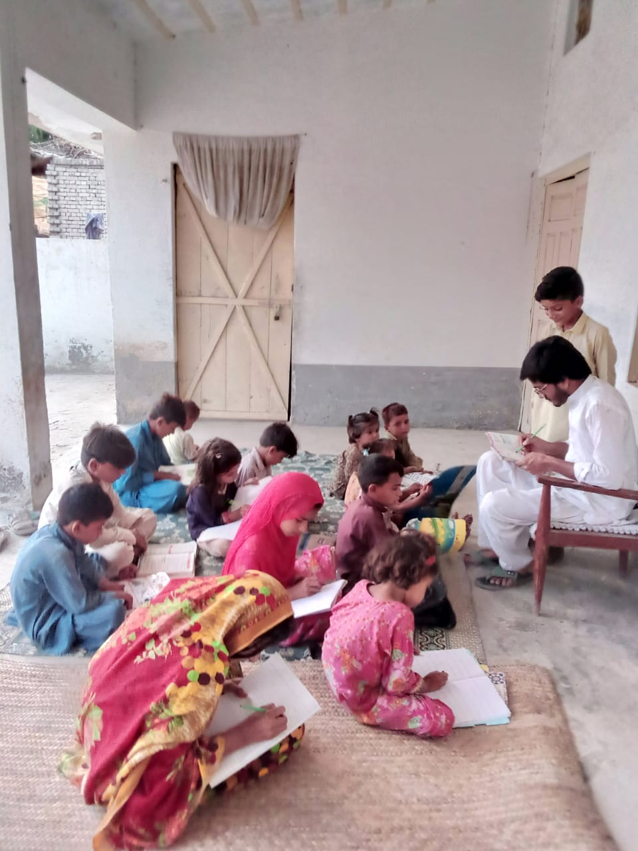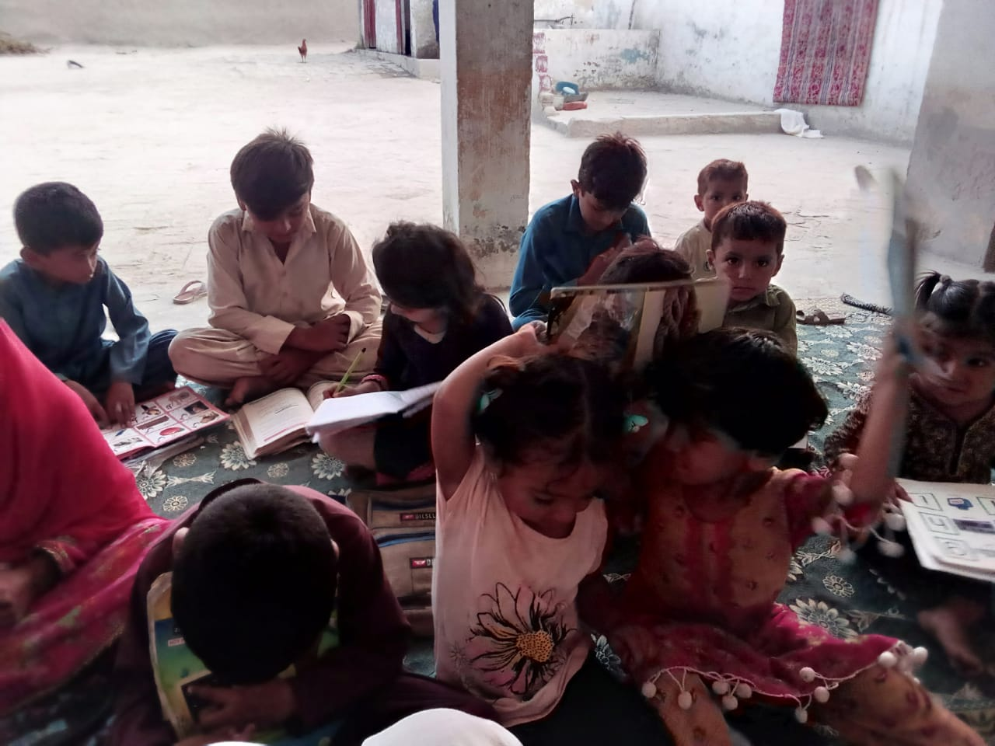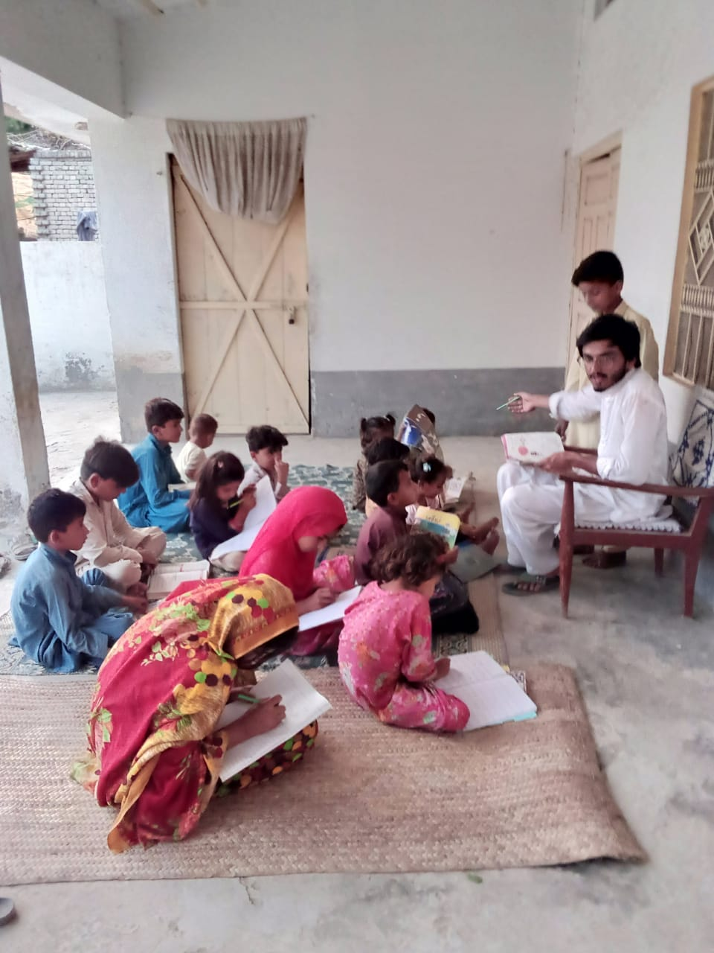Class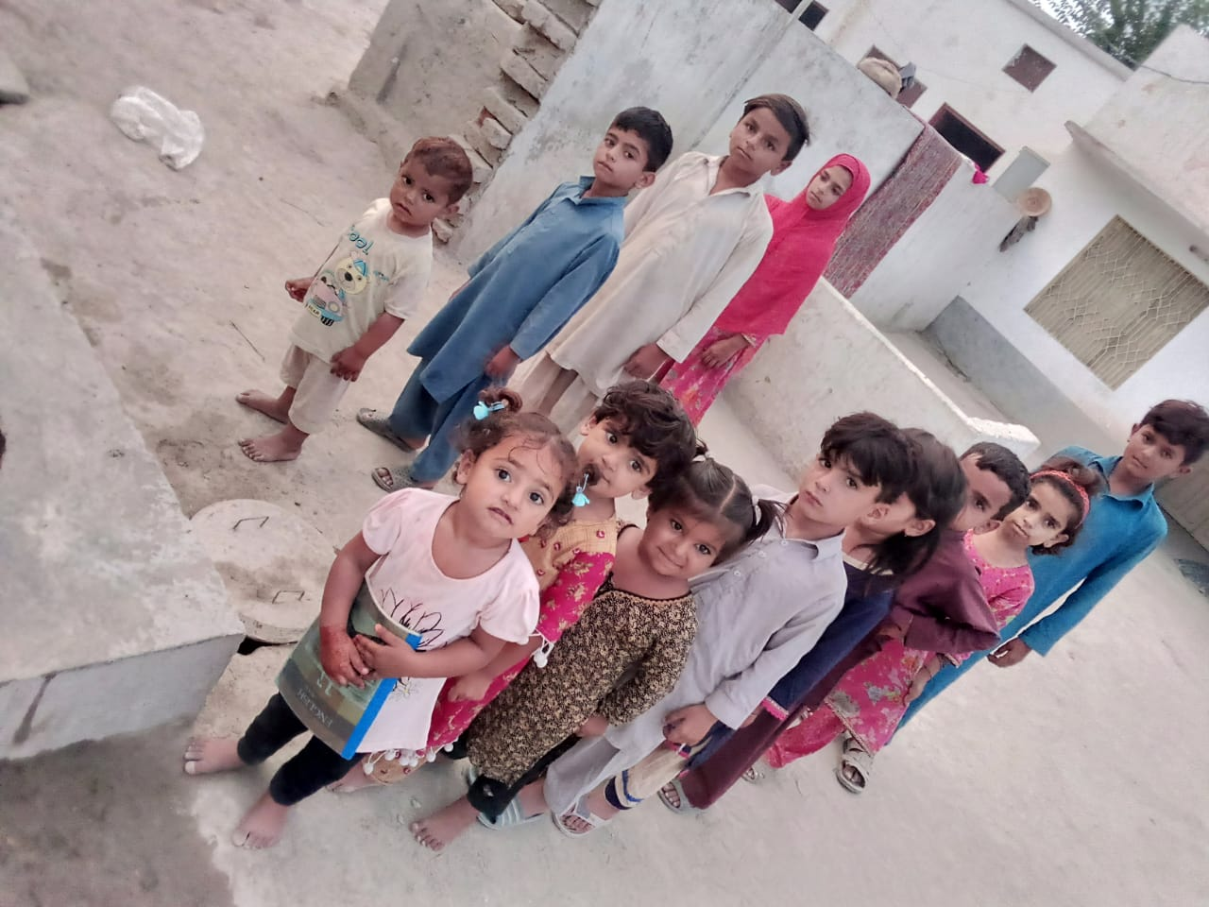 Handwashing

- Needed resources & the source of generation (financial, human resources etc.)
Resources were my mobile or laptop and also internet connection. I also involved in this activity as human resource. I bought mask and hand wash with help of my pocket money.

- Each person’s role in the project: -
I'm one who was involved in this project. I did all that project individually. My family supported me in this activity.
- Proposed duration of the project: -
I would serve children until the reopening of schools. So, it may take duration of one month or more.

- How I evaluate my project for possible outcomes?
- I provided a peaceful environment to children during their studies so they gave us good response.
- I also realized that they were taking their interests when I checked their studies and home works.
- I realized that they restrict their unconcern activities when I started that project.
- I myself follow punctuality and in this way, I selected good time for children study such as morning and second time, it's all depend upon my home working.
- I remained in contact with their parents and request them to give attention to their children in this activity and in return they gave me good response.
- I ensured their course coverage with the help of tests.
- I decided to contact their parents because they belong to my village.

--------------------------------------------------------
Project #02
- Title of the Project: -
Awareness of COVID-19 On the Shops and petrol pump.
- Introduction:
I belong to village and also this area is rural as well, so most of the people were not aware from the preventive measures and all awareness of COVID-19, So I decided to aware all the people of my area villages by hanging posters and making circles at three different shops and one petrol pump from the corona preventive measures. I used drawing in my posters for attraction such as usage of colorful pencils and making rainbow in these posters. I hope most of the people of this area aware completely by my project. So, I have decided to hang posters on the three different shops of different villages and also made circles at these shops with the help of lime.
- Background of the problem:
This disease caused by the novel coronavirus first identified in Wuhan, China, has been named coronavirus disease 2019 (COVID-19)- ‘CO’ stands for corona, ’VI’ for virus, and ‘D’ for disease. Now this virus is spreading all over the World very accelerating speed. This virus destroyed many countries economy very much such as Italy, China, Iran and many other developing countries. Its first case was reported on 26 February 2020 in Sindh, and then whole of the World as well as Pakistan is facing this pandemic disease.
- Present situation:
The present situation was very critical in these days, every province of the Pakistan is facing with this virus, all the medical staff, our police and Pak army are on the front line now a days, and they are fighting with their beats of heart to control this disease. The medical equipment's are now completed with the help of China. The current situation of COVID-19 cases from 31 march to 27 April 2020 is as following.
 | Confirmed Cases | Active Cases | Deaths | Recoveries
AJK | 59 | 24 | 0 | 35
Baluchistan | 781 | 592 | 13 | 176
GB | 318 | 96 | 3 | 219
Islamabad | 245 | 213 | 3 | 29
KPK | 1864 | 1251 | 98 | 515
Punjab | 5446 | 4180 | 83 | 1183
Sindh | 4615 | 3662 | 81 | 872
- Justification of the Project:
As we know that the villages were unaware from the updates of every moment that was carrying in their City.so in this way the villages were also unaware from the pandemic disease of covid-19. All the people belonging to the ruler areas were not sensible to the Corona virus. So, in this way by hanging posters at shops and petrol pump and also making circles at the shops with the help of lime they got much information about corona virus.
- Importance of the Project Activity:
As I described earlier that I belong to village of rural area, the people here were not taking seriously the pandemic disease of corona virus and did not follow the preventive measures of this disease. The most of the people were employers and they were not aware of the COVID-19 preventive measures and all about the awareness of the corona virus that is accelerating very much in the World. I hope by doing this activity all people were aware from my posters and they followed the instructions and preventive measures.
- Practical implications: -
(Who got benefits of the activity?)
As the people who came to shops and petrol pump be able to get the benefits of my project. As I know from every home different member came to the shops to buy their goods. As we also now different people also came to shops as well petrol pumps every day. So, everyone who came to the shops and petrol pump got the benefits, awareness and preventive measures about virus.
- Objectives of the Project: -
- First one to make people sensible about Corona virus.
- Providing them essential knowledge of prevention about the disease of covid-19.
- Providing them essential knowledge about Corona virus.
- Marking them capable to fight against Corona virus in their rural areas.
- By doing this giving them sense of disease that is a spreading highly.
- All that made people to get rid of making jokes on such diseases in these difficult days.
- Plan of Action: -
- How I done this project activity?
- First of all, I made some posters.
- I hanged these posters at different shops in the care of shopkeepers.
- I insist the shopkeepers to read out these posters by their customers.
- I hung posters at the petrol pump where they can be easily read out.
- By making circles of lime at shop the customers was able to follow social distancing.
- I made round circles after every 3 days.
- The process was repeated and comprise of two weeks.
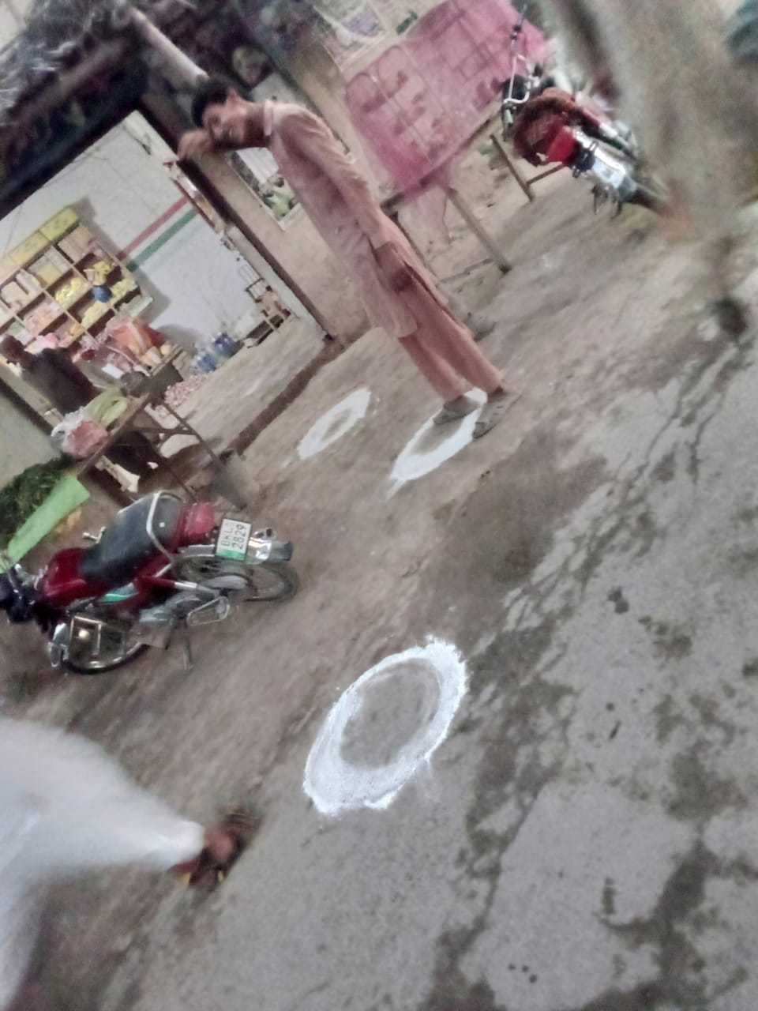
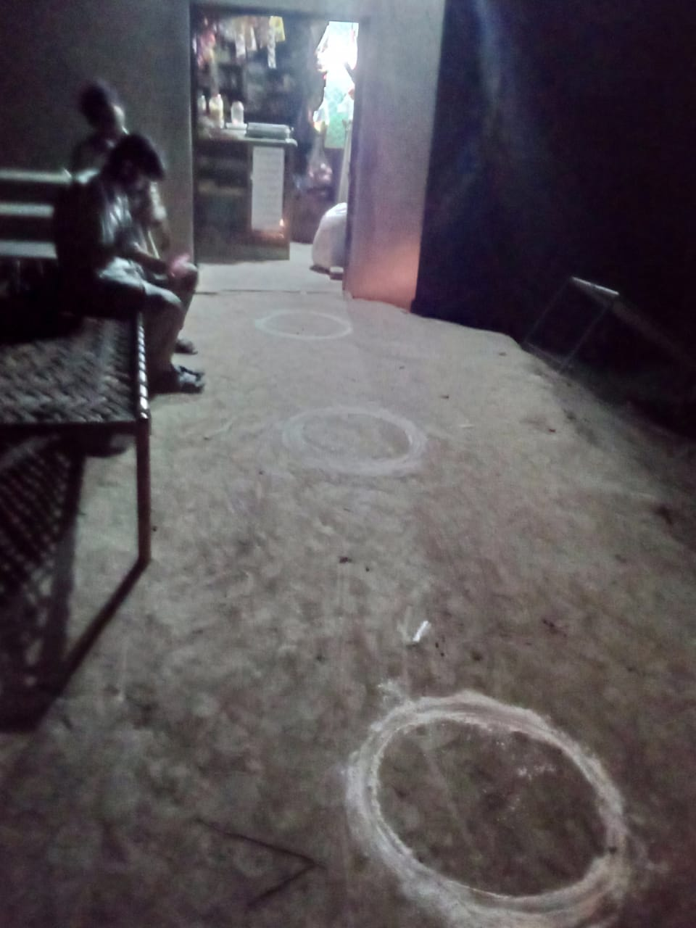
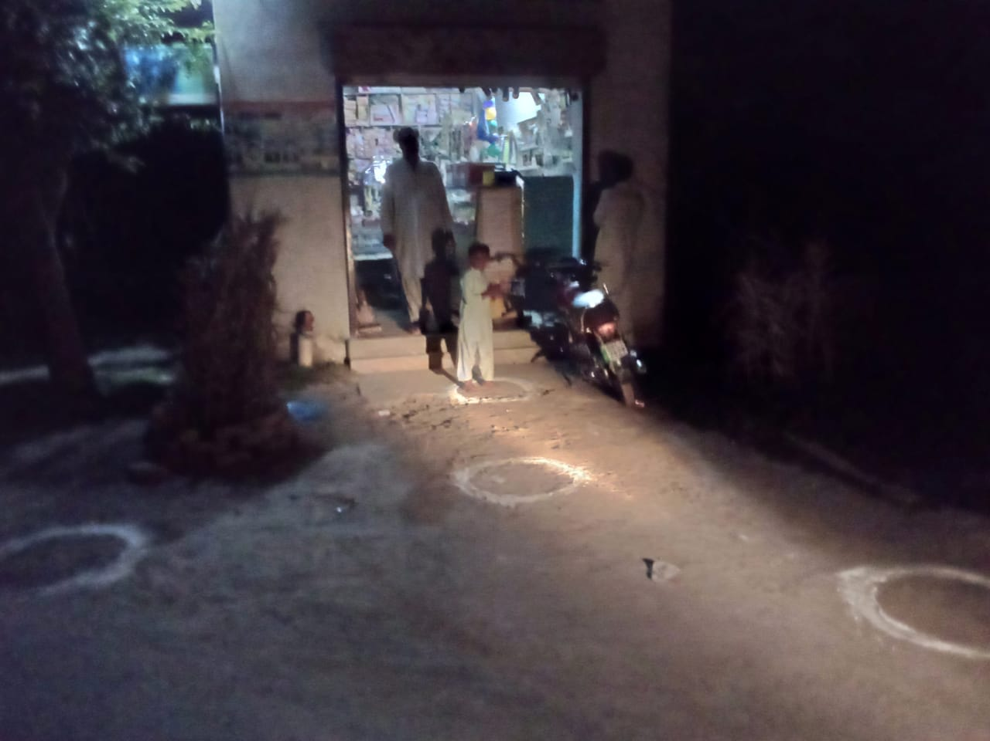
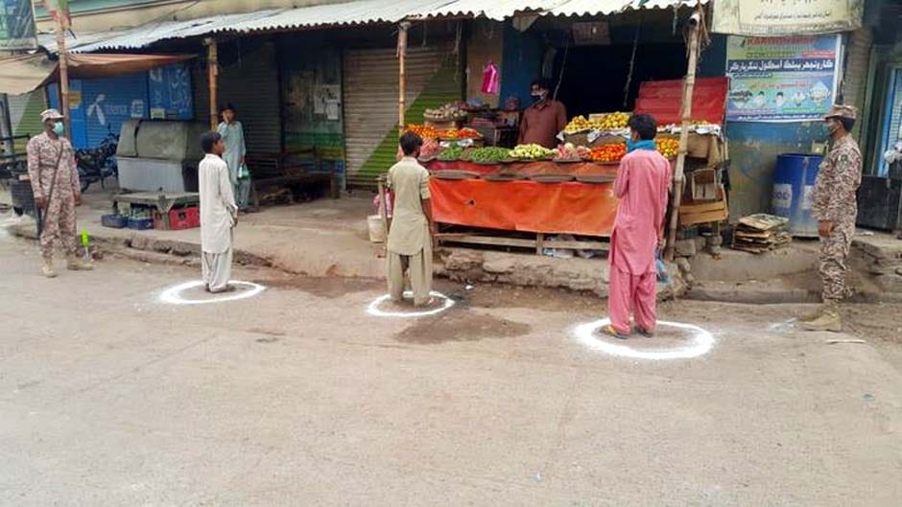
WHITE CIRCLES AT SHOPS
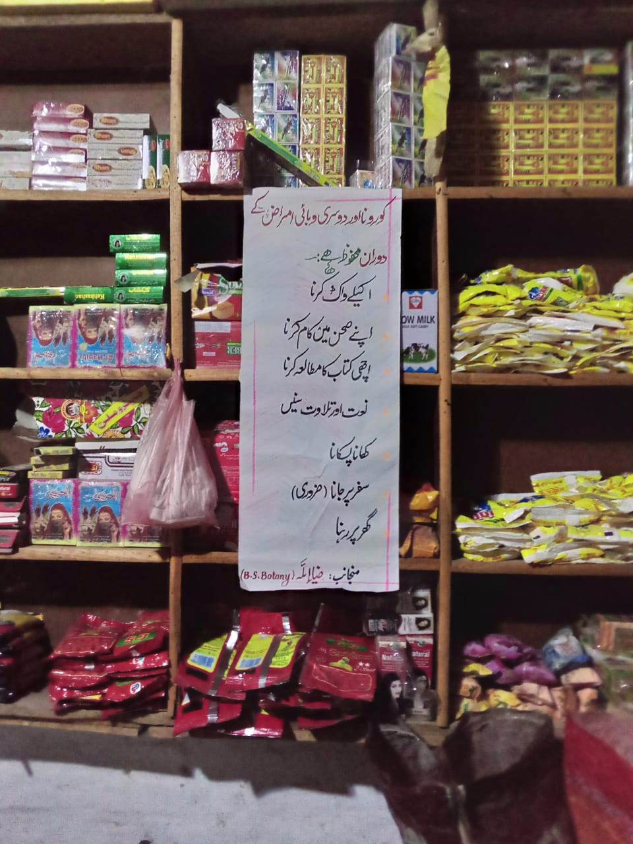
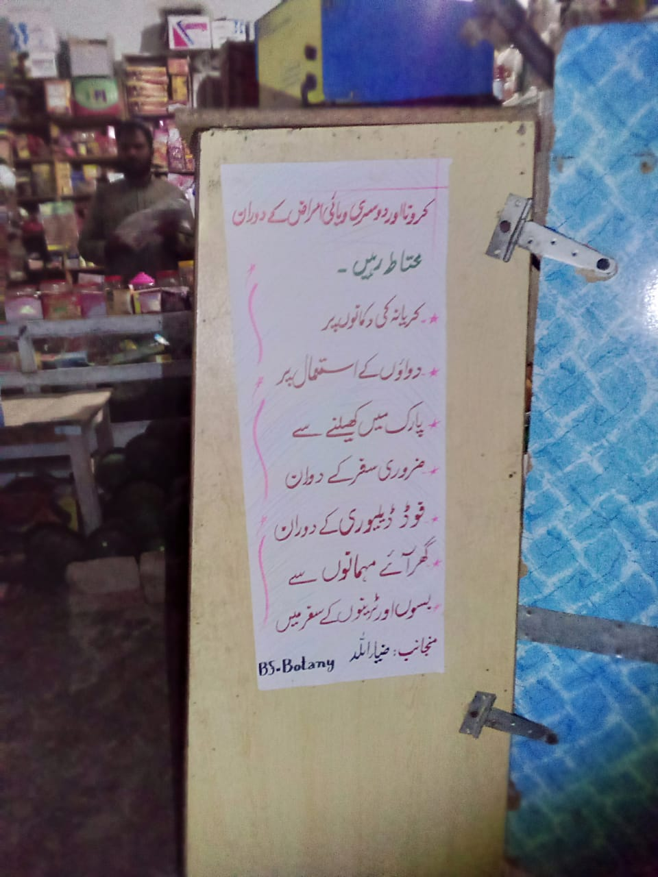
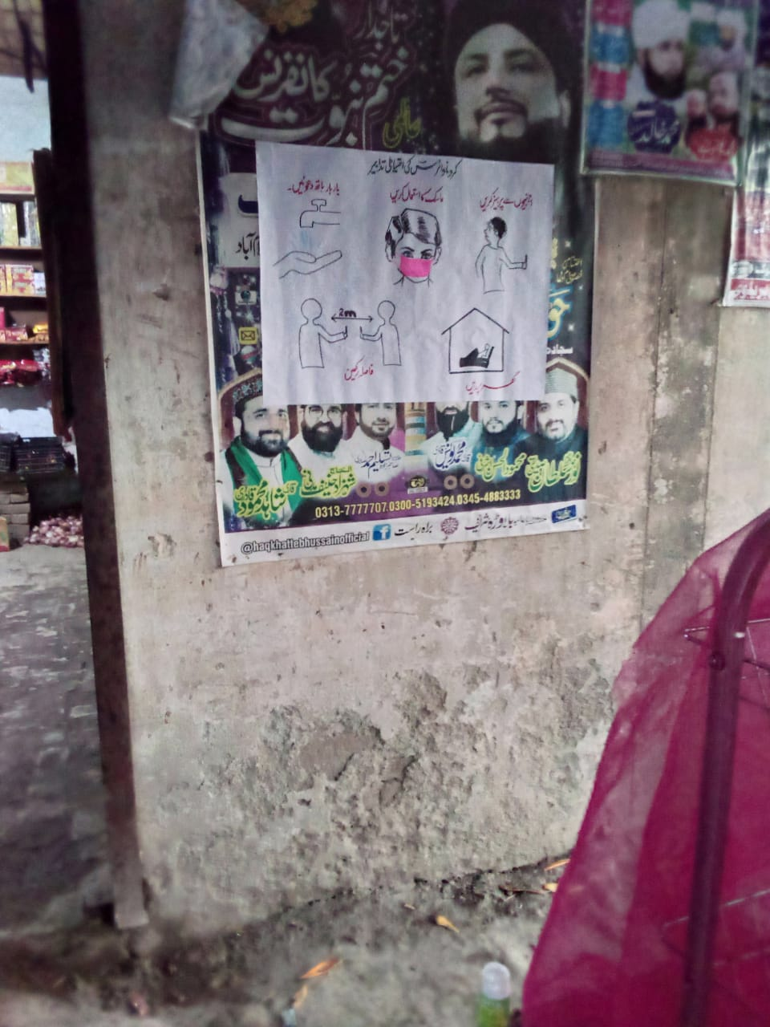
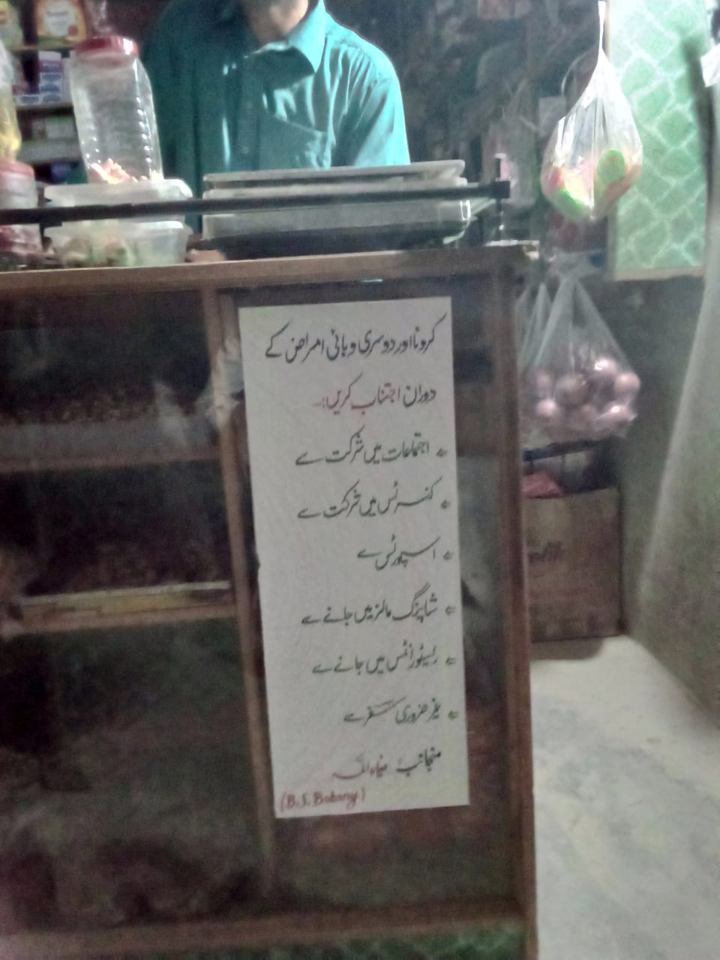
POSTER HANGING AT SHOPS
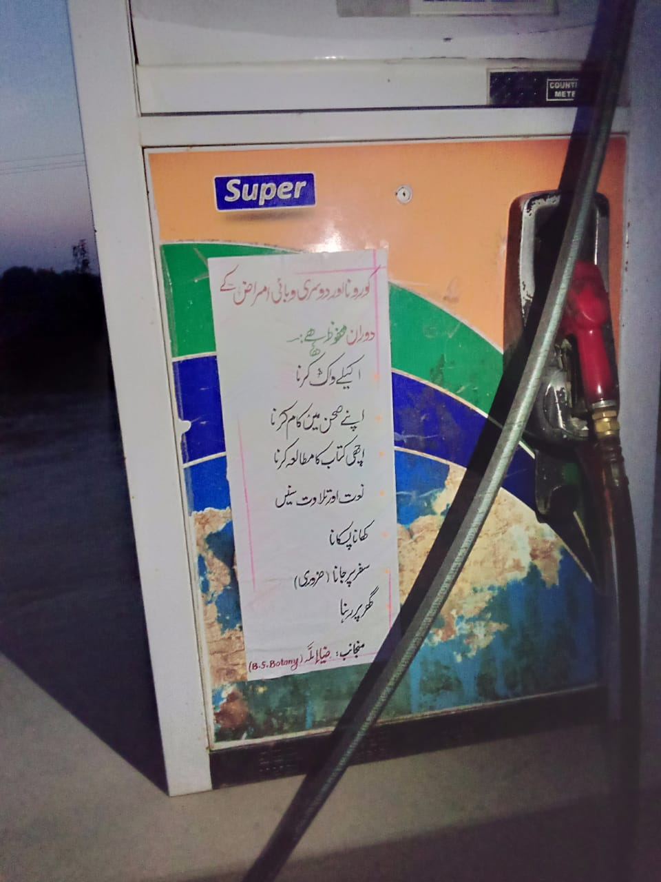
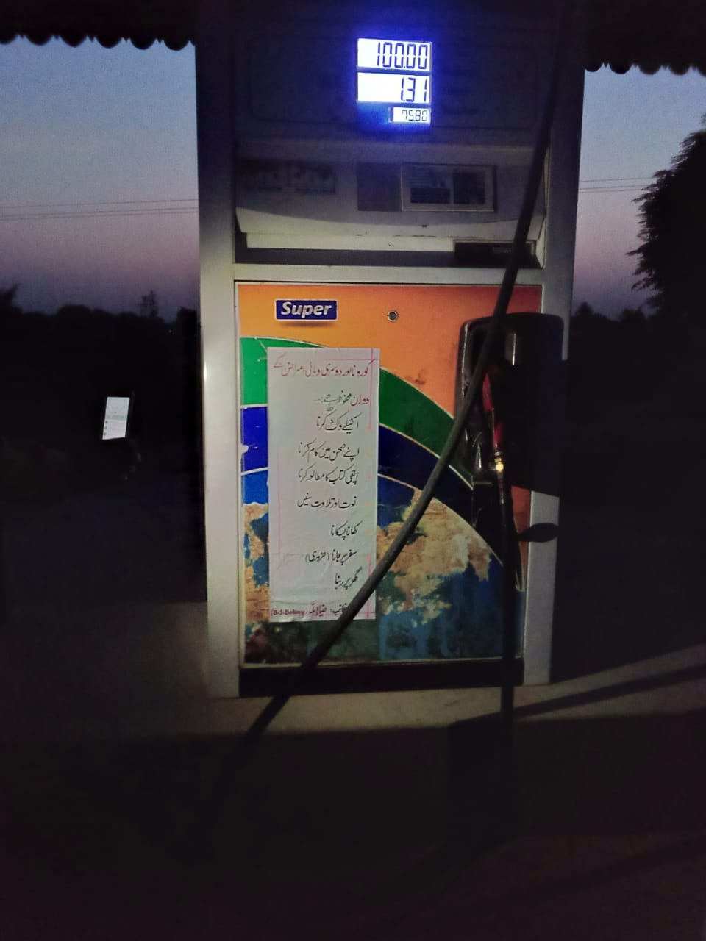
Charts (poster) at petrol pump

- Needed resources & the source of generation (financial, human resources etc.)
- This project was very essential in those days but it was not expensive.
- I have needed some charts colorful pencils to make charts beautiful.
- I have also needed some amount of lime and bicycle tire to make circles.
- All that is carried out by my pocket money.
- I have needed three responsible persons to help me in that way and I got my cousins for this purpose because they are well educated. And one of them is a school teacher and he prove better for my project.

- Each person’s role in the project: -
- Each person role in the project was extraordinary special my cousin who is the school teacher has done well role in my project.
- I also got some techniques from my cousin who is doing graduation in arts to make charts beautiful and attractive.
- All the shopkeepers and petrol pumps owners showed their role unbelievable and they appreciate others to do that.
- Proposed duration of the project: -
- The period of the poster hanging was very much because it depends upon the conditions of the Corona virus and responsibilities of shopkeeper and petrol pump owners.
- The duration of making round circles at shops was two weeks because within two weeks everyone will be able to get awareness and behave as a good citizen.
- How I evaluate my project for possible outcomes?
- I knew about the scope of project according to current situation and decided to start that project.
- Then I make a conceptual concept of my project.
- I gave reference of DC-Bhakkar to shopkeepers and petrol pump owners because I was selected in Corona Relief Tiger force of PM Imran Khan.
- I confirmed that they followed all instruction that I provide them.
- I kept an eye on the people who come to shops and realized that they were asking shopkeepers what Is this? And reading the posters.
- I realized that people were reading my posters at different shops.
- One day I went to shop in the early morning, I saw that a shopkeeper was making circles with the help of bicycle tyre by his own material(choana).
----------------------------------------------------------------------------------------

Project #03
- Title of the Project: -
Whitewashing of Plants.
- Introduction: -
As we know that it was spring season pests such as insect, mite, weeds and other plant diseases attacks plants in this season. To control all these terms whitewashing is applied on the plants to save them from heat and sun. Due to covid-19 unfortunately government school plants were suffering from all of these diseases. So, I have done whitewashing of plants with the permission of school teacher.
- Background of the problem: -
In every year in the spring season white washing was carried out in every school and University by heads of school and University. In this way plants remain safe from termite attacks like weeds mites and another plant disease.
- Present situation: -
But unfortunately, due to the pandemic disease of covid-19 the plants were suffering from termite attack and other such type of diseases. So, it was very necessary to carry out whitewashing a plant to control their diseases. So, I have done White washing of plants in my school near my village.
- Justification of the Project: -
I hope by doing whitewashing of plants should be saved from such type of diseases that they are suffering nowadays. It is carried with the permission of heads of school.in this way all the fruit plants and Shadow plants was safe from these types of diseases.as everyone is worrying about coronavirus and they were not taking concentration to the plants, they were suffering from such type of diseases. I hope it will prove 90% good project in this way.
- Importance of the Project Activity: -
- All plants were saved from all the pest and diseases after whitewashing.
- All plants were look beautiful after white washing.
- In this way we will follow the quote.
‘Save plant, Save earth.’
- It was proving extra ordinary best for mango and other fruit trees.
- Practical implications: -
- (Who got benefits of the activity?):
- In-depth plants will get benefits of the project because they will be alive after whitewashing.
- From outside view all the people will get benefits of this project because each plant gives 5 ml of oxygen per hour but a single person needs 480 liters per hour of oxygen. So, each plant play heed role in this way.
- All the people were getting benefit from fruit plant after whitewashing.
- Objectives of the Project: -
- To save plant from pest.
- To save plant from environmental diseases.
- To save fruit plants from pathogens that a text through trunks like termite attacks.
- To give the plant good look after whitewashing.
- Plan of Action: -
- first of all, I got permission from heads of school to agree them for whitewashing of plants.
- After their permission I bought lime, brush and tank for the preparation of paint.
- Then I did the whitewashing of the fruit plants and other infected plants from termite attacks and other attacks of the weeds.
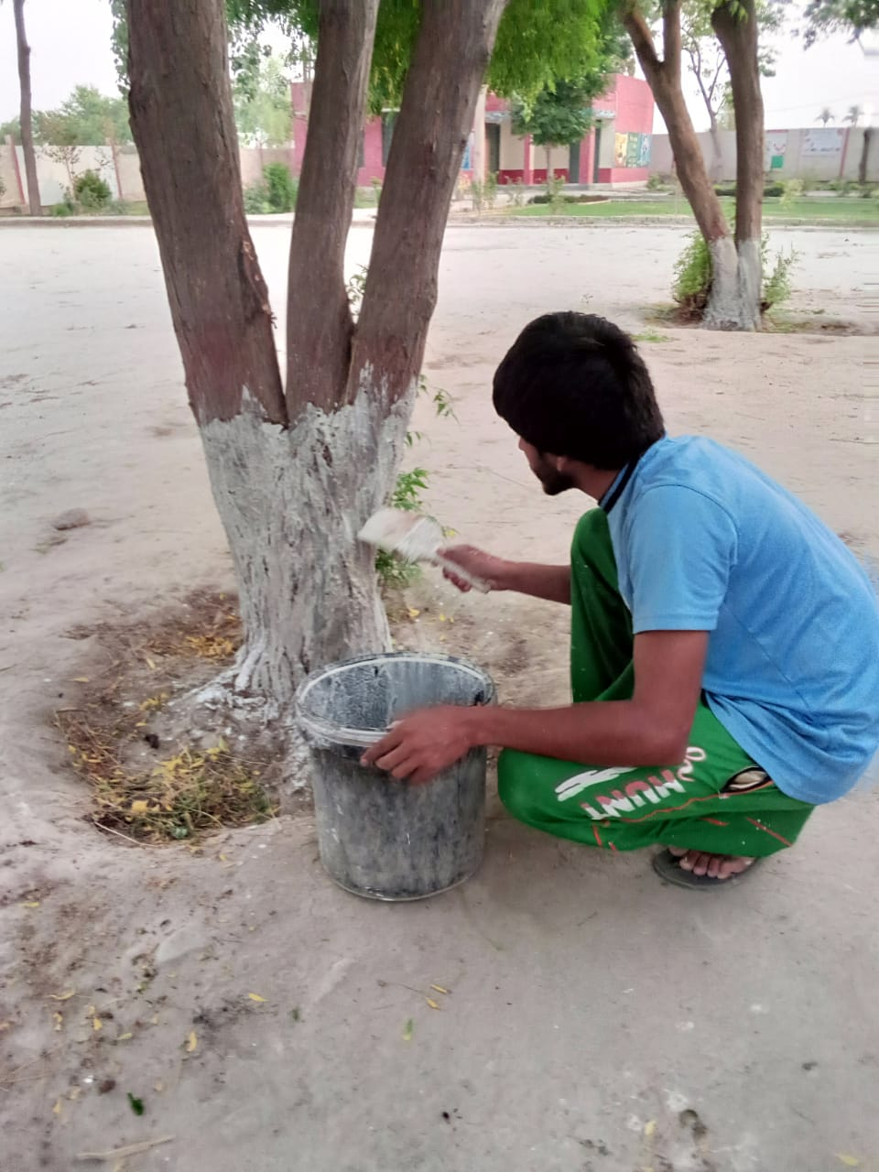
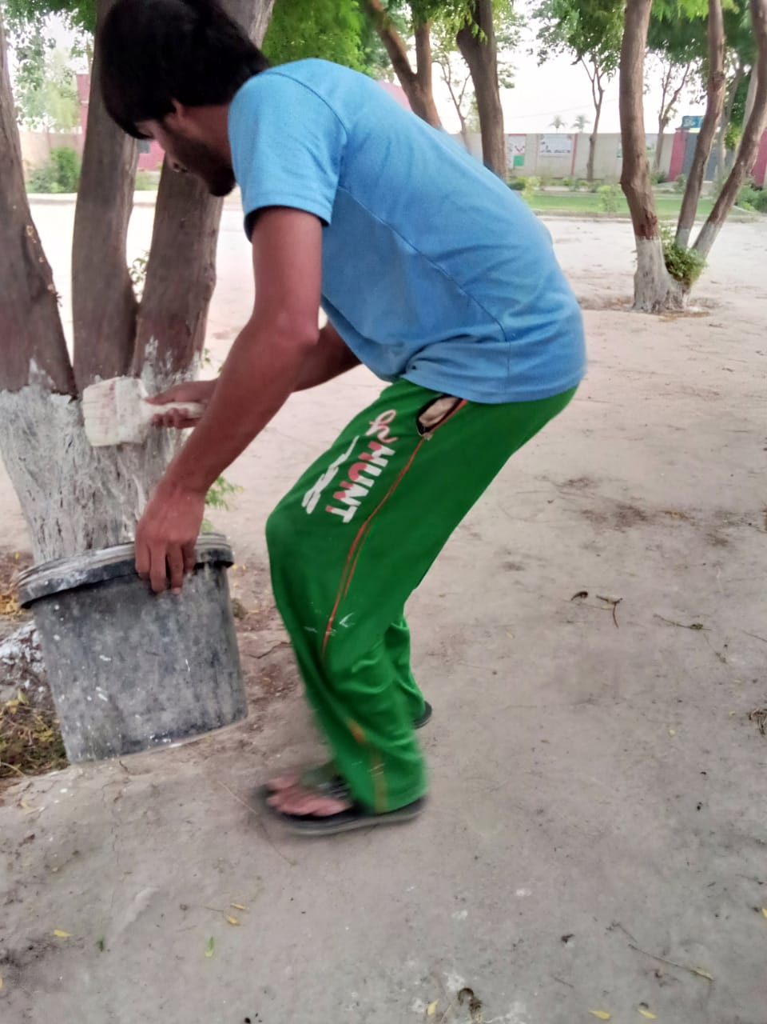
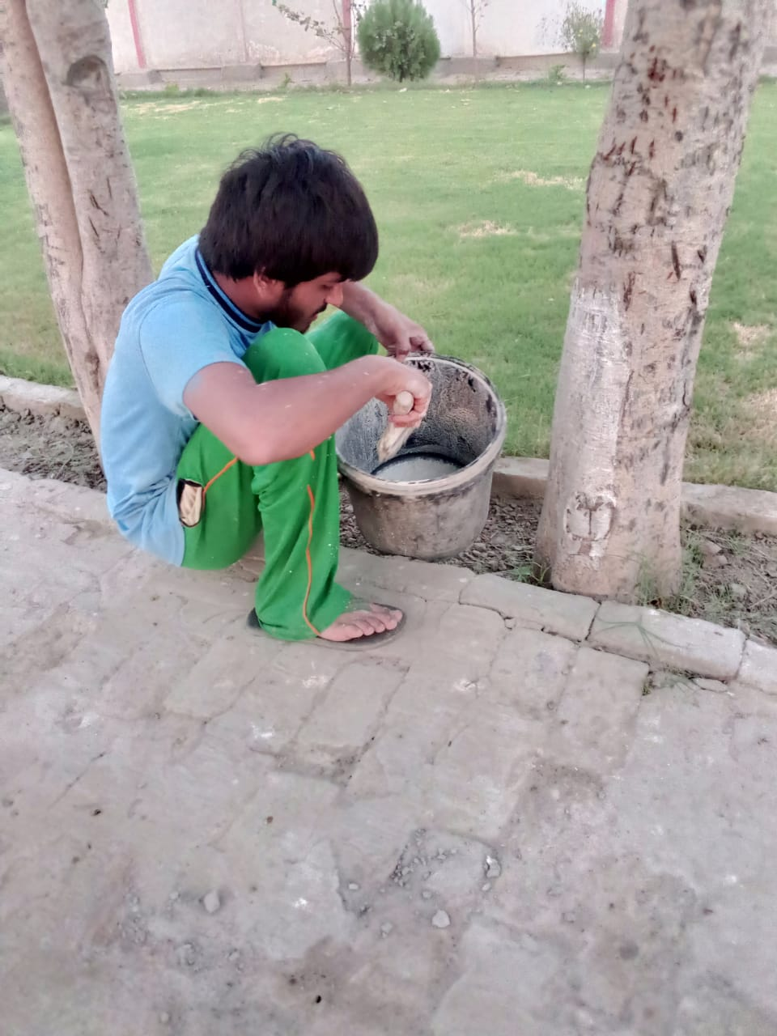
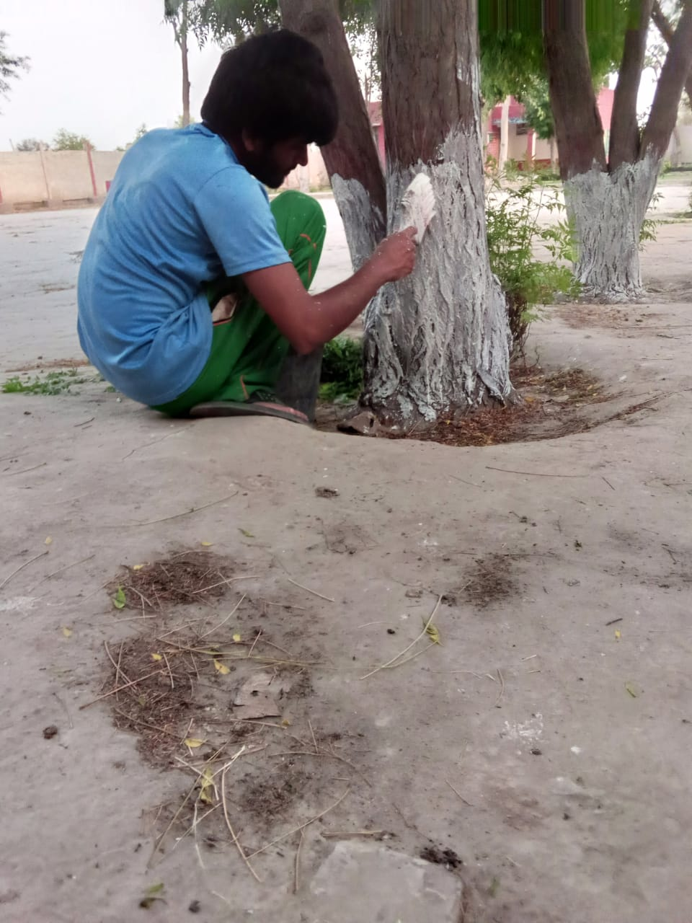
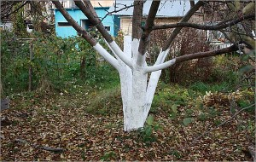
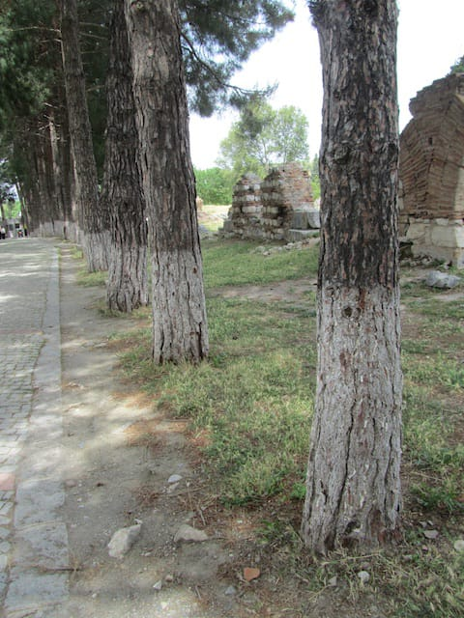
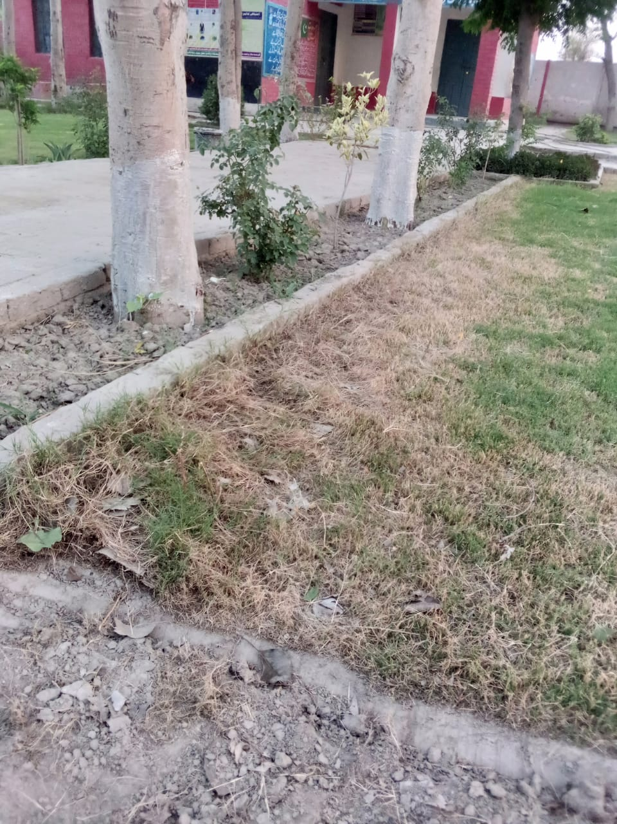
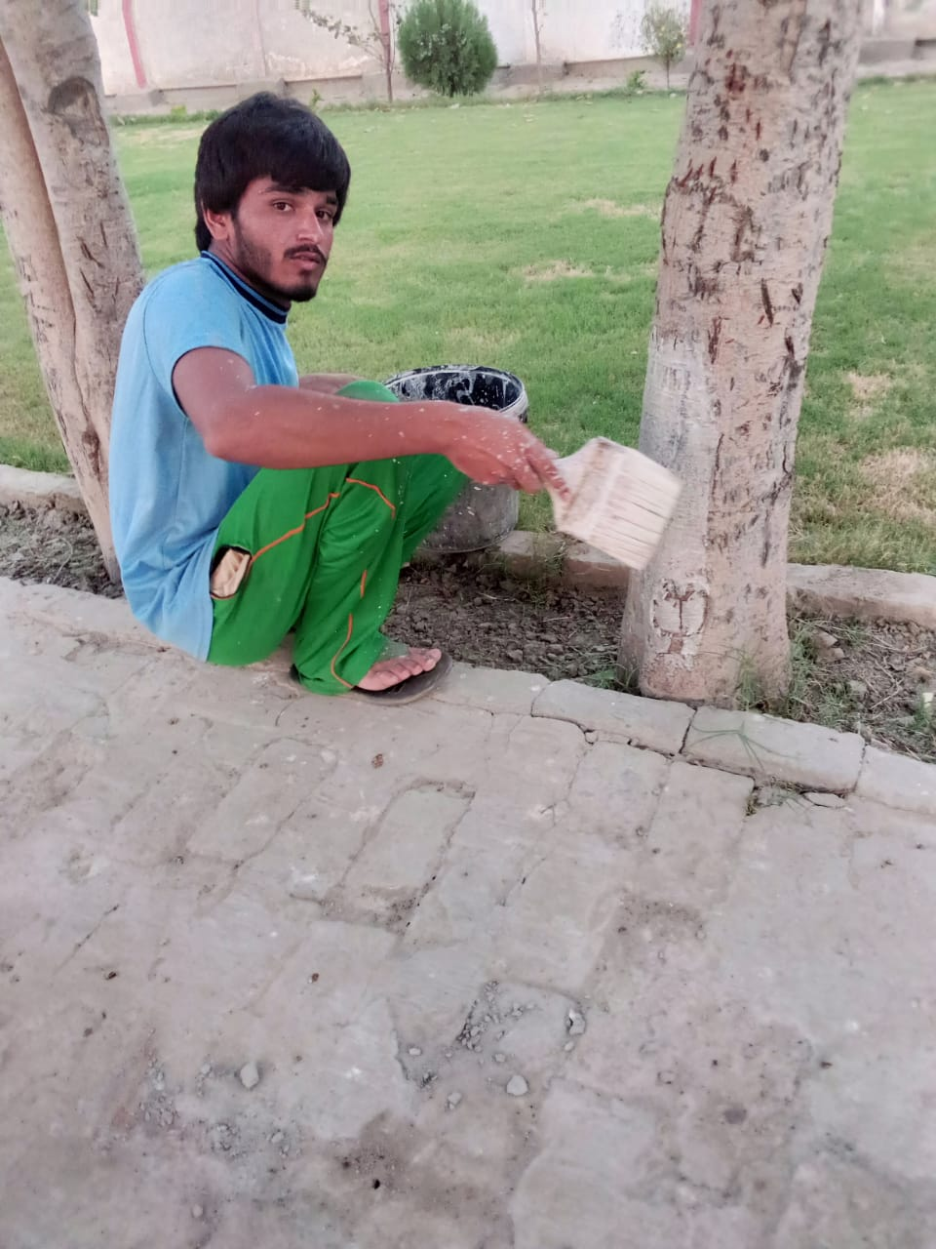
White washing of plants
- How I did this project activity?
- Needed resources & the source of generation (financial, human resources etc.): -
- I with my cousin as well friend went to the shop to buy paint (lime), brush with the pocket money.
- Friend was also good in solving plant related problems.
- After this we have done the project together.
- Each person’s role in the project: -
- Me and my friend role is necessary without my friend I was not able to start the project.
- School teacher role is also necessary for this project because without their trust and permission nothing was possible.
- Proposed duration of the project: -
- Duration was about three days.
- After 3 days white washing of plants was completed.
- How I evaluate my project for possible outcomes?
- By viewing of plants and analyzing plants I saw that a plant was safe from all disease.
- I saw the remedies of termite attack was less due to whitewashing.
- When I meet with school teacher they appreciated me and said that you have done great job.
- In this way I realized that I done my White washing of plants as a project of citizenship.
THE END

