Stem Development
Growth in plants occurs as the stems and roots lengthen. Some plants, especially those that are woody, also increase in thickness during their life span. The increase in length of the shoot is referred to as primary growth. It is the result of cell division in the shoot apical meristem. Secondary growth is characterized by an increase in thickness or girth of the plant. It is caused by cell division in the lateral meristem. Herbaceous plants mostly undergo primary growth, with little secondary growth or increase in thickness. Secondary growth, or “wood”, is noticeable in woody plants; it occurs in some dicots, but occurs very rarely in monocots. Some plant parts, such as stems, continue to grow throughout a plant’s life: a phenomenon called indeterminate growth.
Primary Growth:-
Most primary growth occurs at the apices, or tips, of stems. Primary growth is a result of rapidly-dividing cells in the apical meristems at the shoot tip. Subsequent cell elongation also contributes to primary growth. The growth of shoots during primary growth enables plants to continuously seek water (roots) or sunlight (shoots). The influence of the apical bud on overall plant growth is known as apical dominance, which diminishes the growth of axillary buds that form along the sides of branches and stems. Most coniferous trees exhibit strong apical dominance, thus producing the typical conical Christmas tree shape. If the apical bud is removed, then the axillary buds will start forming lateral branches. Gardeners make use of this fact when they prune plants by cutting off the tops of branches, thus encouraging the axillary buds to grow out, giving the plant a bushy shape.
Secondary Growth:-
The increase in stem thickness that results from secondary growth is due to the activity of the lateral meristems, which are lacking in herbaceous plants. Lateral meristems include the vascular cambium and, in woody plants, the cork cambium. The vascular cambium is located just outside the primary xylem and to the interior of the primary phloem. The cells of the vascular cambium divide and form secondary xylem (tracheids and vessel elements) to the inside and secondary phloem (sieve elements and companion cells) to the outside. The thickening of the stem that occurs in secondary growth is due to the formation of secondary phloem and secondary xylem by the vascular cambium, plus the action of cork cambium, which forms the tough outermost layer of the stem. The cells of the secondary xylem contain lignin, which provides hardiness and strength.
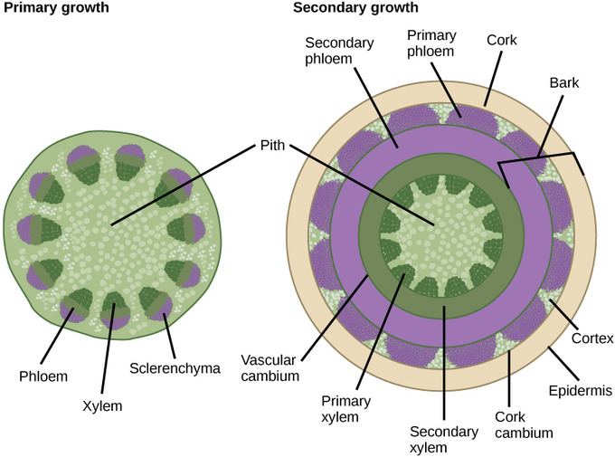

Primary and secondary growth: In woody plants, primary growth is followed by secondary growth, which allows the plant stem to increase in thickness or girth. Secondary vascular tissue is added as the plant grows, as well as a cork layer. The bark of a tree extends from the vascular cambium to the epidermis.
(//courses.lumenlearning.com/boundless-biology/chapter/stems/)

Spiral Grains
Spiral grain, conduits for sap lead from each root to all branches. This uniform distribution of sap is indicated by the paths of vessels and tracheids, and has been proven experimentally by means of dyed sap injected into the base of stems or taken up by roots. Trees receiving water only from roots at one side of the root collar nevertheless stay green and continue growing. Spiral grain in bark distributes food from each branch to other flanks of the stem and to most roots. Experimental interruptions of the sap and food conduits caused the cambial zone to reorient new conduit cells in new directions, bypassing the interruption. In particular, spiral grooves cut into the stem surface caused spiral grain. The new cells reorient through division and growth. Although spiral grain is largely under genetic control, trees appear to have a spiral grain especially where needed for distribution of water when root spheres are dry at one side. Compared with straight-grained trees, spiral-grained stems and branches bend and twist more when exposed to strong wind, in this way offering less wind resistance and being less likely to break. Through the bending and twisting, snow slides down from branches rather than breaking them, but the main function of spiral grain is the uniform distribution of supplies from each root to all branches, and from each branch to many roots.
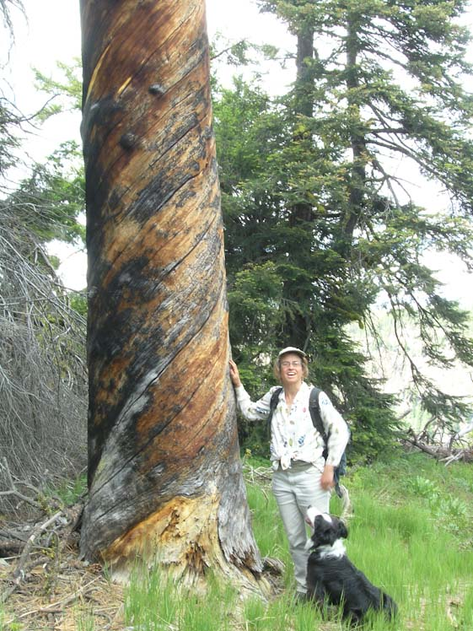
Spiral grain is the helical form taken by xylem tissues in their growth along a tree trunk or limb. Spiral grain is often conspicuous in snags that have lost their bark. (In forest ecology, a snag refers to a standing, dead or dying tree, often missing a top or most of the smaller branches.)
Spiral grain (right-handed) in an old Pinus ponderosa [C.J. Earle, 2007.06.16].
(http://www.conifers.org/topics/spiral_grain.php)

Reaction Wood
A vertical trunk forms normal wood plus some reaction wood when moved in the wind. Horizontal branches and leaning branches must form reaction wood in an attempt to prevent them from bending and cracking under their own weight.
There are two different types of reaction wood, which represent two different approaches to the same problem by woody plants:
- In angiosperms reaction wood is called tension wood. Forms on the upper sides of hardwoods and contains more cellulose than normal wood. Wood with high cellulose content is especially strong in tension and can resist bending downward. Both strategies appear to work most of the time.
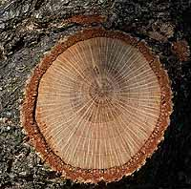

Hardwoods such as oaks form a type of reaction wood called tension wood on the upper side of the branch. Once this fails to prevent the branch from drooping, they switch to develop more wood on the undersides, called normal wood, as shown here. This results in an oval cross section.
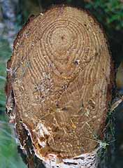
- In gymnosperms it is called compression wood. Forms on the underside of branches and contains more lignin than normal wood. Wood with high lignin content is especially strong in compression.

Conifers form a type of reaction wood called compression wood on the undersides of horizontal limbs. Compression wood attempts to prevent the branch from drooping. The pith in this pine is clearly way above the center point on this branch indicating much more development under the branch than on top. These branches form an oval in cross section.
(http://hort.ifas.ufl.edu/woody/reaction-wood.shtml)

Wood Quality
Wood "quality" means different things to different people. While foresters think of tree size and form, and lumber manufacturers see large, straight and clear logs, customers associate wood quality with other attributes. The building industry, for example, is mainly interested in strength, stiffness and dimensional stability, but it cares very little about basic wood properties. A survey of literature from the Commonwealth Agricultural Bureau database produced over one thousand references to "wood quality". In many cases, the term was used as a synonym to wood density. Many forest scientists appear to consider wood density and fiber length as the key wood quality attributes regardless of end users. Kliger at al. (1994) ascribed this confusion to poor communication among forest management, wood manufacturing and wood-using sectors. If this situation continues, neither the industry nor the end users will be getting what they need. A common definition of wood quality and a better understanding of its impacts on wood manufacturing and customer satisfaction would facilitate communication among all parties concerned.
Many attempts have been made to define wood quality, but the definition proposed by Mitchell (1961) appears to be the most widely cited: "Wood quality is the resultant of physical and chemical characteristics possessed by a tree or a part of a tree that enable it to meet the property requirements for different end products". Almost everybody agrees that wood quality must consider specific end uses, and this definition duly emphasizes their significance, but it fails to consider other aspects that are of importance to manufacturers, foresters or customers. It cannot, therefore, be applied to the forest management/manufacturing/customer chain.
As wood properties affect various aspects of the manufacturing process, wood quality must be defined in terms of the value recovery chain. In addition, the definition needs to include serviceability, and cover attributes of interest to end-users, which may or may not have a direct impact on manufacturing, but will continue to matter long after the product has been sold and installed. This paper accordingly defines wood quality as "all wood characteristics that affect the value recovery chain and the serviceability of end products".
(http://www.fao.org/docrep/ARTICLE/WFC/XII/0674-B1.HTM)

