Information society
Outlines
- Introduction of Information and Society
- Origin and Development of Information Society
- Economic and Social Factors in relevance to IS
- Technology for Information Society
- Information Laws To Regulate IS
- Relationship of Information Society and Knowledge Society
- How the information society differs from earlier societies?
- Criticism
- Conclusion
Definition of Information
“Information is an assemblage of data in a comprehensible form capable of communication and use; the essence of it is that a meaning has been attached to the raw facts.” (Feather, J., & Sturges, P. 2003) p.303 3
Definition of society
The community of people living in a particular country or region, associated to one another and having shared customs, laws and organizations.
Examples of Society
- Agricultural Society
- Industrial Society
- Knowledge Society
- Information society
- An agricultural society, also known as an agrarian society, is a society that constructs social order around reliance upon farming.
- Industrial society is a society driven by the use of technology to enable mass production, supporting a large population with a high capacity for division of labour.
- A knowledge society generates shares and makes available to all members of the society knowledge that may be used to improve the human condition.

Information Society
A society in which information, rather than material goods, has become the chief economic, social and cultural motor. (Whitworth)
An information society is a society where the creation, distribution, use, integration and manipulation of information is a significant economic, political, and cultural activity. The aim of the information society is to gain competitive advantage internationally, through using information technology (IT) in a creative and productive way. (BRANSCOMB) ϖ
Ever since the 1960s, ‘information society’ has been one of the key terms used to describe today’s world. Global Information Society
- Creators of information – writers, musicians, artists, researchers, database producers, web producers
- information products -- books, videos, magazines, web sites
- Distributors of information -- publishers, Internet providers, vendors, producers
- Disseminators of information -- schools, libraries, colleges and universities, businesses, government, museums
- Users of information -- individuals, business persons, researchers, employees and employers 6
- Development of technology (The storage capacity, communication channels, Computer and Internet)
Economic Factor and IS
- Organizations used information as resource, increasing efficiency, effectiveness and stimulating innovation
- Improvement in the quality of the goods and services produced
- Increased sale through Advertisement
- Consumers also use information to make better choices between different products
- Explore their entitlements to public services
- Exercise their civil rights and responsibilities
- Extend public access to educational and cultural provision
SOCIAL FACTORS AND IS
- Illiteracy
- Non-cooperation
- Polarization and Intolerance
- Non-book and gun culture
- Ethical and Religious Issues
- Life styles, attitudes and personal beliefs
- Socially Intense (Linguistic Barriers,Psychological Barriers,Emotional Barriers.,Physical Barriers,Cultural Barriers,Organisational Structure Barriers.,Attitude Barriers,Perception Barriers).

Now role of IS to eradicate such deficiencies to make society a healthy society 11

  - Growth of Telecommunication
  - Computers and ICTs
  - Skilled Professionals
  - Shift in occupational structure
  - Equal opportunities
Information as a critical asset: Creation, acquisition, management, delivery Strong Indicators Use of information by citizens to increase their involvement in public policy making and social life
INFORMATION LAWS TO REGULAE THE IS
- Freedom of Information
- Laws related in regulating information like Copyright & Intellectual Property Rights
TECHONOLGY FOR IS
- Telephone
- Broadcasting Media
- Computer
- Intranet and Internet
- World Wide Web (WWW)
- Tele communication
- Satellite

Critical political economy of MEDIA
Introduction
How the media are organized and funded is central to understanding their role in society. Critical Political Economy of the Media provides a clear, comprehensive and insightful introduction to the political economic analysis of contemporary media.

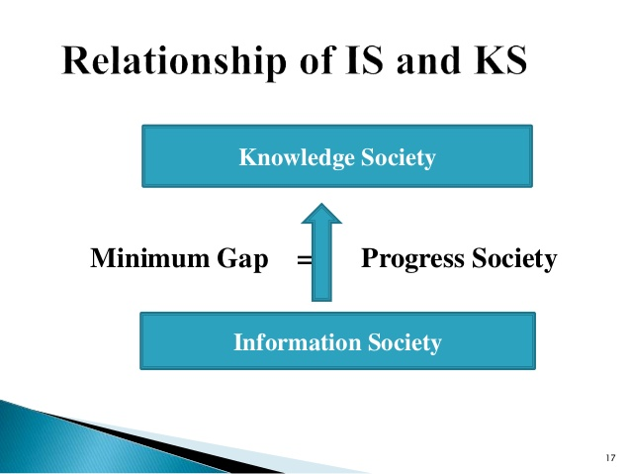

How the information society differs from earlier societies?
Webster (2002):
Five ways to define how IS differs from other types of societies:
- Technological
- Economic
- Occupational
- Spatial
- Cultural

1. Technological
Information technology as the defining feature of society
Different eras / different infrastructures:
- Industrial revolution: roads and railways
- Information revolution: networks and electronic highways

Problems:
- "technological determinism"
- When does a society cease to be industrial and when does it enter the informational era?
- How does one measure this shift?
- Is there really a difference between the "information society" and the "advanced industrial society"?
- How about social values, social shaping of technology

2. Economic

Machlup (1962): structure of American information economy:
- education
- media
- information machines
- information services
- other informational activities (R & D, non-profit activities)

Porat (1977): primary, secondary and non- information sectors

· The information sector is becoming more important in the economy

Problems:
- value judgements; how to define what constitutes information sector and non-information sector?

3. Occupational
- We have achieved an IS when the predominance of occupations is found in information work (when physical strength is replaced by manipulation of figures and text)

Problems:
- How to allocate different types of work to different categories?
- Every occupation requires a degree of information processing

4. Spatial
· The rise of networks
· The IS changes concepts of time and space
Harold A. Innis:
- Empire and Communications (1950), The Bias of Communication (1951) and Changing Concepts of Time (1952).
- Innis was interested in the question of how media technology affect societies and cultures
- Innis classifies different cultures according to what communication technology is dominant in those cultures. According to Innis there has been three different cultural phases in the world-history
1) Oral phase
2) The phase of print and writing
3) The phase of electronic communication
· time-binding media vs. space-binding media.

· modern ICT: the constraints of time and space have been dramatically limited

Problems:
Why more volume and velocity of information flow should mark a new society? Networks have been around for a very long time:

1837 Electric telegraph (Morse and Cooke-Wheatstone)
1851 France – England underwater cable
1866 First transatlantic cable
1876 Invention of the telephone
1878 First American telephone lines
1881 The American network had 123 000 telephones
1887 First international telephone calls (Between Paris and Brussels) (Between London and Paris in 1891)
1896 First steps in radiocommunications (Marconi)
1901 First wireless transatlantic telegraph transmission
1922 First regular radio broadcasts

5. Cultural
- Information in social circulation has increased extraordinarily
- We live in a media-saturated society
- "Postmodern condition"
- According to Bell there are five key elements that characterise the post-industrial society:
- · An economic sector that has changed from producing goods to producing information and services
- · An occupational distribution dominated by professionals and technical class
- · An axial principle by which the centrality of theoretical knowledge is the source of innovation and policy-making
- · A future orientation: the control of technology and technological assesment; and
- · A decision-making process that depends on the creation of a new "intellectual technology"
- Three revolutions inside the industrial societies which led to the post-industrial society:
- 1) steam
- 2) electricity
- 3) information (esp. computers)
- Bell: post-industrial society is an information society

Criticism:
- Gershuny (1979): After the Industrial Society? The Emerging Self-Service Economy
- - Instead of buying services, people want to buy machines that do the service for them -> production of material goods continues to be important
- - The application of theoretical knowledge to production was already important in the industrialism

Conclusion
The information society in many countries like Pakistan is only considered as the development of telecommunication infrastructure but we must acknowledge its socio-economic and institutional importance. (Example: RTI, Punjab Infor. Commission)
We must understand the knowledge needs of different communities and groups. The developed countries like Japan, Canada USA, Germany, United Kingdom etc. may be considered as the information societies but the developing countries like Pakistan are still far away from information society. Lack of education and economic backwardness are hindering the process of transition to an information society. 19
Democracy with the presence of dynamic and free media and independent judiciary will enable us to turn our society into an information society.
As a society, we have yet to realize the importance of having of informed and empowered citizens, more focuses has been development of infrastructure rather than human capacity to use that information/ infrastructure.

