METHODS OF NURSERY SOWING
Method of sowing of nursery depends on the type of soil, water availability, and local custom.
- Wet bed method
- Dry bed method
- Rabi method

i. Wet bed method
- Soak the seed in water for 24 hours, after that cover the seed with wet jute bags and place it under shade.
- Seed will germinate after 36-48 hours.
- Irrigate, plow, puddle and level the field.
- Prepare beds of 1 to 1.5 m width, 4-5 cm height & any convenient length.
- Germinated seed is sown with broadcast method @ 1kg/Marla for ARRI varieties and @ 500-750g/Marla for Basmati varieties.
- 1-1.5-inch water should be present before broadcasting the pre-germinated seed in evening.
- Drainage the water in next evening and again irrigate in next morning. Repeat it for one week.
- Maintain a water level of 2-5 cm, depending on the height of seedlings.
- Apply urea 250g per Marla, if seedling is weak.
- Seedlings will be ready for transplanting in 25-30 days.

ii. Dry bed method
- Practiced where puddling is impossible as soils are loamy or silt loam.
- Plot is prepared in watter conditions after irrigation.
- Dry seed is sown with broadcast method @ 1.5 kg/Marla for ARRI varieties and @ 750g/Marla for Basmati varieties.
- Straw layer is spread and irrigation is applied.
- Straw layer is removed after some days to facilitate sunlight.
- Seedling will be ready in 35-40 days.

iii. Raab method
- Practiced in areas of D.G. khan and Muzaffargarh where soil is hard.
- Uprooting of nursery is difficult.
- Nursery plots are levelled.
- Crop residues (5cm layer) spread uniformly and burnt.
- Ash is pressed on soil after cooling.
- Dry seed is sown with broadcast method @ 2kg/Marla for ARRI varieties and @ 1kg/Marla for Basmati varieties.
- Seedling will be ready in 35-40 days.

PLANTING METHODS OF SUGARCANE
There are two planting methods of sugarcane
- Strip planning
- Pit planting

- Strip planting
It is further divided into three methods
- Single row strip = 60cm apart
- Double row strip = 90 cm apart
- Triple row strip = 120 cm apart
Advantages of strip planting
- Strip planting facilitates interculture and earthing up of crops without damaging the roots.
- Conservation of irrigation water.
- Allows efficient and expeditious interculture and earthing up with btractor or bullocks drawn implements.
- Permits the systematic planting and handling of intercrops without affecting the associated cane crop. Moreover planting of main and intercrops in separate and independent strips not only reduces intercrops competition, but also enables the growers to meet the varying fertilizer requirements, growth pattern and planting time of different crops.
- Eliminates the chances of patchy crop stand since the rows are closely planted.
- Facilitates easy application of herbicides since the strips are well spaced.
- Prevent lodging in case of unusual wind or rain since the strips provide plant support.
- Improves the air circulation and light penetration which enhances the photosynthetic efficiency of the plants and thus their growth and quality.
- Causes better rationing and also allows more effective stubbles sahving, which promotes sprouting.
- Reduces crop damage from trampling by wild boars looking for a space to rest.

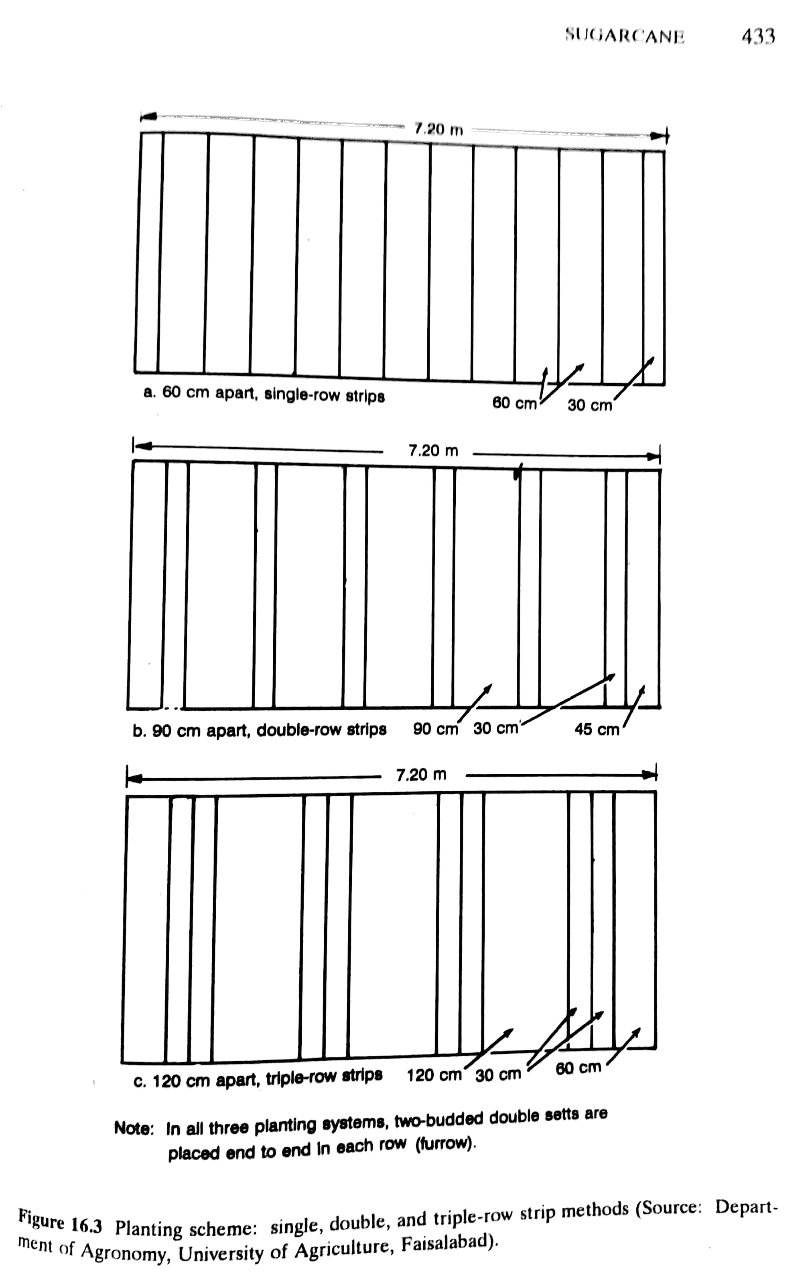
- Pit planting
A new technology was developed by UAF in which sugarcane is planted in 100x100cm pits, 50cm apart with a seeding density of 30 two-budded setts per pit.

Pit are dug to a depth of 60cm and refilled to a level of 45cm with the same soil along with 5kg well rotted FYM per pit mixed well with the soil. Pits are dug at zero tillage and no hoeing or earthing up is done. Fertilizer at the rate of 150-100-100 kg NPK/ha is placed in side the pits.

Advantages of pit planting
Reduces lodging since the plants are firmly anchored in the pits thereby increasing leaf area, promoting air circulation and allowing penetration of light.
Conserving irrigation water and applied fertilizer and manure.
Enables the intercropping of lentil, pea, gram, and wheat in autumn planted cane and mung, mash and cowpea in spring planted cane.
Eliminates expenditures on tillage, hoeing, and earthing up because pits are dug at zero tillage.
Facilitates mulching to conserve soil moisture and efficient use of herbicides and pesticides.
Promotes better ratooning, permitting three to four rations without soil compaction or weeds infestation.
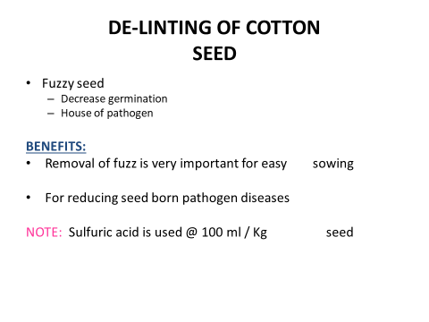

SEED TREATMENT WITH FUNGICIDE
Following are the definitions of seed treatment
Treatment of seed with fungicide for the control of disease i-e loose smut, partial bunt etc.
Soaking treatment to enhance germination or to break dormancy.
Treatment of seed with inoculums.
Equipment
Seed of crop, fungicide, electric balance and rotary or simple drum.
Objective
To control seed borne diseases like loose smut, partial bunt.
Procedure
- Weigh the seed and fungicide on balance according to the rate or ratio (2-3g fungicide/kg seed)
Amount of seed =800kg
Amount of fungicide = 2/1000 x800 =1.6g
- Add seed and fungicide in the rotary or simple drum. If rotary drum is used to fully mix the fungicide with seed. If simple drum is used then simply mix the seed and fungicide with a mixing stick.
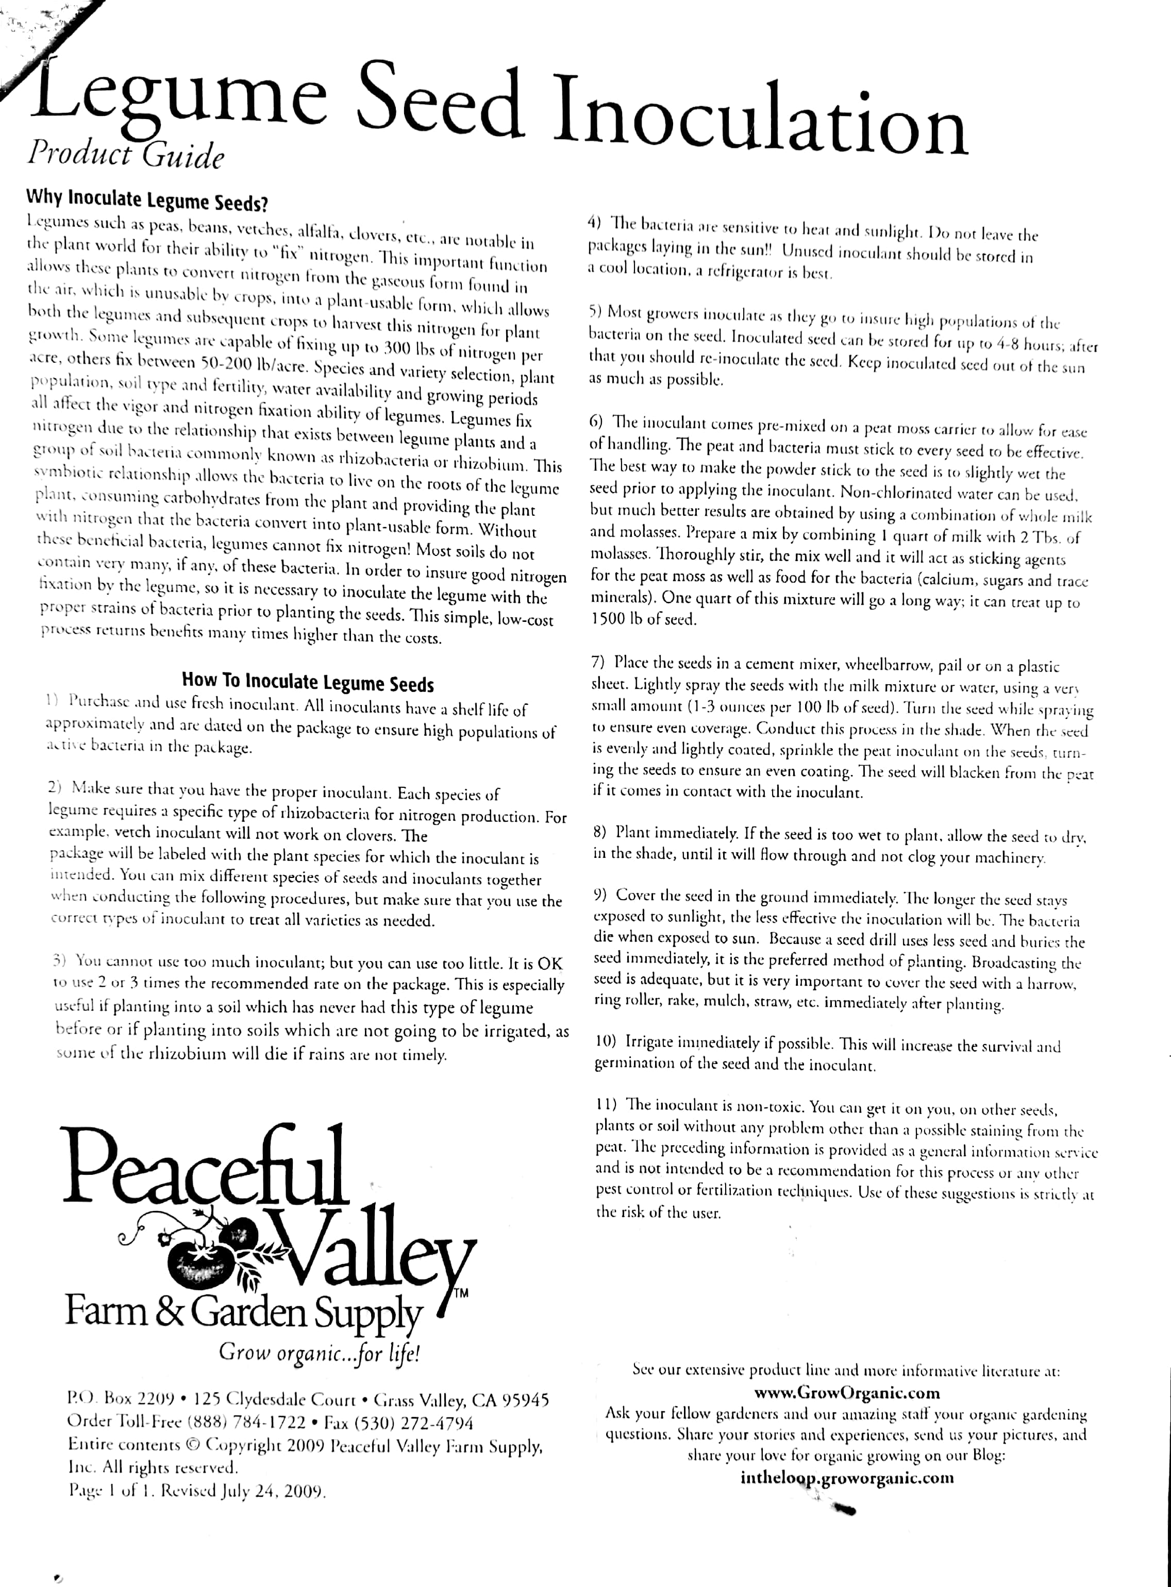
Intercultural operation
Weeding
Removal of weeds is known as weeding. Weed is a plant grown where it is not desired

Objectives

i. To reduce the competition of weeds to crop plants for light, space, water and nutrients.
ii. To get expected output (yield) from crop cultivation.
iii. Weeding in dry condition fulfills the objective of natural mulching.
Mulching
Mulching is a method of conserving soil moisture. It is a very important intercultural operation for rabi and rainfed crops. It is done by making a covering on the soil surface which actually reduces the evaporation of soil water. Mulches are the materials used for mulching.

Objectives
i. To conserve soil moisture.
ii. ii. To reduce excess evaporation loss of soil moisture.
iii. iii. To ensure economic use of irrigation water.

Advantages
i. It keeps the soil moist during the dry season.
ii. It suppresses weed growth and population.
iii. Keeps the soil cool during dry and hot season.
iv. Use of mulches like water hyacinth or straw adds significant amount of organic matter to the soil after decomposition.
v. Natural mulching aerates the soil which helps better respiration of plant roots.
vi. Mulching becomes essential for some crops to prevent contact of product with soil as for example fruits of straw berry plants if come in direct contact with the soil then the fruits will rot. So, mulching becomes essential for strawberry.

Types of mulch

i. Natural mulch (water hyacinth, straw, leaves etc.)
ii. ii. Artificial mulch (polythene, paper etc.)

Types of mulching

i. Natural mulching
ii. Artificial mulching

Natural mulching: It is a method of breaking the surface of dry soil and generally done by stirring the soil surface with the help of some implements like niri, khurpi etc. Weeding in dry condition with the help of niri or khurpi results in natural mulching. When the soil becomes drier, water vapour moves upward towards the soil surface through capillary tubes and escapes into the atmosphere. Natural mulching breaks the soil crust and thereby, opening of capillary tubes gets broken and blocked which results in prevention of upward movement of water vapour. Hence, upward movement of capillary water is restricted and soil moisture is conserved.

Artificial mulching: This includes application of plant leaves, straw, water hyacinth, polythene, sawdust etc. so as to provide a covering on the surface soil which can check the evaporation of soil moisture. Mulch crops may also be grown to conserve soil moisture in bare ground by their thick and multilayered foliage, trailing habit and sometimes, self-seeding nature, for instance cow pea, Alylosia.

Earthing up
Earthing up consists of lifting up or shifting the soil from the central portion of the space between rows towards the base of plants so as to cover the plant base or certain plant organs grown from below or at the soil surface. Earthing up may be done both under wet and dry conditions of soil.

Objectives
i. To make better root anchorage.
ii. To prevent lodging.
iii. To cover stolons and rhizomes in some crops.

Advantages
i. Earthing up creates ridges and furrows in the crop field which later on serves the purpose of irrigation channel.
ii. Earthing up reduces weed growth and population.
iii. Earthing up closes the spreading tillers in sugarcane which makes the tying of canes easier.
iv. Earthing up increasing the number of tubers in potato and prevents solarization of developing tubers.
v. The initiation of new (late) tillers in rice and sugarcane or rhizomes in taro, turmeric and ginger are restricted. vi. The pegs of groundnut, the stolons and the tubers of potato and the stilt roots of maize are covered with earth.

Thinning
Removal of excess plants after germination from the crop field or seed bed is called thinning. Excess plants in a crop field reduce crop yield due to intra crop competition. As a result, there occurs shortage of space, nutrients, light, air and moisture for individual crop plant which ultimately reduce yield. So, if required, excess seedlings are removed leaving the strongest ones.

Gap filling
Several frugivorous and granivorous animals and birds feed on many seeds after they are sown in the field. Moreover, after transplanting many seedlings fail to establish them in the new environment and dies. Then. Gap filling with seeds staggers the period of germination and emergence. As a result, ripening periods extend over time and affect the harvesting which is scheduled once for most crops; and this seriously impairs the quality of produce.

Objectives of thinning and gap filling

The ultimate goal is to ensure the optimum plant population in the crop field. Plant population more than optimum creates competitive condition whereas that less than optimum results in misuse of space, irrigation water and other inputs.

Advantages

Both thinning and gap filling ensures ideal plant population and optimum utilization of sunlight, space, nutrients, moisture and other inputs which ultimately increases yield.

