Osgood and Schramm model
Wilbur Schramm, a well-known communications theorist, developed a straightforward communications model. In Schramm's model he notes, as did Aristotle, that communication always requires three elements — the source, the message and the destination. Ideally, the source encodes a message and transmits it to its destination via some channel, where the message is received and decoded.
However, taking the sociological aspects involved in communication into consideration, Schramm points out that for understanding to take place between the source and the destination, they must have something in common. If the source's and destination's fields of experience overlap, communication can take place. If there is no overlap, or only a small area in common, communication is difficult, if not impossible.
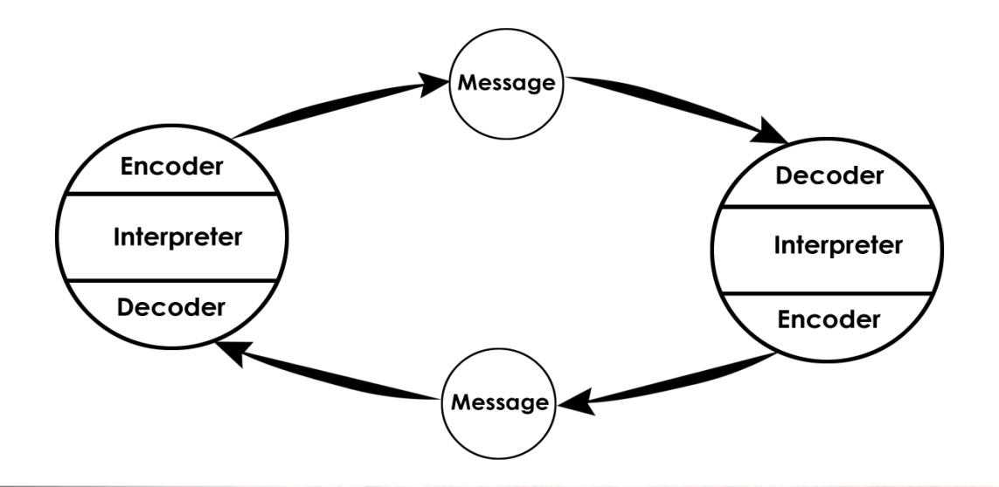
Schramm also formulated a model that explains the process involved in mass communication.

Two are encoding skills: - speaking - writing
Two are decoding skills: - listening - reading
The fifth is crucial to both encoding and decoding: - thought or reasoning
Osgood and Schramm envisioned communication as a circular process which has beginning and or end. Hence their model is called Circular Model. In their view, sender and receiver are interchangeable positions and though not specifically mentioned, feedback is an essential component of this model. There are three functions on each part of the communication circle. They are : encoding, decoding and interpreting. Both sender and receiver are encoders, decoders and interpreters at the same time.
Encoder–Who does encoding orsends the message
Decoder–Who receives the message
Interpreter–Person trying to understand (analyses, perceive) or interpret.
Merits of this model are:
1. Dynamic model-Shows how a situation can change
2. It shows why redundancy is an essential part
3. There is no separate sender and receiver, sender and receiver is the same person
4. Assume communication to be circular in nature
5. Feedback–central feature.

