Topic: Nucleotides and its types

NUCLEOTIDES
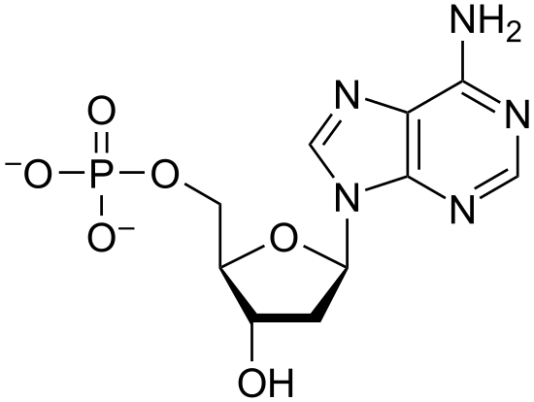
Nucleotides are organic molecules that polymerize to form nucleic acid . So they serve as monomeric units of the nucleic acid polymers most notably deoxyribonucleic acid (DNA) and ribonucleic acid (RNA), both of which are essential biomolecules within all life-forms on Earth . They are essential for all the functions performed by a living cell. They are also essential for transferring information to new cells or the next generation of the living organisms. So, nucleic acids are polymeric macromolecules made up from nucleotides, the monomer-units of nucleic acids. Nucleotides join together to form dinucleotides, tri-nucleotides, and so on resulting in the formation of polymers known as polynucleotides. These polynucleotides then join to form complex nucleic acids like DNA and RNA .
STRUCTURE:

Three molecular structures join to form a nucleotide. These are:
- A Pentose Sugar
- A Nitrogenous Base
- One or more phosphate groups.

Pentose Sugar
A pentose sugar is a monosaccharide having five carbon atoms. It occupies the central position in the structure of a nucleotide. All the other components of a nucleotide are attached to the carbon atoms of the pentose sugar at 2,3 and 5 positions of Carbon as position 1 and 4 are occupied to form circular ring.
Two types of pentose sugars could be present in the structure of a nucleotide. These are;
- Ribose
Ribose is a aldopentose sugar in the form of ring. It is one of the two types of 5-C sugar that is present in nucleotides. Nucleotide in which ribose sugar is present is called ribonucleotide, that is essential component of Ribonucleic acid (RNA).
- 2-Deoxy ribose
Deoxyribose is aldopentose sugar in ringed structure. Nucleotide containing deoxy ribose is called deoxyribonucleotide, such nucleotides combine to form DNA. The main difference between these two sugars is the presence or absence of an oxygen atom at the second carbon atom in structure. Ribose sugar has a hydroxyl group at the second carbon atom whereas the 2-deoxy ribose has only hydrogen atom at its second carbon. Due to absence of hydroxyl group at carbon 2, this sugar is termed as deoxyribose sugar

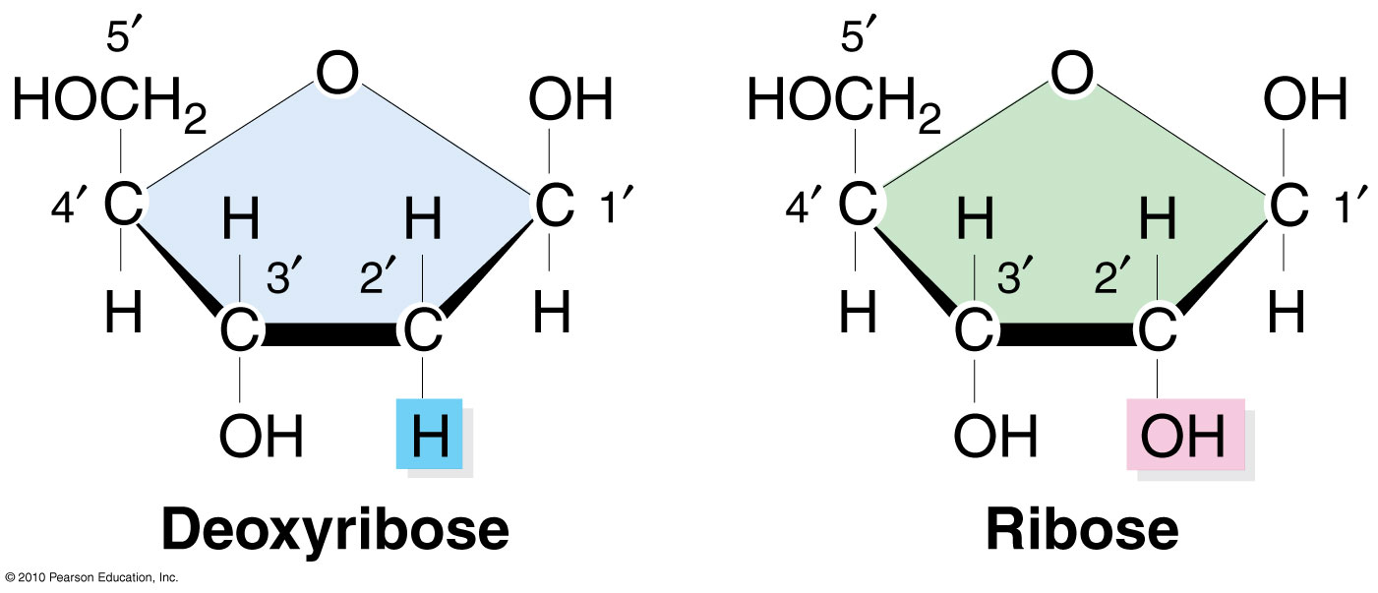

Nitrogenous Bases

A nitrogenous base, or nitrogen-containing base. It is a molecule that is organic in nature with a nitrogen atom that has the chemical properties of a base. The main function of a nitrogenous base in nucleotide is to bind chains of nucleic acids together in DNA. A nitrogenous base has basic properties due to the pair of electrons of a nitrogen atom. Nitrogenous bases are another essential component of nucleotides.
Five different nitrogen bases are present in nucleotides, based on their structure they are divided into two broad categories:
- Purines
- Pyrimidines
Purines:
Purines have two rings in their structure that are made up of carbon and nitrogen atoms. They are dicyclic. One larger ring is hexagonal while the other smaller ring is pentagonal in structure. Nitrogen atoms are present at position in 1, 3, 7 and 9.Two important purines present in nucleotides include:
- Adenine:
Adenine is a purine, which is one of two types of nitrogenous bases. Purines have a double-ringed structure. In DNA, adenine bonds with thymine. In RNA, adenine bonds with uracil.
- Guanine
Like adenine, guanine is a purine nucleotide. It has a double ring. It bonds with cytosine in both DNA and RNA. Guanine binds to cytosine through three hydrogen bonds. This makes the cytosine-guanine bond slightly stronger than the thymine-adenine bond, which only forms two hydrogen bonds.
Pyrimidines:
Pyrimidines contain only one ring made up of both carbon and nitrogen atoms. These are monocyclic. Their ring is also hexagonal. Three purines are important in biological molecules. These include:
- Cytosine
Cytosine is a pyrimidine nucleotide. It has only one ring in its structure. Cytosine bonds with guanine in both DNA and RNA. Bonding with the nucleotide guanine, the two make a strong pair.
- Thymine
Thymine is a pyrimidine nucleotide and has one ring. It bonds with adenine in DNA. Thymine is not found in RNA. In DNA, it forms only two hydrogen bonds with adenine, making them the weaker pair.
Uracil
Most creatures do not use uracil within the DNA because it is short lived, and can degrade into cytosine. However, in RNA uracil is the preferred nucleotide because RNA is also a short lived molecule.
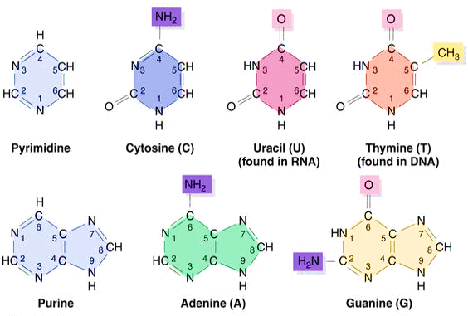

Phosphate group:
These are the third essential component of a nucleotide. They are deprotonated phosphoric acids. Phosphate groups are simply phosphate ions made up of a phosphorus atom bound to four oxygen atoms(PO₄³⁻). They have a negative charge of -3.
The first phosphate group is attached to the fifth carbon of the pentose sugar via an ester bond. The next phosphate group is attached to the first phosphate and so on. On the basis of number of phosphate groups attached to nucleotide they are classified as
- Monophosphate
A nucleotide carrying only one phosphate group is called monophosphate nucleotide e.g. AMP, CMP, etc.
- Diphosphate
A nucleotide carrying two phosphate groups is called diphosphate e.g. ADP, etc.
- Triphosphate
A nucleotide carrying three phosphate groups is called triphosphate nucleotide e.g. ATP, GTP, etc. A free or unincorporated nucleotide usually exists in a triphosphate form and it contains a chain of three phosphates.
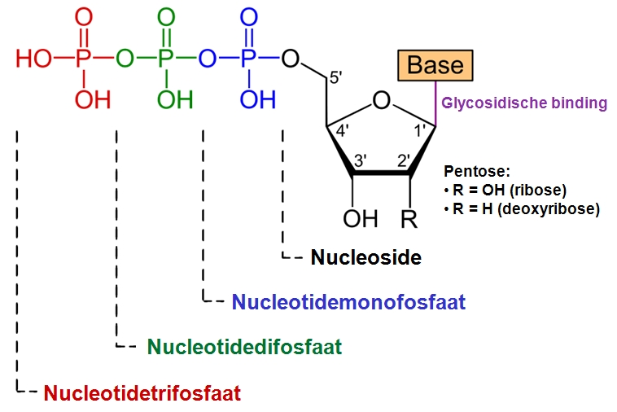

Nucleotide formation:
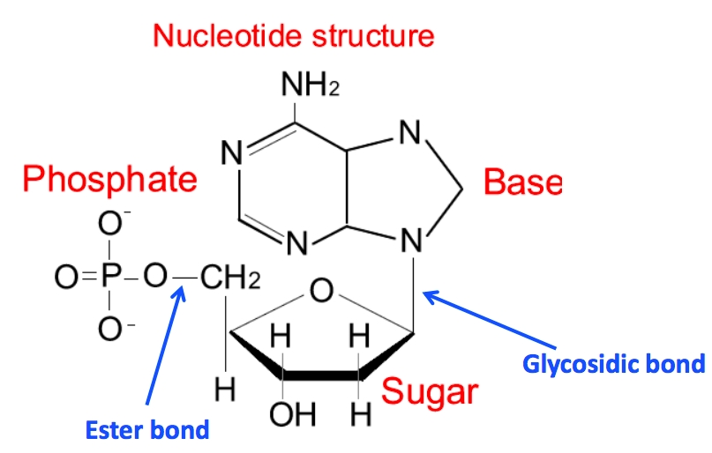
Pentose sugar occupies the central position in a nucleotide to it attaches N- base and phosphate groups. At carbon 1 attaches nitrogenous base and at carbon 5 attaches phosphate group. Bond formed between N-base and carbon is glycosidic bond and the bond between carbon and phosphate is ester bond. In nucleic acids, nucleotides contain either a purine or a pyrimidine base—i.e., the nitrogenous base molecule, also known as a nucleobase—and are termed ribonucleotides if the sugar is ribose, or deoxyribonucleotide if the sugar is deoxyribose. Individual phosphate molecules repetitively connect the sugar-ring molecules in two adjacent nucleotide monomers, thereby connecting the nucleotide monomers of a nucleic acid end-to-end into a long chain. These chain-joins of sugar and phosphate molecules create a 'backbone' strand for a single- or double helix. In any one strand, the chemical orientation (directionality) of the chain-joins runs from the 5'-end to the 3'-end (read: 5 prime-end to 3 prime-end)—referring to the five carbon sites on sugar molecules in adjacent nucleotides. In a double helix, the two strands are oriented in opposite directions, which permits base pairing and complementarity between the base-pairs, all which is essential for replicating or transcribing the encoded information found in DNA.

Ester bond
Its is also called phosphoester or phospho diester bond. Phosphoric acid is always esterified to sugar moiety. That’s why nucleotide is also defined as “Phosphoric acid ester of nucleoside.” It links two sugar molecules, thus connecting two nucleotides. This chain of sugar phoshate bonds create backbone of strands of nucleic acids.
Glycosidic bond:
When pentose sugar and nitrogen base molecule come together, the two hydroxyl groups line up alongside each other: one combines with a hydrogen atom from the other to form water, in turn forming an oxygen bridge across the two molecules, bonding them and creates this bond called a glycosidic bond. In nucleotide, it refers to the nitrogen-carbon linkage between the 9' nitrogen of purine bases or 1' nitrogen of pyrimidine bases and the 1' carbon of the sugar group. It is also called N-glycosidic bond.
Nucleoside and nucleotide:
A nucleoside consists of a nitrogenous base covalently attached to a sugar either ribose or deoxyribose, but without the phosphate group. It is basic in nature due to presence of nitrogen base molecule. Nucleosides are important biological molecules that function as signaling molecules and as precursors to nucleotides needed for DNA and RNA synthesis.
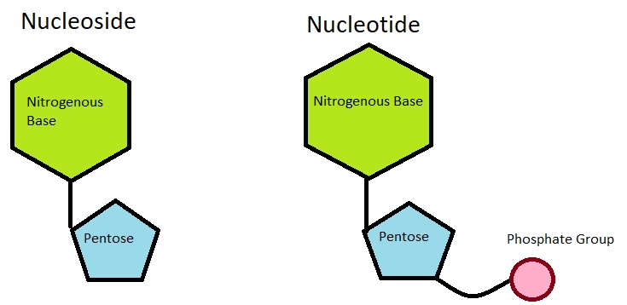
A nucleotide consists of a nitrogenous base, a sugar either ribose or deoxyribose and one to three phosphate groups. One nitrogenous base is attached to the first carbon of a pentose sugar to form a nucleoside. The addition of a phosphate group to a nucleoside makes it nucleotide. It is acidic in nature because of presence of phosphoric acid or phosphate group.

Nucleotide linkage in DNA:
DNA, or deoxyribonucleic acid, is the heritable material found in all cells. DNA provides the instructions to build, maintain, and regulate cells and organisms and is passed on when cells divide and when organisms reproduce. Nitrogenous bases present in DNA are adenine, guanine, cytosine and thymine. DNA is a double stranded molecule. In double helical structure, two poly nucleotide chain arrange in anti-parallel direction. Each chain of the double helix is made up of repeating units, nucleotides. A free, unincorporated nucleotide usually exists in a triphosphate form; that is, it contains a chain of three phosphates. In DNA, however, it loses two of these phosphate groups, so that only one phosphate is incorporated into a strand of DNA. When nucleotides are incorporated into DNA, adjacent nucleotides are linked by a phospho diester bond: a covalent bond is formed between the 5’ phosphate group of one nucleotide and the 3’-OH group of another (see below). In this manner, each strand of DNA has a “backbone” of phosphate-sugar-phosphate-sugar-phosphate. The backbone has a 5’ end (with a free phosphate) and a 3’ end (with a free OH group). In the structure below, each nucleotide is drawn in a different color, for clarity. each nucleotide in DNA contains identical sugar and phosphate groups, there are four different bases and thus four different nucleotides that can be incorporated into DNA.
Hydrogen-bond interactions between the bases allow two strands of DNA to form the double helix. These interactions are specific: A base pairs with T, and C base pairs with G. This occurs via hydrogen bonds. This pairing of bases is called complementary pairing. Strands of DNA are called Complementary.
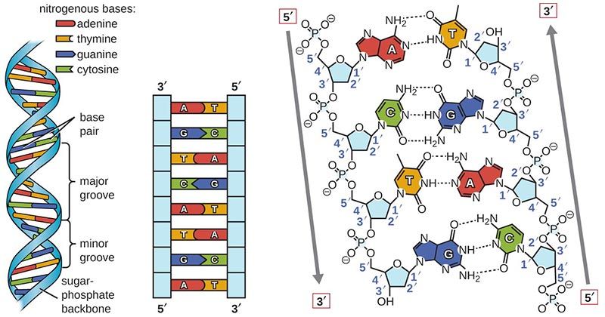

Nucleotide linkage in RNA:
Nitrogenous bases present in RNA are adenine, guanine, cytosine and uracil. RNA is single stranded molecule. Sometimes the same single chain coils back to form double helix. Adenine combines with uracil not thymine in RNA while cytosine and guanine combine in same way.
Types of nucleotide:
- Mononucleotide
These are single nucleotide and are not attached to DNA or RNA. A single nucleotide as opposed to other types, such as dinucleotide and trinucleotide, characterized by being an organic compound made up of a nucleobase, a sugar, and a phosphate group. Being single nucleotide it can have up to 3 phosphates. It can distinguished into 3 types depending upon number of phosphate groups present.
- Monophosphate
- Diphosphate
- Triphosphate
Examples:
- cAMP, a cyclic nucleotide signaling molecule with a single phosphate linked to both 5- and 3-positions.
- pppGpp, a nucleotide signaling molecule with both 5'- and 3'-phosphates

- Dinucleotide:
These are the compounds that contain two nucleotides linked together by covalent together.
Example:
- NADP, a dinucleotide enzymatic cofactor.
- FAD, a dinucleotide enzymatic cofactor in which one of the ribose sugars adopts a linear configuration rather than a ring.
- Polynucleotide:
- DNA stores genetic information and play vital role in inheritance. In addition it also builds, maintains and regulate functions at cellular and organism level.
- RNA produced inside nucleus of cell by DNA. It plays pivotal role in production of all kinds of proteins such as enzymes, hormones, etc.

Functions of nucleotides in human body:
- Building blocks for construction of nucleic acid polymers such as DNA and RNA.
- Singular nucleotides play roles in cellular energy storage and provision in the form of for example ATP.
- They are chemical messengers and play role in cellular signaling e.g. cyclic AMP (cAMP) is a messenger molecule.
- They are source of phosphate groups that are used to modulate the activity of proteins and other signaling molecules.
- They act as enzymatic cofactors, often carrying out redox reactions..
- They are also found in coenzymes like NAD and NADP, these molecules are used in many chemical reactions that play roles in metabolism.

MCQ’S

1. Which of the following is not part of nucleotide structure?
A. 5-carbon sugar
B. Phosphate group
C. Phospholipid*
2. Which is the correct pairing?
A. A-G
B. C-G*
C. T-U
D. U-C
3. Which nucleotide is not found in DNA?
A. Uracil*
B. Thymine
C. Adenine
4. What is not common between uracil and thyamin?
A. Both have ring structure.
B. Both have a methyl group.*
C. Both contain N atoms.

5. What is characteristic of RNA?
A. It contains both purine and pyrimidines.
B. It contains both ribose and deoxyribose.
C. It contains one 5’ end and one 3’ end.*

6. What is nature of DNA?
A. Acidic*
B. Basic
C. Neutral

7. N- base + pentose sugar
A. Nucleotide
B. Nucleoside*
C. Nucleic acid

.8. Adenosine triphosphate is
A. Mononucleotide*
B. Dinucleotide
C. Trinucleotide

9. …………… is always esterified to sugar moiety
A. Phospholipid
B. Nitrogen base molecule
C. Phosphoric acid*

10. The sugar-phosphate backbone attaches to
A. Phosphate group
B. Nitrogen base*
C. 5-C sugar

.............................................................

