Phd in International Management
Various Research Methods Analysis
Submitted by: Sohil Sharma
Horizons University, Paris
PHD 650: Qualitative & Quantitative Methods
Professor: Dr. Perry Haan
Date of Submission: 17th Dec 2018

Table of Contents
Introduction 3
Quantitative Research Method 4
Qualitative Research Method 5
Mixed Research Method 6
Various Circumstances 7
Conclusion 8
Reference 9

Introduction
According to the study done by Creswell (2003), researcher need to focus on three methods when carrying out business research: Quantitative, Qualitative and mixed method approaches. Author mention ‘The first has been available to the social and human scientist for years, the second has emerged primarily during the last three or four decades, and the last is new and still developing in form and substance’. Starting to consider the most fashionable one which is quantitative research method that deals with numbers and amounts to certain extend for describing an event in a form of figures that support the hypotheses and predication modal. The other one is running from ages that is qualitative research method which enable researcher to use texts for justifying their findings, describing the quality of subject, kind of providing mental picture from researcher view. The last on which is less known that others two methods called as mixed methods that includes the mixing of both qualitative and quantitative data for improving the existing measures. A method that involves collecting, analyzing quantitative with qualitative focus group interviews. In this paper my intention will be to drill down the comparison of all the 3 methods by identifying the preferable approaches under what circumstances is better. Applying the concepts from key consideration in my research approach by relating it to my own philosophy of business research.

Quantitative Research Method
A method in which collection of numerical data which can be transformed into statistics are taken into consideration. DeFranzo (2011, para 3) also mention that it is used to quantify attitudes, opinions, behaviors, and other defined variables – and generalize results from a larger sample population, it also measurable data to formulate facts and uncover patterns in research. If researcher is playing with the numbers it means he/she have a good knowledge of interpretations of standard deviations, calculation, correlation etc. In this method data collections are done through various forms like online or paper survey, mobile or kiosk survey even some time face-to-face interviews, online pools and telephone interviews are also considered as a part of it. Creswell (2003) also mention that that knowledge is conjectural absolute truth can never be found (p. 7). Thus, evidence established in research is always imperfect and fallible. Benefits of these time of research lets scientist to conduct broad depth research with accurate result and just because the data is straightforward it is easy to compare outcome amongst other data. On the other side the drawback of this methods is researchers need to have access to the population which can sometime by time-consuming and costly. Personal information can be leak causing a high risk of bias, so question that are define for in-depth study need to short with no probing questions.

Qualitative Research Method
This once is in pictures from many decades. According to DeFranzo (2011) this approach is used to gain an understanding of underlying reasons, opinions, and motivations by providing insights into the problem or helping to develop ideas and hypotheses for potential quantitative research. In simple terms it is method of observation that is gather through non-numerical data. The type of research includes various methods of collecting data through case studies, interviews, focus group like group discussion with participation and observation. One of the quality of these type of research are it covers issue as well as subject in depth and in details plus data is more powerful as its made up of human experience rather than quantitative research. Usually in these types of research the researcher has a clear vision on what to expect as framework of the work can be revised quickly with the fresh information. But everything comes will disadvantages, in here quality depends by the knowledge and skill of researcher so there is some dependency. It could be time consuming with rigidity is more difficulty to assess. Creswell (20030 also talked about that the process of qualitative research is largely inductive, with the inquirer generating meaning from the data collected in the field (p.9). These sorts of research are sometimes not accepted especially within scientific communities’ environment.

Mixed Research Method
The 3rd one that was discuss is mixed research methods which is relatively new in the market and it is still under development. According to FoodRisc Resource Centre (n.a.), Mixed methods research is a methodology for conducting research that involves collecting, analyzing and integrating quantitative (e.g., experiments, surveys) and qualitative (e.g., focus groups, interviews) research. This approach to research is used when this integration provides a better understanding of the research problem than either of each alone.
This sort of approach provides a greater comprehensive understanding of the research problem in details rather than focusing separated on quantitative or qualitative approaches individual plus on top of that it offset the weaknesses of both research too, but design of these research can be very complex. It is not easy to plan and implement one method by drawing the finding that is noted from another research, so that is why is take much more time and resource to plan accordingly. These methods be only suggested to use where understanding the phenomenon in depth plays a great importance to the researcher. It may be sometimes unclear how to resolve the discrepancies that can occur when investigating the findings specially when collection of quantitative data followed by qualitative data.

Various Circumstances
Here we will be discussing about which dimension is preferable under what circumstance and for that we need to put it the table. According to Creswell (2014) suggestion below are the research designs that these approaches tend to use
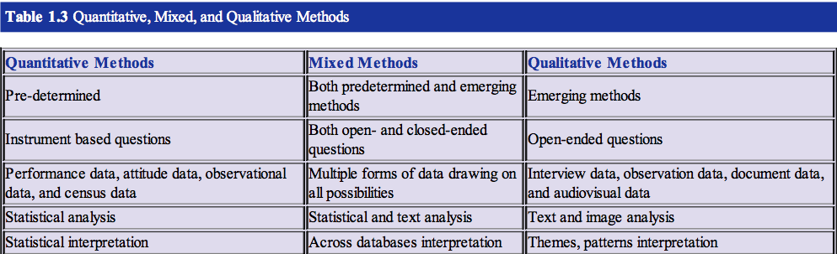
Figure 1: Creswell, 2014, p.45.
In my last course PHD 610, I made my final project on ‘Organizational Behaviours in different geographical area. I utilized surveys from various online resources, document for data collection and that is a part both quantitative and qualitative investigation for conclusion. I applied partially the concepts of key considerations when designing my research approach for identification of how human reacts in certain conditional cause of organizational environment in various parts of country. I was not aware of the third one that is mixed research so was not able to patch in my previous final project. One the format of Qualitative question type which is open ended and quantitative was taken care in my previous project that helps in predicting, confirming, discovering and describe the relationship accordingly.

Conclusion
The paper has given a little insight of quantitative, qualitative and mixed methods approaches when researching. Going further is seems to be appear that mixed methods research will play a greater role in future research than the other two because it contains the potentials to overcome criticism which are pointed at each methodology individually. It should be however pin pointed that a research can never be bias on one methodology as it various from researcher to researcher also depends upon the phenomenon being studied. In an overall, it has been shown that the question which we are performing in the research drives the methodology to be used in future.
The purpose of this study was to understand the ground root of various methodological framework. If you have the budget, then researcher should go for both quantitative and qualitative research as it provides various perspectives. Being aware of various methodology with a good idea help you focusing on the target user with in-depth information gathering. Overall the primary aim of these type of research are to provide a completed detailed description as determining which method is best suitable is an ongoing debateable topic. The reason why it remains unresolved is due to the fact of contain own strengths and weakness which vary depending upon topic.

Reference
Creswell, J. W. (2003). Research design: Qualitative, quantitative, and mixed
method approaches. Chapter 1, A framework for design. Sage Publications,
Inc. Second Edition.
Creswell, J. W. (2014). Research Design Qualitative, Quantitative, and Mixed
Methods Approaches (4th ed., p. 304). Thousand Oaks, CA: SAGE
Publications.
DeFranzo, E. S. (2011). What’s the difference between qualitative and quantitative
research? Retrieved from:
https://www.snapsurveys.com/blog/qualitative-vs-quantitative-research/
FoodRisc Resource Centre (n.a.). A resource centre for food risk and benefit
communication. Retrieved from:
http://resourcecentre.foodrisc.org/mixed-methods-research_185.html

