How to Write an Official Letter with Template and Example
The best way to express an opinion or provide important information to others can be through an official letter. This is a professional way to explain yourself while using simple and concise sentences to avoid taking up the reader's time. Official letters follow a specific structure or format that must be maintained throughout the entire document.
In this article, we explain what an official letter is, how to write an official letter and we provide a template and example of an official letter.

What is an official letter?
An official letter, also known as a "formal letter," is a document professionally written for another company or business professional. They can be used when applying for jobs, issuing a complaint, expressing interest in a job position or thanking someone. Official letters are often written using simple and direct sentences with a formal greeting and signature included. Writing an official letter typically requires following a very structured and specific format.

How to write an official letter
Creating a concise and clear official letter can help explain your intent and purpose in a way your audience may easily understand. Follow the steps below to learn how to write an official letter.
- Set up your font and margins.
- Create your heading.
- Write your salutation.
- Use your body paragraphs to state your reasons for writing.
- Add your closing body paragraph and signature.
- Mention and add your enclosures.
- Proofread and send your letter.

1. Set up your font and margins
Before you begin, you want to ensure your letter is not only simple to understand, but simple to read as well. To keep your letter clean and professional, you should set your margins to be one inch per each side of the document. Using simple fonts like Verdana, Arial, Calibri or Times New Roman with a 12-point size will give your official letter a clean look as well.

2. Create your heading
Once your fonts are set, you can begin addressing your letter. First, write your name in the top left-hand corner of the page. Include your name, address and the current date. You can also include your phone number and email if you are requesting further contact.
You can now input the recipient's address information directly beneath yours. Write their name, title of their organization if they are representing one, followed by the address. Review the name and address of your recipient more than once to ensure you've written the correct address and spelled their name right.

3. Write your salutation
You can now professionally greet your reader. A common salutation used in official letters is, "Dear Ms. or Mr. Last name". If you know both their first name or last name, you can include that in the salutation. For example, you can write, "Dear Alex Smith". If you know their gender, you can write, "Dear Mr. Alex Smith" or "Dear Ms. Alex Smith". If you're unaware of the name of the recipient, you can write, "Dear Sir or Madam".

4. Use your body paragraphs to state your reasons for writing
The body paragraphs are where you can capture your main points and professionally explain your concerns, opinions or other information to your recipient. You can briefly introduce yourself and begin by explaining your reason for writing this letter. You can use verbiage such as, "I am writing to you today because..."
Once you've explained what the recipient will read, you can expand further throughout the next paragraph. Include details that support your first statement. For example, if you were writing a recommendation letter, you could expand on the skills of the person your recommending by saying, "Avery's time-management and organizational skills have improved the efficiency of my business by 12% since the beginning of the quarter."
You can continue giving examples until you believe your point has been clearly understood by the reader. Keep your sentences short, simple and easy for the reader to understand.

5. Add your closing body paragraph and signature
To finalize your letter, you can write your conclusion paragraph. This paragraph can be short and will finalize the document by repeating your main point, explaining any possible next steps or thanking the recipient for taking the time to read your letter.
After closing the letter, you can provide your closing signature at the end of the document. Examples of common letter signatures are:
- Sincerely
- Sincerely yours
- With appreciation
- Thank you
- Regards
- Yours truly
- Respectfully yours
Select your closing signature and write your name at the bottom of the letter.

6. Mention and add your enclosures
Enclosures are additional materials added to your letter to support your document, similar to when you attach a file to an email. If you're attaching a document to complement your letter, you should mention it near the end of your letter. To inform the reader that an additional document is attached, you can include the word "enclosure" at the end of the letter after your name. You can also shorten the word by writing, "encl."

7. Proofread and send your letter
After you've finished writing, you can read through the letter to catch any grammatical or spelling errors. You can also review it to ensure it makes sense and is clear enough for the recipient to understand. Once proofread, you can send the letter to the recipient. Pick a plain white, square or rectangular envelope. Fold the letter properly so it fits in the envelope.
Write your name and address in the top left-hand corner of the envelope followed by the recipient's name and address in the middle. Put a stamp on the right-hand corner and send your letter to the desired recipient.

Official letter vs unofficial letter
Since both official and unofficial letters are written documents used to send messages to others, it may be easy to confuse the two.
Official letters are often:
- Typed and never handwritten
- Following strict, standard grammar and English rules
- Containing short and concise sentences
- Using a specific, professional structure
Unofficial letters don't follow a structure as strict as official letters. Instead, official letters contain:
- Less professional and more casual language
- Words that are handwritten or typed
- No specific type of formatting or structure they have to follow

Official letter types
People may write official letters for various reasons that involve professionally expressing their interests, concerns or disagreements. Common official letter types can include:

Resignation letters
When an employee leaves their current position, they may send a brief resignation letter to their employer or hiring manager to explain their reason for leaving and to develop a plan for their transition process.

Cover letters
Writing a cover letter is one of the most common uses for official letters. Applicants can write cover letters when applying for a new job position, grant programs or educational programs.

Complaint letters
Many individuals or companies may use an official letter structure to express a complaint with a product or service. An employee may be asked to write a complaint letter on behalf of a company who is dissatisfied with a product used by its employees.

Professional thank you notes
After a job interview, an applicant may write a professional thank you note to express their gratitude to the employer for meeting with them and considering them for the position.

Letter of interest
If a candidate is interested in working for a company but doesn't see any job postings for their desired position, they may write a letter of interest stating that they would like to pursue a position with the company if an opportunity is available.

Letter of recommendation
When an applicant is applying for a job position or an educational program, the institution may ask for a letter of recommendation. The person writing the letter is often someone who worked closely with the applicant and is vouching for their qualifications for the position.

Business announcement
Companies who are expecting a significant change will write a business announcement that is released to the public. This can be an announcement for a new product, the filling of a leadership role or explaining an upcoming event they're hosting or attending.

What to include in an official letter
Official letters are often written using a professional tone and must include specific elements to remain professional and clear throughout the entire letter. To maintain proper official letter etiquette, you should include the elements below:
- A heading that lists your address and the recipient's address
- A formal salutation
- One paragraph stating your reasons for writing the letter
- Another paragraph expanding further on the introduction paragraph
- A final paragraph concluding the letter
- Closing letter signature
- Necessary enclosures to support the document

What not to include in an official letter
As you create your official letter for the desired audience, a professional verbiage and tone must be consistent throughout the entire document. To do this, you should avoid the following elements when writing an official letter:
- The phrase "Miss" in your salutation
- Being too formal that your letter sounds unclear, impersonal and difficult to understand
- Contractions
- Incomplete sentences
- Colorful font or stationery
- Lengthy sentences or paragraphs

Official letter template
The template below will show how to properly write an official letter.
[Your name]
[Your street name and number]
[City, state zip code]
[Company name]
[Company street name and number]
[City, state zip code]
[Current date]
[Recipient name]
[Recipient job title]
Dear [recipient name],
[The first sentence of your first paragraph is an introductionand explains your reasoning for writing to the recipient. You can use the next two to three sentences to further explain the topic of your letter. Try to refrain from giving details or examples until the second paragraph.]
[This second paragraph will describe your point further. You can use examples or other details to inform the reader of your opinion or important information. The second paragraph should remain around three to four sentences long, meaning your letter should be short, concise and straightforward.]
[This last paragraph should conclude the letter. You can thank them for their time reading this and can suggest any necessary follow-up steps.]
[Closing sign off],
[Your name]
[Signature]
Enclosure: [the supporting document you've enclosed]

Official letter example
Below is an example of an official letter. You can use this as a reference as you write your own official letter.
Avery May
123 Kansas Ln
Kansas City, MO 64105
Roberts Media Group
334 Sunflower Ln
Kansas CIty, MO 64105
December 17, 2019
Cameron Jones
Account Manager
Dear Ms. Cameron Jones,
I am writing to inform you of my resignation from Roberts Media Group as the Account Coordinator, effective two weeks from the current date.
I appreciate all the support, encouragement and motivation I've received during my time in this position. I have decided to pursue a position where I can apply more of my team building and leadership skills. Over the next two weeks, I will continue to dedicate my time toward finishing the rest of my projects and will provide any necessary training to ease the transition process.
Thank you again for the support you've given me and thank you for taking the time to read this. If you would like to schedule a meeting to discuss this further, I would be happy to talk when you are free.
Sincerely,
Avery May
Enclosed:
List of my current projects
Schedule to complete them all

[JOINING REPORT FORMAT]

Date: ______________
To,
The Principal,
INSTITUTE OF TECHNOLOGY,
Lahore.

Subject: JOINING LETTER.

Sir,
In response to your appointment letter vide letter dated ______________________ in connection with the interviews held on ________________________, I would like to inform you that I have joined your institute today at _____________ as an _________________ in ___________________________ department.
I thank you for providing me the opportunity to serve the institute. I will perform my duties sincerely, honestly and to the best of my abilities.
Thanking you.

Yours faithfully,

Why are they called minutes of a meeting?
According to Today I Found Out, the "minutes" of "meeting minutes" don't refer to the minute measurement of time, but to the "minute" (my-newt) notes taken during meetings.

What’s involved with meeting minutes?
As mentioned above, there are essentially five steps involved with meeting minutes:
- Pre-Planning
- Record taking - at the meeting
- Minutes writing or transcribing
- Distributing or sharing of meeting minutes
- Filing or storage of minutes for future reference

1. Pre-planning meeting minutes:
A well-planned meeting helps ensure effective meeting minutes. If the Chair and the Secretary or minutes-taker work together to ensure the agenda and meeting are well thought out, it makes minute taking much easier. For example, depending on the meeting structure and the tools you use, the minutes-taker could work with the Chair to create a document format that works as an agenda and minutes outline as well.

What is the agenda of a meeting?
Meeting agenda = outline:
At the very least, it’s important to get a copy of the meeting agenda and use it as a guide or outline for taking notes, setting up your mom format, and preparing the minutes – with the order and numbering of items on the minutes of meeting matching those of the agenda.
In addition, the agenda and/or meeting notice also provides information that will need to be included in the minutes, such as:
- the names of all the meeting attendees, including guests or speakers
- documents that are sent out with the agenda or handed out in the meeting – copies (digital or hard copy) of handouts should be stored with the meeting minutes for future reference and for sharing with those who were unable to attend the meeting (and others as determined by the meeting’s Chair).

Clarifying Expectations:
When you take on a new role as minutes-taker or Secretary, be sure to ask the Chair of the committee or Board what their expectations are of your role during the meeting, as well as the type of detail he/she expects in the minutes. For example, if your Board or committee will be dealing with motions, or voting on items/issues, be clear on whether you need to offer names of those making motions, seconding, etc. If you will be dealing with this type of procedures, you (and your Chair) may want to refer to Robert’s Rules of Order.

2. What should be included in meeting minutes?
Before you start taking notes, it’s important to understand the type of information you need to record at the meeting. As noted earlier, your organization may have required content and a specific mom format that you’ll need to follow, but generally, meeting minutes usually include the following:
- Date and time of the meeting
- Names of the meeting participants and those unable to attend (e.g., “regrets”)
- Acceptance or corrections/amendments to previous meeting minutes
- Decisions made about each agenda item, for example:
  - Actions taken or agreed to be taken
  - Next steps
  - Voting outcomes – e.g., (if necessary, details regarding who made motions; who seconded and approved or via show of hands, etc.)
  - Motions taken or rejected
  - Items to be held over
  - New business
  - Next meeting date and time
You can find more templates and details on formatting meeting minutes here.
Tips that might help your note taking:
- Create an outline – as discussed earlier, having an outline (or template) based on the agenda makes it easy for you to simply jot down notes, decisions, etc. under each item as you go along. If you are taking notes by hand, consider including space below each item on your outline for your hand-written notes, then print these out and use this to capture minutes.
- Check-off attendees as they enter the room - if you know the meeting attendees, you can check them off as they arrive, if not have folks introduce themselves at the start of the meeting or circulate an attendance list they can check-off themselves.
- Record decisions or notes on action items in your outline as soon as they occur to be sure they are recorded accurately
- Ask for clarification if necessary – for example, if the group moves on without making a decision or an obvious conclusion, ask for clarification of the decision and/or next steps involved.
- Don’t try to capture it all – you can’t keep up if you try to write down the conversation verbatim, so be sure to simply (and clearly) write (or type) just the decisions, assignments, action steps, etc.
- Record it – literally, if you are concerned about being able to keep up with note taking, consider recording the meeting (e.g., on your smart phone, iPad, recording device, etc.) but be sure to let participants know they are being recording. While you don’t want to use the recording to create a word-for-word transcript of the meeting, the recording can come in handy if you need clarification.

Meeting Minutes Template:
Here's a simple template you can refer to next time you need to take meeting minutes.

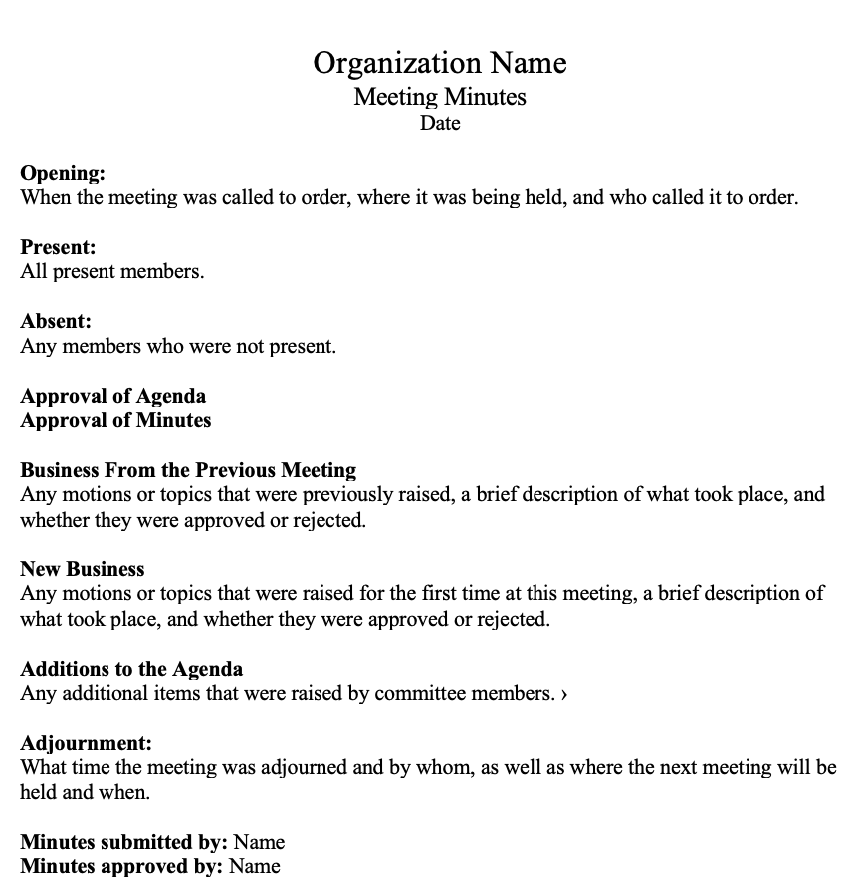
You can also find more meeting minutes templates made for Microsoft Word here.

Meeting Minutes Sample:
Still wondering if you're taking notes correctly? Here's a sample of what meeting minutes at a board meeting might look like.
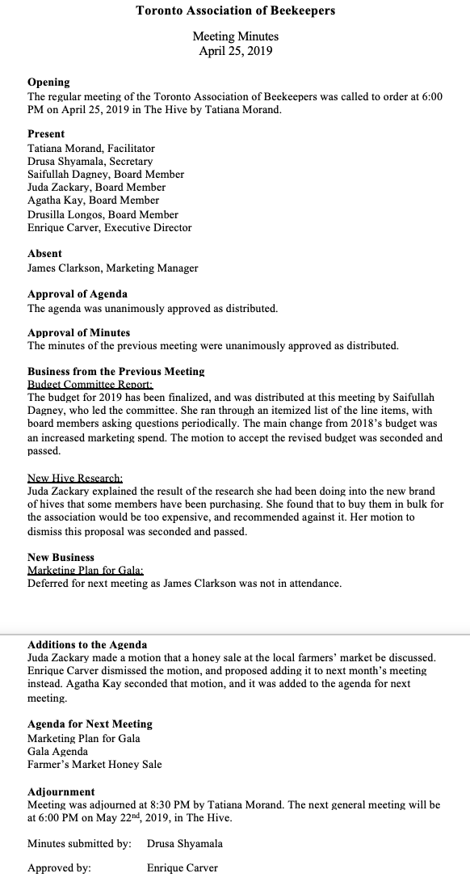

3. The Minutes Writing Process
Once the meeting is over, it’s time to pull together your notes and write the minutes. Here are some tips that might help:
- Try to write the minutes as soon after the meeting as possible while everything is fresh in your mind.
- Review your outline and if necessary, add additional notes or clarify points raised. Also check to ensure all decisions, actions and motions are clearly noted.
- Ensure you're including sufficient detail
  - For Board of Director’s minutes in particular, we recommend including a short description of each action taken, as well as the rationale behind the decision
  - If there was a lot of discussion before passing a motion, write down the major arguments for and against
- Edit to ensure brevity and clarity, so the minutes are easy to read
- In terms of mom format, here are a few things to keep in mind:
  - Be objective
  - Write in the same tense throughout
  - Avoid using names other than to record motions and seconds.
  - Avoid personal observations — the minutes should be solely fact-based
  - If you need to refer to other documents, don't try to summarize them. Rather, simply indicate where they can be found or attach them as an appendix

Notice of a Meeting:
When a meeting is to be convened, a notice is required to be sent to all who are to attend it.

It should satisfy these conditions:

1. It should be under proper authority
2. It should state the name of the organisation
3. It should state the day, date, time, and place. Also, sometimes, how to reach the place
4. It should be well in advance. Some require seven days’ notice, some 48 hours’
5. It should state the purpose and, if possible, the agenda
6. It should carry the date of circulation and convener’s/secretary’s signature
7. It should go to all persons required at the meet
8. It should mention the TA/DA etc. payable and the arrangements for this

In practice, it is necessary to ensure that the notice has reached in time. This may be done telephonically. Dispatch section and post are prone to delays

We often find that between the date of a letter from a major public organisation and the post mark on the letter, there is a gap of 10-12 days. A notice that should reach seven days before a meet should not reach seven days after the meet

