Departement of BS Education
Assignment: Thinking and understanding
Concepts of'Problem Solving

Subject:
Educational Psychology

Submitted To:Ma'am Hina Zahra

Submitted By: Ihsan Ullah-Daniyal Safdar-Naeem Raza
Roll No : BEDF19BM046
BDF19BM034
BDF19BM018

UOS SUB CAMPUS BHAKKAR

- Definitions:
Thinking refers to accessing the mind to develop ideas, make decisions and store and retrieve memoriess . it is the process of consideringh or reasoning about something. we use our thinking ability in order to make sense of experiences , organize information , make connections, ask questions, make plans or make desisions.
- 1.the process of considering or reasoning about something.
- 2.the action of using one's mind to produce thoughts
- 3. Thinking is a mental activity in its cognitive aspect.
- 4. Thinking is the reorganization of concepts.
- 5.Thinking is mental exploration to find out solution to a problem.

- Characteristics:

It is one of the most important aspects of ones cognitive behavior.
It depends on both – perception and memory.
Thinking is a mental process which starts with a problem and concludes with its solution. It involves trial and error; analysis and synthesis; foresight and hindsight.
It is a symbolic behavior.
It is a cognitive activity.
It is always directed to achieve some purpose.
It is different from day-dreaming and imagination.
It is a problem-solving behavior.
There is mental exploration instead of motor exploration..
(e.g.: if a person gets locked in a room and loses his keys and he starts searching for them in different places. This becomes motor exploration. But if he tries to think of different ways of how he can get out of the room then this becomes mental exploration- THINKING.) Thinking is a symbolic activity. (e.g.: engineers use mental images and symbols to design the plan for buildings)

- Types

1. Creative thinking
An ability to conceive new and innovative ideas by breaking from established thoughts, theories, rules, and procedures. People who use this thinking often hear that they “think outside the box”.

2. Analytical thinking
An ability to separate a whole into its basic parts in order to examine the parts and their relationships. People with this type of thinking are great problem-solvers and have a structured and methodical way of approaching tasks.
3. Critical thinking
The process of exercising careful evaluation or judgment. Critical thinkers do this in order to determine the authenticity, accuracy, worth, validity, or value of something. Rather than strictly breaking down information into parts, critical thinkers explore other elements that could have impacted conclusions.
4. Concrete thinking
More often than not, these type of thinkers prefer to think, comprehend and apply factual knowledge. It is about thinking of objects or ideas as specific items, rather than as a theoretical representation of a general concept. It involves practical thinking only, always literal, and to-the-point.
5. Abstract thinking
An ability to relate seemingly random things with each other and make the connections that others find difficult to see. People with this type of thinking pay attention to the hidden meanings behind things relating them to other items, events, or experiences. Abstract thinkers usually can observe things as theories and/or possibilities.
6. Divergent thinking
This mindset takes the path of exploring an infinite number of solutions to find one that is effective. So, instead of starting off with a set number of possibilities and converging on an answer, divergent thinkers go as far and wide as necessary and move outwards in search of the solution.

7. Convergent thinking
A process of combining a finite number of perspectives or ideas to find a single solution. Convergent thinkers will target these possibilities, or converge them inwards, to come up with a solution.
Consider it as a multiple-choice question in an exam. You have four possible answers but only one is right. In order to solve the problem, you would use convergent thinking.

- The Importance of Thinking

Thinking is an important mental process. It helps us to define and organise experiences, plan, learn, reflect and create. But sometimes our thinking may for a variety of reasons become unhelpful and this has a negative impact on our well being.

Some negative types of thinking may include:
When our thinking dwells in the past to a level that it influences our ability to function in the present;
When our thinking is constructed of language that is absolute in character and leaves little room for imagining a different future;
When our thinking prevents us from recognising our own strengths or the strengths of others.
- Definitions of understading
understanding is a psychological process related to an abstract or physical object, such as a person, situation,or message whereby one is able to think about it and use concepts to deal adequately with that object. understading is a relation between the knower and an object of understanding . Understanding implies abilities and dispositions with respect to and object of knowledge that are sufficient to support intelligent behavior

- characteristics of Understanding
- Unconditional love
- No or less expectations
- accedpting people as they are
- postive attitude toward people
- patient towards people
- Selfless attitude toward people
- Unconditional care for people in all Situations

- Importance of understanding
- When something is meaningfully understood, it is retained much longer, can be built upon to acquire further understanding , is usually very versatile in the situations and ways it can be used, and facilitates creativity.
- For example , the law of supply and demand (understading that a higher price for something will reduce the amount demanded and increase the amount supplied) is something which one is not likely to forget once it is meaningfully understand. it is importent for acquiring and understanding of cinsumption theory. it can be applied in a broad range of ways, including deciding how much to charge for cutting someone's lawn and deciding for whom to vote. And it helps one to be creative in finding ways to maximize your income.
- Similarly, once you understand what an atom is, you are not likely to forget it; it is essential for understading the chemical behavior of matter (atomic theory); it is a broadly useful concept in chemistry and it greatly facilitates a chemist's ability to develop creative ideas and products.

- What is problem solving?
Problem solving is the act of defining a problem; determining the cause of the problem; identifying, prioritizing, and selecting alternatives for a solution; and implementing a solution. The problem-solving process.
Nature of problem solving!
Problem solving is the mental process of analyzing a situation, learning what options are available, and then choosing the alternative that will result in the desired outcome or some other selected goal.

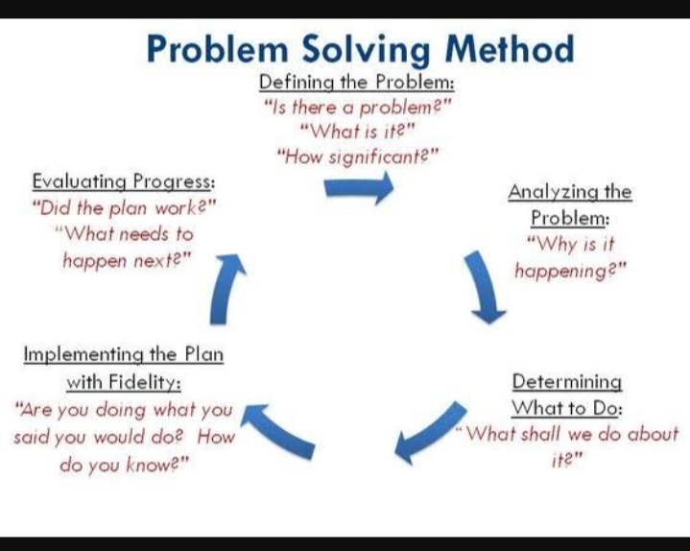

- Some key problem-solving skills include:
- Active listening.
- Analysis.
- Research.
- Creativity.
- Communication.
- Dependability.
- Decision making.
- Team-building.
- What is the nature of a problem?

The nature of your problem is more like the general idea of it. For example, if you were calling a computer support number, they would ask what the nature of your problem was. You could just say "Internet connection issues" instead of "My Internet keeps losing connection when I do this specific thing on my computer.

What are the 7 steps to problem solving?
- Here are seven-steps for an effective problem-solving process.
- Identify the issues.
- Be clear about what the problem is. ...
- Understand everyone's interests. ...
- List the possible solutions (options) ...
- Evaluate the options. ...
- Select an option or options. ...
- Document the agreement(s). ...
- Agree on contingencies, monitoring, and evaluation.

- Strategy means!
A problem-solving strategy is a plan of action used to find a solution. Different strategies have different action plans associated with them ([link]). For example, a well-known strategy is trial and error. The old adage, “If at first you don't succeed, try, try again” describes trial and error.

- The 10 problem solving strategies include:
- The 10 problem solving strategies include:
- Guess and check.
- Make a table or chart.
- Draw a picture or diagram.
- Act out the problem.
- Find a pattern or use a rule.
- Check for relevant or irrelevant information.
- Find smaller parts of a large problem.
- Make an organised list.
- Factors!

Below we have outlined the key factors affecting the problem solving process.
Understanding the problem. The most important factor in solving a problem is to first fully understand it. ...
Personality types/Temperament. ...
Skills/Competencies. ...
Resources available. ...
External.

- Why is problem solving is important in life?
Problem-solving is important both to individuals and organizations because it enables us to exert control over our environment. ... Problem-solving gives us a mechanism for identifying these things, figuring out why they are broken and determining a course of action to fix them.

