INTERNATIONAL LAW OF THE SEA
AND
AN OVERVIEW IN TANZANIAN LAWS
©Honestworld
Contents;
- INTRODUCTION
1.0 WHAT IS IT?
  - GENERAL OVERVIEW ON THE IMPORTANCE OF SEA
  - COMMON TERMS ON THE LAW OF THE SEA
- HISTORICAL BACKGROUND ON THE LAW OF THE SEA
- UNITED NATIONS ON THE LAW OF THE SEA
  - MARITIME ZONES
  - TERRITORIAL WATERS
  - TERRITORIAL SEA
  - CONTIGUOUS ZONE
  - EXCLUSIVE ECONOMIC ZONE
  - HIGH SEAS
- TANZANIA AND LAW OF THE SEA
4.1 HISTORICAL BACKGROUND
4.2 LAWS ON SEA
4.3 SHORTCOMINGS OF TANZANIA ON THE LAW OF THE SEA CONVENTIONS.
4.4 POSSIBLE SOLUTION.
5. SUMMARY.

- INTRODUCTION
  - WHAT IS IT?
Law of the Sea is a body of international law that concerns the principles and rules of which public entities, especially states, interact in maritime matters, including navigational rights, sea mineral rights, and coastal waters jurisdiction.
The Law of the Sea sets down a series of rules that regulate the entitlement of coastal states to maritime zones, their rights and duties within these zones and how the boundaries of each zone should be established.
Law of the Sea, as a branch of international law concerned with public order at sea. Much of this law is codified in the United Nations Convention on the Law of the Sea, signed Dec. 10, 1982. The convention, described as a “constitution for the oceans,” represents an attempt to codify international law regarding territorial waters, sea-lanes, and ocean resources.
  - GENERAL OVERVIEW ON THE IMPORTANCE OF SEA
We can make a long list of how the sea (ocean) and marine life are important to us. Did you know the Oceans cover greater than 70% of the earth’s surface? They contain 99% of the living space on earth! Without this space for organisms to survive, there would be five fewer phyla of animals on the earth. Perhaps this is the most important reason to protect the sea.
The seas have historically performed two important functions: first, as a
medium of communication, and secondly as a vast reservoir of resources,
both living and non-living. Both of these functions have stimulated the
development of legal rules. The fundamental principle governing the
law of the sea is that ‘the land dominates the sea’ so that the land territorial situation constitutes the starting point for the determination of the
maritime rights of a coastal state.
Biodiversity
Coral reefs, salt marshes, estuaries and mangrove and seagrass beds are just a few of the ocean environments which support a large number of different species of organisms – that is, have a high biodiversity. Estuaries are brackish water systems that empty their waters into the world’s oceans and support many, many fish and other organisms. Along with coral reefs, estuaries sustain 75 percent of all commercial fish and shellfish during some point of their life cycles! Spawning organisms make reefs and estuaries their home because animals can find an abundance of food and excellent
protection from predators. In the estuary, the seagrasses provide protection to juveniles and food for the herbivore. Mangroves not only act as nurseries for commercially important marine species, they also act as a filtering system for coastal water.
Natural resources
The ocean floor habitat is not as well-known as coral reefs or coastal areas, but it is very important to all the organisms that live on the bottom (benthic organisms), as well as commercially important as well. The continental shelves and ocean floor are home to many important minerals, including oil and natural gas. Natural gas and oil play a major role in meeting world energy needs. The outer continental shelf contains more than 50 percent of the world's remaining undiscovered natural gas and oil resources.
Transportation
Not only are oceans important to sustain life, but also for moving materials that we use. More than 90 percent world’s trade (by weight) passes through ports and harbours. Without commercial ships and barges, transportation of goods from place to place would be much more difficult and expensive. Cities which have good natural harbours have always had an advantage, and even today are some of the largest cities in the world.
Climate and weather
Did you know warm ocean waters provide the energy to fuelstorm systems that provide fresh water vital to land-dwelling organisms? The oceans interact with and affect global weather and climate. As the air passes over warm waters, it rises due to warming. As it cools, condensation of the water creates rainfall. If the air passes over cooler waters, it cools and sinks.
The importance of the ocean cannot be debated. It truly contains some of the planet's most fascinating ecosystems.
  - COMMON TERMS ON THE LAW OF THE SEA

- The maritime zones- are sea-zones recognised under international law include, the territorial sea, the contiguous zone, the exclusive economic zone, the continental shelf, the high seas and the Area.
Read; UNCLOS from Part II.
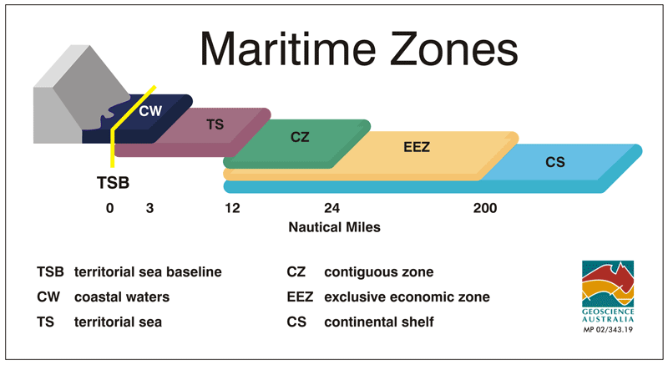
- The baseline- is a legal construct: an artificial boundary line that determines where a State’s maritime sovereignty and jurisdiction begins and ends. In fact, baselines determine all areas of maritime jurisdiction. They create a demarcation between areas where a State has no rights and those where a State does enjoy rights. We should now note that the default baseline under UNCLOS is the normal baseline. According to Article 5 of UNCLOS, a normal baseline is drawn at the low-water line, as stated in official charts. Perhaps the easiest way to think of a normal baseline is as an “outline” of a State’s coast. Waters on the landward side of a baseline are considered a State's internal waters, treated much in the way that land would be treated. However, in some situations, it is either impractical or uneconomical to draw a normal baseline. In such cases, straight baselines are used in lieu of normal baselines.
Normally, a sea baseline follows the low-water line of a coastal state Article 5 of UNCLOS 1982.
Literally, it is the method of measuring maritime zones. The coastal state itself has to determine the baseline, which must then be shown on charts or defined by adequate geographical coordinates and given adequate publicity (article 16). It involves the following methods
- Normal baseline
Article 5 of UNCLOS provides; Except where otherwise provided in this Convention, the normal baseline for measuring the breadth (width) of the territorial sea is the low-water line along the coast as marked on large-scale charts officially recognised by the coastal State.
- Reefs
Article 6 of UNCLOS provides; In the case of islands situated on atolls or of islands having fringing reefs, the baseline for measuring the breadth of the territorial sea is the seaward low-water line of the reef, as shown by the appropriate symbol on charts officially recognised by the coastal State.
- Straight baseline
Are normally applied in rough costs which are either curved or in the case or an inland. Under Article 4(1), straight baselines may be used in localities where the coastline is deeply indented and cut into, or if there is a fringe of islands along its coast in its immediate vicinity.
Conditions in the application of straight baselines:
- Article 4(2) maintains that “straight baselines must not depart to any appreciable extent from the general direction of the coast, and the sea areas lying within the lines must be sufficiently linked to the land domain to be subject to the regime of internal waters.”
- Article 4(5) indicates that “State may not draw straight baselines in such a way as to cut off from the high seas the territorial sea of another State.”
- Article 4(6) states that “State utilising a straight baseline system must clearly indicate the lines on charts to which ‘due publicity’ must be given.” And finally,
- Article 4(4) tells us that “Account may be taken of economic interest peculiar to the region concerned, the reality and importance of which are clearly evidenced by a long usage.”
- Article 7(1) states that straight baselines should be used when normal baselines are impractical. This would in the case of coastal States with deeply indented coastlines (Norway and Chile, for example) or fringing islands that mask the coastline (Italy, Greece, Northern Canada).
There is no specified length for straight baselines (although the longest straight baseline drawn by Norway was 44 nautical miles in length.
The first guidelines for drawing straight baselines arose out of one of the most famous (and contentious) cases in international law: the 1951 Anglo-Norwegian Fisheries Case (UK V NORWAY). In this case, the United Kingdom and Norway contested access to fisheries off the Norwegian coast. Norway had attempted to claim ocean areas through some creative cartography: by drawing “straight baselines” from points along its rugged coastline and asserting that the enclosed areas in between the deep fjords were exclusive Norwegian fisheries. The U.K. argued against this by maintaining that baselines should follow the outline of the coast, using the trace parallel or course tangent methods of drawing baselines. The ICJ eventually ruled in favour of Norway’s method of drawing straight baselines.
- Archipelagic baselines.
The method of delimiting the territorial sea is that of joining the outermost points of the outermost inland and drying reefs. For purpose of facilitating navigation, the archipelago must designate/indicate sea lanes to be followed by ships and other marine vessels exercising the right of innocent passage.
UNCLOS contains special rules for drawing baselines around archipelagoes. Article 46(b) provides a rather exhaustive definition of an archipelago as “a group of islands, including parts of islands, interconnecting waters and other natural features which are so closely interrelated that such islands, waters and other natural features from an intrinsic geographical, economic and political entity, or which historically have been regarded as such.” Article 46(a) defines an archipelagic state as a “state consisting wholly of one or more archipelagoes and may include other islands.” Examples of archipelagic states would include Indonesia, The Philippines, and Japan.
Although given separate treatment in UNCLOS, the guidelines for drawing archipelagic baselines are similar to those for drawing straight baselines. Generally, archipelagic states may, according to Article 47(1), “draw straight archipelagic baselines joining the outermost points of the outermost islands.” Article 47(2) provides that archipelagic baselines may not exceed 100 nautical miles in length. Article 47(1) furthermore states that archipelagic baselines must be drawn such that the ratio in archipelagic states of water area to the land area must fall in between 1 to 1 and 9 to 1.
There are limits to the drawing of archipelagic baselines, however. Article 47(3) states that the archipelagic baselines shall not depart to any appreciable extent from the general configuration of the archipelago. Article 47(4) indicates that archipelagic baselines shall not be drawn to and from low-tide elevations.
- Equidistance.
This is the method used to delimit the territorial seas of two adjacent and opposite states. The method begins normally with negotiations and agreement of the two states on delimitation in particular and specific circumstances the two states may resort to
historical titles however in absence of an agreement on delimitations or absence of agreement on the application of historical titles then the solution is to resort to the application of the equidistance principle.
- Internal waters- Covers all water and waterways on the landward side of the baseline. The coastal state is free to set laws, regulate use, and use any resource. Foreign vessels have no right of passage within internal waters.
It includes waterways such as rivers and canals, and sometimes the water within small bays. In inland waters, the sovereignty of the state is equal to that which it exercises on the mainland. The coastal state is free to make laws relating to its internal waters, regulate any use, and use any resource. In the absence of agreements to the contrary, foreign vessels have no right of passage within internal waters, and this lack of right to innocent passage is the key difference between internal waters and territorial waters. The "archipelagic waters" within the outermost islands of archipelagic states are treated as internal waters with the exception that innocent passage must be allowed, although the archipelagic state may designate certain sea lanes in these waters.
When a foreign vessel is authorised to enter inland waters, it is subject to the laws of the coastal State, with one exception: the crew of the ship is subject to the law of the flag State. This extends to labour conditions as well as to crimes committed on board the ship, even if docked at a port. Offences committed in the harbour and the crimes committed there by the crew of a foreign vessel always fall under the jurisdiction of the coastal State. The coastal State can intervene in ship affairs when the master of the vessel requires the intervention of the local authorities, when there is a danger to the peace and security of the coastal State, or to enforce customs rules.
- TERRITORIAL SEA
It’s simply Waters adjacent to a state's coast and subject to its sovereignty. that area of the sea immediately adjacent to the shores of a state and subject to the territorial jurisdiction of that state. As defined by the 1982 United Nations Convention on the Law of the Sea, is a belt of coastal waters extending at most 12 nautical miles (22.2 km; 13.8 mi) from the baseline (usually the mean low-water mark) of a coastal state. The territorial sea is regarded as the sovereign territory of the state, although foreign ships (civilian) are allowed innocent passage through it or transit passage for straits; this sovereignty also extends to the airspace over and seabed below.
The term "territorial waters" is also sometimes used informally to refer to any area of water over which a state has jurisdiction, including internal waters, the contiguous zone, the exclusive economic zone and potentially the continental shelf.
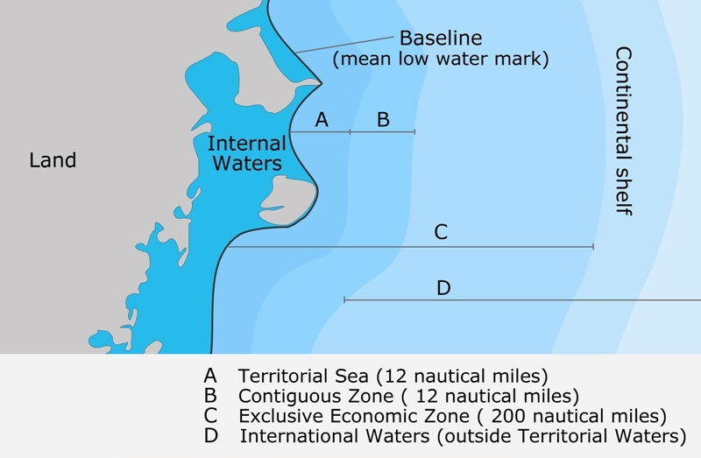
Sum up
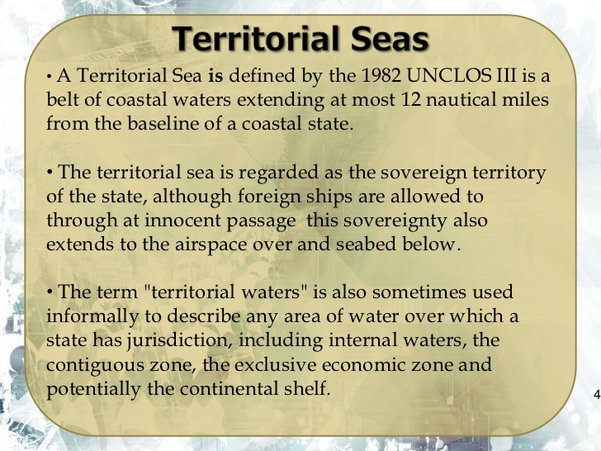
According to convention
Article 3
Breadth of the territorial sea
Every State has the right to establish the breadth of its territorial sea up to a limit not exceeding 12 nautical miles, measured from baselines determined in accordance with this Convention.

Article 4
Outer limit of the territorial sea
The outer limit of the territorial sea is the line every point of which is at a distance from the nearest point of the baseline equal to the breadth of the territorial sea.
IN SUMMARY
The territorial sea is that area of water adjacent to the coast which the coastal state is permitted by international law to exercise sovereign competency for purpose of 3 things: -
1. Jurisdiction
2. Control
3. Exploitation
Sovereignty territory – seabed, water column, airspace
Article 2 (3) says
The sovereignty over the territorial sea is exercised subject to this Convention and to other rules of international law.
• Breadth – up to 12 nautical miles
•Exception to other states is in the right of Innocent Passage but subject to certain conditions. Passage is characterized as innocent passage, if it is not prejudicial to the interest of the coastal state. Innocent passage is characterized with moving purposely.

What is Innocent Passage?
Right of a foreign ship to pass through the territorial waters of a coastal state so long as the passage does not interfere with or prejudices the state's good order, peace, and security.
Article 19
Meaning of innocent passage
- Passage is innocent so long as it is not prejudicial to the peace, good order or security of the coastal State. Such passage shall take place in conformity with this Convention and with other rules of international law.
In summary:
Innocent Passage
• Continuous and expeditious transit, through territorial waters or internal waters, en-route to or from the high seas
• Article 19(1): “Passage is innocent so long as it is not prejudicial to the peace, good order, or security of the coastal State”
• Non-innocent passage may be prevented
• Submarines must transit on the surface and show their flag (Article 20)
• No right of overflight
• May be temporarily suspended
• Emerging issues:
Hazardous vessels? Warships?
– Right of innocent passage – Prior notification/permission
- CONTIGUOUS ZONE
The contiguous zone is a band of water extending from the outer edge of the territorial sea to up to 24 nautical miles (44.4 km; 27.6 mi) from the baseline.
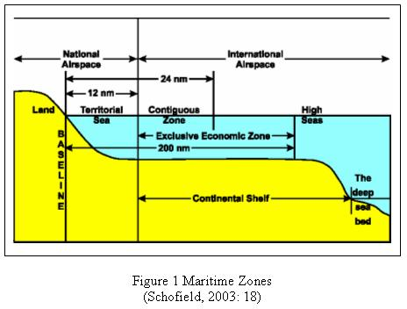
A state can exert limited control for the purpose of preventing or punishing "infringement of its customs, fiscal, immigration or sanitary laws and regulations within its territory or territorial sea".
This will typically be 12 nautical miles (22 km; 14 mi) wide, but could be more (if a state has chosen to claim a territorial sea of less than 12 nautical miles), or less, if it would otherwise overlap another state's contiguous zone. However, unlike the territorial sea, there is no standard rule for resolving such conflicts and the states in question must negotiate their own compromise.
In Summary
Contiguous Zone
• 12 - 24 nm
- Overlays EEZ
- Foreign aircraft have overflight rights
- Foreign vessels have full navigational, fishing and marine scientific research rights (so long as they are not infringing customs, fiscal, immigration and sanitation laws and assuming no EEZ declared for the latter rights)
- Extends territorial sea enforcement
Article 33:
- “prevent infringement of its customs, fiscal, immigration or sanitary laws and regulations within its territory or territorial sea.

- Exclusive economic zone
An area of coastal water and seabed within a certain distance of a country's coastline, to which the country claims exclusive rights for fishing, drilling, and other economic activities.
Exclusive Economic Zone (EEZ) extends not more than 200 nautical miles from the territorial sea baseline and is adjacent to the 12 nautical mile territorial sea.
Beyond its territorial waters, every coastal country may establish an exclusive economic zone (EEZ) extending 200 nautical miles (370 km) from shore (baseline). Within the EEZ the coastal state has the right to exploit and regulate fisheries, construct artificial islands and installations, use the zone for other economic purposes (e.g., the generation of energy from waves), and regulate scientific research by foreign vessels. Otherwise, foreign vessels (and aircraft) are entitled to move freely through (and over) the zone.
Consider the following image:
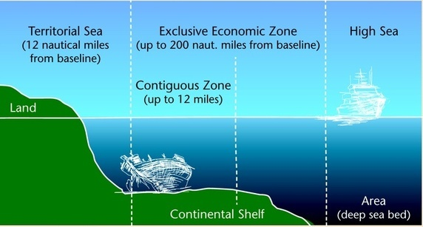
Within the EEZ, the costal state has:
- Sovereign rights for the purpose of exploring, exploiting, conserving and managing natural resources, whether living and nonliving, of the seabed and subsoil and the superjacent waters and with regard to other activities for the economic exploitation and exploration of the zone, such as the production of energy from the water, currents and winds;
- Jurisdiction as provided for in international and domestic laws with regard to the establishment and use of artificial islands, installations, and structures, marine scientific research, and the protection and preservation of the marine environment; and
- Other rights and duties provided for under international and domestic laws.
- Continental shelf
article 76
Definition of the continental shelf
The continental shelf of a coastal State comprises the seabed and subsoil of the submarine areas that extend beyond its territorial sea throughout the natural prolongation of its land territory to the outer edge of the continental margin, or to a distance of 200 nautical miles from the baselines from which the breadth of the territorial sea is measured where the outer edge of the continental margin does not extend up to that distance.
The continental shelf is an underwater landmass which extends from a continent, resulting in an area of relatively shallow water known as a shelf sea.
Illustration
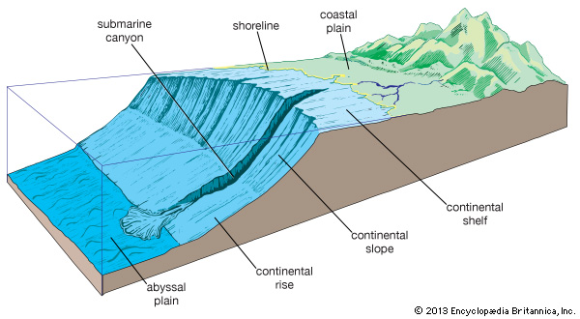

Article 77
Rights of the coastal State over the continental shelf
1. The coastal State exercises over the continental shelf sovereign rights for the purpose of exploring it and exploiting its natural resources.
2. The rights referred to in paragraph 1 are exclusive in the sense that if the coastal State does not explore the continental shelf or exploit its natural resources, no one may undertake these activities without the express consent of the coastal State.
3. The rights of the coastal State over the continental shelf do not depend on occupation, effective or notional, or on any express proclamation.
Article 79
Submarine cables and pipelines on the continental shelf
1. All States are entitled to lay submarine cables and pipelines on the continental shelf, in accordance with the provisions of this article.
2. Subject to its right to take reasonable measures for the exploration of the continental shelf, the exploitation of its natural resources and the prevention, reduction and control of pollution from pipelines, the coastal State may not impede the laying or maintenance of such cables or pipelines.

- Landlocked States

article 124 (1(a) of the Convention defines the term land-locked State as ‘a State which has no sea-coast’. Putting it simply, land-locked state means a state which has no sea-coast; instead, it depends on its Neighbouring state (s) to have access to the sea. In other words, land-locked state relays on transit state which is ‘a state with or without a seacoast, situated between a land-locked state and the sea, through whose territory traffic in transit passes (Article 124 (1, b) of the Convention). Thus, land-locked states are those states which get access to the sea through the territory of their Neighbouring states known as transit states.
OR
Landlocked states are sates that are either entirely or almost entirely surrounded by land. They have no coastline or border any sea. There are about 48 landlocked states, includes Afghanistan, Botswana, Burkina Faso, Burundi, Ethiopia, Lesotho, Malawi, Mali etc.

- Geographically disadvantaged States
Article 70
For the purposes of this Part, "geographically disadvantaged States" means coastal States, including States bordering enclosed or semi-enclosed seas, whose geographical situation makes them dependent upon the exploitation of the living resources of the exclusive economic zones of other States in the sub region or region for adequate supplies of fish for the nutritional purposes of their populations or parts thereof, and coastal States which can claim no exclusive economic zones of their own.
Geographically disadvantaged States shall have the right to participate, on an equitable basis, in the exploitation of an appropriate part of the surplus of the living resources of the exclusive economic zones of coastal States of the same sub region or region, taking into account the relevant economic and geographical circumstances of all the States concerned and in conformity with the provisions of this article and of articles 61 and 62.
History of the law of the sea
    - 1493 pope divided the sea. (The Treaty Of Tordesillas)
The Treaty of Tordesillas was a treaty between Portugal and Spain in 1494 in which they agreed to divide up all the land in the Americas between the two of them, no matter who was already living there. Pope Alexander VI was the Pope at the time of the treaty. He drew an imaginary line 2,193 kilometers to the west of the Cape Verde Islands, gave Portugal the land to the east of this line, and gave Spain the land to the west of this line. King Ferdinand II of Aragon and Queen Isabella of Castile were the rulers of Spain at the time and together they signed this treaty in Tordesillas, Spain, which is how the treaty got its name.

See part II, V and VII of the UNCLOS (united nations convention on the law of the sea)
http://www.epa.gov/OWOW/estuaries/coastlines/summer97/hawaii.html
1998 Project Oceanography Fall Series, p 4
Article 8

