Invitation Letter | Format, Samples and How To Write An Invitation Letter?
Invitation Letter: It is a letter written to invite people to a particular event. This can be written for a marriage, engagement, graduation ceremony, exhibition, annual day, etc. It can be a formal as well as an informal letter. It can be written by an individual or an organization addressed to a person or an organization. The objective of this letter is to arrange the number of positions for the guests before some days of the event date. An invitation Letter enables the host to achieve their target in managing the event. Read the article below to know more about writing an Invitation Letter.
Get Other Types of Letter Writing like Formal, Informal and Different Types of Letter Writing Samples.

Invitation Letter Writing Tips
Refer to the following writing tips before writing an Invitation Letter.
- It must include the address, date, and time of the event on the left side of the letter.
- Make sure to mention the salutation at the beginning and your signature at the ending of the letter.
- Make sure to write a grammatically correct and concise letter.
- It should indicate whether it is a formal or informal letter.
- The host must express his or her warm welcome to the guests.

Invitation Letter Format
Refer to the following Invitation Letter Format before writing an invitation letter.
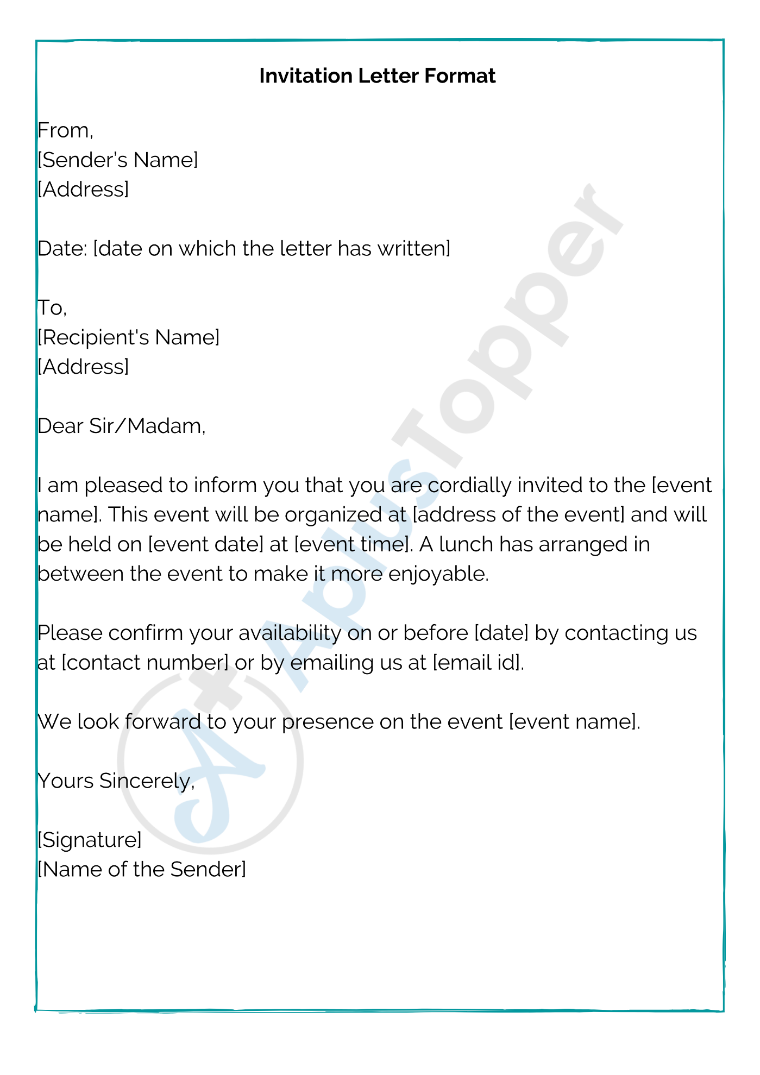

How to Write a Regret Letter
A regret letter is a kinder term for a rejection letter. They both do the same thing: Let someone down. While letters of regret are a necessary part of hiring, publishing, college applications and more, they are almost always painful to receive. They are not that much fun to write, either. But letters of regret do serve a purpose, and learning to write one well is important.

Basic Format for a Rejection Letter
Follow a set of general guidelines for writing a rejection letter no matter the occasion. It's almost always best to keep these letters short and to the point – you don't want the recipient to sit there pondering your meaning before the rejection dawns on them. And, you also don't want your message to be murky.
- Say thank you for their time, their application, their interest, depending on the circumstances.
- Deliver the rejection.
- Provide the primary reason for the rejection.
- Offer kind words or even a glimmer of hope, depending on the circumstances.

Sample Letter of Regret for a Job
Dear X,
Thanks so much for taking the time to meet with us last week. While your resume is strong, we are seeking a candidate with more experience in writing digital content. I hope you find the right job in the near future.
Sincerely
Note that the letter begins with a thank you, moves quickly to the rejection and the reason for that rejection, then ends with kind words.

When a Longer Rejection Letter Makes Sense
Once in a while, you want a rejection letter to do more than simply reject. For example, you're filling a position at work, and the candidate didn't get the job but came very close. In this case, write a rejection letter that will keep the applicant open to future options with the company.
Or maybe you run a magazine or literary journal, and the submission wasn't quite there but was awfully close. You'd like to see more of this applicant's work, so the letter should explain what went wrong and how to improve their chances next time. In this case, add a lot more detail to your reasons for the rejection.

Sample of an Encouraging Rejection Letter
Dear X,
Thank you for submitting your story to our magazine. While it's not a fit for us at this time, I suggest you try again in the future. I'd like to see a story where you focus more thoroughly on both character development and plot. At times, this story wandered, and I wanted a clear line from start to finish. I was also left wanting to know a lot more about the character of Mary. She was intriguing, but unformed. Please consider submitting another story in the future.
Best wishes

Declining an invitation
One thing you never want to do to a friend or a business partner is to ignore a request to come to an event or to simply ignore an invite. If you’ve been RSVP’d to an invitation, then what you might not know is that the R in RSVP actually stands for respond. So basically, the requester is asking for your response not because they think highly of you (although they do), but because they would like to know how many people are going to attend. Just write out a quick and short letter explaining why have decided to decline the invitation.

Declining an invitation Sample
Steps Starting to Write
- Thank the recipient and mention what the invitation was initially for. This not only clarifies that you read the letter they sent but some people will have more than one event going on at the exact same time.
- Mention that the relationship you have with the person is special and that you wish you could be there.
- If you have a prior commitment or particular reason as to why the invitation is being declined, state it here. This is optional but it’s nice for people to know why an invitation is declined by someone.

Declining an invitation Sample

Dear Mary,
I received your invitation to a get together for the annual Holiday party for your block and I’m honored that I was invited to join you. Thanks for the kind and generous offer and I really wish I could be there, but I’m afraid I have to decline the event. I will be busy with work and I’ll be on a business trip in France for that week, so I’m afraid I will have to miss this particular event.
However, I will be in town for New Years’ Eve, so if you would like to get together for that, I would be more than happy to do so!

Sincerely with love,
Eve

Sales Correspondence
Sales Correspondence is a written communication between two parties with the motive of sales. A sales letter is a form of sale correspondence. It is a letter that tries to sell a product. Sales letters are an effective way to communicate with clients.
It may target a specific group to grab their attention. It is like a salesman discussing the purpose but in the form of a letter. A sales letter can be general or particular in nature.

Objectives and Advantages of Sales Letter

Objectives of Sales Letter
- A sales letter aims at reaching the reader to purchase the product.
- Introduction and marketing of new products and services.
- To reach potential customers.
- Expansion of the market.

Advantages of Sales Letter
- A sales letter is less expensive.
- Reach a client where a salesman cannot.
- Reach a number of clients all at the same time.
- Ease of understanding and availability of full details.
- More convenient, efficient, and comprehensive.

Elements and Format of Sales Letter

Elements of Sales Letter
Headline: Here the writer wants to grab the reader’s attention toward the main purpose of the letter.
Introduction: It is the introductory paragraph. Introduction in the sales letter provides the details of the product or the service. It also provides the reader with the cost, quality, saving and other related information.
Body: Here the writer builds his credibility. The writers provide with the worth of the product, its difference from other similar products, a list of satisfied customers, terms of contract etc.
Call to Action: In this section, the writer asks for the reader’s response and can express the gratitude. It also includes various details like warranty, discount etc.

Format of Sales Letter
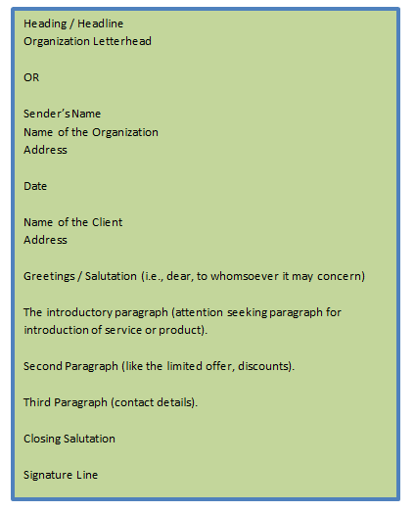

Writing Tips for Writing Sales Letter
- Introduce the ideas in a way that compels the reader to take a positive action.
- Introduce yourself and the product well.
- Be clear in what you are offering.
- Choose your words as per the targeted audience.
- Always use a headline.
- Make the first sentence of each paragraph count.
- Use of font styles, font sizes, bullets, and numbering etc.
- Use relevant statement showing the credibility of the product.
- Suitable closing sentences.
- Correct use of salutation.
- Proper and complete details of the product and availability.
- Always ask for attention, build interest, desire, and call of action.
- Have a simple and convincing tone.
- Avoid creating confusion and uncertainty.
- Avoid being clever and funny.
- Include your name, signature, and other contact details.
- Do not use fancy words or slangs.
- Always revise and edit the letter.

Types of Sales Letters
A sales letter has a specific purpose to meet. The various purposes can be the introduction of a new product or service, availing new offers, selling incentive etc. Let us discuss some of them here.

Introductory
This type of letter is written to a customer or a consumer to introduce to the company or a product. It also explains how readers will get benefit from the product or the service. It must grab people’s attention, build their interest and call to action.

Product Update
As the name suggests, this type of letter is to describe the benefits of new products over older ones. Other details like a limited period to purchase and discount can also be included.

Selling Incentive
It promotes existing products among current customers. This type of letter must build some excitement among the reader to buy the product.

Thank You
A sender writes this letter to thank the customers to be a part of the business. It shows the value of the customer. A brief mention is given on the availability of product for the customer.

Holiday Celebration
This letter gives a chance to offer a product as a gift for customers. It also shows the discounts and the offers limited to the holiday celebration.

Invitation
It is an invitation to the customers for any celebration. This helps the customers to feel important.

Lost Customer
This type of letter is for the customers who have not been too active recently. It helps the organization to bind with them and offers them good deals.

Solved Example for You
Problem: Which of the following should be kept in mind as a customer’s point of view while writing a sales letter?
- Points showing the inexpensiveness of the service.
- Expiry of the deals.
- Points showing the need.
- Points showing the costliness of the service for show off.
Solution: All the above except point d.

