Junction Tables (Many-to-Many Relationships)

When you need to establish a many-to-many relationship between two groups, the simplest solution is to use a Junction Table. A Junction Table (sometimes referred to as a "Bridge Table") is a table that contains references to both groups; bridging them together. For example: A school includes two groups: Students and Classes. One student can attend many classes, and one class can contain many students. Hence, the "many-to-many" relationship between students and classes. Here's how you relate the two groups using a Junction Table:
tblStudents
StudentID [Primary Key, AutoNumber]
strFirstName
strLastName
tblClasses
ClassID [Primary Key, AutoNumber]
strClassDescription
tblClassMembers
ClassMemberID [Primary Key, AutoNumber]
lngClassID [Foreign Key to tblClasses.ClassID]
lngStudentID [Foreign Key to tblStudents.StudentID]
strSeatLocation
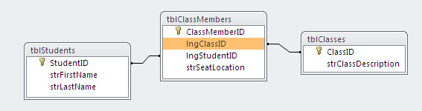
The Junction Table, tblClassMembers, contains one record for each student/class combination. Note that tblClassMembers can contain additional information about that combined piece of information: strSeatLocation. Because you know the student and the class, you can describe where the student sits during that class.
Because AutoNumber fields are the most common Primary Key for a table, you will just need to use a Long Integer field in your Junction Table to provide the link, since Autonumber fields are, by definition, Long Integer data type.

