1. Introduction to Food Preservation
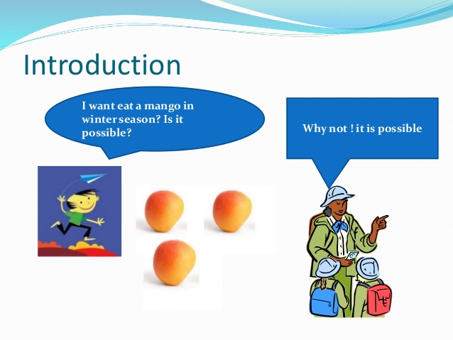
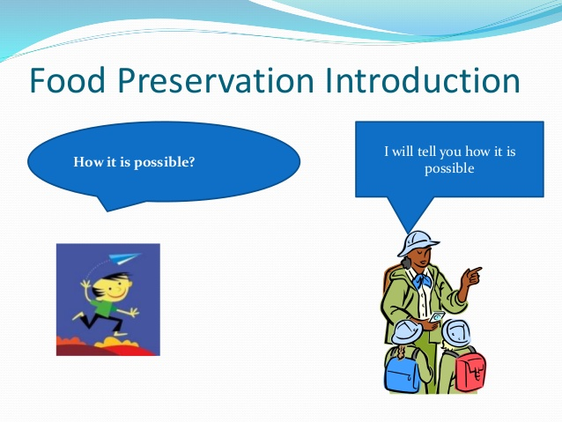

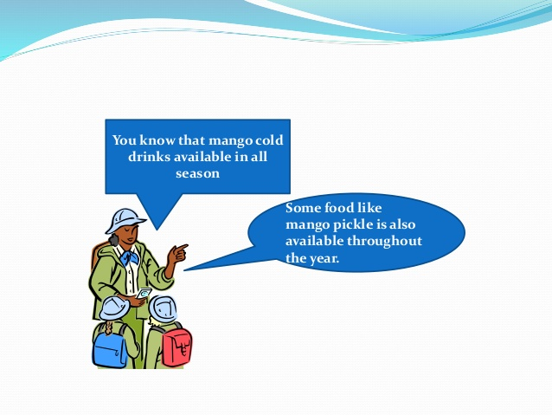

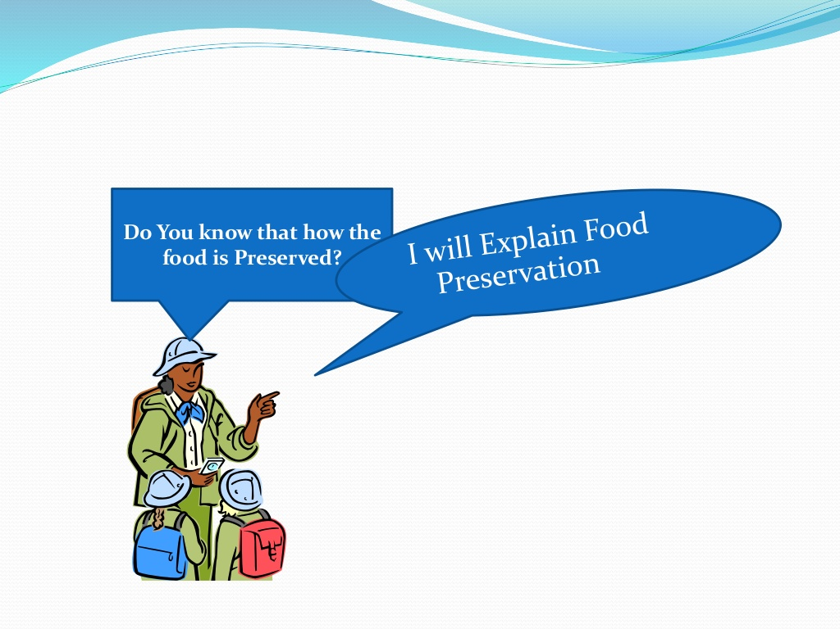
Food preservation is a process in which
Food and vegetables are prevented from getting spoilt, the color, taste, nutritional values of food is also preserved and shelf life of food product is increased.
So the definition of Food Preservation states that a method in which food is subjected to various treatments to prolong the length of time for which it retains its quality characteristics.
The preservation and processing of food is not as simple or straightforward as it was in the past. A number of new preservation techniques are being developed to satisfy current demands of economic preservation and consumer satisfaction in nutritional and sensory aspects, convenience, safety, absence of chemical preservatives, price, and environmental safety.
Preservation methods start with the complete analysis and understanding of the whole food chain, including growing, harvesting, processing, packaging, and distribution; thus an integrated approach needs to be applied. It lies at the heart of food science and technology, and it is the main purpose of food processing. First, it is important to identify the properties or characteristics that need to be preserved. One property may be important for one product, but detrimental for others. For example, collapse and pore formation occur during the drying of foods. This can be desirable or undesirable depending on the desired quality of the dried product, for example, crust formation is desirable for long bowl life in the case of breakfast cereal ingredients, and quick rehydration is necessary (i.e., no crust and more open pores) for instant soup ingredients. In another instance,the consumer expects apple juice to be clear whereas orange juice could be cloudy.
Why Preservation?
Another important question is why food needs to be preserved. The main reasons for food preservation are to overcome in appropriate planning in agriculture, produce value-added products, and provide variation in diet. The agricultural industry produces raw food materials in different sectors. Inadequate management or improper planning in agricultural production can be overcome by avoiding inappropriate areas, times, and amounts of raw food materials as well as by increasing storage life using simple methods of preservation. Value-added food products can give better-quality foods in terms of improved nutritional, functional, convenience, and sensory properties. Consumer demand for healthier and more convenient foods also affects the way food is preserved. Eating should be pleasurable to the consumer, and not boring. People like to eat wide varieties of foods with different tastes and flavors. Variation in the diet is important, particularly in underdeveloped countries to reduce reliance on a specific type of grain (i.e., rice or wheat). In food preservation, the important points that need to be considered are
● The desired level of quality
● The preservation length
● The group for whom the products are preserved

2. Raw Material Properties:
The main raw material properties of importance to the processor are geometry, colour, texture, functional properties and flavour.
2.1 Geometric Properties
Food units of regular geometry are much easier to handle and are better suited to high speed mechanised operations. In addition, the more uniform the geometry of raw materials, the less rejection and waste will be produced during preparation operations such as peeling, trimming and slicing. For example, potatoes of smooth shape with few and shallow eyes are much easier to peel and wash mechanically than irregular units. Smooth-skinned fruits and vegetables are much easier to clean and are less likely to harbour insects or fungi than ribbed or irregular units.
Agricultural products do not come in regular shapes and exact sizes. Size and shape are inseparable, but are very difficult to define mathematically in solid food materials. Geometry is, however, vital to packaging and controlling fill-in weights. It may, for example, be important to determine how much mass or how many units may be filled into a square box or cylindrical can. This would require a vast number of measurements to perform exactly and thus approximations must be made. Size and shape are also important to heat processing and freezing, as they will determine the rate and extent of heat transfer within food units.
Specific surface (area/mass) may be an important expression of geometry, especially when considering surface phenomena such as the economics of fruit peeling, or surface processes such as smoking and brining.
The presence of geometric defects, such as projections and depressions, complicate any attempt to quantify the geometry of raw materials, as well as presenting processors with cleaning and handling problems and yield loss. Selection of cultivars with the minimum defect level is advisable. There are two approaches to securing the optimum geometric characteristics: firstly the selection of appropriate varieties, and secondly sorting and grading operations.
2.2 Colour:
Color and colour uniformity are vital components of visual quality of fresh foods and play a major role in consumer choice. However, it may be less important in raw materials for processing. For low temperature processes such as chilling, freezing or freeze-drying, the colour changes little during processing, and thus the colour of the raw material is a good guide to suitability for processing. For more severe processing, the colour may change markedly during the process. Green vegetables, such as peas, spinach or green beans, on heating change colour from bright green to a dull olive green. This is due to the conversion of chlorophyll to pheophytin. It is possible to protect against this by addition of sodium bicarbonate to the cooking water, which raises the pH. However, this may cause softening of texture and the use of added colourants may be a more practical solution. Some fruits may lose their colour during canning, while pears develop a pink tinge. Potatoes are subject to browning during heat processing due to the Maillard reaction. Therefore, different varieties are more suitable for fried products where browning is desirable, than canned products in which browning would be a major problem.
Again there are two approaches: i.e. procuring raw materials of the appropriate variety and stage of maturity, and sorting by colour to remove unwanted units.
2.3 Texture:
The texture of raw materials is frequently changed during processing. Textural changes are caused by a wide variety of effects, including water loss, protein denaturation which may result in loss of water-holding capacity or coagulation, hydrolysis and solubilisation of proteins. The raw material must be robust enough to withstand the mechanical stresses during preparation, for example abrasion during cleaning of fruit and vegetables. Peas and beans must be able to withstand mechanical podding. Raw materials must be chosen so that the texture of the processed product is correct, such as canned fruits and vegetables in which raw materials must be able to withstand heat processing without being too hard or coarse for consumption. Texture is dependent on the variety as well as the maturity of the raw material and may be assessed by sensory panels or commercial instruments.
2.4 Flavour:
Flavour is a rather subjective property which is difficult to quantify. Again, flavours are altered during processing and, following severe processing, the main flavours may be derived from additives. Hence, the lack of strong flavours may be the most important requirement. In fact, raw material flavour is often not a major determinant as long as the material imparts only those flavours which are characteristic of the food. Other properties may predominate. Flavour is normally assessed by human tasters, although sometimes flavour can be linked to some analytical test, such as sugar/acid levels in fruits.
2.5 Functional Properties:
The functionality of a raw material is the combination of properties which determine product quality and process effectiveness. These properties differ greatly for different raw materials and processes, and may be measured by chemical analysis or process testing.
For example, a number of possible parameters may be monitored in wheat. Wheat for different purposes may be selected according to protein content. Hard wheat with 11.5–14.0% protein is desirable for white bread and some wholewheat breads require even higher protein levels, 14–16%. In contrast, soft or weak flours with lower protein contents are suited to chemically leavened products with a lighter or more tender structure. Hence protein levels of 8–11% are adequate for biscuits, cakes, pastry, noodles and similar products. Varieties of wheat for processing are selected on this basis; and measurement of protein content would be a good guide to process suitability. Similar considerations apply to other raw materials. Chemical analysis of fat and protein in milk may be carried out to determine its suitability for manufacturing cheese, yoghurt or cream.
3. Storage and Transportation of Raw Materials
3.1 Storage
Storage of food is necessary at all points of the food chain from raw materials, through manufacture, distribution, retailers and final purchasers. Today’s consumers expect a much greater variety of products, including nonlocal materials, to be available throughout the year. Effective transportation and storage systems for raw materials are essential to meet this need. Storage of materials whose supply or demand fluctuate in a predictable manner, especially seasonal produce, is necessary to increase availability. It is essential that processors maintain stocks of raw materials, therefore storage is necessary to buffer demand. All raw materials deteriorate during storage. The quantities of raw materials held in store and the times of storage vary widely for different cases. The ‘just in time’ approaches used in other industries are less common in food processing. The primary objective is to maintain the best possible quality during storage, and hence avoid spoilage during the storage period.
The main factors which govern the quality of stored foods are temperature, moisture/humidity and atmospheric composition. Different raw materials provide very different challenges. Fruits and vegetables remain as living tissues until they are processed and the main aim is to reduce respiration rate without tissue damage. Storage times vary widely between types. Young tissues such as shoots, green peas and immature fruits have high respiration rates and shorter storage periods, while mature fruits and roots and storage organs such as bulbs and tubers, e.g. onions, potatoes, sugar beets, respire much more slowly and hence have longer storage periods. Many fruits (including bananas, apples, tomatoes and mangoes) display a sharp increase in respiration rate during ripening, just before the point of optimum ripening. Quality should be optimal at harvest, and the task is to preserve quality during storage.
With meat storage the overriding problem is growth of spoilage bacteria, while avoiding oxidative rancidity. Cereals must be dried before storage to avoidgermination and mould growth and subsequently must be stored under conditions which prevent infestation with rodents, birds, insects or moulds. Hence, very different storage conditions may be employed for different raw materials. The main methods employed in raw material storage are the control of temperature, humidity and composition of atmosphere.
3.1.1 Temperature
The rate of biochemical reactions is related to temperature, such that lower storage temperatures lead to slower degradation of foods by biochemical spoilage, as well as reduced growth of bacteria and fungi. There may also be limited bacteriocidal effects at very low temperatures.
It is desirable to monitor temperature throughout raw material storage and distribution. Precooling to remove the ‘field heat’ is an effective strategy to reduce the period of high initial respiration rate in rapidly respiring produce prior to transportation and storage. For example, peas for freezing are harvested in the cool early morning and rushed to cold storage rooms within 2–3 h. Other produce, such
as leafy vegetables (lettuce, celery, cabbage) or sweetcorn, may be cooled using water sprays or drench streams. Hydrocooling obviously reduces water loss.
3.1.2 Humidity:
If the humidity of the storage environment exceeds the equilibrium relative humidity (ERH) of the food, the food will gain moisture during storage, and vice versa. Uptake of water during storage is associated with susceptibility to growth of microorganisms, whilst water loss results in economic loss and more specific problems, such as cracking of seed coats of cereals, or skins of fruits and vegetables. Ideally, the humidity of the store would equal the ERH of the food so that moisture is neither gained nor lost, but in practice a compromise may be necessary. The water activity (aw) of most fresh foods (e.g. fruit, vegetables, meat, fish, milk) is in the range 0.98–1.00, but they are frequently stored at a lower humidity.
3.1.3 Composition of Atmosphere
Controlling the atmospheric composition during storage of many raw materials is beneficial. With some materials, the major aim is to maintain an oxygen-free atmosphere to prevent oxidation, e.g. coffee, baked goods, while in other cases adequate ventilation may be necessary to prevent anaerobic fermentation leading to off flavours. In living produce, atmosphere control allows the possibility of slowing down metabolic processes, hence retarding respiration, ripening, senescence and the development of disorders. The aim is to introduce N2 and remove O2, allowing a build up of CO2. The technique allows year-round distribution of apples and pears, where controlled atmospheres in combination with refrigeration can give shelflives up to 10 months, much greater than by chilling alone. The particular atmospheres are cultivar specific, but in the range 1–10% CO₂, 2–13% O₂ at 3°C for apples and 0°C for pears.
3.2 Transportation
Food transportation is an essential link in the food chain. Raw materials, food ingredients, fresh produce and processed products are all transported on a local and global level, by land, sea and air. In the modern world, where consumers expect year-round supplies and nonlocal products, long distance transport of many foods has become commonplace and air transport may be necessary for perishable materials. Transportation of food is really an extension of storage: a refrigerated lorry is basically a cold store on wheels. However, transport also subjects the material to physical and mechanical stresses, and possibly rapid changes in temperature and humidity, which are not encountered during static storage. It is necessary to consider both the stresses imposed during the transport and those encountered during loading and unloading. In many situations, transport is multimodal. During loading and unloading, the cargo may be broken into smaller units where more rapid heat penetration may occur. The major challenges during transportation are to maintain the quality of the food during transport, and to apply good logistics – in other words, to move the goods to the right place at the right time and in good condition.

