Topic: Meiosis

Cell division:-
“Cell division is the process by which a parent cell divides into two or more daughter cells.” Cell division usually occurs as part of a larger cell cycle. In eukaryotes, there are two distinct types of cell division: a vegetative division, which is take place in (Mitosis) whereby “each daughter cell is genetically identical to the parent cell. and a reproductive cell division,” which is take place in (meiosis) whereby “the number of chromosomes in the daughter cells is reduced by half to produce haploid gametes.”
Function of cell division:-
Cell division has many important functions but three are main functions, which are reproduction of unicellular organisms and the production of gametes and growth in eukaryotes. The process of meiosis in eukaryotes produces sex cells or gametes with half the chromosome compliment of somatic cells. All cell derived from pre existing cells. It is also necessary to replace worn out cell in multicellular organisms. It is necessary for growth in multicellular organisms.
Diagram of cell division:-
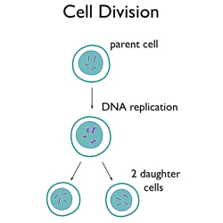

Types of cell division:-
- Amitosis.
- Mitosis.
- Meiosis
“Meiosis”
Define:-
“Meiosis is the process in eukaryotic, sexually-reproducing animals that reduces the number of chromosomes in a cell before reproduction.”
Explanation:-
In Meiosis, two rounds of division are involve that ultimately result in four cells with only one copy of each paternal and maternal chromosome and are (haploid). Additionally, prior to this division, genetic material from the paternal and maternal copies of each chromosome is crossed over, producing new combinations of code on each chromosome. During Fertilization, the haploid cells are produced by meiosis from both male and female ,that are fused to create a cell with two copies of each chromosome again, which is zygote.
Many organisms package these cells into gametes, such as egg and sperm. The gametes can meet, during reproduction, and then, fuse to create a new zygote. Because the number of alleles (An allele is a term coined to describe a specific copy of a gene). are reduced during meiosis, the combination of two gametes will yield a zygote with the same number of alleles as the parents. In diploid organisms, there are two copies of each gene.
History of Meiosis:-
Meiosis was discovered and described for the first time in sea urchin eggs in 1876 by the German biologist Oscar Hertwig. Description on it was made again in 1883, at the level of chromosomes, by the Belgian zoologist Edouard Van Beneden, in Ascaris roundworm eggs. Description on the significance of Meiosis for reproduction and inheritance, however, was made only in 1890 by German biologist August Weismann, He observed that two cell divisions were necessary to transform one diploid cell into four haploid cells if the number of chromosomes had to be maintained. In 1911, the American geneticist Thomas Hunt Morgan detected crossovers in meiosis in the fruit fly Drosophila melanogaster, which helped to establish that genetic traits are transmitted on chromosomes.
The term "meiosis" is derived from the Greek word, meaning 'lessening'. It was introduced to biology by J.B. Farmer and J.E.S. Moore in 1905.

Meiosis in plants or Animals:-
Meiosis occurs in all animals and plants. The end result, gametes production ,with half the number of chromosomes as the parent cell, is the same, but there is difference in detailed process. In animals, meiosis produces gametes directly. In land plants and some algae, there is an alternation of generations such that meiosis in the diploid sporophyte generation produces haploid spores. These spores multiply by mitosis, developed into haploid gametophyte generation, which then gives rise to gametes directly (without further meiosis). In both animals and plants, the final stage for the fusion of gametes is (restoring the original number of chromosomes.)
Where it occur:-
- Meiosis occurs in eukaryotic life cycles involving sexual reproduction.
- It always occurs in reproductive cell (meiocytes).
- In lower plant Meiosis occurs after fertilization in zygote.
- In higher plant it occurs before fertilization in the time of gametes formation.
Facts about meiosis:-
- Meiosis is the type of cell division by which germ cells are produced.
Two meiotic divisions take place:-
- Meiosis I
- Meiosis II
- It is also called Reduction-division.
- Original cell is diploid(2n).
- Four daughter cells produced that are monoploid.
- Daughter cells consist of half number of chromosomes as the original cell.
- Produce gametes (eggs and sperm).
- Occurs in the testes in males(spermatogenesis).
- Occurs in the females (oogenesis).
- During Meiosis, DNA replicates once, but the nucleus divides twice.

Function of Meiosis:-
Meiosis is necessary for many sexually-reproducing animals to ensure the same number of chromosomes in the offspring as in the parents. The fertilization act includes two cells fusing together to become a new zygote. If the number of alleles of each gene is not reduced to 1 in the gametes there is production of zygote, that have 4 copies of each gene in the offspring. In many animals, this would lead to many developmental defects.
In other organisms, polyploidy is common and they can exist with many copies of the same gene. However, if they are polyploidy, the organisms can not survive, meiosis must occur before reproduction. Meiosis occurs in two distinct divisions, with different phases in each.

Phases of Meiosis:-
Before meiosis, replication of DNA is take place, as in mitosis. Meiosis then consists of two cell divisions, known as meiosis I and meiosis II. In the first division, which involves different phases, the duplicated DNA is separated into daughter cells. In the next division, which immediately follows the first, during this division, the two alleles of each gene are separated into individual cells.
Remember, before meiosis starts the normally diploid DNA has been duplicated. This means there are 4 copies of each gene, present in 2 full sets of DNA, each set having 2 alleles. There are six stages within each of the divisions, namely prophase, prometaphase, metaphase, anaphase, telophase and cytokinesis. Meiosis I and Meiosis II. In each of these phases, there is a prophase, a metaphase, and anaphase and a telophase. In meiosis I these are known as prophase I, metaphase I, anaphase I and telophase I, while in meiosis II they are known as prophase II, metaphase II, anaphase II and telophase II. Different products are formed by these phases, although the basic principles of each are the same. Also, meiosis I is preceded in interphase by both G phase and S phase, while meiosis II is only preceded by S phase:
The description of these stages are given below:-
Phases of Meiosis I :-
After Interphase I, meiosis I occurs where proteins are grown in G phase and chromosomes are replicated in S phase. Following this, four phases occur. Meiosis I is known as reductive division, as the cells are reduced from being diploid cells to being haploid cells.
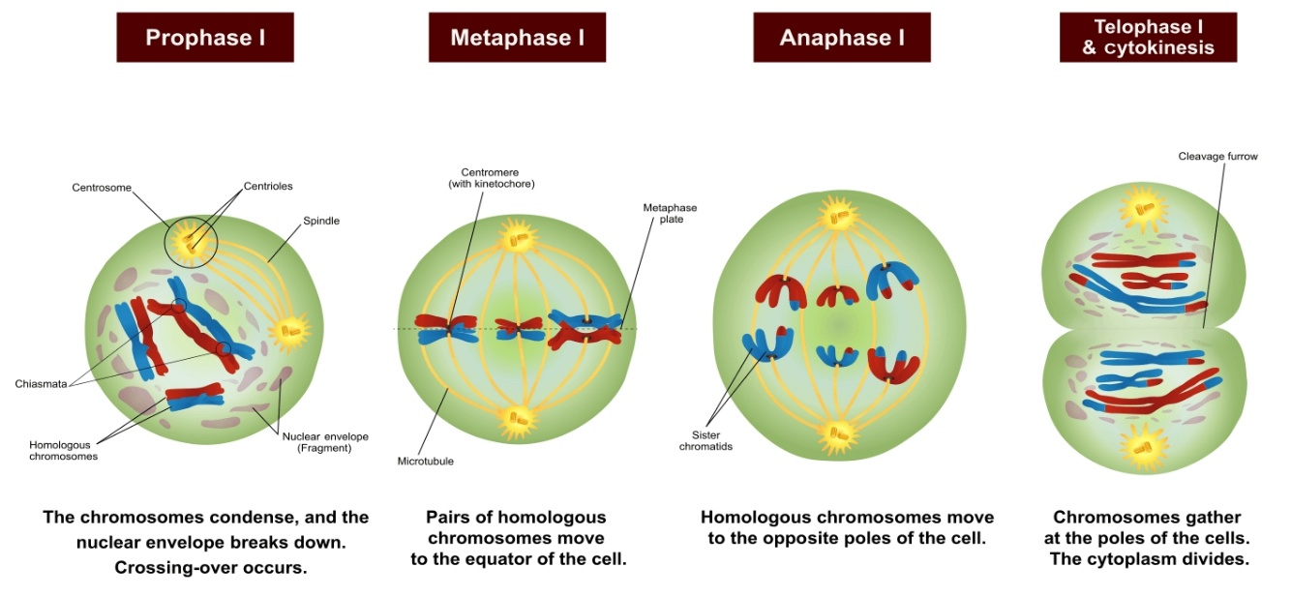
Prophase I :-
Prophase I, the first step in meiosis I, in which DNA is exchanged between homologous chromosomes in a process called homologous recombination. This often results in chromosomal cross over. “Crossing over is the exchange of genetic material between non-sister chromatids of homologous chromosomes during meiosis, which results in new allelic combinations in the daughter cells.” The paired and replicated chromosomes are called bivalent or tetrads. The process of pairing the homologous chromosomes is called synopsis. At this stage, non sister chromatids may cross over at points called chiasmata.
Prophase 1 is the first stage of meiosis and is defined by five different phases; Leptotene, Zygotene, Pachytene, Diplotene and Diakinesis. Prophase 1 is essentially the crossing over and recombination of genetic material between non sister chromatids - this results in the genetically unidentical, haploid daughter chromatid cells.

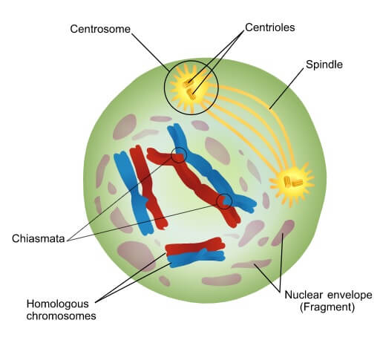

Leptotene :-
Leptotene is the first of five stages of Prophase 1 and consists of the condensing of the already replicated chromosomes, this procedure continues throughout Prophase 1. The chromosomes become visible by using electron microscopy, which can distinguish between sister chromatids. The appearance of the chromosomes at this stage of Prophase 1 is likened to “a string with beads”, these beads are called chromomeres. Each sister chromatids is attached to the nuclear envelope and are so close together that they can be mistaken for only one chromosomes. This is a very short stage of Prophase 1.

Zygotene :-
Zygotene is the sub-stage where synapsis between homologous chromosomes begins. It is also known as zygonema. These synapsis can form up and down the chromosomes allowing numerous points of contact called synaptonemal complex. this can be compared to a zipper structure, due to the coils of chromatin. The synaptonemal complex facilitates synapsis by holding the aligned chromosomes together. After the homologous pairs synapse they are either called tetrads or bivalent. Bivalent is more commonly used at an advanced level as it is a better choice due to similar names for similar states (a single homolog is a 'univalent', and three homologs are a 'trivalent'.

Pachytene :-
Once the synapse is formed it is called a bivalent (where a chromatid of one pair is synapsed/attached to the chromatid in a homologous chromosomes and crossing over can occur. Subsequently, the synapses snap completing the crossing over of the genetic information. As a result the variation in genetic material has been increased significantly, because up and down the chromosome there has been an exchanged of the mother and father's genetic material. The two sister chromatids separate from each other, but the homologous chromosomes remain attached. This makes the complex look much thicker. The synaptonemal complex is complete, allowing chiasma to form. This is what allows the crossing over alleles to occur as this is a process that only happens over a small region of the chromosomes.

Diplotene :-
During this phase the two homologous chromosomes begin to migrate apart as the 'synaptonemal complex' disintegrates between the two chromosomal arms and they begin to repel one another. This allows the two chromosome to move apart, and they are held only by the chiasmata. When this process occurs the chromosome begin to uncoil, contrary to the natural progression of Prophase, however, they are still coiled enough to allow a distinct image of a chiasma formation under a microscope. The chiasma are fully visible at this stage, so can be seen to move towards the end of the chromatids in a process known as terminalization.

Diakinesis:-
Diakinesis is the final step of Prophase 1 and is the termination of the condensing of the chromosomes, this allows the chiasmata and bivalent structure to be seen more clearly under an electron microscope. The chromosomes are at their most condensed form during Diakinesis. The homologous chromosomes in a bivalent are still connected by at least 1 chiasma. The rest of this phase is setting up the cell to make way for metaphase 1. Therefore, the nucleolus disappears, the nuclear envelope disintegrates and the centrioles (centrosome) move to the equator, while the mitotic spindles migrate.

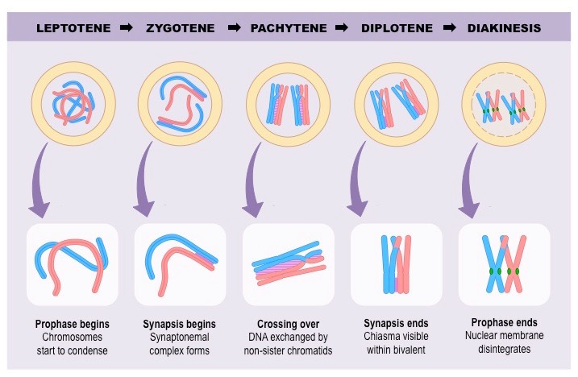

Metaphase I:-
“The pairs of chromosomes (bivalents) become arranged on the metaphase plate and are attached to the now fully formed meiotic spindle.” Metaphase I of meiosis I, the homologous pairs of chromosomes line up on the metaphase plate, near the center of the cell. This step is referred to as a reductional division. The homologous chromosomes that contain the two different alleles for each gene are lined up to be separated. while the chromosomes line up on the metaphase plate with their homologous pair, there is no order upon which side the maternal or paternal chromosomes line up. This process is the molecular reason behind the segregation. The law of segregation tells us that each allele has the same chance of being passed on to offspring. In metaphase I of meiosis, the alleles are separated, allowing for this phenomenon to happen. In meiosis, the lining up of homologous chromosomes leaves 2 alleles in the final cells, but they are on sister chromatids and are clones of the same source of DNA.

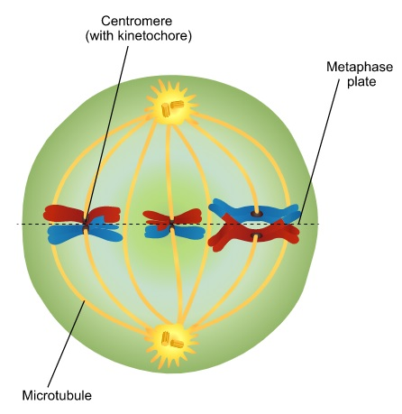

Anaphase I:-
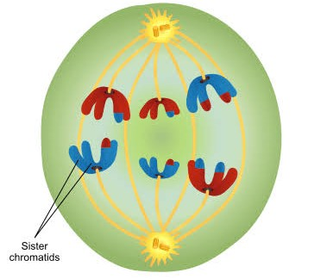
Microtubules begin to shorten, pulling one chromosome of each homologous pair to opposite poles in a process known as disjunction. Most like anaphase of mitosis, the chromosomes are now pulled towards the centrioles at each side of the cell. However, the centrosomes holding the sister chromatids together do not dissolve in anaphase I of meiosis, meaning that only homologous chromosomes are separated, not sister chromatids.

Telophase I:-
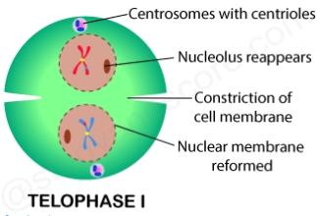
In telophase I, the chromosomes are pulled completely apart and new nuclear envelopes form. Meiosis I ends when the chromosomes of each homologous pair arrive at opposing poles of the cell. The microtubules disintegrate, and a new nuclear membrane forms around each haploid set of chromosomes. The chromosomes uncoil, forming chromatin again, and cytokinesis occurs, forming two non-identical daughter cells. A resting phase known as interkinesis or interphase II happens in some organisms.

Results of Meiosis I :-
Two new cells are formed, each are haploid in their DNA, but with 2 copies, are the result of meiosis I. although there are 2 alleles for each gene, they are on sister chromatid copies of each other. These are considered as haploid cells. These cells take a short rest before entering the second division of meiosis, meiosis II.

Phases of Meiosis II :-

Meiosis II, begin with interkinesis or interphase II. This differs from interphase I, in which no S phase occurs, as the DNA has already been replicated. Thus only a G phase occurs. Meiosis II is known as equational division, in which the cells begin as haploid cells and end as haploid cells. There are four phases in meiosis II: these are differ slightly from meiosis I.
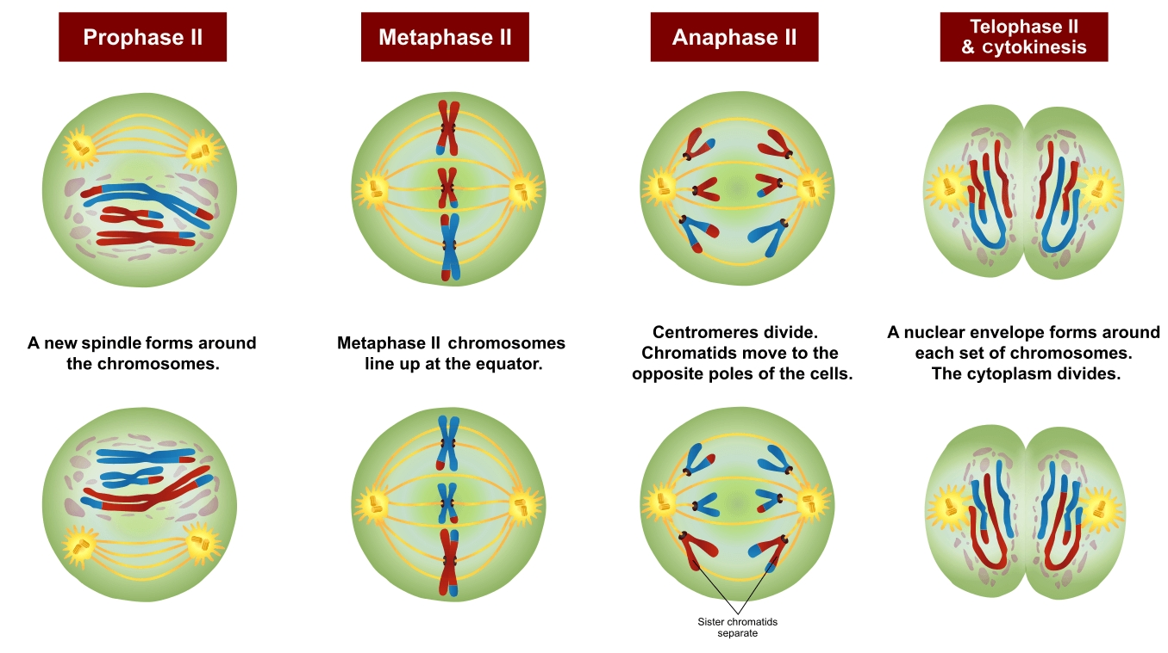

Prophase II:-
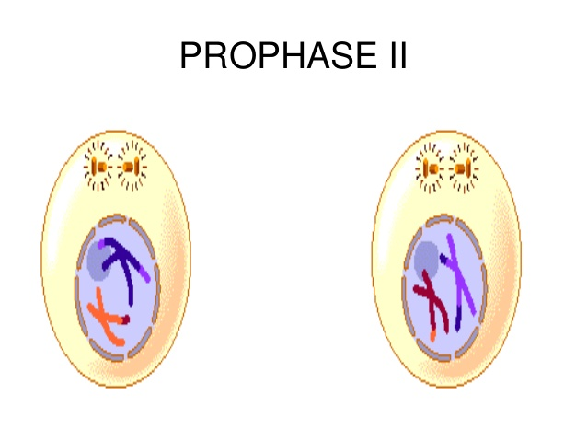
Prophase II resembles prophase I. Chromatin condenses to form visible chromosomes again The disappearance of nuclear envelopes take place and centrioles are formed. Microtubules extend across the cell to connect to the kinetochores of individual chromatids, connected by centromeres. The chromosomes begin to get pulled toward the metaphase plate. No crossing over occurs.

Metaphase II:-
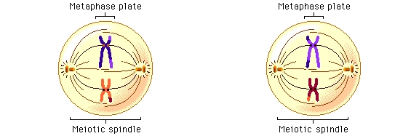
Now resembling mitosis, the chromosomes line up with their centromeres on the metaphase plate.. At this stage, attachment of centromeres is through protein cohesin. The chromosomes align at the equatorial plane, which is rotated 90° compared to the equatorial plane in meiosis I. One sister chromatid faces each pole, with the arms divergent.

Anaphase II:-
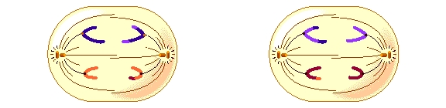
The sister chromatids separate. They are now called sister chromosomes and are pulled toward the centrioles. This separation marks the final division of the DNA. Unlike the first division, this division is known as an equational division, because each cell ends up with the same quantity of chromosomes as when the division started, but with no copies.

Telophase II:-

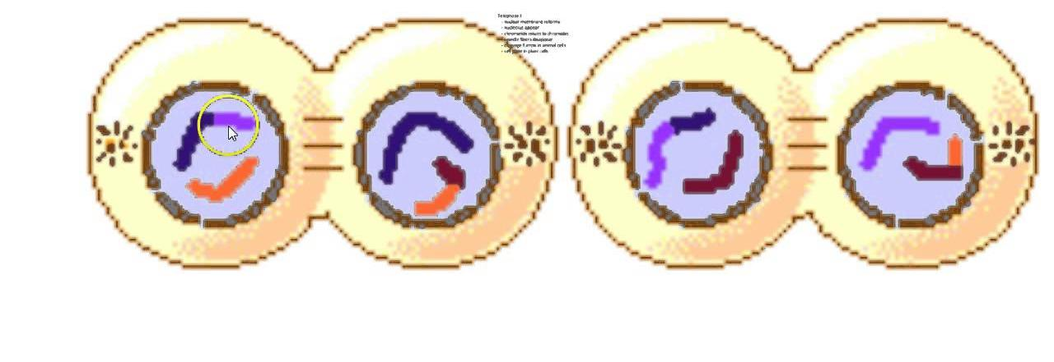
Meiosis II ends when the sister chromosomes have reached opposing poles. The spindle disintegrates, and the chromosomes recoil, forming chromatin. A nuclear envelope forms around each haploid chromosome set, before cytokinesis occurs, two daughter cells are formed from each parent cell, or four haploid daughter cells in total.

Results of Meiosis II:-
At the end of meiosis II, there are 4 cells, each are haploid, and have only 1 copy of the genome. These cells can now be developed into gametes, eggs in females and sperm in males.

Difference between meiosis I and Meiosis II:-

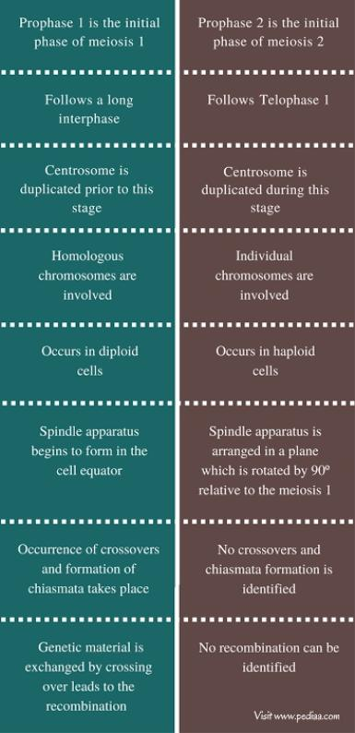

Mcqs:-
- When was meiosis discovered for the first time:
    - 1876
    - 1889
    - 1920
    - 1877
- How many phases of Meiosis:
    - One
    - Two
    - Three
    - Four
- Crossing over occur in which division of meiosis:
    - First division
    - 2nd division
    - Both of them
    - None of these
- _______ is the first point in meiosis where the four parts of tetrads are actually visible:
    - Diplotene
    - Pachytene
    - Diakinesis
    - Leptotene
- When homologous pairs synapse they are either called _____
    - Tetrads
    - Bivalent
    - Both of these
    - None of these
- At the end of Meiosis II how many haploid cells are produced:
    - Four
    - Two
    - Three
    - Five
- Which phase of meiosis is also called reduction division:
    - Meiosis II
    - Meiosis I
    - Both of them
    - None of these
- The chiasma are fully visible at Diplotene stage, so can be seen to move towards the end of the chromatids in a process
    - Synaptonemal complex
    - Bivalent
    - Terminalization
    - Crossing over
- Meiosis is necessary for which type of animals:
    - Asexually-reproducing animals
    - Sexually-reproducing animals
    - Both of them
    - None of these
- In lower plant when Meiosis occur in zygote.
    - After fertilization
    - Before fertilization
    - Does not occur
    - None of these

