The Criminal Justice System

Introduction:
Place yourself in the following situation: You have been stopped by the police, who suspect you of committing a crime. One officer begins to read you your rights:
You have the right to remain silent. Anything you say can and will be used against you in a court of law.
You have most likely heard those words on television shows and in movies, but they have never been directed at you before. The officer continues:
You have the right to speak to an attorney.
You are struggling to make sense of what is happening. Minutes ago, you and two friends were strolling through the mall. One friend was carrying a shopping bag stuffed with new purchases from a clothing store. As you made your way across the parking lot, a police car raced up. Two officers jumped out and said you were under arrest. When you asked why, they said that you were suspected of shoplifting. They said that you had been observed taking items from a store without paying for them.

Click to read caption
Gaetano/Corbis
Scenes from the criminal justice system
Now, as you are pressed into the backseat of the patrol car, you wonder how you got into this mess. You know you did not steal anything, but what about your friends? Other questions begin to trouble you. What will happen when you get to the police station? How will you be treated? What can you expect from the police and the justice system?
The first thing to remember as you enter this system is that you are presumed innocent. If you are charged with a crime, you will have the opportunity to assert your innocence before a judge and, if tried, a jury. Throughout this process, you will also be guaranteed certain rights under the Constitution, including the right to a fair trial.
This chapter examines the workings of the criminal justice system. It follows a hypothetical case through the various stages of the criminal process, from the commission of a crime to the dispensing of justice. Along the way, it lays out the procedures used to judge criminal acts and to protect the rights of the accused.
Section II: The Crime:
In the squad car, the officers who arrested you tell you that a security camera in the mall caught you and your friends shoplifting goods from a store. They tell you that your arrest is based on probable cause, or a reasonable suspicion that you have committed a crime. As far as you know, you did nothing wrong. Is it possible to commit a crime without knowing it? The answer to that question depends on a number of factors.

Elements of a Crime: A Wrongful Act with Intent
A crime is the intentional commission of an act that violates the law. To qualify as a crime, an act must consist of two basic elements. It must be wrongful, and it must be carried out with intent. To be wrongful, an act must do harm to other individuals or to society.
A crime must always be defined through a law that specifies a particular act as illegal. People commit many wrongful acts every day in our society, but not all of these acts are crimes. For a person’s bad behavior to qualify as a crime, it must have been described and prohibited by law before the act was committed.
Furthermore, a behavior can be labeled “criminal” only if an illegal act was committed with intent. In other words, the act of wrongdoing must be accompanied by the conscious intention to carry out that act. Such behavior is considered criminal, even if the suspect is ignorant of the law.

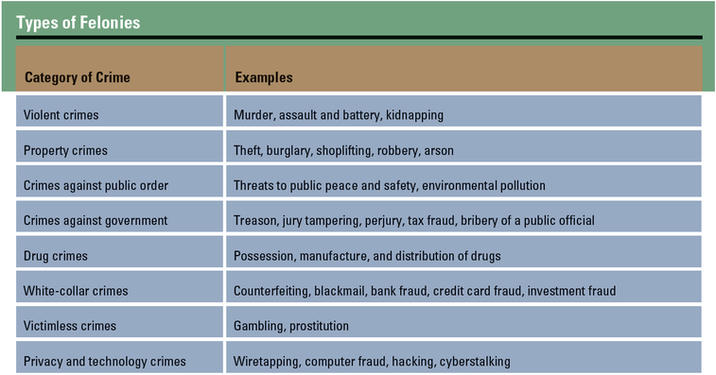

Types of Crimes: Misdemeanors and Felonies
Crimes in the United States are usually categorized as either misdemeanors or felonies. A misdemeanor [misdemeanor: a minor crime, typically punishable by a fine or no more than one year in prison] is a criminal offense that is generally less serious than a felony. Misdemeanors are mostly punishable by fines or short jail sentences, usually of less than one year. A felony [felony: a serious crime that is usually punishable by more than one year in prison] is a more serious crime. A conviction for a felony offense can result in extended prison time or, in extreme cases, even a death sentence. Felonies that are punishable by death are called capital crimes [capital crime: a felony punishable by death] .
The circumstances or effects of a crime may help determine whether it is classified as a misdemeanor or a felony. For example, shoplifting may be classed as a misdemeanor, or petty theft, if the dollar value of the goods stolen is less than a certain amount. This amount varies by state. In California, for example, the amount is $400. On the other hand, shoplifting may be classed as a felony, or grand theft, if the dollar value is greater than a certain amount. The value of the stolen goods thus helps define the seriousness of the crime.
The effects of an illegal act can also help define its seriousness. In the case of a violent assault, such as a stabbing, whether the victim lives or dies may influence how authorities define the crime and determine a punishment.

The Due Process Rights of Suspects in a Crime
Any person suspected of committing a crime has a number of due process rights. The words “due process” show up twice in the Constitution: in the Fifth and Fourteenth amendments. Each of these amendments prohibits the government from depriving any person of “life, liberty, or property” without “due process of law.”
Basically, due process means the government cannot act unfairly, arbitrarily, or unreasonably in its treatment of criminal suspects. Observing due process means that suspects must always be told of the charges against them. It also guarantees them the opportunity to defend themselves in court.
The Constitution guarantees two types of due process: procedural and substantive. Procedural due process [procedural due process: the principle that the procedures followed by the government in enforcing the law must not violate constitutional rights and liberties] refers to the procedures, or the “how,” of law enforcement. This means that if the government sets out to deprive someone of life, liberty, or property, it must do so through a fair and reasonable legal process.
The Supreme Court upheld the principle of procedural due process in the 1970 case of Goldberg v. Kelly. In this case, the plaintiff, John Kelly, had accused the state of New York of terminating welfare payments to recipients without giving them a fair chance to defend their rights. New York allowed residents to respond in writing to notice of such termination, but it did not give them the opportunity to appear in person to state their case. The Court determined that the failure to provide a public hearing in advance of termination violated procedural due process.
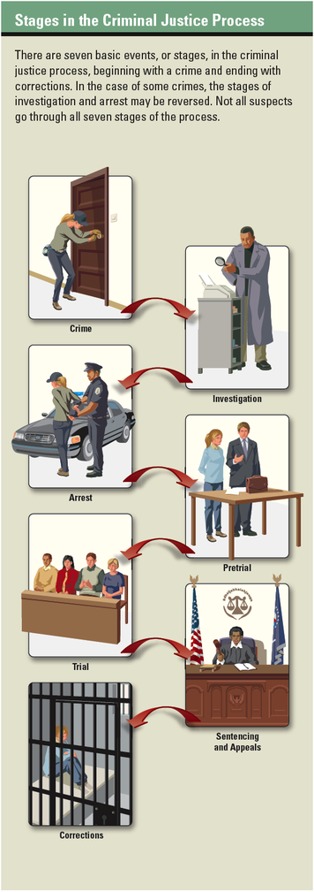

Substantive due process [substantive due process: the principle that the substance of the laws enforced by the government must not violate constitutional rights and liberties] , on the other hand, relates to the substance of a law rather than the way it is enforced. In such cases, the Court looks at the content of the law to see how it affects due process rights. In the 1923 case of Meyer v. Nebraska, for example, the Court overturned a Nebraska law that forbade the teaching of foreign languages to students in grades lower than ninth grade. The case involved a teacher who taught schoolchildren to read in German.
In its decision, the Court held that the Nebraska law violated intellectual liberty as guaranteed under the Due Process Clause of the Fourteenth Amendment. Writing for the majority, Justice James C. McReynolds noted that many liberties are protected under due process, including the freedom to “acquire useful knowledge.” This was one of the first cases in which the Court applied substantive due process to the protection of civil liberties.

Limitations on the Due Process Rights of Juveniles
Due process rights for juveniles—persons under the age of 18—are somewhat different from those for adults. These differences stem from reform laws of the early 1900s, which sought to separate juveniles from adults in the criminal justice system. As a result of these laws, juvenile offenders were tried in special courts and housed in reform schools rather than in prisons.
The new juvenile courts created by these reforms sought to take the circumstances of young offenders into account when handing down sentences. However, the proceedings of these courts were held without juries and sometimes without attorneys. This meant that they typically failed to grant due process rights to juvenile suspects.
In 1967, the Supreme Court handed down a decision in the case of In re Gault that expanded the rights of juvenile suspects. Gerald Gault, age 15, had been accused of making an obscene phone call to a neighbor. At his court hearing, Gault admitted to taking part in the call. He testified that he had dialed the number but that a friend had done all of the talking.
No eyewitness testified against Gault, because the neighbor who made the complaint did not show up in court. Nevertheless, the judge concluded that Gault was guilty and sentenced him to six years in a state reform school. An adult convicted of the same crime would have served no more than 60 days in a county jail.
In reviewing the case, the Supreme Court said that juveniles should receive many of the same due process rights as adults. These include the right to be notified of the charges against them, the right to an attorney, the right to confront witnesses, and the right to remain silent. Gault had been given none of these rights. As a result of the Court’s decision, Gault was released and a new hearing was held under different conditions.
Today, juveniles enjoy many, but not all, of the due process rights guaranteed to adults. For example, in McKeiver v. Pennsylvania (1971), the Supreme Court concluded that juries are not mandatory in juvenile cases.
In recent years, there have been growing calls for states to “get tough” on juvenile crime. In some cases, juveniles accused of serious crimes have been tried as adults. This adult status gives juveniles more due process rights, but it also means they face stiffer penalties if convicted.

Section III: The Investigation:
In the story at the beginning of this chapter, police officers took you and your friends into custody shortly after a crime took place. In many criminal cases, however, the arrest would take place later, after a police investigation.
When police learn of a crime, typically the first thing they do is gather evidence and talk to witnesses to identify likely suspects. They then present this information to a government prosecutor, who decides whether a suspect should be arrested and charged with a crime. For serious or complicated crimes, a criminal investigation can take weeks, months, or even years.

The Fourth Amendment Offers Protection from Unreasonable Searches and Seizures

Click to read caption
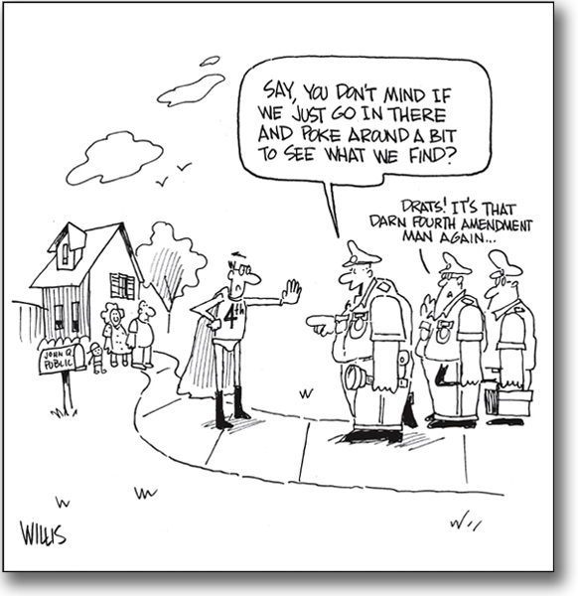
©TCI/Scott Willis
The Constitution and federal and state laws offer guarantees against illegal search and seizure. But citizens must remain vigilant to make sure their rights are protected.
After stopping you and your friends outside the mall, the police officers searched the shopping bag your friend was carrying to look for evidence. They found clothing and some jewelry, which your friend insisted had all been paid for with a credit card.
The officers had a right to search the bag based on probable cause. In other cases, however, suspects may have a legal right to refuse a police search. That right is based on the Fourth Amendment, which says that Americans have the right to be “secure in their persons, houses, papers, and effects.” The Fourth Amendment also prohibits “unreasonable searches and seizures.”
This Search and Seizure Clause means police officers must have good reason to arrest a suspect or to seize a suspect’s property. They also must have a strong legal basis for carrying out a search of someone’s property or possessions. In most cases, this means police must obtain a search warrant [search warrant: a document issued by a judge that authorizes law enforcement officers to search a person’s property or possessions] from a judge to carry out a legal search.

Gathering Evidence
Before prosecutors file a criminal charge, they try to make sure they have a viable case against the suspect. To do this, they must try to get as clear a picture as possible of what happened before, during, and after the crime. This requires an examination of both direct and circumstantial evidence.
Direct evidence [direct evidence: information about a crime provided by a witness who saw the crime, or by a video or audio recording of the crime] is information provided either by a witness who saw the crime occur or by a video or audio recording of the crime. Circumstantial evidence [circumstantial evidence: information about a crime that can be inferred from other facts] is information that can be inferred from other facts. For example, if a suspect’s fingerprints are found on the steering wheel of a car, police can infer that the suspect was present in that car at some point. The fingerprints thus become circumstantial evidence. If a neighbor actually saw the suspect in the car, however, that is direct evidence. For law enforcement officers to gather these kinds of evidence, they must conduct searches.
Although the Fourth Amendment is meant to protect citizens from unreasonable searches and seizures, it also implicitly allows for “reasonable” police actions. But how do law enforcement officers know when a search is reasonable?
Several Supreme Court decisions in the past few decades have helped law enforcement officials answer this question. Two of these cases, Katz v. United States (1967) and Terry v. Ohio (1968), were discussed in detail in Chapter 5. In Katz, the Court determined that a search was not permitted under the Fourth Amendment whenever a person had a “reasonable expectation of privacy.” In Terry, however, the Court held that a “stop and frisk” search was reasonable when police had cause to be suspicious of a suspect’s behavior.
The Court has found other searches and seizures without warrants to be reasonable when the invasion of privacy is minimal or when special circumstances apply. Here are some examples:
• Sobriety checkpoints. Because the intrusion is slight, stopping motorists at roadblocks to search for drunk drivers is considered reasonable.
• Airport searches. Searching carry-on luggage is considered permissible to lessen the danger of airline hijacking.
• Student searches. In New Jersey v. T.L.O. (1985), the Supreme Court held that school officials can search students on school grounds without probable cause.
• Consent searches. Police are legally allowed to search a person’s property if the person provides voluntary consent and is not coerced.

How Search Warrants Work
The Fourth Amendment sets out certain conditions under which warrants can be issued. This portion of the amendment is known as the Warrant Clause [Warrant Clause: a portion of the Fourth Amendment that sets out certain conditions under which warrants can be issued] .
The Warrant Clause first states that any search warrant issued must be based on probable cause. Probable cause is more than just a gut feeling or suspicion. In the case of Brinegar v. United States (1949), the Supreme Court noted,
In dealing with probable cause . . . we deal with probabilities. These are not technical; they are the factual and practical considerations of everyday life on which reasonable and prudent men . . . act.
To obtain a search warrant, law enforcement officials must present evidence of probable cause to a judge. If the evidence is convincing, the judge will issue a warrant. The warrant describes the exact place to be searched and the items or persons to be seized. This exactness keeps officers from carrying out generalized searches without a clear idea of what they are looking for.
It is not always feasible for police to obtain a warrant before performing a search, however. In certain situations, searches may be made without a warrant. Here are some examples:
• During a lawful arrest. The Supreme Court has determined that police can search an arrested suspect and the immediate area of the arrest for weapons or evidence that could be destroyed.
• When evidence is in plain view. If evidence is plainly visible to an officer and the officer is legally entitled to be in that location, the evidence can be seized without a warrant.
• When in hot pursuit. If police are chasing a suspect, they can follow that suspect into a building and seize any evidence found there.
• Automobile searches. Police can make warrantless searches of automobiles under certain circumstances, since a vehicle might be moved before a warrant is obtained.

Illegally Gained Evidence: The Exclusionary Rule
During an investigation, police officers must be careful to obtain all evidence legally. In the 1914 case of Weeks v. United States, the Supreme Court held that the seizing of evidence illegally would result in the exclusion of that evidence during trial. This exclusionary rule [exclusionary rule: the principle that illegally seized evidence cannot be used in a court of law] has been tested many times since then. One notable instance was the 1961 case of Mapp v. Ohio.
The Mapp case began when police in Cleveland, Ohio, arrested Dollree Mapp after a search of her home turned up books and photographs judged to be obscene. Although the police did not have a valid search warrant, Mapp was convicted for possession of obscene materials. On appeal, the Ohio Supreme Court upheld Mapp’s conviction on the grounds that the Fourth Amendment’s protections did not apply to state law enforcement.
The Supreme Court disagreed with the lower court’s decision. A Court majority concluded that “all evidence obtained by searches and seizures in violation of the Constitution is . . . inadmissible in a state court.” This meant that all levels of the criminal justice system—local, state, and federal—had to enforce rules against the use of evidence that was illegally obtained.
Section IV: The Arrest
In the hypothetical shoplifting case, your arrest at the mall occurred at the scene of the crime. Under such circumstances, the police do not need to get an arrest warrant. Like a search warrant, an arrest warrant [arrest warrant: a document issued by a judge that authorizes the arrest of a suspect in a crime] must be issued by a judge and be based on probable cause. When officers find a likely suspect at the scene of a crime, however, they can make a warrantless arrest [warrantless arrest: an arrest of a suspect without a warrant, often at the scene of the crime] .
Law enforcement officers must follow very specific steps when making an arrest. From the moment a suspect is placed in handcuffs until the time the suspect is jailed or released, police officers are required to follow proper procedures to ensure that the suspect’s rights are protected.

Due Process During an Arrest: Miranda Rights
A landmark Supreme Court decision in the 1966 case of Miranda v. Arizona helped ensure that police officers observe due process when taking suspects into custody. This decision requires officers to inform suspects of their rights as they are being arrested.
The Miranda case began in Phoenix, Arizona, in 1963, when Ernesto Miranda was arrested for rape and kidnapping after a victim identified him in a police lineup. During questioning by police, Miranda confessed in writing to both crimes. The police later admitted that they did not inform Miranda of his Fifth Amendment right against self-incrimination or of his Sixth Amendment right to have an attorney present during questioning. They argued, however, that Miranda had been arrested before and therefore must have been aware of his rights. At his trial, Miranda was convicted and given a sentence of 20 to 30 years in prison for each crime.
Miranda’s attorney appealed to the Arizona Supreme Court, arguing that the confession was not admissible evidence because Miranda had been denied his legal rights. The state court denied Miranda’s appeal and upheld his conviction. In 1966, the U.S. Supreme Court agreed to hear Miranda v. Arizona, along with three similar cases in other states.
Noting that the interrogation of Miranda was done in an “atmosphere . . . of intimidation,” the Court concluded that for a confession to be valid, a suspect must be informed of his or her rights. The Court said that a confession could not be admitted as evidence unless a suspect had been told the following:
• You have the right to remain silent.
• Anything you say can be used against you in court.
• You have the right to an attorney and to have that attorney present while you are being questioned.
• If you cannot afford an attorney, one will be appointed for you before questioning begins.
These Miranda warnings [Miranda warnings: the list of rights that must be read to a criminal suspect at the time of his or her arrest] have become a cornerstone of the procedures that officers follow when making an arrest. Any statements offered by a suspect before Miranda warnings are given cannot be offered as evidence in a trial. In addition, any evidence that officers might uncover as result of an illegal confession is also inadmissible in court.
The Court has noted exceptions to its decision in the Miranda case, however. One is the “public safety” exception. Police can question suspects before giving the Miranda warnings if they believe public safety is at risk. For example, in 1984, New York City police chased an armed suspect into a grocery store. When they asked him where his gun was, he showed it to them. In this case, the gun was admitted as evidence, because locating the gun quickly was critical to public safety.

“Book ’Em”: Processing Suspects After an Arrest
When criminal suspects arrive at the police station after their arrest, they are “booked,” or processed. They are asked to give their name, date of birth, and other personal information. They are informed of the charges against them, though these charges will later be stated more formally in a courtroom. They are also fingerprinted, photographed, and searched. In some cases, suspects are required to stand in a police lineup to be viewed by witnesses.
During booking, an officer confiscates a suspect’s personal property. The officer makes a list of everything taken and has the suspect sign the list.
The suspect has the right to make a phone call during booking. Most suspects call family members, friends, or a lawyer. In some cases, a lawyer may be able to get the charges dropped. Otherwise, the suspect has to remain in jail, awaiting the next stage in the criminal justice process.
Section V: Pretrial Activity
The shoplifting story that began this chapter has a happy ending—at least for you. When you arrive at the police station, a detective reviews the videotape from the mall and concludes, to your great relief, that you played no direct role in the shoplifting incident. Instead of being booked, you are released without charges. It has been a difficult experience, but justice has been served and you are free to go.
It is a different story for your friends, however. The videotape provides sufficient evidence to hold them on suspicion of shoplifting. Over the next few days, they will go through various pretrial activities. During this pretrial stage, they are assumed to be innocent until proven guilty. This means the police and prosecution must show enough evidence to support the criminal charges against them.

The Initial Appearance: The Pretrial Process Begins
The Sixth Amendment requires that criminal prosecutions move forward quickly. Within 48 hours of their arrest, suspects must have the opportunity to appear in court. At this first pretrial appearance, they are reminded of their rights and of the charges against them. They are also told that if they cannot afford an attorney, one will be appointed for them at public expense.
A suspect’s initial appearance in court also offers the possibility of release from jail. A judge will decide whether the defendant should be released from custody and under what conditions.
One way a defendant can be released from custody is through the posting of bail. Bail is money that a defendant hands over to the court as a guarantee that he or she will return for trial. The amount of bail is set by the judge in each particular case. Once bail has been posted, the defendant is released from jail until the trial.
A judge may decide not to set bail, depending on the circumstances of a case. For example, a judge may conclude that a defendant is a “flight risk,” meaning he or she might not return for trial despite posting bail. Or a judge may decide that the defendant would pose a possible danger to others if released.
The issue of risk to others was at the heart of the Supreme Court’s decision in the 1987 case of United States v. Salerno. The defendant in the case argued that denying bail to suspects who were considered dangerous violated their constitutional rights. The Court concluded, however, that judges could deny bail based on public safety.
At the initial pretrial hearing, defendants facing a misdemeanor charge are required to enter a plea of guilty or not guilty. Defendants in felony cases, however, do not enter a plea until a later court appearance.

The Preliminary Hearing: Will There Be a Trial?
The next pretrial step in most felony cases is the preliminary hearing. The purpose of this hearing is to determine whether there is enough evidence to take a case to trial. The prosecutor must prove that there is probable cause that a crime was committed and that the suspect committed it.
During the preliminary hearing, the prosecutor calls witnesses whose testimony will support the prosecution’s case. In some states, the courts also allow cross-examination of witnesses by the defense attorney. Preliminary hearings tend to be brief, however, as the main goal is to determine whether there is sufficient evidence to justify a trial.

Grand Juries Also Weigh Evidence
In some felony cases, a grand jury takes the place of a preliminary hearing. A grand jury [grand jury: a group of citizens who examine the evidence in a serious criminal case to decide whether a person accused of a crime should be indicted, or charged] is a type of jury that weighs evidence and determines whether a trial is warranted.
Grand juries are quite different from trial juries. They are larger, consisting of 16 to 23 jurors. These jurors serve for a set period of time—often for a month or more. They consider a number of cases rather than just one as a trial jury would. Grand juries meet in secret to protect the reputation of those under investigation.
Grand juries also differ from trial juries in that they do not hear both sides of a case. They only hear the prosecution’s version of events. Jurors must consider this question: Did a crime take place, and did this defendant commit it? If they believe the answer to both parts of the question is yes, they will return an indictment [indictment: a formal accusation of criminal behavior handed down by a grand jury; this means that the accused person will be brought to trial] , or formal accusation, against the suspect.
Under the terms of the Fifth Amendment, any serious violation of federal law must be brought before a federal grand jury. At the state level, however, grand juries are less common. Some states do not use either grand juries or preliminary hearings. In those states, a defendant may have to stand trial based solely on a prosecutor’s formal statement of evidence to the court.

The Arraignment: Entering a Plea
Assuming there is enough evidence to go to trial, the next step in the pretrial process is the arraignment [arraignment: the stage in the criminal process when a person accused of a crime is informed of the charges and allowed to enter a plea of “guilty” or “not guilty”] . This is a court appearance in which the suspect must enter a plea. If the plea is guilty, the judge will set a date to announce punishment. If the plea is not guilty, the judge will set a trial date.
Before the arraignment, a defendant may arrange a plea bargain [plea bargain: an agreement whereby a defendant pleads guilty in return for a lesser charge or reduced sentence] . This is an agreement in which the defendant pleads guilty in exchange for a lighter sentence. Although a plea bargain may result in jail time, some defendants choose this option to avoid a longer sentence or to spare them the time and expense of a trial.
Critics of plea bargaining argue that it sometimes lets dangerous criminals get out of jail too soon. Other critics worry that it allows the government to pressure innocent people into pleading guilty for fear of a heavy sentence should they lose in court. Supporters, however, argue that plea bargaining helps keep the court system from clogging up with too many cases.
Section VI: The Trial
Several weeks have passed since your friends were arrested and booked on suspicion of shoplifting. With the help of a lawyer, they secured bail and spent only one night in jail. During the pretrial phase, however, a judge determined that there was enough evidence to put them on trial. Because the value of the shoplifted goods exceeded $400, they have been charged with grand theft. Now the day has arrived when they must appear in court to defend themselves before a judge and jury.

The Right to a Speedy and Public Trial
The Sixth Amendment forms the basis of a suspect’s constitutional right to a fair and impartial trial. The first phrase of this amendment says that the “accused shall enjoy the right to a speedy and public trial.” But what do these words mean in practice? For example, what constitutes a “speedy trial”?
The Supreme Court has shed some light on this question. In 1972, the Court reviewed a case in which a suspect’s trial was delayed 16 times before he was finally tried and convicted. Because the defendant had not objected to the first 11 delays, the Supreme Court upheld his conviction. However, the Court listed the following four factors to consider in deciding whether a trial has been “speedy”:
• the length of the delay
• the prosecutor’s reasons for the delay
• the defendant’s views on the delay
• potential harm to the defendant caused by the delay
Congress has set a limit of 100 days after an arrest for a federal case to be brought to trial. If this time limit is not met, a case may be dismissed. Defendants have been known to waive this right, however, to give their attorneys more time to prepare or to accommodate the needs of key witnesses. Some states have followed federal guidelines and set their own limits under which a case must be tried.
The “public” part of the “speedy and public” clause has also been subject to interpretation. The framers of the Sixth Amendment believed that it was important to keep trials public in order to ensure a fair judgment for the defendant. They also assumed that society would benefit from seeing justice served.
But what happens when holding a public trial might actually hurt the defendant? In certain cases, for example, the presence of the news media at a trial could affect public opinion and influence the jury. In such cases, judges may decide to change the location of a trial or to isolate the jury.
Although television cameras are now allowed at many trials, judges have been known to ban cameras from the courtroom on the grounds that they could distort the justice process. The Supreme Court has determined that such bans do not violate the Sixth Amendment.
Inevitably, the defendant’s right to a fair trial sometimes conflicts with the public’s desire for access to trial proceedings. In 1979, the Supreme Court concluded in the case of Gannett Co. v. DePasquale that the public does not necessarily have the right to attend all trials. However, a year later, in Richmond Newspapers Inc. v. Virginia,, the Court decided that, with the exception of cases involving national security, the public’s right to view trials should be maintained if at all possible.

The Right to Be Judged by an Impartial Jury of One’s Peers
Trial by jury is one of the fundamental rights guaranteed under the Constitution. In fact, it is the only right that is specified both in the main body of the Constitution and in the Bill of Rights. The Sixth Amendment, however, goes beyond simply guaranteeing the right to a trial by jury. It also mandates that the jury be impartial, or unbiased, and made up of members of the local community.
Traditionally, juries have consisted of 12 jurors who must reach a unanimous verdict for a case to be decided. Federal courts still uphold those standards. The Supreme Court has held, however, that 12 jurors are not essential to decide a case, as long as there are enough members to facilitate group deliberation.
The need for a unanimous verdict has also come into question. In the 1972 case of Apodaca v. Oregon, the Court held that verdicts in non–death penalty cases do not need to be unanimous. However, a Court decision in 1979 made it a requirement for smaller, six-member juries to reach a unanimous verdict.
Most important, the Sixth Amendment requires that juries be impartial. This requirement mainly affects the way in which potential jurors are chosen. Possible jurors are usually selected from a master list compiled from various sources. The idea is to draw from a pool of people who represent a cross-section of the community. Names are then selected at random from the master list, and those selected receive a jury summons.
During a process known as voir dire [voir dire: the process during jury selection in which the lawyers and judge question potential jurors to determine whether there is reason to disqualify them from a trial] , the lawyers and judge in a case question potential jurors to determine whether there is any reason to disqualify them. A lawyer may challenge a juror “for cause” by stating a specific objection. For example, a prosecutor might challenge a juror on a murder case if that person is opposed to the death penalty. If the judge approves the challenge, the juror is disqualified.
Lawyers may also exclude jurors based on a peremptory challenge [peremptory challenge: a rejection of a prospective juror for which no specific reason need be given] . This is a challenge that is given without reason but that is usually based on a perceived bias in the jury candidate. Lawyers are generally granted a limited number of peremptory challenges in each case.
Until the 1980s, lawyers could use peremptory challenges whenever they chose, with no restrictions. In the 1986 case of Batson v. Kentucky, however, the Supreme Court concluded that this unrestricted process violated the Constitution. The case involved a black defendant who had been convicted of burglary. In the original trial, the prosecuting attorney used his peremptory challenges to exclude four black jurors, leaving an all-white jury to decide the case.
The Court held that the prosecutor’s actions violated the Sixth and Fourteenth amendments. The Court said that if prosecutors try to exclude jurors based solely on race, they may be asked to explain their reasons. They may even be challenged by the defendant and ordered to change their approach. In 1992, the Court later extended these rules to defense attorneys. Two years later, it prohibited peremptory challenges based on gender.

The Right to an Adequate Defense

Click to read caption
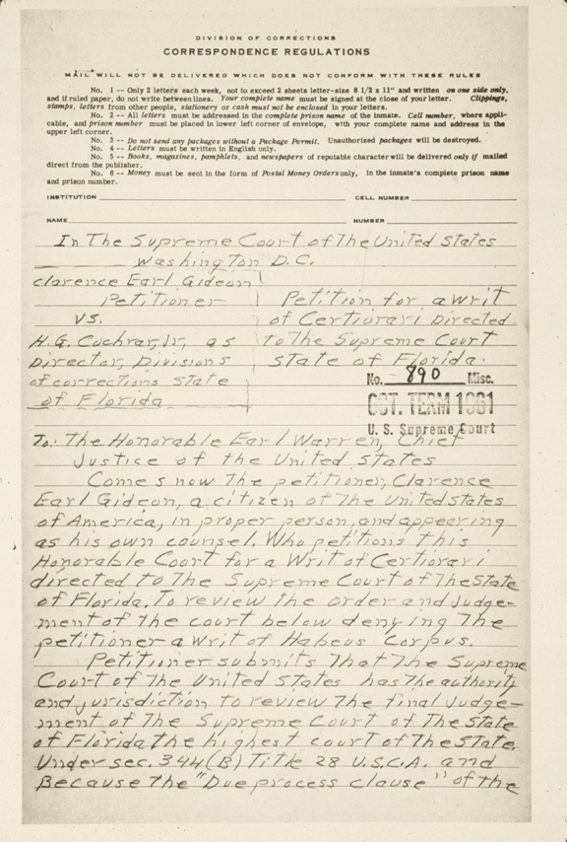
Getty Images
Clarence Gideon’s case before the Supreme Court in 1963 helped secure every defendant’s Sixth Amendment right to a lawyer. Gideon’s case made it to the Court on the strength of his handwritten petition, which was fi led from his prison cell.
The last right guaranteed by the Sixth Amendment, the right to an attorney, is also essential to the judicial process. In fact, the Supreme Court has noted that the right to legal counsel is the most pervasive of a defendant’s rights, because it “affects his ability to assert any other rights.”
Because defendants must have access to legal counsel, the Supreme Court has said that they have the right to a free, court-appointed lawyer if they cannot afford to hire one. That right was upheld in the 1963 case of Gideon v. Wainwright, as discussed in Chapter 5.
A year later, the Supreme Court reinforced the legal right to an attorney in Escobedo v. Illinois. Danny Escobedo, the defendant in the original case, had been arrested and questioned by police in connection with a murder. During this questioning, police repeatedly denied Escobedo’s requests to speak to a lawyer. He later confessed to the murder and was convicted.
In its decision, the Supreme Court found that the police had violated Escobedo’s Sixth Amendment right to an attorney. This right applies, said the Court, when “a police investigation is no longer a general inquiry into an unsolved crime but has begun to focus on a particular suspect in police custody.” This case produced the “Escobedo rule,” an application of the exclusionary rule that disallows evidence gained from a confession made without an attorney present.
In 1984, the Court considered the question of what constitutes effective legal counsel in the case of Strickland v. Washington. This case centered on a defendant who had been sentenced to death in a murder case. The defendant had confessed to the crime but charged that his lawyer had violated his rights by not providing enough evidence in his case to avoid the death sentence.
In its decision, the Court agreed that defendants are entitled to “reasonably effective assistance” of counsel. To claim ineffective counsel, defendants must show that errors made by the attorney were sufficient to prevent a fair trial. In effect, defendants must prove that more competent counsel could have produced a different outcome. In this particular case, however, the Court upheld the man’s conviction on the grounds that additional evidence would not have affected the outcome.

The Rules of Evidence in Criminal Trials
The burden of proof in a trial rests with the prosecution. It is the government’s job to prove beyond a reasonable doubt that the defendant is guilty. Prosecutors seek to do this by presenting both direct and circumstantial evidence. In addition, prosecutors must obey the rules of evidence when presenting their case.
In general, evidence must satisfy two main rules to be admissible. First, it must be relevant. This means there must be a valid reason to introduce it. If a defendant is accused of murder, evidence that he is diabetic is probably not relevant. Second, evidence must be competent. In other words, it must meet certain standards of reliability. The testimony of a very young child might not be considered competent, for example, because the child might not be a reliable eyewitness.
The judge in a case has the final say on whether evidence is admissible. The judge’s role is to make sure that both the defense and the prosecution follow the law and that justice is served. Either side can appeal a judge’s decision, however, if they believe the judge made legal errors.

The Constitutional Protection from Self-Incrimination
One of the biggest decisions a defense attorney must make is whether to have the defendant testify. The Fifth Amendment protects a defendant’s right not to testify. This is to protect the accused from self-incrimination. Still, jurors are often curious about a defendant’s side of the story and may wonder why someone would choose not to take the witness stand.
The Fifth Amendment’s protection against self-incrimination, however, does not prohibit the state from requiring a defendant to submit evidence such as fingerprints, handwriting samples, and DNA samples. This type of evidence is called physical evidence [physical evidence: any physical object submitted as evidence in a trial, including fingerprints and DNA samples] . The Court has said that the use of physical evidence is permissible to obtain a conviction.

Jury Deliberations: Beyond a Reasonable Doubt
After both the prosecution and the defense attorney have presented their final arguments, the case is handed over to the jury. The jury then retires to the jury room to deliberate behind closed doors.
The first thing members of a jury typically do is choose a foreman to act as chairperson. They then discuss all aspects of the case, including court procedures, testimony, and evidence. Jurors may also request additional information from the judge if they are uncertain about anything. Following these procedures, most juries are able to reach a verdict quickly, often in less than two hours.
To reach a guilty verdict, jurors must agree that the defendant is guilty, beyond a reasonable doubt, of the crime in question. Depending on the laws involved, the jury may have the option of choosing to convict the accused of a lesser offense. Once the jurors have agreed on a verdict, they inform the judge and return to the courtroom. The jury foreman then announces the verdict in court.
If judged guilty, the defendant is usually taken into custody to await punishment. Following an acquittal [acquittal: a trial verdict of “not guilty”] , or “not guilty” verdict, however, the defendant leaves the courtroom a free person and the case is officially over. The protection of double jeopardy afforded by the Fifth Amendment prevents a person from being tried again for the same crime.
As mentioned previously, juries are usually required to reach a unanimous verdict. If they fail to do so, the result is a hung jury [hung jury: a jury that is deadlocked and cannot agree on a verdict] . In such cases, the judge dismisses the jurors. The prosecutor then has the option of retrying the case with a new jury.
Section VII: Sentencing and Appeals
Your friends’ trial for shoplifting was relatively short, lasting just two days. The prosecution relied heavily on evidence from the videotape, which clearly showed them stuffing merchandise into a bag. A store clerk also testified that your friends left the store carrying the bag without paying for anything. Your friends’ attorney argued that they meant to pay for the goods but simply forgot. The jury found this argument unconvincing and returned a verdict of guilty on the charge of grand theft.
After the verdict, your friends were taken to a nearby detention facility to await sentencing [sentencing: the stage of a trial when the judge announces the punishment for a crime] . This is the moment when the judge announces the punishment for a crime. After the sentence is announced, your friends may have the opportunity to file an appeal.

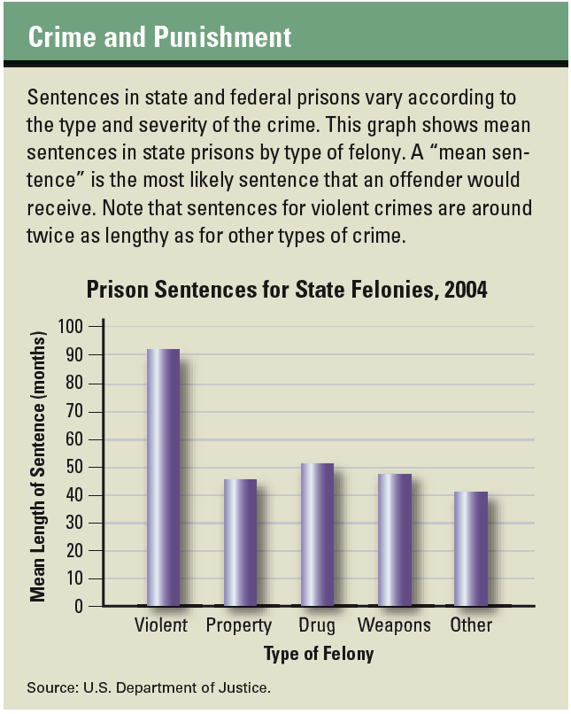

Making the Punishment Fit the Crime and the Criminal
In some trials, the jury may recommend a particular sentence as punishment for a crime. Ultimately, though, it is the judge’s responsibility to assign a sentence. Judges try to make the punishment fit the crime and the criminal, assigning tougher penalties for more serious crimes or repeat offenders. However, that task is not always clear-cut.
Judges consider many factors before handing down a sentence. Often, they will request a presentence report, prepared by the court staff. This report provides details about the crime and the surrounding circumstances. It supplies background on the defendant, including any criminal record the defendant may have. It also offers a recommendation on sentencing.
If the recommendation is imprisonment, judges can choose to apply either indeterminate or determinate sentencing. Indeterminate sentencing [indeterminate sentencing: the practice of assigning a convicted criminal a variable term in prison] means assigning the criminal a variable term in prison, ranging from a minimum sentence to a maximum sentence. A review board may examine the case every few years to decide whether the inmate should be eligible for parole [parole: an early release from prison based on good behavior] , or an early release from prison. For example, a judge might hand down a sentence of 10 to 15 years for a robbery conviction. A parole board might decide, however, that the prisoner is eligible for release after 7 years in prison. Factors involved in that decision might include the inmate’s behavior and his or her chances of staying out of trouble after returning to society.
Determinate sentencing [determinate sentencing: the practice of assigning a convicted criminal a fixed term in prison] , on the other hand, means that the judge sets a specific amount of time that a criminal must serve in prison. This option often rules out any possibility of parole, and the criminal is given a fixed date for his or her release.
In some cases, a defendant is convicted of multiple crimes and therefore given multiple sentences. In such cases, the judge may prescribe a concurrent sentence, in which the defendant serves each sentence at the same time. For example, if a person convicted on two charges received a sentence of 10 years and another of 5 years, a concurrent sentence would release the inmate in no more than 10 years.
On the other hand, the judge might prescribe a consecutive sentence. In that case, the same criminal would serve the two sentences back to back, for a total of 15 years, with little chance of parole.

Other Sentencing Options
In addition to imprisonment, a judge may choose from among other sentencing options, including those listed below. These options may be assigned on their own or in combination with others.
• A suspended sentence.The defendant does not have to serve time in prison immediately, but may have to serve time later if he or she is rearrested or violates a condition of parole.
• Probation. The defendant must report to a probation officer, who ensures that the defendant is following certain conditions set down by the judge.
• Home confinement. Rather than a prison sentence, the defendant serves time at home and can leave only for preapproved reasons, such as work, appointments, or school.
• A fine. The defendant may be required to pay a certain sum of money to the government.
• Restitution. Restitution [restitution: a repayment by an offender to a victim for losses, damages, or injuries resulting from a crime] means that the defendant must pay back or make up for whatever losses the victim has sustained.
• Work release. The defendant is imprisoned but is allowed to work in the community during workdays.
The goal of sentencing is usually one of three outcomes, or a combination of all three: deterrence, rehabilitation, and incapacitation. The idea of deterrence is to assign a harsh enough sentence to discourage criminals from committing another crime. Rehabilitation is the process of helping criminals change so that they can live productive lives and be less likely to resort to crime in the future. Incapacitation ensures that criminals are locked up so that they can no longer pose a threat to society.
The most extreme form of punishment, the death penalty, has long been controversial. Some critics of capital punishment claim that it violates the Eighth Amendment, which forbids “cruel and unusual punishment.” In 1976, however, the Supreme Court determined that capital punishment was permitted under the Constitution.
Nevertheless, the Supreme Court has decided against capital punishment in certain cases. In 1986, for example, it concluded that executing a prisoner who has been diagnosed as insane is unconstitutional. In 2002, it came to the same conclusion about the execution of mentally retarded persons. Three years later, in the case of Roper v. Simmons, the Court considered the question of capital punishment for juveniles. At the age of 17, Christopher Simmons had been sentenced to death by a state court. In its decision, the Court said that executing minors is prohibited by the Eighth Amendment.

Click to read caption
Roberto Schmidt-AFP/Getty Images
In cases where felons pose little risk to the community, judges may sentence them to home confinement rather than to prison. In such cases, the felon may be required to wear an electronic ankle bracelet, a tracking device that police can use to monitor the felon’s location.

Raising Legal Questions During Appeals
Defendants who believe that they were wrongfully convicted have the right to appeal to a higher court. Their appeal will be heard, however, only if they can reasonably argue that the judge in their case committed an error of law. Though many appeals are filed every year, only a few are actually reviewed by appeals courts. From that handful of cases, even fewer have their original conviction overturned.
Reasons for requesting an appeal vary, depending on the case. Defendants may appeal because they believe the jury selection was flawed, their lawyer was ineffective, or the law was not interpreted correctly. They may also appeal because they feel their due process rights were denied, which was the issue in the 1963 case of Brady v. Maryland.
In the Brady case, the defendant appealed his conviction for murder on the grounds that the prosecution concealed evidence that might have influenced the death sentence he received. This evidence showed that although the defendant had been involved in the crime, another person had actually committed the murder.
The Maryland Court of Appeals, the state’s supreme court, upheld Brady’s conviction but said a lower court should review his death sentence. The Supreme Court agreed, arguing that withholding evidence violates due process “where the evidence is material either to guilt or to punishment.”
On average, criminal defendants win on appeal only about one in eight times. In those cases, the appeals court sends instructions to a lower court to retry the case under different conditions. In about half of these cases, however, the defendants are found guilty a second time.
Section VIII: The Corrections System
After your friends’ conviction for shoplifting, the judge handed them a relatively tough sentence as a form of deterrence. She sentenced them to 90 days of incarceration [incarceration: imprisonment in a jail, prison, or other correctional facility as punishment for a crime] , or jail time, in a county correctional facility, followed by six months of probation. During their probation, they will be required to report regularly to a probation officer and to remain within the county. The judge also sentenced them to restitution, requiring them to return the stolen goods and make an oral and written apology to the store manager.
Apprehensive about serving time in jail, your friends asked their attorney whether they should appeal their sentence. The lawyer said they had no grounds for appeal, because the judge followed proper legal procedures during the trial. Instead, their attorney urged them to accept the terms of punishment.

Prisons, Parole, and Pardons
Serving time in the corrections system is a tough punishment for anyone. Inmates lose many of the rights and privileges they enjoyed in society, most notably the freedom to live their lives as they see fit.
Not all prisons are alike. White-collar or petty criminals normally end up in minimum-security prisons, where conditions are relatively lenient. Violent criminals, on the other hand, are sent to maximum-security prisons, where conditions are quite harsh.
No matter what their crime, however, all prisoners are guaranteed certain fundamental rights under the Constitution and state and federal law. The Eighth Amendment’s protection against “cruel and unusual punishment” ensures that prisoners are provided a basic standard of living. Due process rights require that they be granted access to the parole process. The Fourteenth Amendment’s Equal Protection Clause protects them from discrimination on the basis of race, gender, or religion.
In addition, the Supreme Court has determined that all prisoners have certain specific rights, including the right to receive mail, to get adequate medical care, and to practice their religion. In Cutter v. Wilkinson, (2005), the Court said that prisoners cannot be denied the exercise of their religious beliefs, even if those beliefs are outside the mainstream of established religions. In most states, however, prisoners are still denied the right to vote.
After a certain amount of time, most inmates are eligible for release. Some are released because they have served their full sentence. Others leave prison because they have been granted parole.
The parole process varies from state to state. In some states, prisoners must apply for parole by submitting a request to the parole board. In others, the parole board automatically considers parole when prisoners have served a certain amount of their sentence. The prisoner may then be asked to appear at a parole hearing. At this hearing, the parole board hears testimony and examines evidence to determine whether parole should be granted.
Many released prisoners find that their return to society is not smooth. For one thing, the released prisoner now has a criminal record, which can make it difficult to find a job or a place to live. In some cases, former prisoners may decide to apply for a pardon. A pardon is a formal document stating that the person has paid his or her debt to society and has become a productive member of the community.
Pardons can be granted only by the president, in the case of a federal crime, or by governors, in the case of state crimes. Pardons are rarely granted, however. When they are, they restore all of the rights that were lost by offenders when they were convicted.

