The Aryan Invasion Theory (C. 1800-1500 BC)
The Indus Valley Civilization may have met its demise due to invasion. According to one theory by British archaeologist Mortimer Wheeler, a nomadic, Indo-European tribe, called the Aryans, suddenly overwhelmed and conquered the Indus River Valley.
Wheeler, who was Director-General of the Archaeological Survey of India from 1944 to 1948, posited that many unburied corpses found in the top levels of the Mohenjo-daro archaeological site were victims of war. The theory suggested that by using horses and more advanced weapons against the peaceful Harappan people, the Aryans may have easily defeated them.
Yet shortly after Wheeler proposed his theory, other scholars dismissed it by explaining that the skeletons were not victims of invasion massacres, but rather the remains of hasty burials. Wheeler himself eventually admitted that the theory could not be proven and the skeletons indicated only a final phase of human occupation, with the decay of the city structures likely a result of it becoming uninhabited.
Later opponents of the invasion theory went so far as to state that adherents to the idea put forth in the 1940s were subtly justifying the British government’s policy of intrusion into, and subsequent colonial rule over, India.
Various elements of the Indus Civilization are found in later cultures, suggesting the civilization did not disappear suddenly due to an invasion. Many scholars came to believe in an Indo-Aryan Migration theory stating that the Harappan culture was assimilated during a migration of the Aryan people into northwest India.
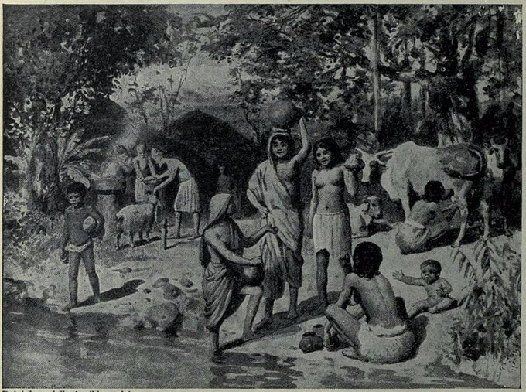
Aryans in India. An early 20th-century depiction of Aryan people settling in agricultural villages in India.

