Internal and External Environment Factors that Influences Organizational Decision Making
Organizational environment denotes internal and external environmental factors influencing organizational activates and decision making.
Every organization, whether business or non-business, has its environment. The organizational environment is always dynamic and ever-changing.
Changes today are so frequent and every change brings so many challenges that managers and leaders of the organization need to be vigilant about the environmental changes. The environment of an organization consists of its surroundings – anything that affects its operations, favorably or unfavorably.
Environment embraces such abstract things as an organization’s image and such remote visible issues as economic conditions of the country and political situations.
The environmental forces abstracts and visible need careful analysis. The systematic and adequate analysis produces the information necessary for making judgments about what strategy to pursue.
Managers cannot make appropriate and sound strategy simply based on their guesses and instincts. They must use relevant information that directly flows from the analysis of their organization’s environment.

Types of Organizational Environment
By the word “environment” we understand the surroundings or conditions in which a particular activity is carried on.
And we know that organization is a social entity that has a hierarchical structure where all necessary items are put together and they act within it to reach the collective goal.
Organizations or more specific business organizations, and their activates are always being affected by the environment. In an organization, every action of the management body is influenced by the environment.
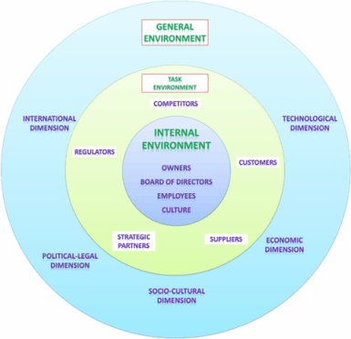
Organizations have an external and internal environment;
- Internal environment / Micro environment.
- External environment / Macro Environment.
  - General environment.
  - Industry environment.
An organization’s operations are affected by both types of environments.
Therefore, the managers need to make an in-depth analysis of the elements of the environments so that they can develop in themselves an understanding of the internal and external situations of the organization.
Based on their understanding, they will be better able to establish the required objectives for their organization and formulate appropriate strategies to achieve those objectives.
In this post, we will look at the elements of the organizations’ environment.

Internal Environment of Organization
Forces or conditions or surroundings within the boundary of the organization are the elements of the internal environment of the organization.
The internal environment generally consists of those elements that exist within or inside the organization such as physical resources, financial resources, human resources, information resources, technological resources, organization’s goodwill, corporate culture and the like.
The internal environment includes everything within the boundaries of the organization.
Some of these are tangible, such as the physical facilities, the plant capacity technology, proprietary technology or know-how; some are intangible, such as information processing and communication capabilities, reward and task structure, performance expectations, power structure management capability and dynamics of the organization’s culture.
Based on those resources, the organization can create and deliver value to the customer. This value is fundamental to defining the organization’s purpose, and the premise on which it seeks to be profitable.
Are we adding value by research and development or by customer service, or by prompt delivery or by cutting any intermediary which reduces the customers’ costs?
Organizations build capabilities over a long time. They consistently invest in some areas so that they can build strong competitive businesses based on the uniqueness they have created.
The manager’s response to the external environment would depend upon the availability and the configuration of resource deployment within the organization.
The deployment of resources is a key managerial responsibility.
Top management is vested with the responsibility of allocating resources between the ongoing operations/activities and also with future operations which are of strategic nature, that is they might yield returns in some future time which require resources now to be nurtured and have some associated risks. The top management has to balance the conflicting demands of both as resources are always finite.
For example, General Electric is an aggressive innovator and marketer who has been ruthless in its approach to changing proactively as well as reactively to sustain its competitive positions in the respective industries. This implies that over the years General Electric has invested in developing those capabilities, systems, and processes that enable it to respond.
Elements of internal environment are;
- Owners and Shareholders.
- Board of Directors.
- Employees.
- Organizational Culture.
- Resources of the Organization.
- Organization’s image/goodwill.
The internal environment consists mainly of the organization’s owners, the board of directors, employees and culture.
- Owners and Shareholders
Owners are people who invested in the company and have property rights and claims on the organization. Owners can be an individual or group of persons who started the company; or who bought a share of the company in the share market.
They have the right to change the company’s policy at any time.
Owners of an organization may be an individual in the case of sole proprietorship business, partners in a partnership firm, shareholders or stockholders in a limited company or members in a cooperative society. In public enterprises, the government of the country is the owner.
Whoever the owners, they are an integral part of the organization’s internal environment. Owners play an important role in influencing the affairs of the business. This is the reason why managers should take more care of the owners of their organizations.
- Board of Directors
The board of directors is the governing body of the company who is elected by stockholders, and they are given the responsibility for overseeing a firm’s top managers such as the general manager.
- Employees
Employees or the workforce, the most important element of an organization’s internal environment, which performs the tasks of the administration. Individual employees and also the labor unions they join are important parts of the internal environment.
If managed properly they can positively change the organization’s policy. But ill-management of the workforce could lead to a catastrophic situation for the company.
- Organizational Culture
Organizational culture is the collective behavior of members of an organization and the values, visions, beliefs, habits that they attach to their actions.
An organization’s culture plays a major role in shaping its success because the culture is an important determinant of how well their organization will perform.
As the foundation of the organization’s internal environment, it plays a major role in shaping managerial behavior.
An organization’s culture is viewed as the foundation of its internal environment. Organizational culture (or corporate culture) significantly influences employee behavior.
Culture is important to every employee including managers who work in the organization.
A strong culture helps a firm achieve its goals better than a firm having a weak culture. Culture in an organization develops and ‘blossoms’ over many years, starting from the practices of the founder(s).
Since culture is an important internal environmental concern for an organization, managers need to understand its influence on organizational activities.
- Resources of the Organization
An organization s resources can be discussed under five broad heads: physical resources, human resources; financial resources, informational resources, and technological resources. Physical resources include land and buildings, warehouses, all kinds of materials, equipment and machinery.
Examples are office buildings, computers, furniture, fans, and air conditioners.
Human resources include all employees of the organization from the top level to the lowest level of the organization. Examples are teachers in a university, marketing executives in a manufacturing company, and manual workers in a factory.
Financial resources include capital used for financing the operations of the organization including working capital. Examples are investment by owners, profits, reserve funds, and revenues received out of a sale. Informational resources encompass ‘usable data needed to make effective decisions.
Examples are sales forecasts, price lists from suppliers, market-related data, employee profile, and production reports.
- Organization’s image/goodwill
The reputation of an organization is a very valuable intangible asset. High reputation or goodwill develops a favorable image of the organization in the minds of the public (so to say, in the minds of the customers).
‘No- reputation’ cannot create any positive image. A negative image destroys the organization’s efforts to attract customers in a competitive world.
The internal environment of an organization consists of the conditions and forces that exist within the organization.
Internal environment {sometimes called micro-environment) portrays an organization’s ‘in-house’ situations.
An organization has full control over these situations. Unlike the external environment, firms can directly control the internal environment.
Internal environment includes various internal factors of the organization such as resources, owners/shareholders, a board of directors, employees and trade union, goodwill, and corporate culture. These factors are detailed out below.

External Environment of Organization – Factors Outside of Organization’s Scope
Factors outside or organization are the elements of the external environment. The organization has no control over how the external environment elements will shape up.
The external environment embraces all general environmental factors and an organization’s specific industry-related factors. The general environmental factors include those factors that are common ir\ nature and generally affect all organizations.
Because of their general nature, an individual organization alone may not be able to substantially control their influence on its business operations.
Managers have to continuously read signals from the external environment to spot emerging opportunities and threats. The external environment presents opportunities for growth leadership, and market dominance, it also poses the threat of obsolescence for products, technology, and markets.
While one section of an organization faces opportunities, another faces threats from a similar environment, perhaps because there is differentiation in their respective resources, capabilities and entrenched positions within the industry.
For example, the burgeoning mobile telephone market in India provides enormous opportunities for different types of organizations from handset manufacturers, content developers, application developers, mobile signal tower manufacturers, to service providers.
At the same time, it poses a threat to the fixed-line telephone business which for a long time, has been the monopoly of public sector enterprises.
The increasing demand for telecommunication services in India post-deregulation was an enormous opportunity for early entrants to enter the telecom services business and compete for revenue with state-owned organizations.
At the same time, the growing demand for mobile services led to an expansion of industrial capacity, price wars, lowering of call tariffs, acquisitions, and declining industry profits.
India has one of the lowest call rates in the world. As the industry matured and consolidation took place, the old players had to alter their business models and strategies.
The external environment can be subdivided into 2 layers;
- General Environment.
- Task / Industry Environment.
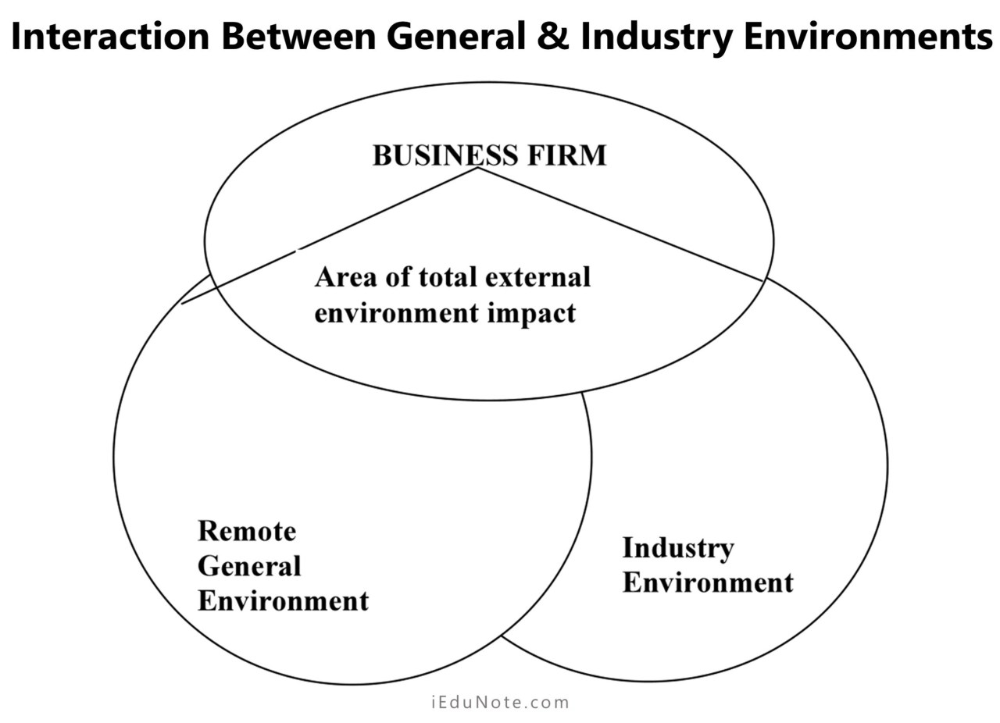

General Environment of Organization – Common Factors that All company in the Economy Faces
The general environment usually includes political, economic, sociocultural, technological, legal, environmental (natural) and demographic factors in a particular country or region. The general environment consists of factors that may have an immediate direct effect on operations but influences the activities of the firm.
The factors of the general environment are broad and non-specific whereas the dimensions of the task environment are composed of the specific organization.
The external environment consists of an organization’s external factors that affect its businesses indirectly. The organization has no or little control over these factors; that means, the external environment is generally non-controllable.
However, there may be exceptions. The external environmental factors reside outside the organization, which can lead to opportunities or threats.
For the convenience of analysis, we can divide the external environment into two groups: (a) general environment (or remote environment), and (b) industry environment (some call it ‘immediate operating environment’, ‘task environment or‘specific environment’).
The general environment consists of those factors in the external environment that indirectly affect the business operations of firms.
The major factors that constitute the general environment include political situations, economic conditions, social and cultural factors, technological advancements, legal/regulatory factors, natural environment, and demographics in a particular country or region.
The industry environment consists of those factors in the external environment that exist in the industry in which the organizations operate their business. The industry environmental factors are generally more controllable by a firm than the general environmental factors.
Industry environment comprises those factors in the external environment that exists in tie concerned industry of a firm in which it is operating its business.
For example, US Pharma is operating its business in the pharmaceutical industry.
Therefore, all factors that are likely to affect the business operations of Incepta Pharmaceuticals Limited would be included in the ‘industry environment’ of the company.
There are mainly 6 factors in the industry environment such as suppliers, buyers & customers, competitors & new entrants, substitute products, regulators, and strategic partners.
It may be noted that some industry environmental factors such as competitors and substitute products may-exist even outside the concerned industry.
For example, a leasing company may emerge as a competitor of the companies in the banking industry in terms of attracting deposits and providing loans to business houses.
Regarding the industry environment, the important issue to appreciate is that they reside in the immediate competitive situations of a firm.
Also, they are very specific in the sense that they can be easily identified. For these reasons, they are often regarded as ‘specific environment’ or ‘task environment’.
The strategy-makers must understand the challenges and complexities of both the general environmental factors and the industry environmental factors. They need to appreciate that the general environmental factors are largely non-controllable because of their distantly located external nature.
When strategists take into cognizance of both the general (remote) and industry (operating) environments, they are likely to become more proactive in strategic planning.
In the following discussions, you will find a broad description of the general environment.

Elements of the General External Environment
The general environment includes the; distant factors in-the external environment that is general or common in nature. Its impact on the operations of the firm, its competitors and customers make its analysis imperative.
We can use the PESTLE model for the identification and analysis of the factors in the general environment. PESTLE Model covers political, economic, sociocultural, technological, legal, and environmental (natural).
- Political factors.
- Economic factors.
- Sociocultural factors.
- Economical factors.
- Legal factors.
- (Natural) Environmental factors.
Along with these, we can add additional factors that suit the current modern business atmosphere.
- Demographic factors.
- International factors.
Let’s see the elements or factors of the general environment.
- Political Legal Factors
The political factors of the general environment refer to the business-government relationship and the overall political situation of a country.
A good business-government relationship is essential to the economy and most importantly for the business.
The government of a country intervenes in the national economy through setting policies/rules for business In our country, we see many such policies – import policy, export policy, taxation policy, investment policy, drug policy, competition policy, consumer protection policy, etc.
Sometimes, the government pursues a nationalization policy for state ownership of a business.
Some countries, such as India, pursue state-driven mercantilism to reduce imports and increase exports. Some countries; have liberalized their economy and shifted from centrally managed economy to a capitalist economy or welfare economy.
In many 3rd world countries, the successive governments are emphasizing more on privatization rather than on state ownership. As global competition has increased, the government has also liberalized its trade policies to be in line with the WTO agreements.
Another important issue is political stability that affects the operations of business firms substantially. Evert decision about investment is highly affected by political stability.
We have seen in several countries in Asia, Africa, Latin America, how political instability has in the past affected investment and trading in the country.
In many 3rd world countries also, political instability or political/ disturbances substantially affected businesses.
Besides, government agencies and pressure groups (special interest groups) are also exercising influences on business operations of firms that have a political character.
Managers must be able to understand the implications of the activities of these agencies and groups. Government agencies include different ministries, the office of the Controller of Imports and Exports, Board of Investment, National Board of Revenue, etc.
Pressure groups include Consumers Association of Bangladesh, various Chambers of Commerce and Industry, Employers’ Associations, Environmental Protection Movement and the like.
Since the pressure groups put restraints on the business managers, managers should have clear ideas about the actions of these groups.
- Economic Factors
The economic factor of an organization is the overall status if the economic system in which the organization operates. The important economic factors for business are inflation, interest rates, and unemployment.
These factors of the economy always affect the demand for products. During inflation, the company pays more for its resources and to cover the higher costs for it, they raise commodity prices.
When interest rates are high, customers are less willing to borrow money and the company itself must pay more when it borrows. When unemployment is high, the company can be very selective about who it hires, but customers’ buying power is low as fewer people are working.
A country’s economic conditions affect market attractiveness. The performance of business organizations is affected by the health of a nation’s economy.
Several economic variables are relevant in determining business opportunities.
Examples of economic factors include the trend in economic growth, income levels of population, inflation rate, tax rates for individuals and business organizations, etc.
There is thus a need to analyze the economic environment prudently by the business firms.
The economic environment comprises a distinct variable with which management must be concerned. The economy of a country can be in a situation of boom or recession or depression or recovery or it may be in a state of fluctuation.
Managers/strategy-makers must have the ability to predict the state of the economy. the»s warrants the necessity of studying the economic environment to identify changes, trends and their strategic implications.
Business organizations operate their businesses in markets consisting of people.
These people are likely to become customers when they have purchasing power. And purchasing power depends on income, prices, savings, debt and availability of credit.
Therefore, business organizations must pay attention to the income and consumption patterns of the customers.
However, all the economic variables in the economy must be treated holistically for the clear envisioning of the entire economy and the market
- Socio-Cultural Factors
Customs, mores, values and demographic characteristics of the society in which the organization operates are what made up the socio-cultural factors of the general environment.
The socio-cultural dimension must be well studied by a manager. It indicates the product, services, and standards of conduct that society is likely to value and appreciate. The standard of business conduct varies from culture to culture and so does the taste and necessity of products and services.
Socio-cultural forces include culture, lifestyle changes, social mobility, attitudes towards technology, and people’s values, opinion, beliefs, etc.
A society’s values and altitudes form the cornerstone of society. They often drive other conditions and changes. The hand for many products changes with the changes in social attitudes.
Socio-cultural factors differ across countries.
In many countries, worker diversity is now a common phenomenon.
We find in first world countries the increasing life span of population, trend towards fewer children, movement of population from rural areas to urban areas, increasing rate of female education, entry of more and more women into the mainstream workforce, etc.
All these have a primary effect on a country’s social character and health.
Therefore, managers of business organizations need to study and predict the impact of social and cultural changes on the future of business operations in terms of meeting consumer needs and
interests.
Business firms must offer products in the society that correspond to their values and attitudes.
- Technological Factors
It denotes to the methods available for converting resources into products or services. Managers must be careful about the technological factor. Investment decisions must be accurate in new technologies and they must be adaptable to them.
Technological factors include information technology, the Internet, biotechnology, global transfer of technology and so forth. None can deny the fact that the pace of change in these technological dimensions is extremely fast.
Technological changes substantially affect a firm’s operations in many ways. The advancement of industrialization in any Country depends mostly on the technological environment. Technology has major impacts on product development, manufacturing efficiencies, and potential competition.
The business organizations facing problems with changing technology are always in more difficulties than those organizations that have stable technologies.
The effects of technological changes occur primarily through new products, processes, and materials. An entire industry may be transformed or revitalized due to the use of new technology.
Strategy formulation is linked to technological changes. An intelligent response to the ever-increasing technological advances should be entrepreneurial rather than reactive.
Strategic managers need to monitor developments in technology for their particular industry when formulating a strategy. A quick and thorough study of technological changes; helps managers achieve a higher market share because of the early adoption of new technology.
A firm must be aware of technological changes to avoid obsolescence arid promote innovation. It means that strategy managers of an organization must be adept in – technological forecasting. Technological forecasting can
- Legal Factors
The legal environment consists of laws and regulatory frameworks in a country. Many laws regulate the business operations of enterprises such as the Factories Act, Industrial Relations Ordinance, the Contract Act, and the Company law, just to name a few.
Business laws primarily protect companies from unfair competition and also protect consumers from unfair business practices.
Business laws also protect society at large. The laws regarding a merger, acquisitions, industry regulation, employment conditions, unionization, workmen’s compensation and the like affect a firm’s strategy. Even globalization has caused significant repercussions in the legal environment.
Thus, the business managers must have thorough knowledge about the major laws that protect business enterprises, consumers and society.
And the overall situation of law implementation and justices in a country indicates that there is a favorable situation in business in a country.
- Environmental / Natural Factors
Strategy-makers need to analyze the trends in the natural environment of the country where it is operating its business.
The most pertinent issues in the natural environment that strategy-makers should consider include the availability of raw materials and other inputs, changes in the cost of energy, levels of environmental pollution, and the changing role of government ‘in environmental protection.
Changes in physical/natural environment, such as global warming, will heavily affect our daily lives and the functioning of our organizations with a variety of consequences.
- Demographic Factors
The demographic environment is concerned with a country’s population.
Specifically, it is related to the population’s size, age structure, geographic distribution, ethnic mix, and income distribution.
With over 7 billion population the demographic changes are evident all over the world. In some countries there is negative population growth and’in some countries, couples are averaging fewer than two children. In general, the average age is increasing.
In many countries, rural-urban migration is rampant. These trends suggest numerous opportunities for firms to develop products and services to meet the needs of diversified groups of people in society.
Strategy-makers must make an analysis of the demographic issues, especially, size and growth rate of population, age distribution, ethnic mix, educational level, household patterns, and inter-regional movements.
- International Factors
Virtually every organization is affected by international factors. It refers to the degree to which an organization is involved in or affected by businesses in other countries.
Global society concept has brought all the nation together and modern network of communication and transportation technology, almost every part of the world is connected.
General external environmental factors are interrelated with organizational success.
Therefore, strategy-makers need to analyze all of them in an interrelated fashion to understand and visualize the ‘whole of the environment.

Industry/Task Environment of Organization – Industry Factors that are Vital for Business Functions
A business firm’s strategy is affected by the structural characteristics of the industry, it is thus considered essential for a firm to make an elaborate analysis of the industry in which the firm operates its business.
Based on Michael Porter’s research results, Van industry structure consists of suppliers, buyers, direct competitors, new entrants, and substitutes. The strategy-makers of a firm need to be concerned with the impact of the industry structure on the firm’s strategy.
Once the external environmental analysis has been completed, they should embark upon industry analysis. Industry analysis helps them have clear information about what is happening in the industry in which their companies are operating their businesses.
Since the industry contains competition, its analysis brings to light the complexities of the competition and the consequent challenges facing the industry.
The industry environmental factors, on the other hand, are those factors in the external environment that specifically reside in a particular industry and affect competition such as suppliers, customers, competitors, and substitute products
The task environment consists of factors that directly affect and are affected by the organization’s operations. These factors include suppliers, customers, competitors, regulators and so on.
A manager can identify environmental factors of specific interest rather than having to deal with a more abstract dimension of the general environment.

Elements of the industry or task environment
As a manager or entrepreneur, you should be able to identify the various elements of the industry environment so that you can take appropriate steps to respond to them effectively in order to survive in the industry.
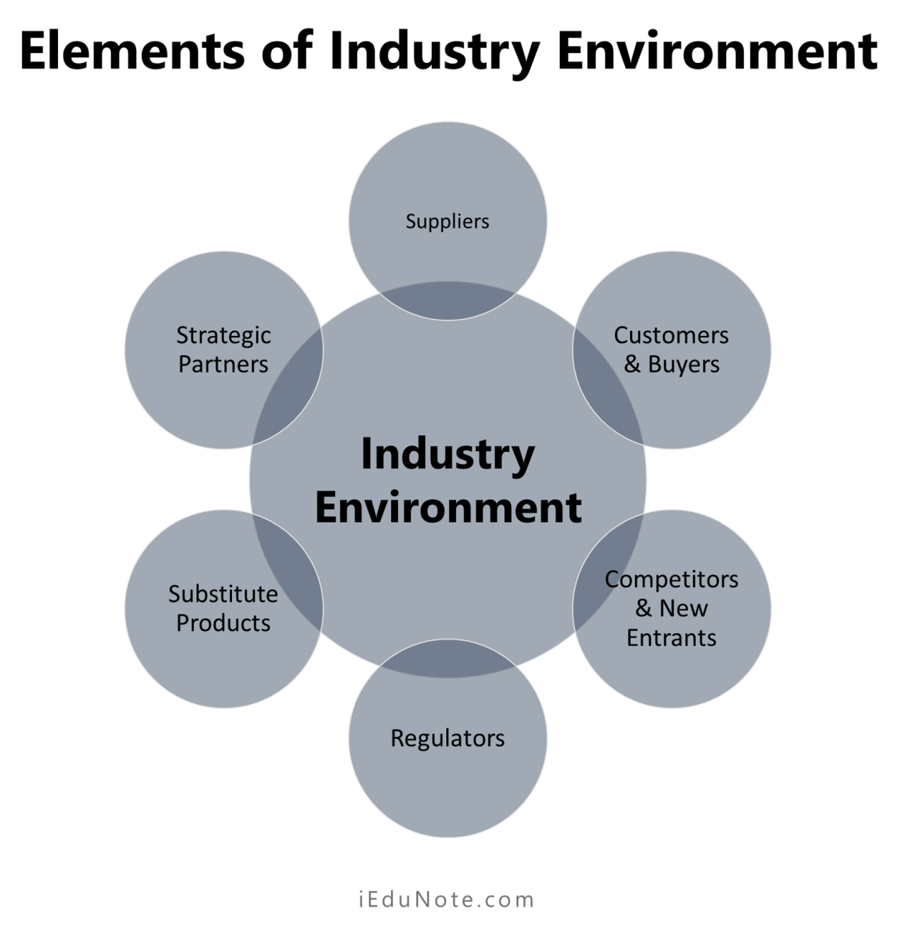
- Suppliers.
- Customers & Buyers.
- Competitors & New Entrants.
- Regulators.
- Substitute Products.
- Strategic Partners.
The different elements of the task environment may be discussed as under:
- Suppliers
Suppliers are the providers of production or service materials. Dealing with suppliers is an important task of management.
A good relationship between the organization and the suppliers is important for an organization to keep a steady following of quality input materials.
Suppliers are sources of resources such as raw materials, components, equipment, financial support, services, and office Supplies.
To ensure the long-term survival and growth of a company, it is essential to develop a dependable relationship between a business-firm and its suppliers. Concerning its competitive position with suppliers, a company should address the following questions;
  - Are the suppliers’ prices competitive?
  - Do suppliers offer attractive quantity discounts?
  - How costly are their shipping charges?
  - Are vendors competitive in terms of production standards?
  - Are suppliers’abilities, reputation, and services competitive?
  - Are suppliers reciprocally dependent on the firm?
- Customers & Buyers
“Satisfaction of customer”- the primary goal of every organization. The customer is who pays money for the organization’s product or services. They are the peoples who hand them the profit that the companies are targeting.
Managers should pay close attention to the customers’ dimension of the task environment because its customers purchase that keeps a company alive and sound.
Strategy managers must understand the composition of the company’s customers.
With this end in view, they need to develop an exhaustive customer profile of both the present and potential customers. Managers will be in a better position to pragmatically plan the firm’s strategic operations, anticipate changes in the size of the markets and anticipate demand patterns.
While constructing a customer profile, managers need to use information regarding geographic -location of customers,’ demographic characteristics of buyers, psychographic issues and buyer behavior.
- Competitors & New Entrants.
Policies of the organization are often influenced by the competitors.
Competitive marketplace companies are always trying to stay and go further ahead of their competitors. In the current world economy, competition and competitors in all respects have increased tremendously.
A firm needs to analyze the competitive intensity in the industry. It needs to understand the competitive position in the industry to improve its chance of designing winning strategies.
Many companies develop a ‘competitor profile’ to more accurately forecast their short-and-long-term growth and profit? potentials.
A competitor profile may include such variables as market share, product line, the effectiveness of sales distribution, price competitiveness, advertising and promotion effectiveness, location, and age of the facility, production capacity, raw material costs, financial position, etc.
The positive effect of this is that the customers always have options and the overall quality of products goes high.
The new entrants are the upcoming competitors of the firm. They are potential competitors because when they enter the industry with similar types of products, the competitive intensity increases.
- Regulators
Regulators are units in the task environment that have the authority to control, regulate or influence an organization’s policies and practices.
Government agencies are the main player in the environment and interest groups are created by its members to attempt to influence organizations as well as the government. Trade unions and the chamber of commerce are common examples of an interest group.
- Substitute Products
The producers of substitute products are indirect competitors.
Substitute products serve the same categories of customers. They can meet the similar needs of customers, and therefore, emerge, as threats.
For example, when the detergent powder is capable of meeting customer needs in a much better way or even in the same way as the laundry soap does, the detergent powder becomes a strong indirect competitor of laundry soap.
- Strategic Partners
They are the organization and individuals with whom the organization is to an agreement or understanding for the benefit of the organization. These strategic partners in some way influence the organization’s activities in various ways.
The industry environment is the competitive environment of a business organization. Industry environment substantially affects a firm’s business operations, because it is the ‘immediate’ external environment of the firm, which is also known as ‘immediate operating environment.’
Every firm operates its business in an industry and therefore its activities are directly affected by any change in the industry and therefore its activities are directly affected by any changes in the industry environment.
Changes in the genera! the environment can have a direct impact on any of the factors in the industry environment.
An organization has greater control over the industry’s environmental factors than the general environmental factors.
One point is to be noted that although the industry environment affects all the firms in the industry, in reality, all firms are not affected equally.

Influence of Internal and Environment on Business
Business managers must understand the various facets of the impacts of the external environment.
They need to recognize that the external environment has many aspects that can have a significant impact on the operations of a firm. They need to undertake an analysis of the environment regularly.
This is particularly important for the reason that developments/changes in the remote environment influence the business organizations. They also need to understand the influences of changes in the industry environment.
Managers are benefited in several ways when they have a deep understanding and appreciation of the impact of environmental factors on business:
- Knowledge of the environment helps managers identify the direction to which they should proceed. They will travel along with a distinct way of changing direction, whenever necessary. Without an understanding of the environment, managers are like a bicycle without a handlebar – no way of maneuvering while riding on a street.
- Managers can isolate those factors, especially in the external environment, which are of specific interest to the organization.
- Managers can take preparation to deal with a predicted crisis in any of the factors in the environment. They can develop crisis plans for overcoming crises that affect an organization.
- The key to achieving organizational effectiveness is understanding of the environment in which the firm operates its
No knowledge or inadequate knowledge is very likely to lead managers to ineffectiveness because of ‘running on the wrong road for reaching the goals.

Conclusion
The environment irrespective of its external or internal nature, a manager must have a clear understanding of them.
Normally, you would not go for a walk in the rain without an umbrella, because you understand the environment and you know when it rains you can get wet.
Similarly, if a manager does not know and understand the environment of the organization, he or she will definitively get wet or dry and the organization also in today’s fast and hyper-moving organizational environment.

